**Options API to Composition API migration project need to done(Udemy)**

**What is Vue.js?**

It is JS framework used to develop interactive and reactive web frontend. It can be done with the normal Vennila JS but in this we need to write everything from scratch and is error prone. Also in teamwork they may not know our coding standards. But if we use Vue.js , that provides the std utility to be used by all team members as well as the rules to be followed.

Vue.js and React.js are both popular JavaScript tools for building user interfaces, but they differ in their approach and features. Here's a comparison:

* **Framework vs. Library**:

Vue.js is a framework providing a complete solution for front-end development, while React is a library focused specifically on UI components.

* **Templating**:

Vue.js uses HTML-based templates, which are familiar to web designers, while React uses JSX, a syntax extension that allows writing HTML-like code within JavaScript.

* **Learning Curve**:

Vue.js is generally considered easier to learn, especially for beginners, due to its simpler syntax and clear separation of concerns. React has a steeper learning curve, requiring a solid understanding of JavaScript concepts.

* **State Management**:

Vue.js offers built-in state management with Vuex (or Pinia), while React relies on external libraries like Redux or Context API for managing complex application states.

* **Flexibility**:

React is highly flexible, allowing developers to choose their own tools and libraries. Vue.js provides a more opinionated approach with a set of official tools.

* **Performance**:

Vue.js is known for its speed and efficiency in DOM manipulation. Both use a virtual DOM to optimize updates.

* **Ecosystem**:

React has a larger and more mature ecosystem with a vast number of libraries and tools. Vue.js has a growing ecosystem with strong community support.

* **Use Cases**:

React is often preferred for large, complex applications with long-term development plans, while Vue.js is suitable for smaller projects, SPAs, and rapid prototyping.

* **Corporate backing**:

React is backed by Facebook, while Vue.js is backed by the Vue team and community, including companies like Laravel and Alibaba.

|  |  |  |
| --- | --- | --- |
| **Feature** | **Vue.js** | **React.js** |
| Type | Framework | Library |
| Templating | HTML-based templates | JSX |
| Learning Curve | Easier | Steeper |
| State Management | Built-in (Vuex/Pinia) | External libraries (Redux, Context API) |
| Flexibility | More opinionated, with official tools | Highly flexible, choose your own tools |
| Performance | Fast and efficient DOM manipulation | Virtual DOM for optimized updates |
| Ecosystem | Growing, strong community support | Larger, more mature ecosystem |
| Use Cases | Smaller projects, SPAs, rapid prototyping | Large, complex applications, long-term plans |

**Guide to create / use Vue**

[Quick Start | Vue.js](https://vuejs.org/guide/quick-start)

In general js, we instruct browser line by line on what to do (Ex: get the btn element, on change of input add to the list and clear the input) but in case of vue we just need to specify the end result and the data we need in our vue app and leave it up to Vue to what needs to created / remove from the DOM at which point of time

Note: If we are controlling a html element with Vue then we are controlling all its child element too.

One vue app can control only one html element and automatically controls all the child elements.

“Vue.createApp()” <- In this Vue is a global object. createApp() method is used to create vue App while takes over control of the HTML code. The createApp accepts the Javascript object which is used to configure the Vue App (configure means which kind of data Vue App uses.

Example:

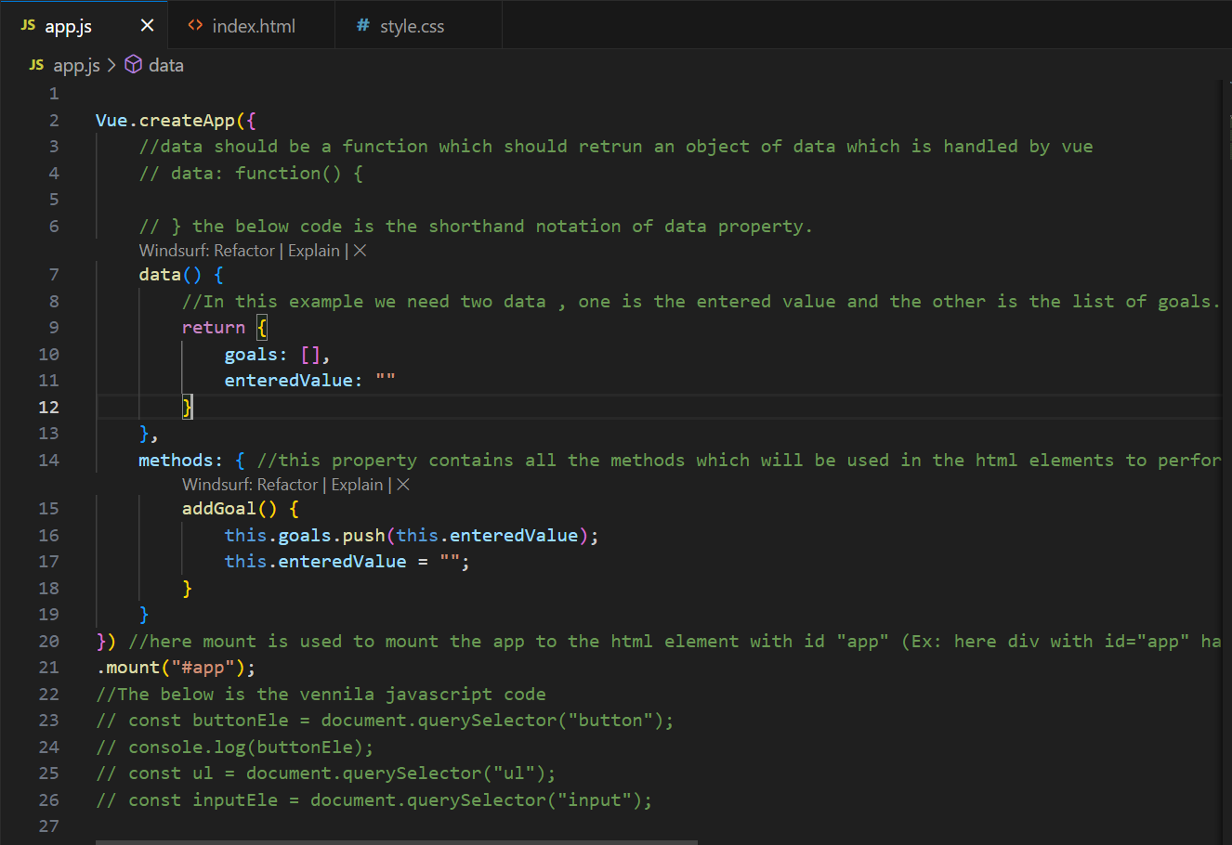

***Note: .mount() accepts a parameter of precise CSS selector. Here since it is an id so passed with “#”.***

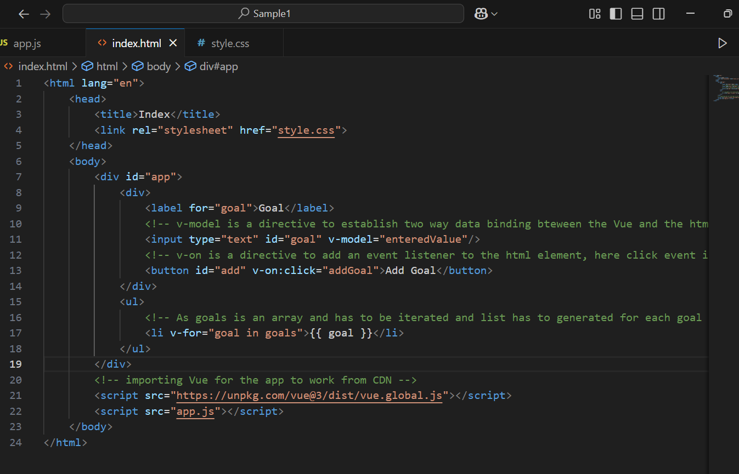

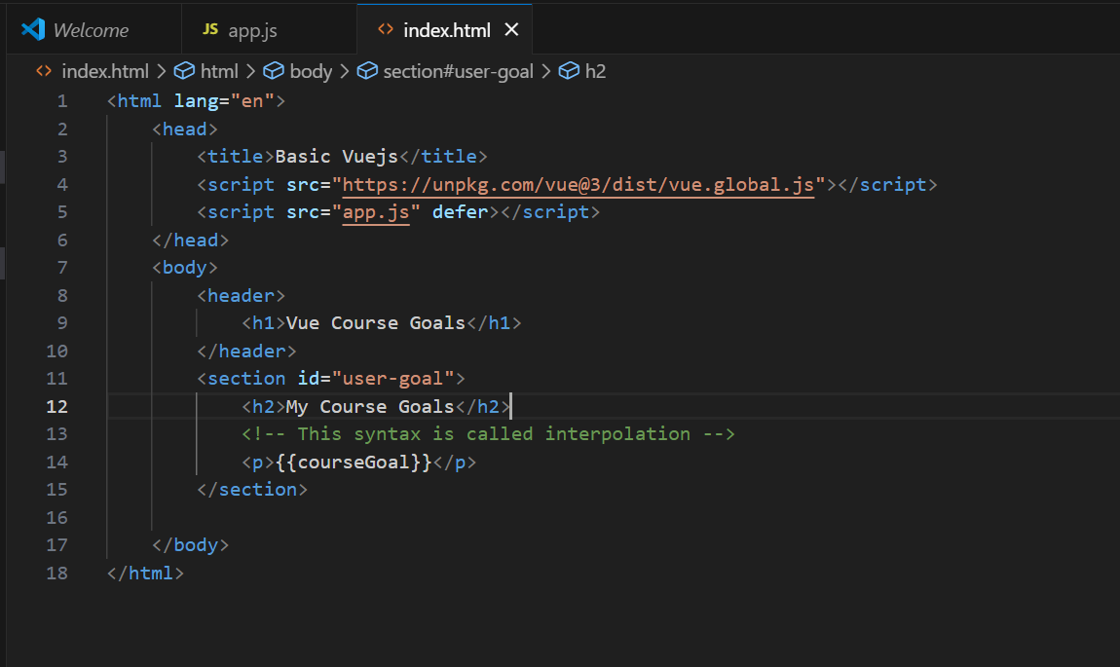

***Note: If the interpolation is placed outside the vue controlled are then it is displayed as such. The interpolation logic works only if used between the html tags. If used inside the properties then it will not work. In that case we need to use v-bind along with the kind of attribute.***

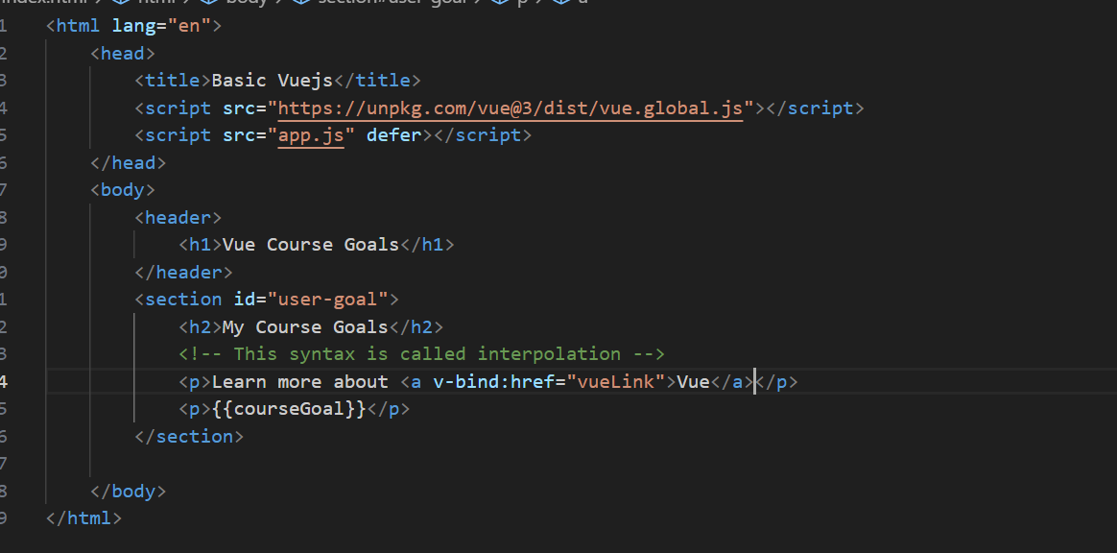

***Method Invocation:***

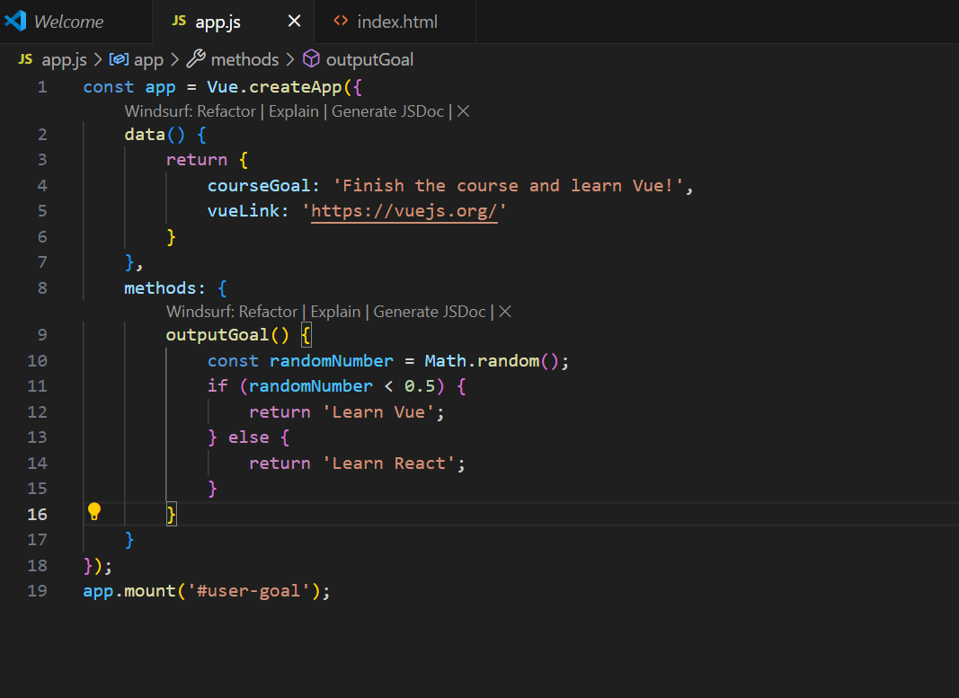

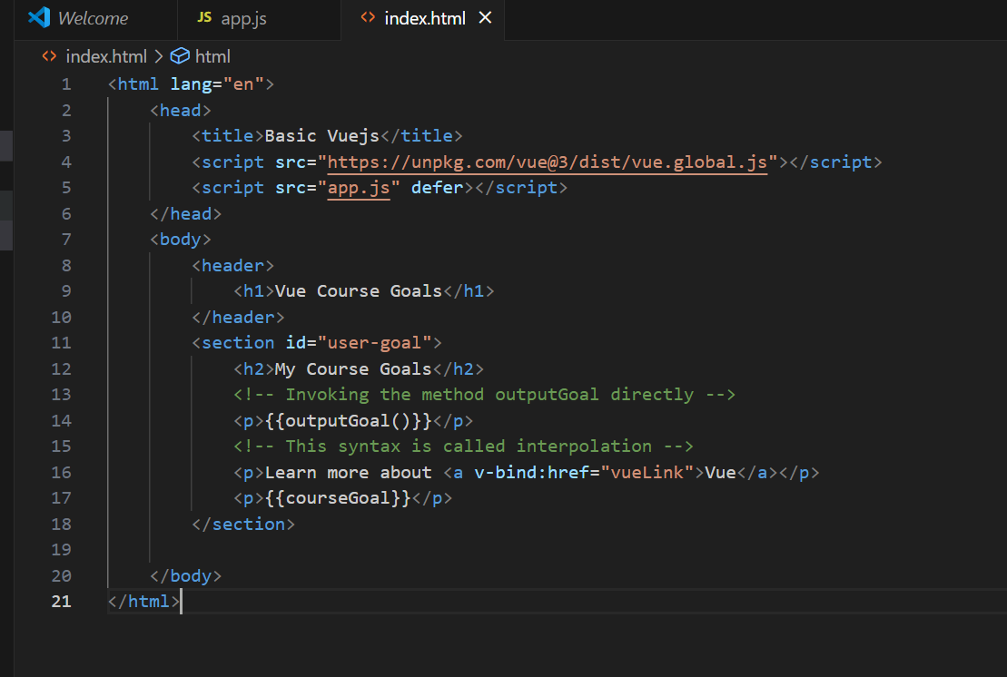

***Accessing vue data in the vue method:***

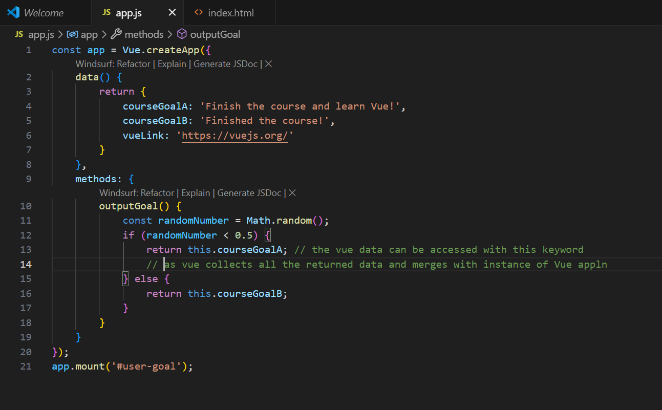

***Note: If any styles are passed in the interpolation, then html styles are displayed as text only and not interpreted as HTML. This double curly braces is good as it prevent cross site scripting.***

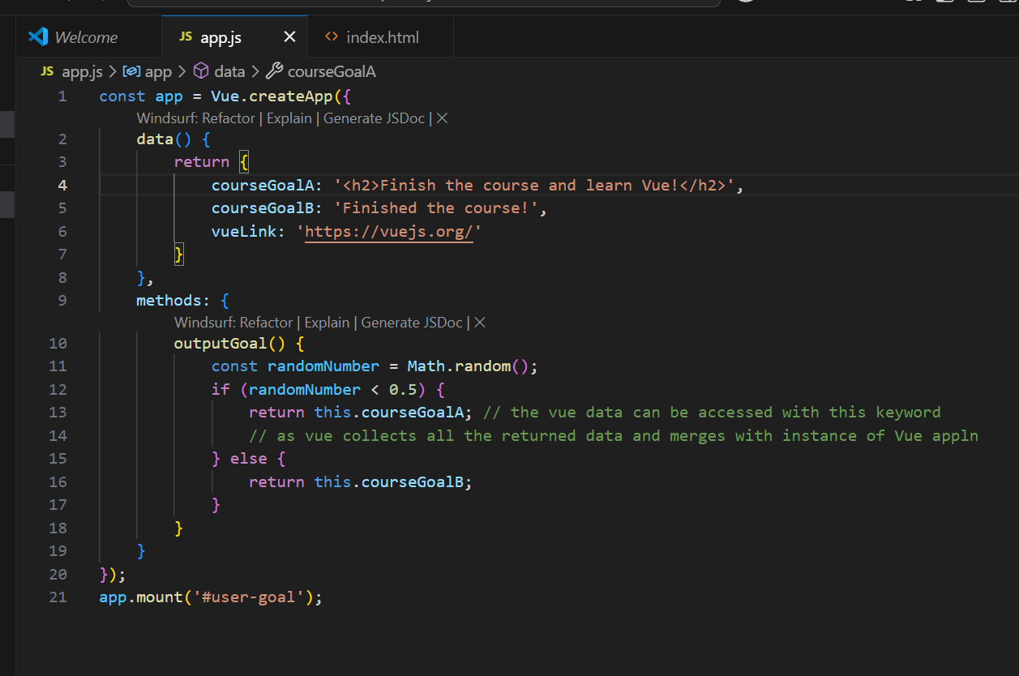

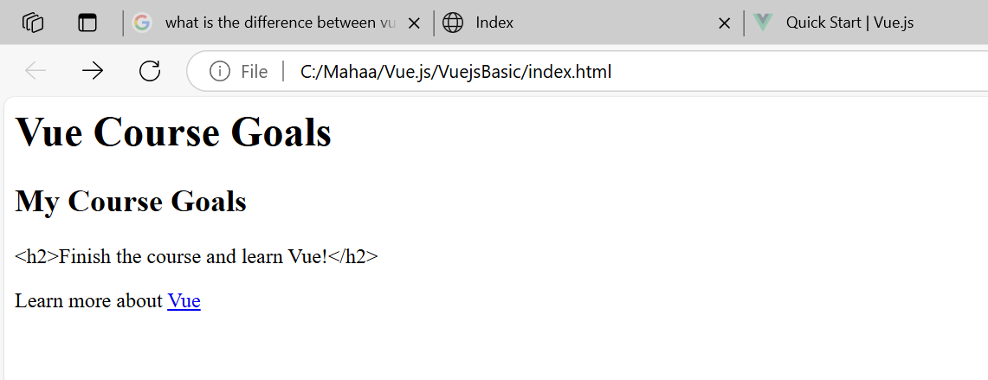

***But sometimes we need to render as html , for that we have the directive “v-html” this instructs that the content should be displayed as html whereas the “v-bind” is used to associate the property with the html attribute.***

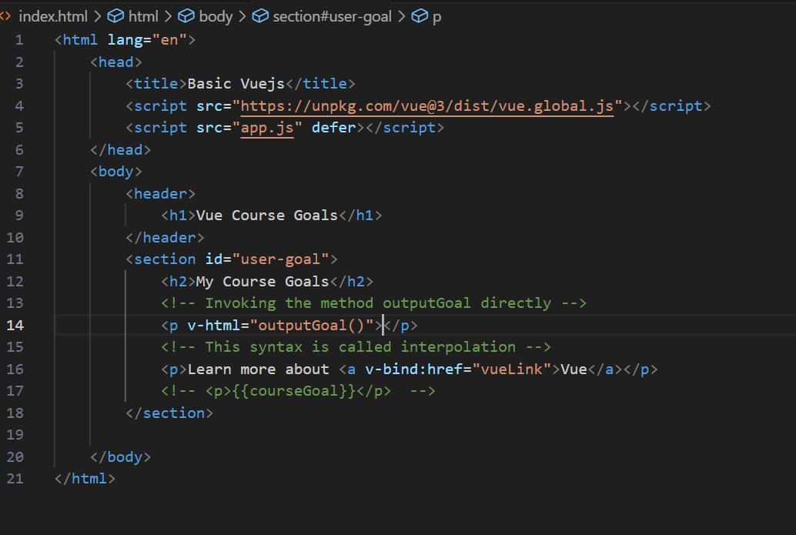

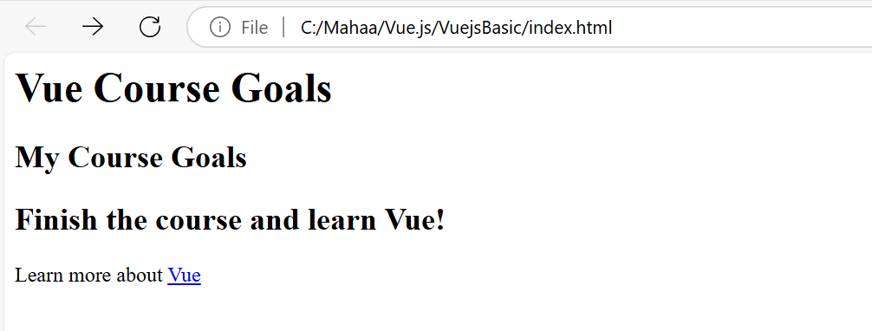

***Method with Params:***

***Method mapped with event is not passing param***

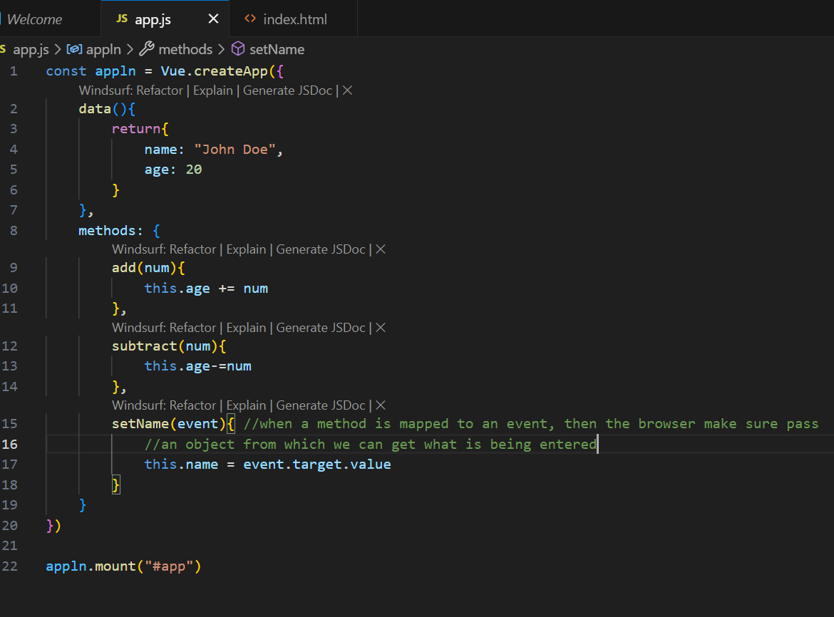

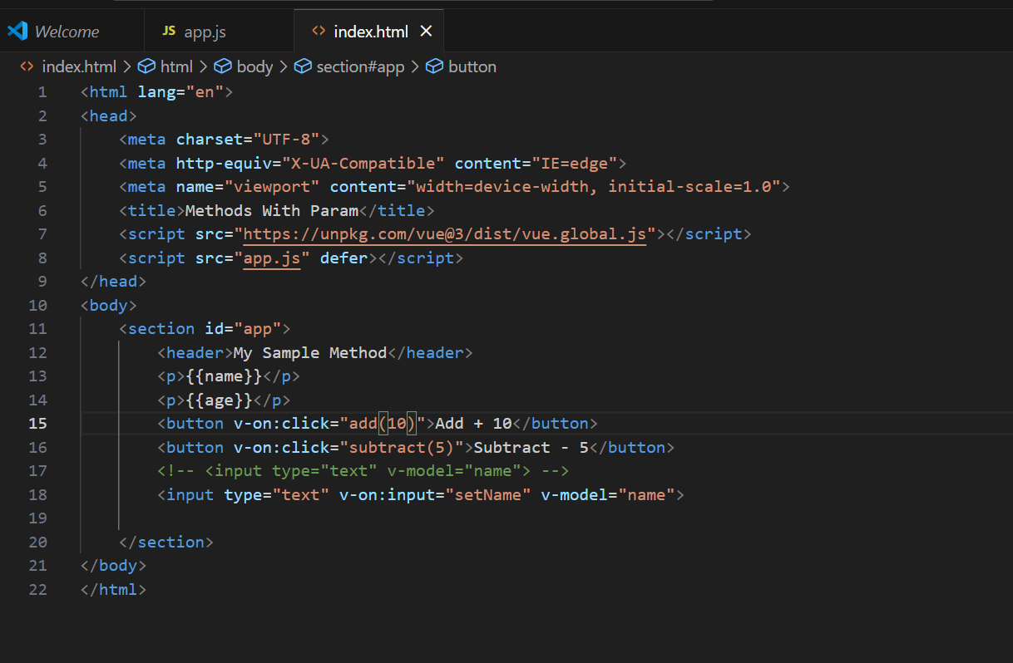

***Method mapped with event is passing param***

*Note: In this case we should pass the default event object(can be accessed as $event) along with the user param*

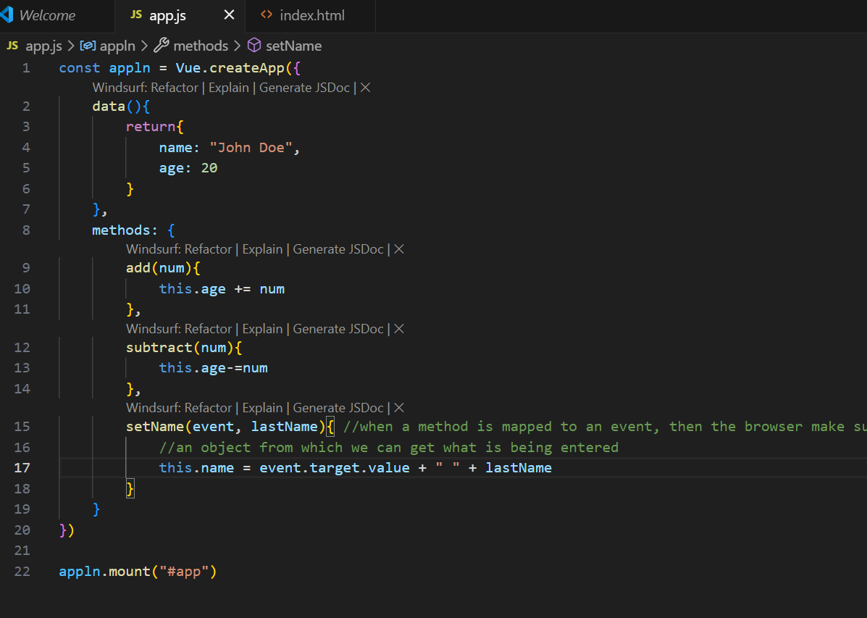

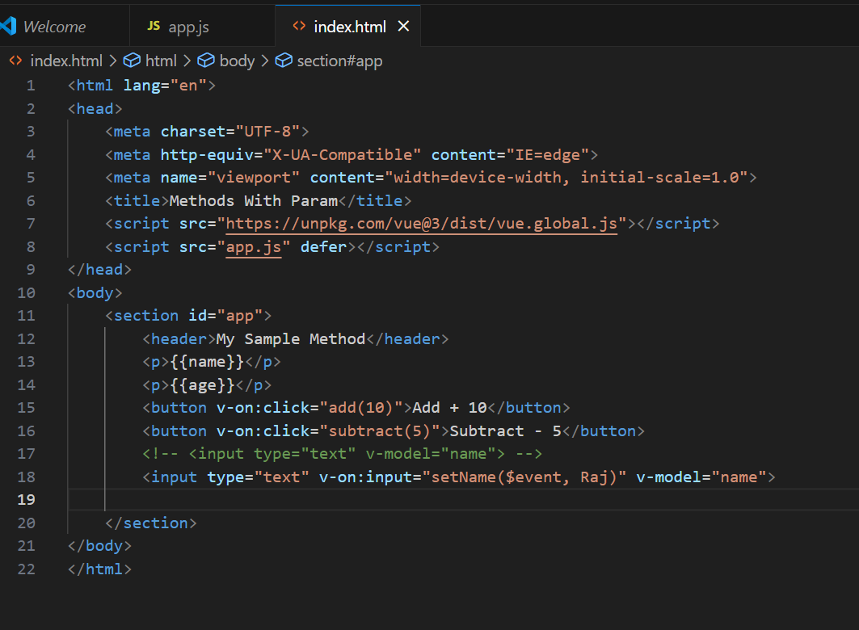

***Event Modifiers:***

*Note: Suppose there is a form element with the input and button elements inside, on click of the button will reload the page or refresh the page as by default, browser submits the data and send a request to server even if it is handled via Vue.*

***Preventing form submission on button click using preventDefault() is an old way of handling:***

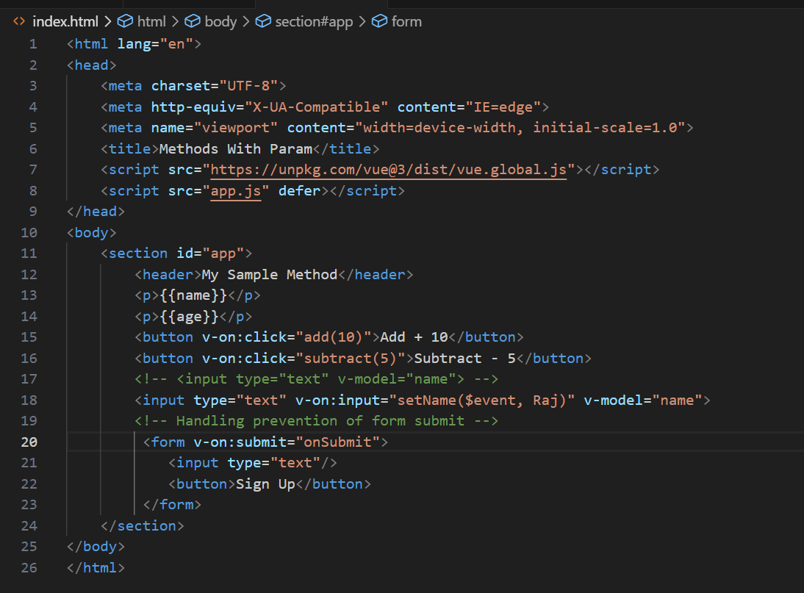

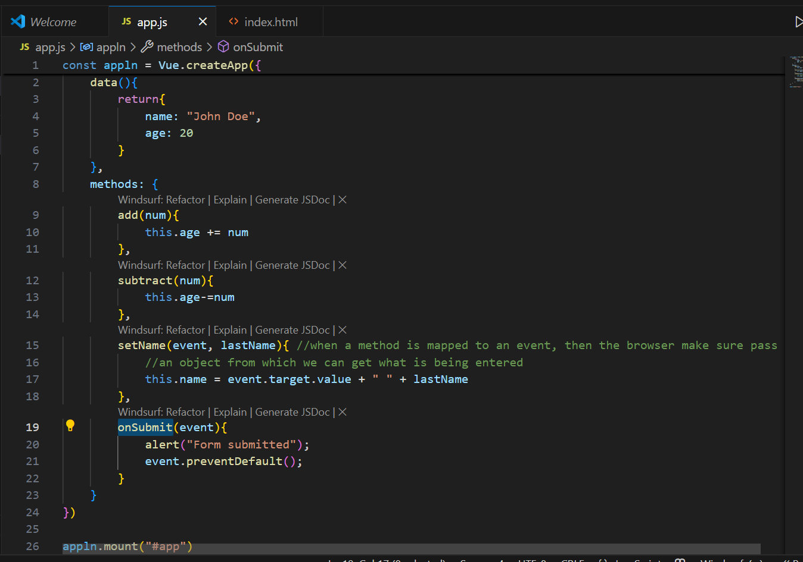

***Preventing form submission on button click using event modifier as Vue provide modifiers to prevent default behaviour:***

***(Ex:*** v-on:submit.prevent="onSubmit" ***)***

***In the above “.prevent” is the modifier used to prevent the default behaviour of the event***

v-on:submit.stop="onSubmit" <- here the "stop" modifier is used to stop the propagation

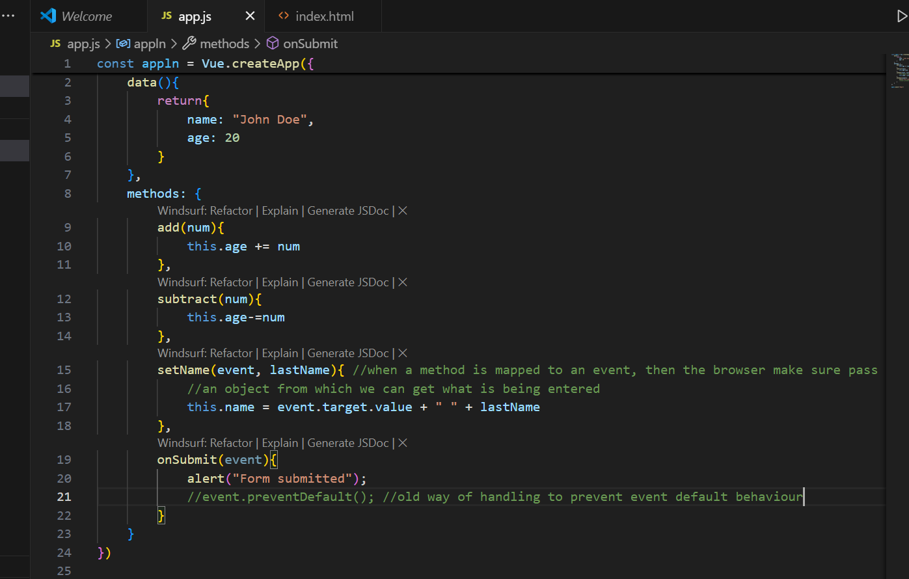

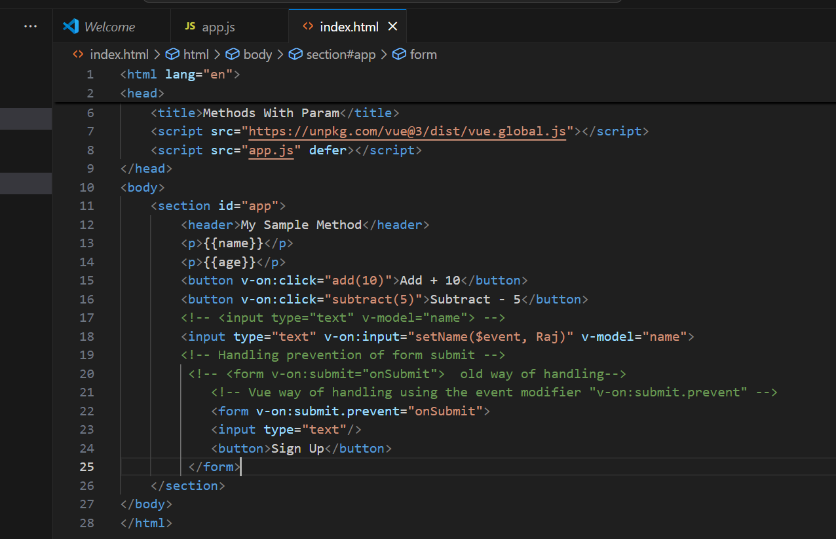

***Apart from preventing default behaviour of event and browser, the modifiers can be linked with the events like when to occur***

***The click by default get triggered on left click of the mouse***

***<button v-on:click="add(10)">Add + 10</button>***

***<button v-on:click="subtract(5)">Subtract - 5</button>***

***This default behaviour can be overridden using the modifier as below:***

***<button v-on:click="add(10)">Add + 10</button>***

***<button v-on:click.right="subtract(5)">Subtract - 5</button> <- triggers on right click***

***<button v-on:click.middle="subtract(5)">Subtract - 5</button> <- triggers on middle click***

***<button v-on:click.left="subtract(5)">Subtract - 5</button> <- triggers on left click, but it is not required as it is the default behaviour.***

***Using the modifiers when we modify when to trigger the event***

*Note: In the below example, the “confirmName” method will be called only when the enter key is pressed in the input*

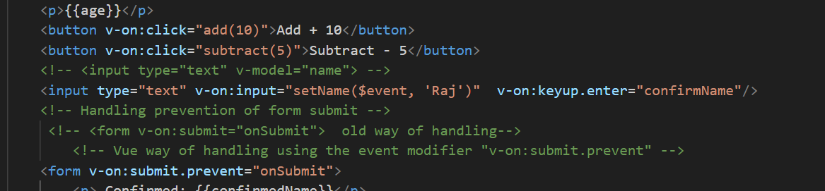

***Lock the initial content using v-once:***

*<p v-once>Initial Age: {{age}}</p>*

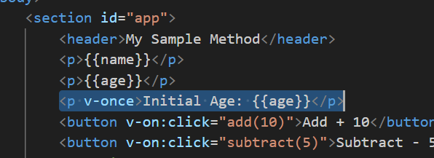

***v-model directive:***

*The directive “v-model” is just a shortcut for “v-bind:value” and “v-on:input”*

*Note: This is used for 2 way binding, “v-bind:value” is to bind the value with the input element or control and “v-on:input” is to listen to the events*

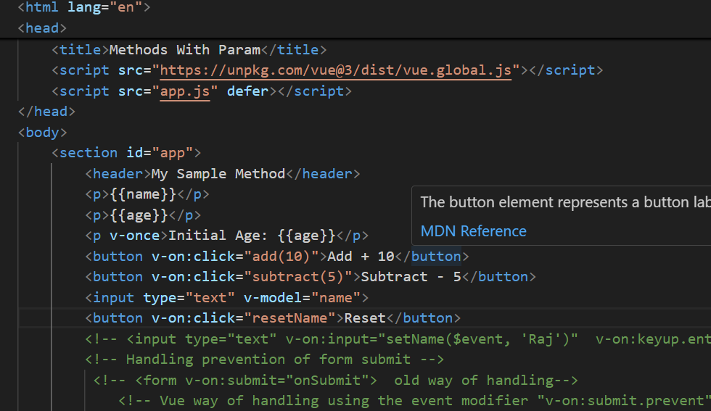

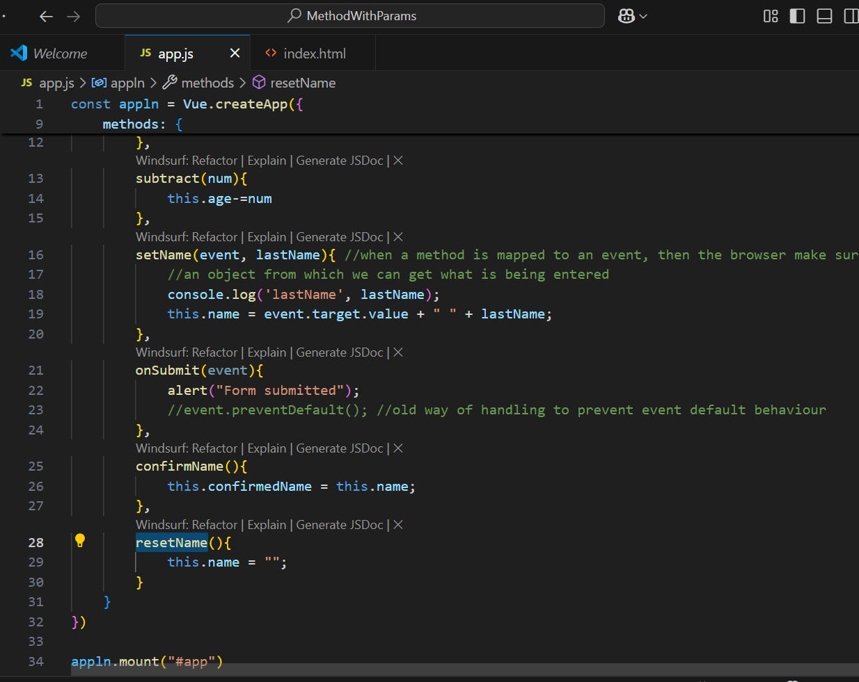

*Note: In case of vue, all the bindings and method calls except event call will be executed when any of the changes occurrence, so it affects the performance. Ie. all the methods except event handling will be executed.*

*In the below example, the “confirmedName()” method is called directly and so it gets executed if any changes occur in the Vue. So to display the dynamic content method is not the best solution.*

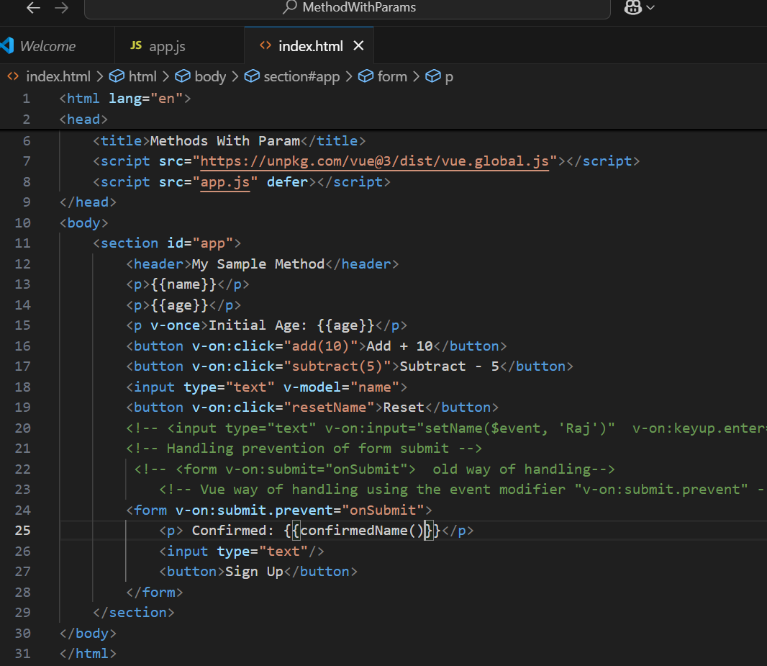

***Computed Properties:***

*Hence the solution to the above problem is the “computed properties” in this the methods will be executed only when one of its dependency changes and once during the initial rendering of the page.*

*Note: The computed properties are actually methods but are invoked just like the variables and, so the computed properties have to be named similar to variables.*

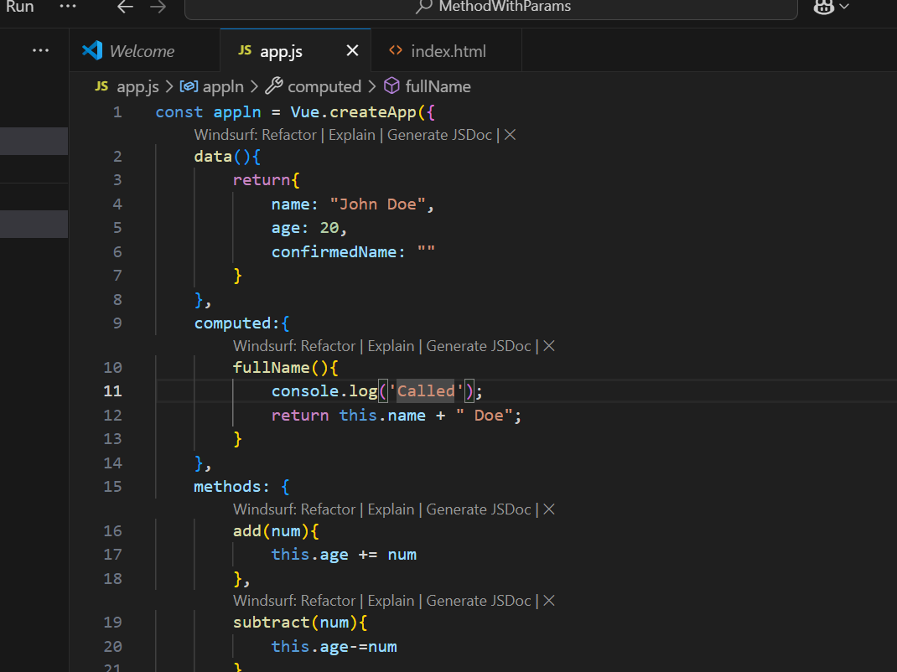

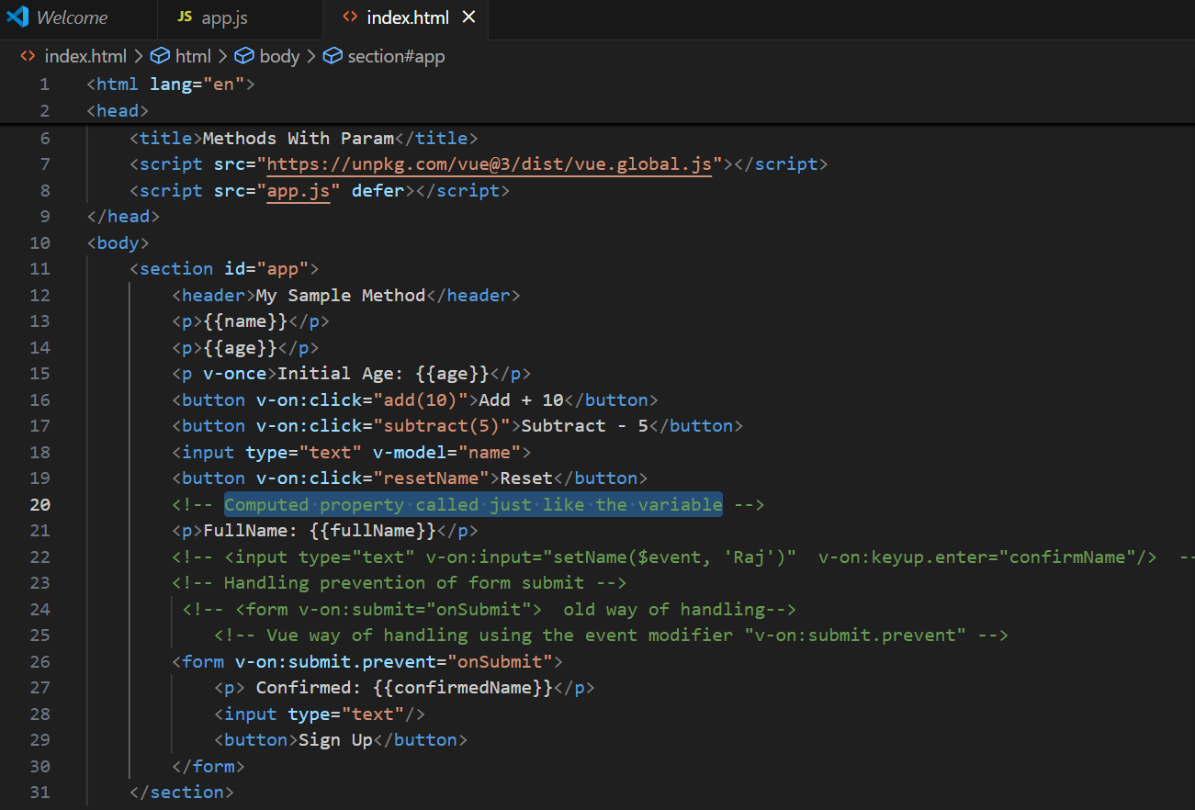

*Working with Watchers:*

*Watchers are nothing but the methods which gets executed when one of its dependency is changed or updated. The name of this should be the name of the property / methods. While execution Vue matches the watcher methods with the variables or methods and gets executed if it’s dependency variable is changed.*

*Note: This watcher is not called anywhere in the code, it is executed as and when one of the dependency is updated.*

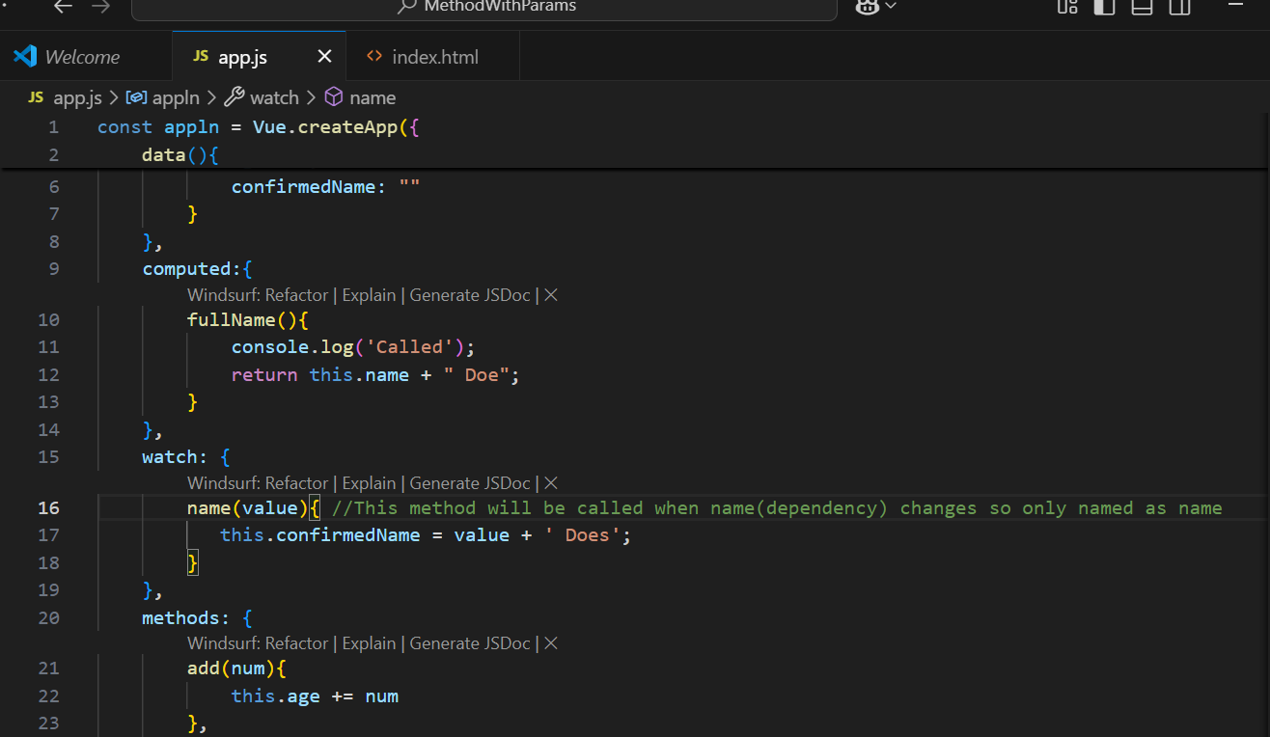

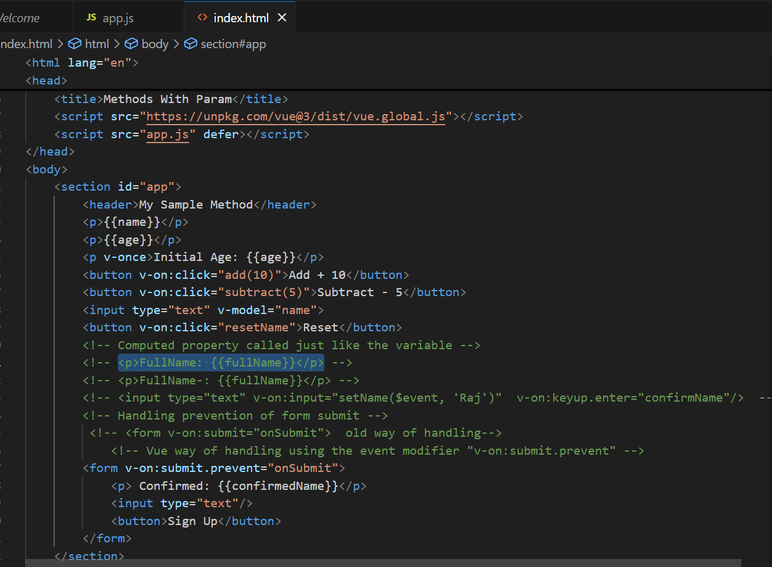

*Note: The updated value will be displayed in the “confirmedName”.*

*Note: If more than one dependency has to be handled then we can’t use the watcher as the different methods need to be created for each dependency whereas in case of computed properties, more than one properties can be handled in a single method.*

*If a change in one property updates the other property or more then watcher would be best. Can be used for http request.*

*If we just some computation to be displayed in UI, then computed properties would be the best option*

*Note: Short hand for v-on: is @ and for v-bind: is :*

*Example:*

*“v-bind:value” can be written as “:value”*

*Anything can be added as usual after click*

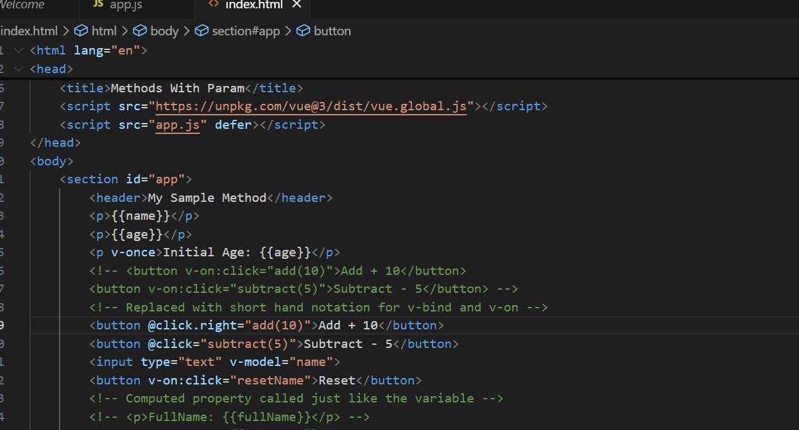

***Dynamic Styles:***

*Note: If we apply inline styles, it overrides all other styles like class based etc. while sometimes we need it but often it leads to problem*

*If we need to use the Vue variable, we need to bind the vue variable to that element to use it.*

*By default the common classes can placed in the direct class attribute whereas the dynamic classes can be placed in the v-bind:class.*

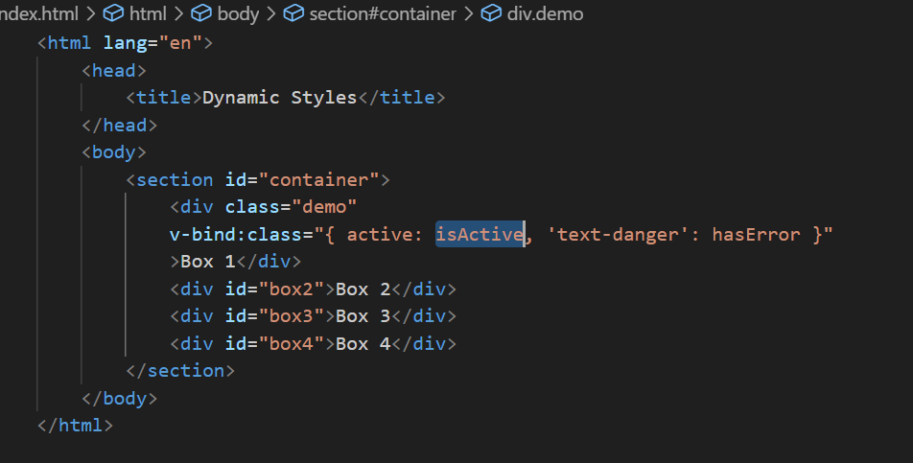

*If we need to move the above object properties for dynamic classes, we can move that object to the computed properties. This logic can be used only when logic is complex.*

*Another way: We can pass dynamic classes in array syntax:*

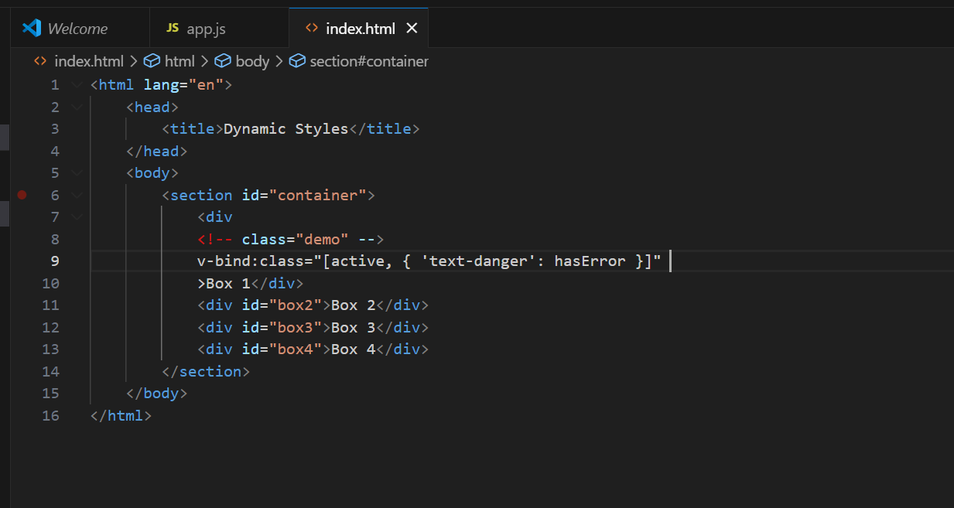

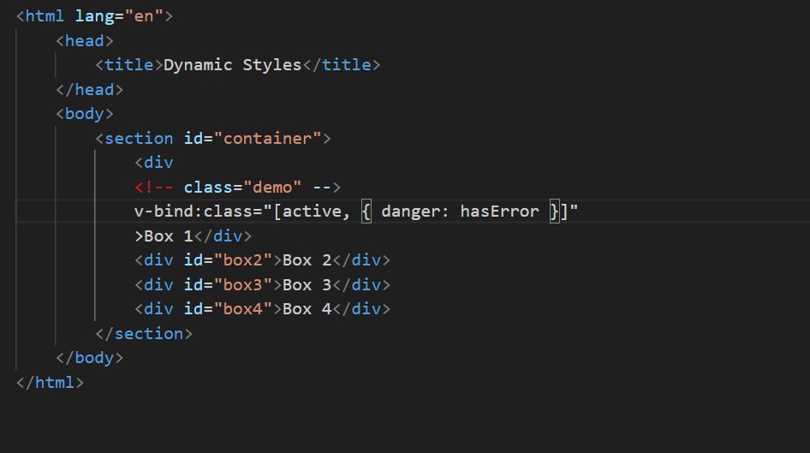

**v-if, v-else and v-else-if:**

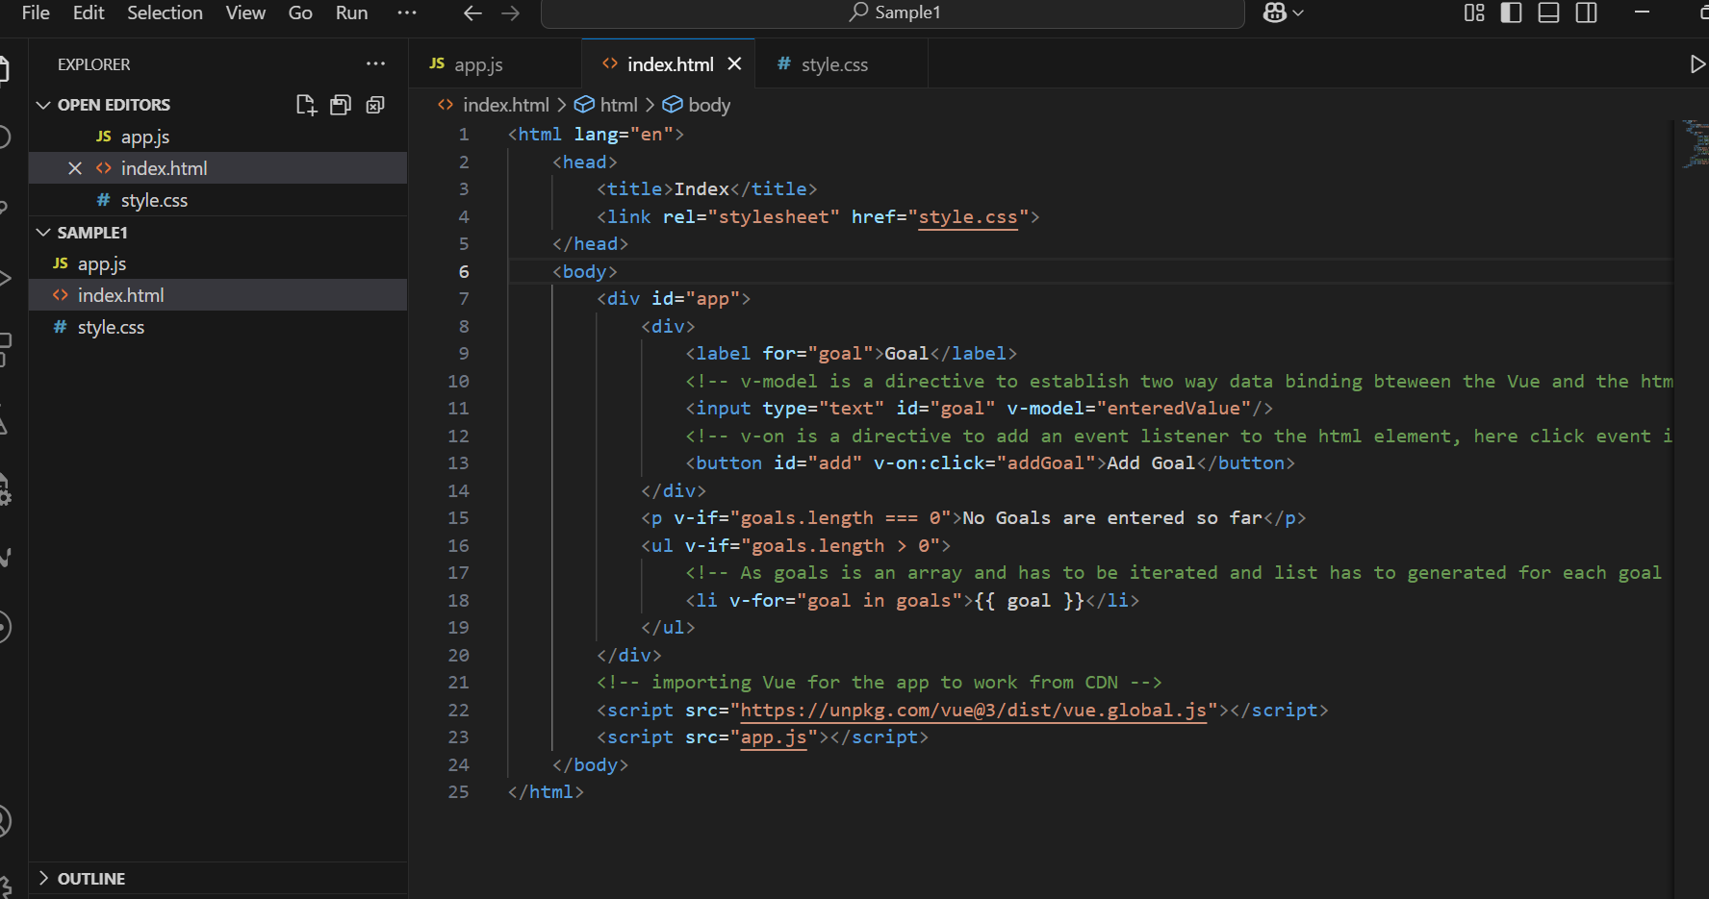

*Note: v-else has to be in the element directly below the v-if statement(neighbour)*

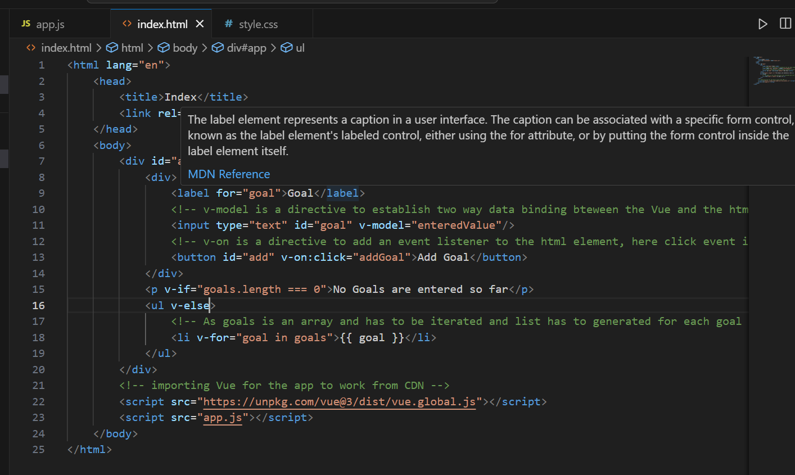

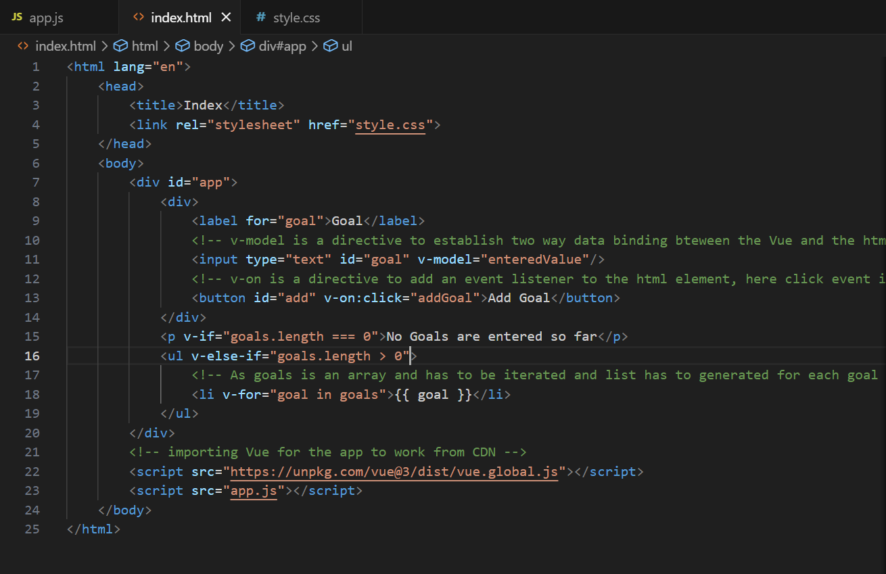

***v-show:***

*We can use v-show in the place of v-if, v-else. For each if else statement we must have v-show. On seeing we feel it is cumbersome as we need to write each one separately.*

*In case v-show if we see in the developer tool, the element will be there with the display set as hidden where as in case of v-if the element itself will not be generated. From the performance perspective, v-if is the best.*

*v-show we need to use , in case where we keep on toggling(visible/invisible) the display of the element.*

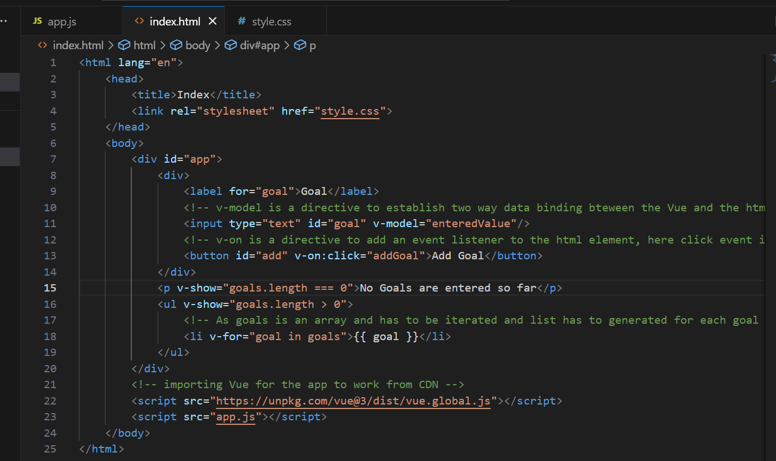

*The v-for will add the new element to the end of the list, will not re-render the existing item, which otherwise would have a performance issue.*

*With the v-for directive we not only get the item but also we get the index.*

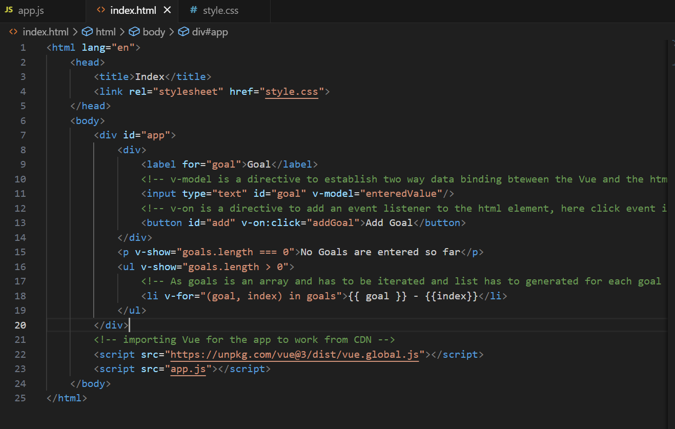

***v-for for object:***

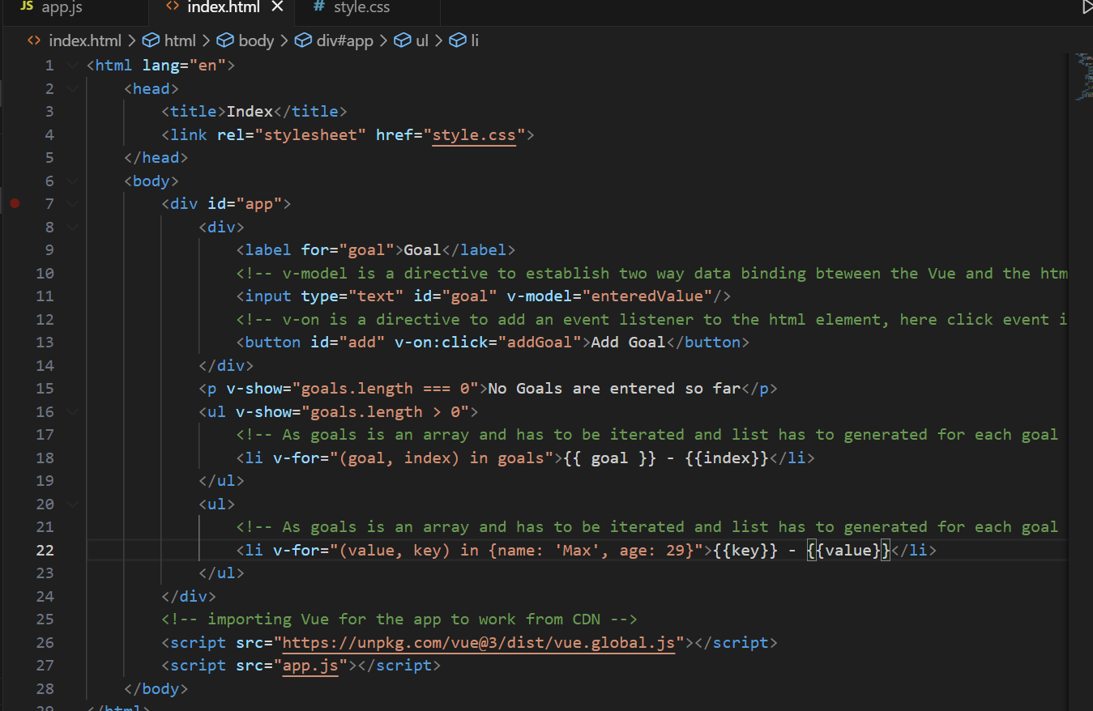

*Index also extracted which is supported by vue*

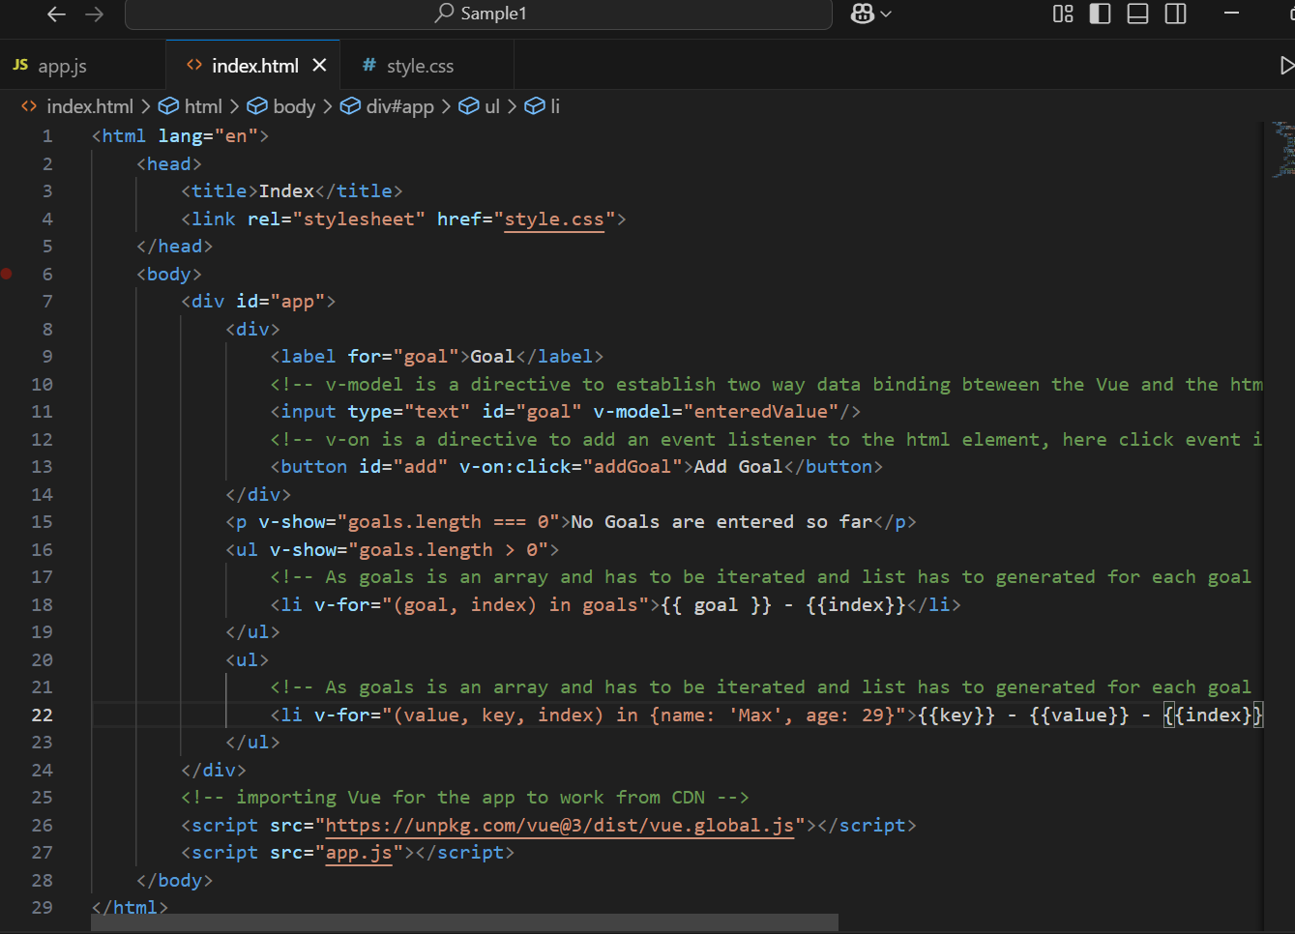

***For loop to print the number sequence:***

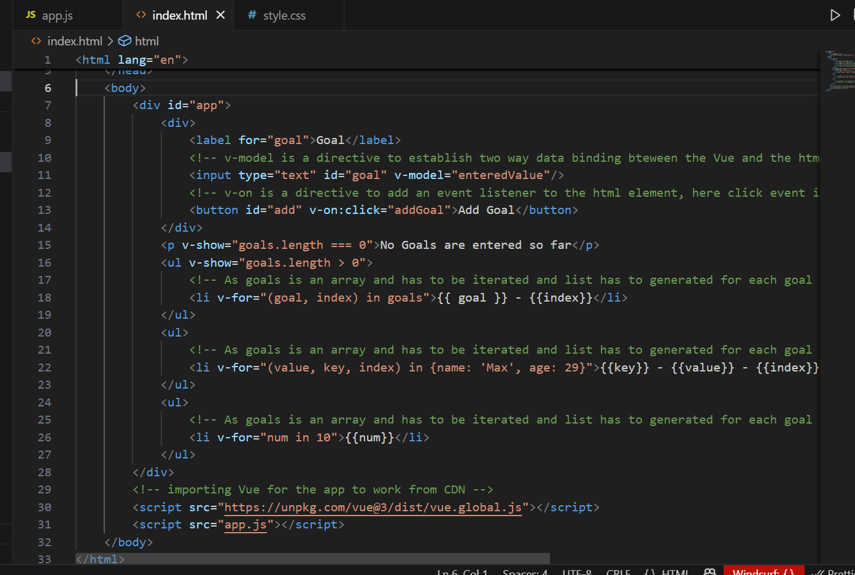

***To remove the list item:***

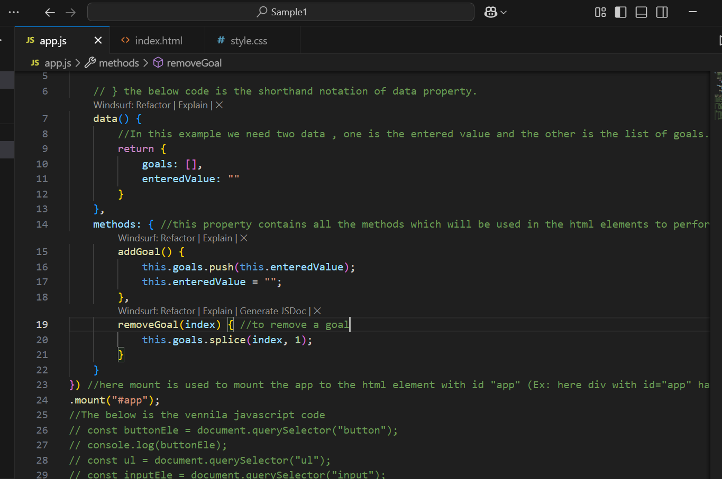

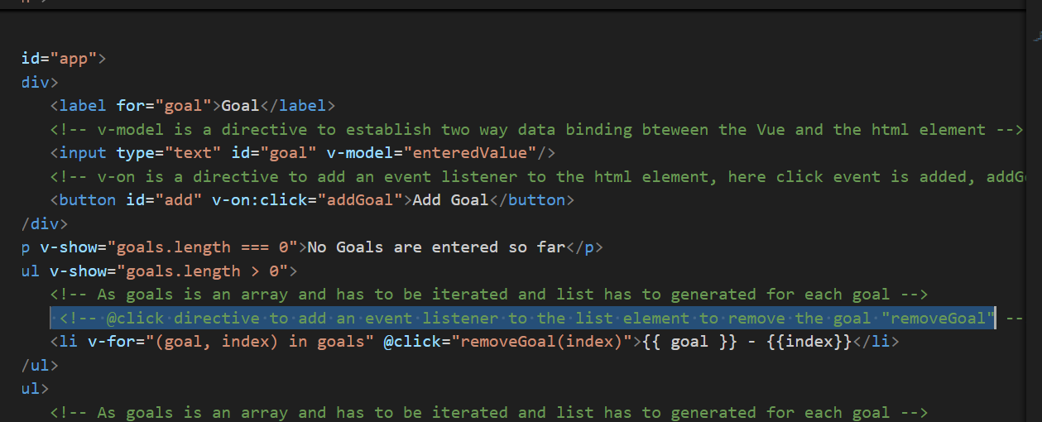

*Note: While removing the list, Vue actually won’t re-render the entire list. Suppose we delete the 1st item, it won’t delete the item, it copies the content of 2nd item to the 1st item. Suppose we have input element for each list, then the text entered in the 2nd element will be lost and retains only what was there in the first element as only the dynamic content is copied and html structure remains the same.*

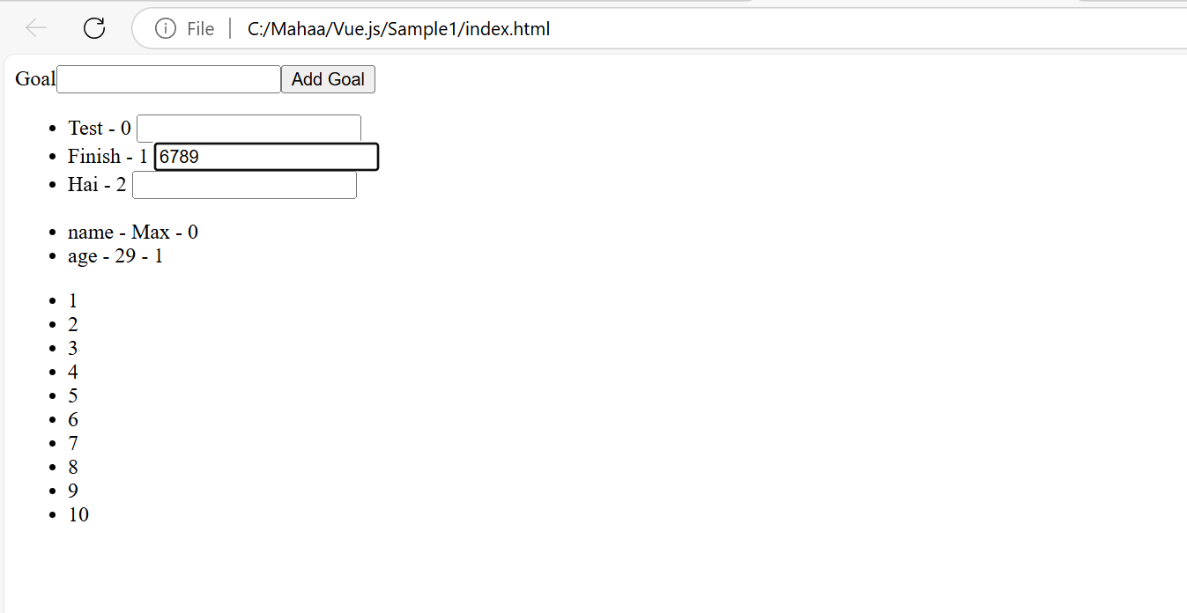

*Going to delete the first element: and so the 2nd element input content of “6789” will also be lost for that item and gets mapped to the 3rd item. To overcome this issue we need to add key for each list item(v-for).*

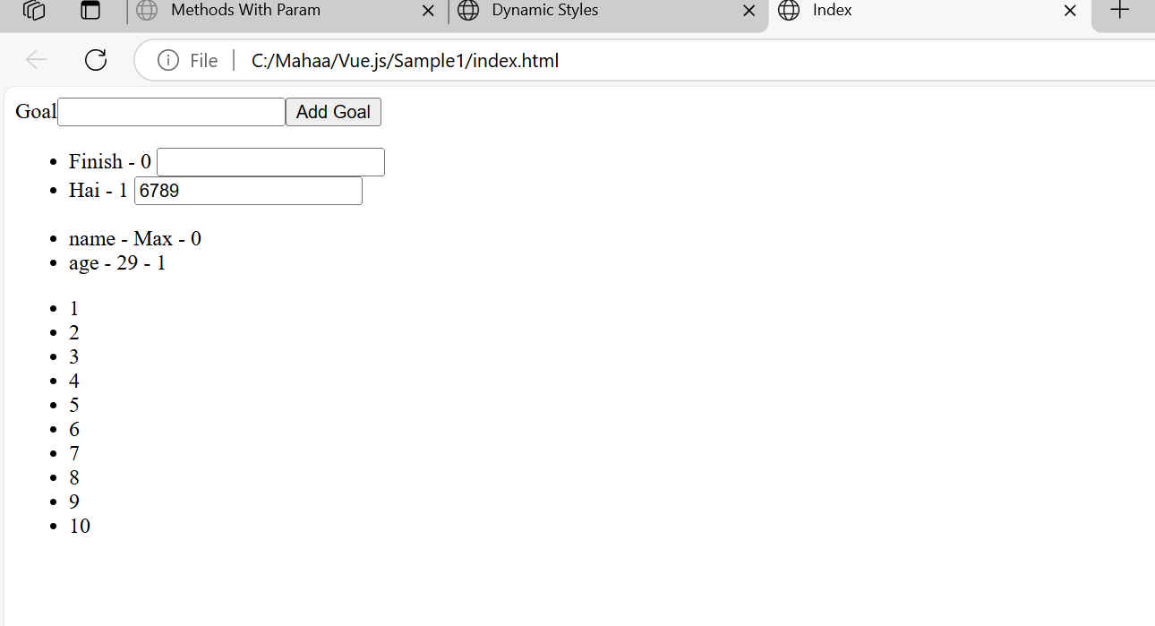

***How does Vue works:***

Vue keeps track of all the data objects defined. It would take the data objects and merge with all the properties and store in the global behind the scene managed object. In the same object the methods defined also merged.

While accessing the methods and data inside Vue app js file, this is used which represents the above global object.

It returns the data object into a reactive data object by essentially wrapping the javaScript objects with the proxy. Due to this feature , Javascript proxy notifies vue whenever any changes occur in the data object or properties, so that Vue recognizes and go to UI code to find where update is required and do changes appropriately.

*Note: JavaScript by default is not reactive. But Vue has built-in mechanism to understand the changes(proxy’s)*

*We can have multiple Vue app each associated with the different section(part) of the page which works independently . Dependent ones has to be grouped together. We can’t use one appl to handle multiple html parts(template).*

***How vue updates DOM:***

*Vue updates DOM elements through a virtual DOM and an asynchronous update queue. When data changes, Vue doesn't immediately update the actual DOM. Instead, it creates a new virtual DOM, compares it to the previous one, and identifies the differences. These differences, or "patches," are then applied to the real DOM in an efficient manner. This process happens asynchronously, meaning that Vue collects all the* *changes within a single event loop and applies them together in the "next tick" to optimize performance.*

***Vue Life Cycle:***

*beforeCreate() -> This is the first phase where the Vue app is under initialization and nothing will be seen in the UI*

*created() -> The app is created and is aware of the data properties and other methods but still there is nothing in the screen.*

*beforeMount() -> Now it is the time to compile the template. Here all the interpolations and dynamic interpretations are replaced with the actual value. Even now nothing is seen on the screen but is everything is ready just before the UI display.*

*mounted() -> The UI is now visible for the user.*

*Instance Unmounted -> beforeUnmount(), unmounted() -> everything is removed from the DOM and nothing is displayed in UI. The app is dead. Any cleanup code , as well as http call to keep track of the unmount can be done here.*

*Note: app.unmount(); -> method is used to unmount the appln. In real time this is not used at all as we usually won’t unmount.*

***Components:***

*The component is another appln (mini-app) which is associated with the main Vue appln*

*The component have to be mounted in the Vue App, and then we need to provide the identifier as well as the configuration.*

*xx.component(yy, zz)*

*xx -> Vue Appln*

*yy -> Identifier, it has to be of two words with hyphen inbetween. Ex: list-component*

*zz -> configuration object*

*Example: app.js*

const app = Vue.createApp({

    data() {

        return {

           friends:[

            {id: 'jane', name: 'Jane Doe', phone: '555-555-5555', email: 'jane@me.com', showDetails: false},

            {id: 'john', name: 'John Doe', phone: '555-555-7777', email: 'john@me.com', showDetails: false},

           ],

        }

    },

    // computed: {

    //     getShowDetails(index) {

    //         console.log('val:', 'index:',index);

    //         return this.friends[index].showDetails;

    //     }

    // },

    methods: {

        toggleDetails(index) {

            this.friends[index].showDetails = !this.friends[index].showDetails;

        },

        getShowDetails(index) {

            console.log('val:', 'index:',index);

            return this.friends[index].showDetails;

        }

    }

});

app.component('friend-details', {

    template: `

       <li>

            <h2>{{ friend.id }}</h2>

            <button @click="toggleFriendsDetails">{{ showDetails? 'Hide Details' : 'Show Details'}}</button>

            <ul v-if="showDetails">

                <li><strong>Phone:</strong> {{ friend.phone }}</li>

                <li><strong>Email:</strong> {{ friend.email }}</li>

            </ul>

        </li>

    `,

    //props: ['friend']

    data() {

        return {

            friend: {id: 'jane', name: 'Jane Doe', phone: '555-555-5555', email: 'jane@me.com'},

                // {id: 'john', name: 'John Doe', phone: '555-555-7777', email: 'john@me.com', showDetails: false},

            showDetails: false

        }

    },

    methods:{

        toggleFriendsDetails() {

            this.showDetails = !this.showDetails;

        },

    }

});

app.mount('#app');

*index.html*

<html lang="en">

    <head>

        <title>Component</title>

        <script src="app.js" defer></script>

        <script src="https://unpkg.com/vue@3/dist/vue.global.js"></script>

    </head>

    <body>

        <section id="app">

            <ul>

                <!-- <li v-for="(friend, index) in friends" :key="friend.id">

                    <h2>{{ friend.id }}</h2>

                    <button @click="toggleDetails(index)">{{getShowDetails(index) ? 'Hide Details' : 'Show Details'}}</button>

                    <ul v-if="getShowDetails(index)">

                        <li><strong>Phone:</strong> {{ friend.phone }}</li>

                        <li><strong>Email:</strong> {{ friend.email }}</li>

                    </ul>

                </li> -->

                <!-- <friend-details v-for="friend in friends" :key="friend.id" :friend="friend"></friend-details> -->

                <friend-details></friend-details>

            </ul>

        </section>

    </body>

</html>

**Need a proper (development) server:**

In case of normal appln, the appln will be opened with the https:// protocol whereas in case of Vue appln it will be opened with File:// protocol (opened as File in the browser whereas other applns open as website with https:// protocol)

Some modern JavaScript/browser doesn’t support the some features of the Vue File. But at the end of the day, the appln will be deployed in a server and served as https:// not via file://.

Vue CLI:

Vue CLI is just an additional tool to create project with certain configurations and with certain built-in tools that give us all those nice features like auto-complete, automatic detection of changes, etc.

Note: Nodejs is a javaScript runtime which allows to run the javaScript code outside the browser. It can be used to write server side code.

***Syntax to install Vue CLI: (command to install vue/cli globally)7***

***npm install –g @vue/c***li

***To create App:***

***vue create xxxx***

***where xxxx -> name of the application***

***Command to start the server locally:***

***npm run serve***

***Note: The packages in the package.json represents that those packages in dependencies when we run “npm install” for a repository cloned project. If the project is created with “vue create xxx” will be automatically added to the project and housed in the node_modules folder. we need not do anything for the packages in devDependencies as those for the project setup etc. like development server may come from any of those packages.***

***Project Folder and files:***

*Inside the public folder, we have only one index.html file in which we have a div with id “app” on which the Vue app will be mounted. The “src” folder will have all the javascript file which we are going to write. This is our working directory.*

*“main.js” file is the main js file and is the main entry point for the project.*

*“App.vue” file allows to write vue Appln in a neater way. “template” tag to write the UI, “script” tag to define the Appl configuration like data, methods etc. “style” tag for appln style.*

***App.vue:***

<template>

  <div id="app">

    <img alt="Vue logo" src="./assets/logo.png">

    <HelloWorld msg="Welcome to Your Vue.js App"/>

  </div>

</template>

<script>

import HelloWorld from './components/HelloWorld.vue'

export default {

  name: 'App',

  components: {

    HelloWorld

  }

}

</script>

<style>

#app {

  font-family: Avenir, Helvetica, Arial, sans-serif;

  -webkit-font-smoothing: antialiased;

  -moz-osx-font-smoothing: grayscale;

  text-align: center;

  color: #2c3e50;

  margin-top: 60px;

}

</style>

**Now the code in the app.vue is just a white code as the vs code didn’t understand it. To make it understand we need add the extension “vetur”**

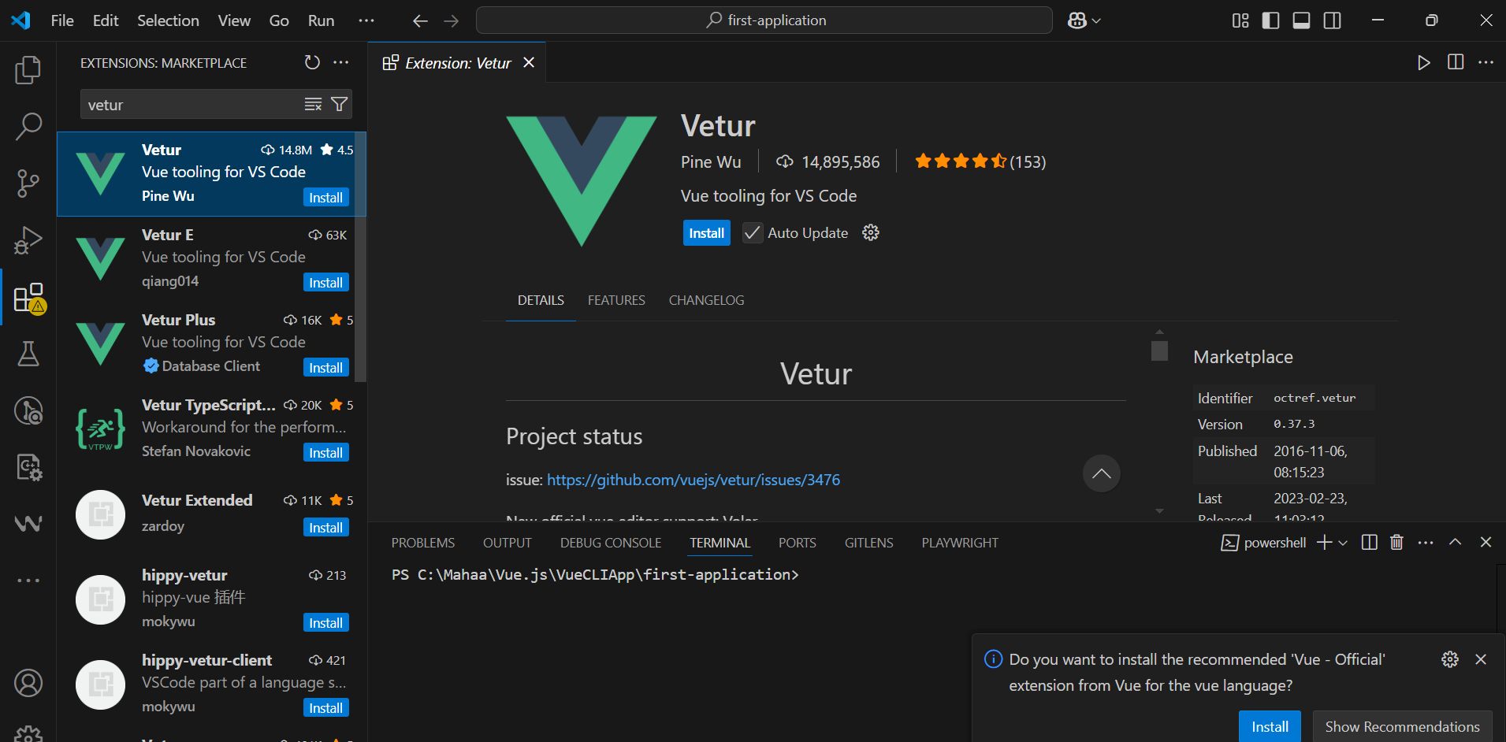

***After adding the extension:(It also helps for the developers in the development by providing auto completion)***

<template>

  <div id="app">

    <img alt="Vue logo" src="./assets/logo.png">

    <HelloWorld msg="Welcome to Your Vue.js App"/>

  </div>

</template>

<script>

import HelloWorld from './components/HelloWorld.vue'

export default {

  name: 'App',

  components: {

    HelloWorld

  }

}

</script>

<style>

#app {

  font-family: Avenir, Helvetica, Arial, sans-serif;

  -webkit-font-smoothing: antialiased;

  -moz-osx-font-smoothing: grayscale;

  text-align: center;

  color: #2c3e50;

  margin-top: 60px;

}

</style>

*The code in this file will not work in the browser, the vue will convert into the code which works in the browser, we as the developer has the nice environment to define the html elements, styles and data setup*

The Vue Cli uses the Build workflow to convert the .vue file code in to browser understandable js code. In the Build step , it converts the .vue code which uses Vue specific syntax and features in to standard js code. Then the converted js appln is deployed in the server to serve as the web appln to the client.

The “serve” property in the “scripts” property is one which not only does the running the development and displaying website. It is the one which does the build step (converts the vue code in to executable javascript code)

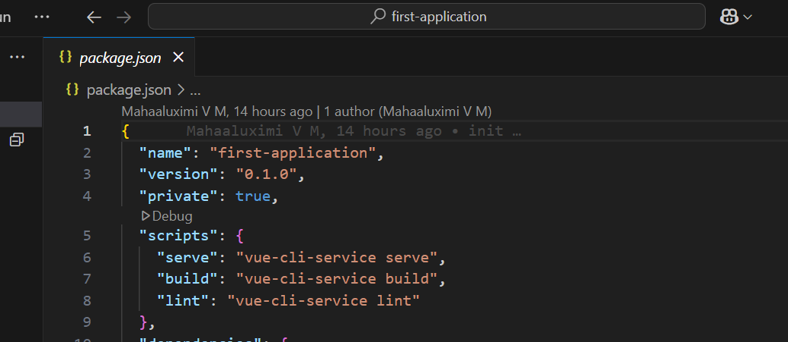

**Simple Appln without Components:**

**App.vue**

<template>

    <section>

        <h2>My friends</h2>

        <ul>

            <li v-for="friend in friends" :key="friend.id">

                <h2>{{ friend.name }}</h2>

                <button @click="friend.phone = 'Updated'">Update Phone</button>

            </li>

        </ul>

    </section>

    </template>

<script>

export default {

  data() {

    return {

      friends: [

        {

          id: "manoj",

          name: "Manoj",

          phone: "1234567890",

          email: "m@n.com",

        },

        {

          id: "sreeja",

          name: "Sreeja",

          phone: "6667 7777 11",

          email: "sreeja@n.com",

        },

      ],

    };

  },

};

</script>

**main.js**

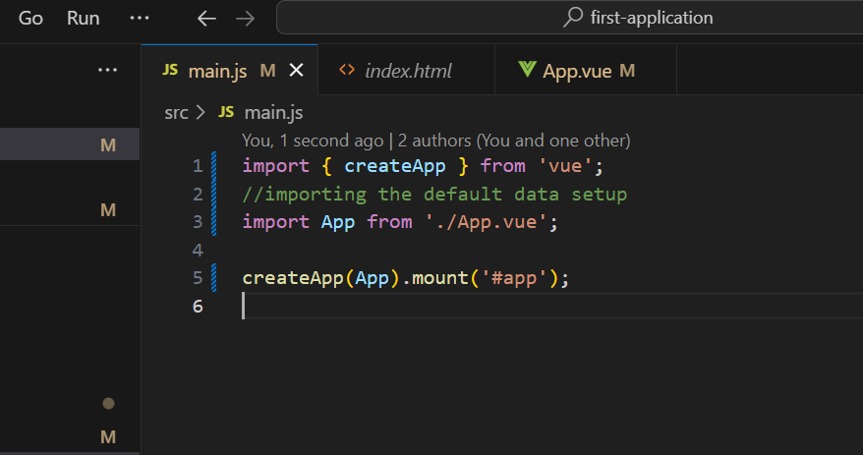

***Note: The base .vue file could be name as App.vue as a best practise . Each word we can start with the capital character***

***Mounting component in the Vue app:***

* Create a component vue file similar to vue app file. In that file export the data configuration
* Import the exported data configuration in the file where the app is mounted. Here say main.js

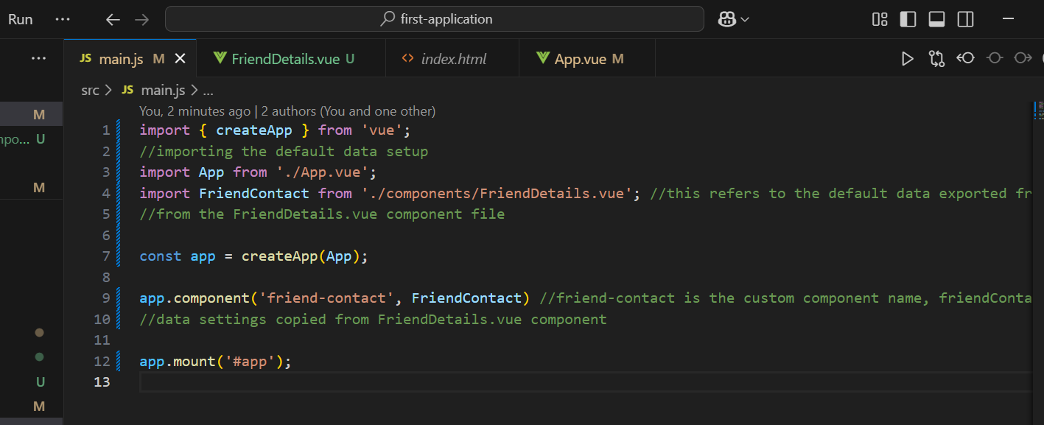

* Then it can be consumed in the App.vue file using the custom identifier

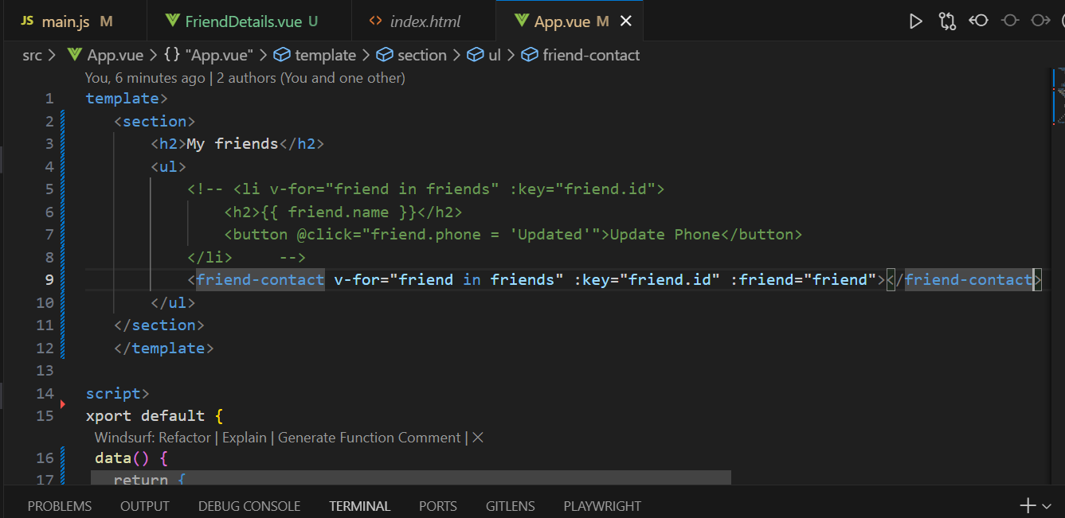

***Adding styles using tag(App.vue)***

<template>

    <section>

        <header><h1>My Friends</h1></header>

        <ul>

            <!-- <li v-for="friend in friends" :key="friend.id">

                <h2>{{ friend.name }}</h2>

                <button @click="friend.phone = 'Updated'">Update Phone</button>

            </li>     -->

            <friend-contact v-for="friend in friends" :key="friend.id" :friend="friend"></friend-contact>

        </ul>

    </section>

    </template>

<script>

export default {

  data() {

    return {

      friends: [

        {

          id: "manoj",

          name: "Manoj",

          phone: "1234567890",

          email: "m@n.com",

        },

        {

          id: "sreeja",

          name: "Sreeja",

          phone: "6667 7777 11",

          email: "sreeja@n.com",

        },

      ],

    };

  },

};

</script>

<style>

* {

  box-sizing: border-box;

}

html {

  font-family: "Jost", sans-serif;

}

body {

  margin: 0;

}

header {

  box-shadow: 0 2px 8px rgba(0, 0, 0, 0.26);

  margin: 3rem auto;

  border-radius: 10px;

  padding: 1rem;

  background-color: #58004d;

  color: white;

  text-align: center;

  width: 90%;

  max-width: 40rem;

}

#app ul {

  margin: 0;

  padding: 0;

  list-style-type: none;

}

#app li,

#app form {

  box-shadow: 0 2px 8px rgba(0, 0, 0, 0.26);

  margin: 1rem auto;

  border-radius: 10px;

  padding: 1rem;

  text-align: center;

  width: 90%;

  max-width: 40rem;

}

#app h2 {

  font-size: 2rem;

  border-bottom: 4px solid #ccc;

  color: #58004d;

  margin: 0 0 1rem 0;

}

#app button {

  font: inherit;

  cursor: pointer;

  border: 1px solid #ff0077;

  background-color: #ff0077;

  color: white;

  padding: 0.05rem 1rem;

  box-shadow: 1px 1px 2px rgba(0, 0, 0, 0.26);

}

#app button:hover,

#app button:active {

  background-color: #ec3169;

  border-color: #ec3169;

  box-shadow: 1px 1px 4px rgba(0, 0, 0, 0.26);

}

</style>

*Note: We store the data required for the app, in that app itself.*

***FriendDetails.vue***

<template>

    <li>

        <h2>{{ friend.name }} {{ friend.isFavorite  ? '(Favorite)' : ''}}</h2>

        <button @click="toggleFavorite">Toggle Favorite</button>

        <button @click="toggleDetails">{{ displayDetails ? 'Hide Details' : 'Show Details'}}</button>

        <button @click="deleteContact(friend.id)">Delete</button>

        <ul v-if="displayDetails">

            <li><strong>Phone:</strong> {{ friend.phone }}</li>

            <li><strong>Email:</strong> {{ friend.email }}</li>

        </ul>

    </li>

</template>

<script>

export default {

    inject:['friendList', 'deleteContact'],

    //inject:['test'],

    props: ['friend'],

    // props: {

    //     id: {

    //         type: String,

    //         required: true

    //     },

    //     name: {

    //         type: String,

    //         required: true

    //     },

    //     phone: {

    //         type: String,

    //         required: true

    //     },

    //     email: {

    //         type: String,

    //         required: true

    //     },

    //     isFavorite: {

    //         type: Boolean,

    //         required: false,

    //         default: false,

    //         // validator(value) {

    //         //     return value === '1' || value === '0';

    //         // }

    //     }

    // },

    emits: ['toggle-favorite', 'delete-contact'],

    // emits: {

    //     // Define the custom event and validating the argument

    //     'toggle-favorite': function (id) {

    //         if (id) {

    //             return true;

    //         } else {

    //             console.warn('Id is missing');

    //             return false;

    //         }

    //     }

    // },

    data() {

       return {

        displayDetails: false,

       }

   },

   methods: {

       toggleDetails() {

           this.displayDetails = !this.displayDetails

       },

       toggleFavorite() {

        //    if (this.isFavoriteFriend == '1') {

        //        this.isFavoriteFriend = '0';

        //    } else {

        //        this.isFavoriteFriend = '1';

        //    }

        //console.log('loggedIn:', this.test.friendList[0].name, 'login:', this.test.login);

        this.$emit('toggle-favorite', this.friend.id);

       },

    //    deleteContact(){

    //         this.$emit('delete-contact', this.friend.id);

    //    }

   }

};

</script>

***AddNewFriend.vue:***

<template>

  <form @submit.prevent="addFriend">

    <section>

      <div>

        <strong><label for="name">Name</label></strong>

        <input type="text" name="name" v-model="name" />

      </div>

      <div>

        <strong><label for="name">Phone</label></strong>

        <input type="tel" name="phone" v-model="phone" />

      </div>

      <div>

        <strong><label for="name">Email</label></strong>

        <input type="email" name="email" v-model="email" />

      </div>

      <div>

        <button>Add Friend</button>

      </div>

    </section>

  </form>

</template>

<script>

export default {

  emits: ["add-newfriend"],

  data() {

    return {

      name: "",

      phone: "",

      email: "",

    };

  },

  methods: {

    addFriend() {

      //event.preventDefault();

      //alert('called');

      console.log(

        "name:",

        this.name,

        "phone:",

        this.phone,

        "email:",

        this.email

      );

      this.$emit("add-newfriend", this.name, this.phone, this.email);

    },

  },

};

</script>

***Props:***

*The props are used to pass data from the invoking app/component to the invoked component*

***Passing props from the invoking app/component:***

*In the example below name, phone and email are the props being passed*

*:name is given for prop as it is mapped with the vue data , shorthand form of “v-bind:name”*

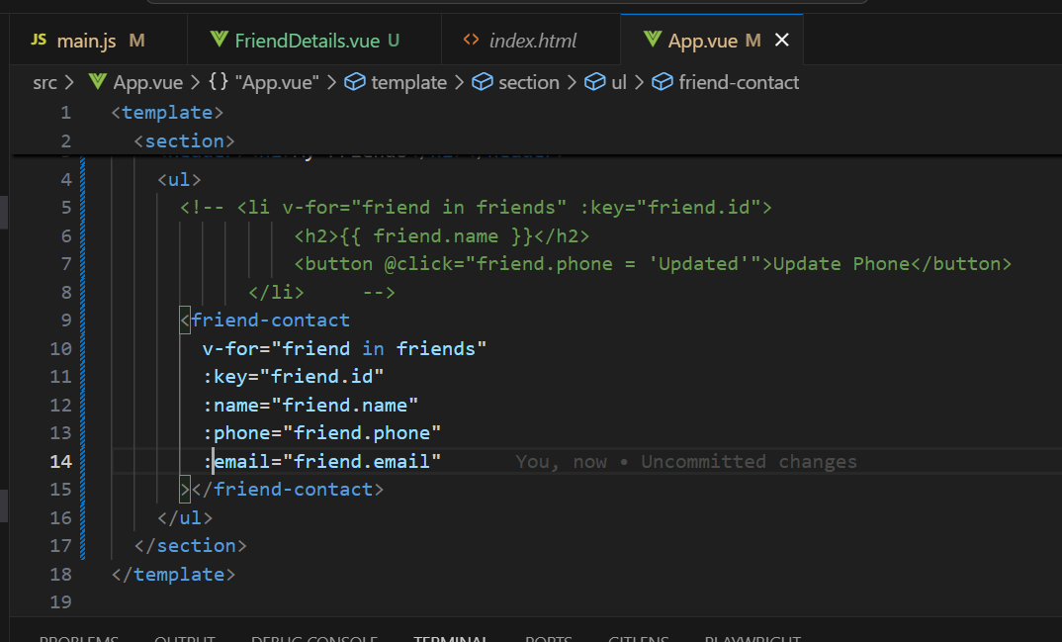

*Intimating the Invoked Component of the props it is going to receive:*

*To do that we need to add new property “props”, in which we need to specify the name of the props to be received.*

*Here in the given example, the props are “name, phone, email”*

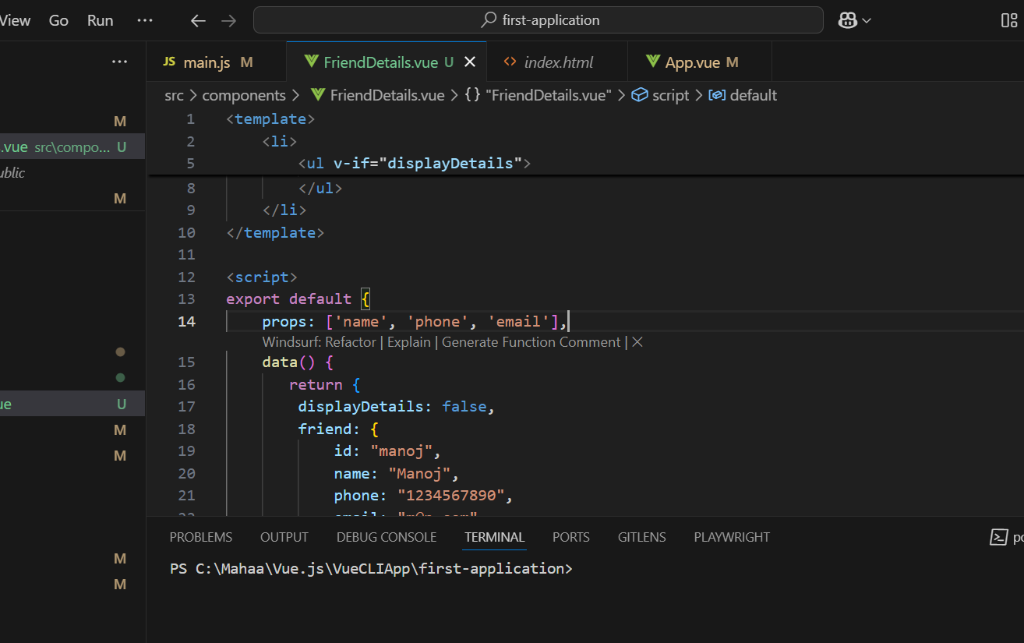

*Usage of this props in the template is just with the same as other data props, need of this keyword to access inside the <script> tag ie App configuration*

***Unidirectional data flow:***

*Props is used to pass data from parent to child. The props should never be mutated in the child, if so then we get the mutation error as it violates the unidirectional data flow.*

*Hence the prop data has to be changed in the parent only and not in the child*

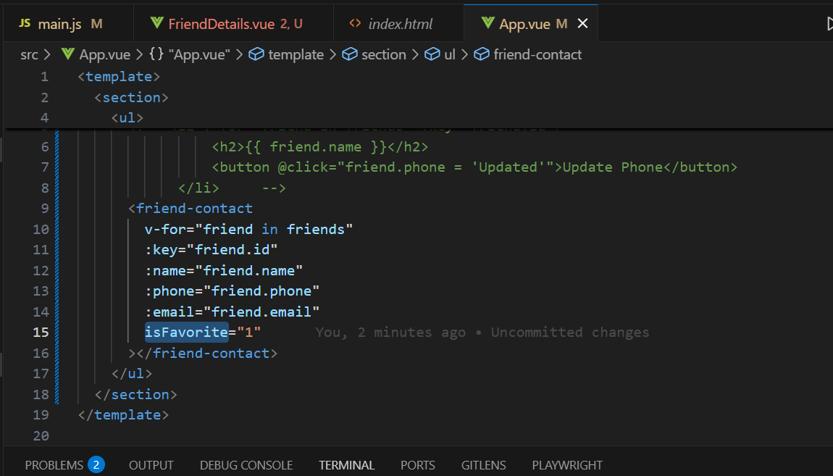

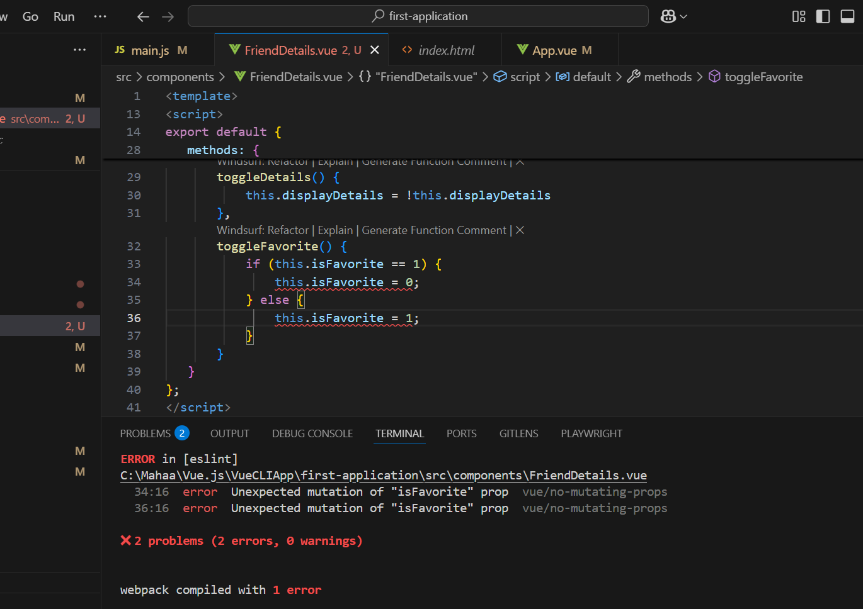

*If we need to change the prop value received from parent and the same needn’t be communicated to the parent then we can handle this situation by defining a new local data and assign the prop value to it(which is initial setup) and henceforth we should use the local data property. Now the unidirectional data flow is not breached.*

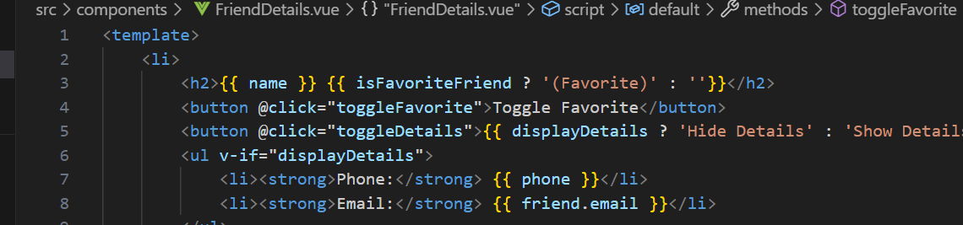

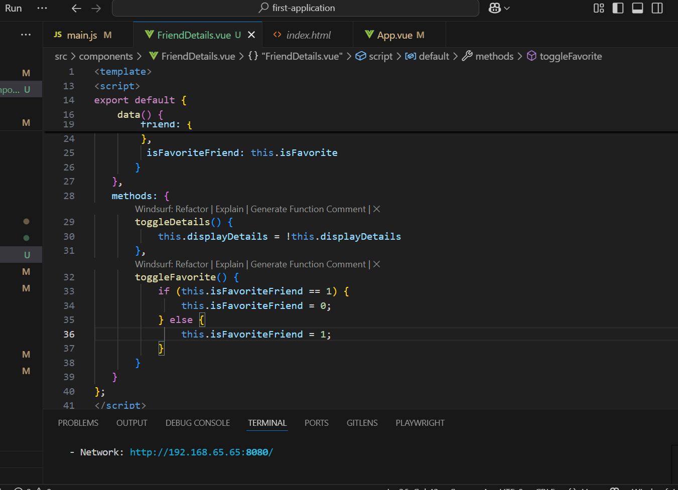

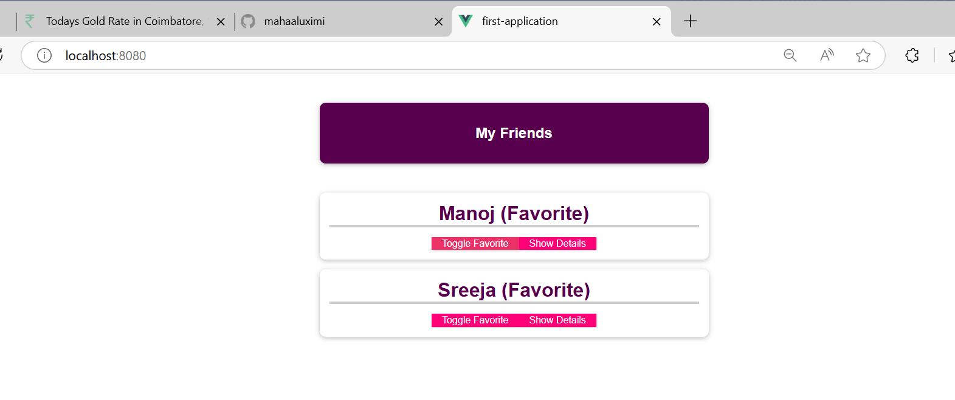

*On clicking the ToggleFavorite button*

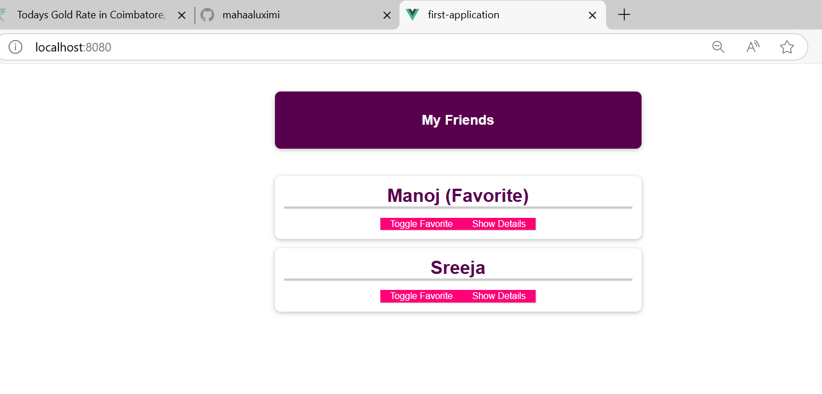

***Prop validation:***

*So far we have just defined props as an array, but we haven’t validated the prop for type and required. To handle it we can define the props as an object and specifying each expected property along with required ness and type.*

***Type 1:*** *Specifying type as well as required, if that property is not mandatory then it can be specified as required: false*

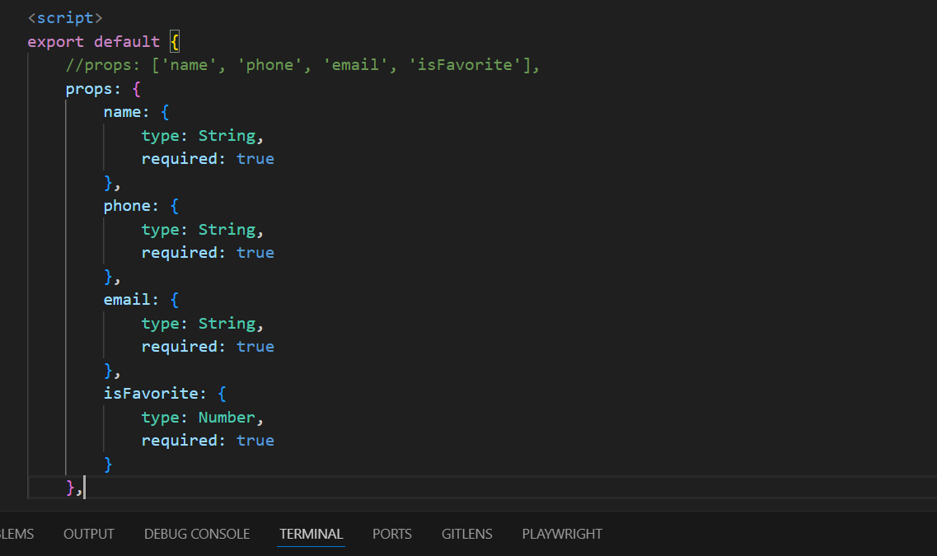

*If any mandatory attribute is missing in the prop, then we won’t get error in the UI, but in the console we get the warning*

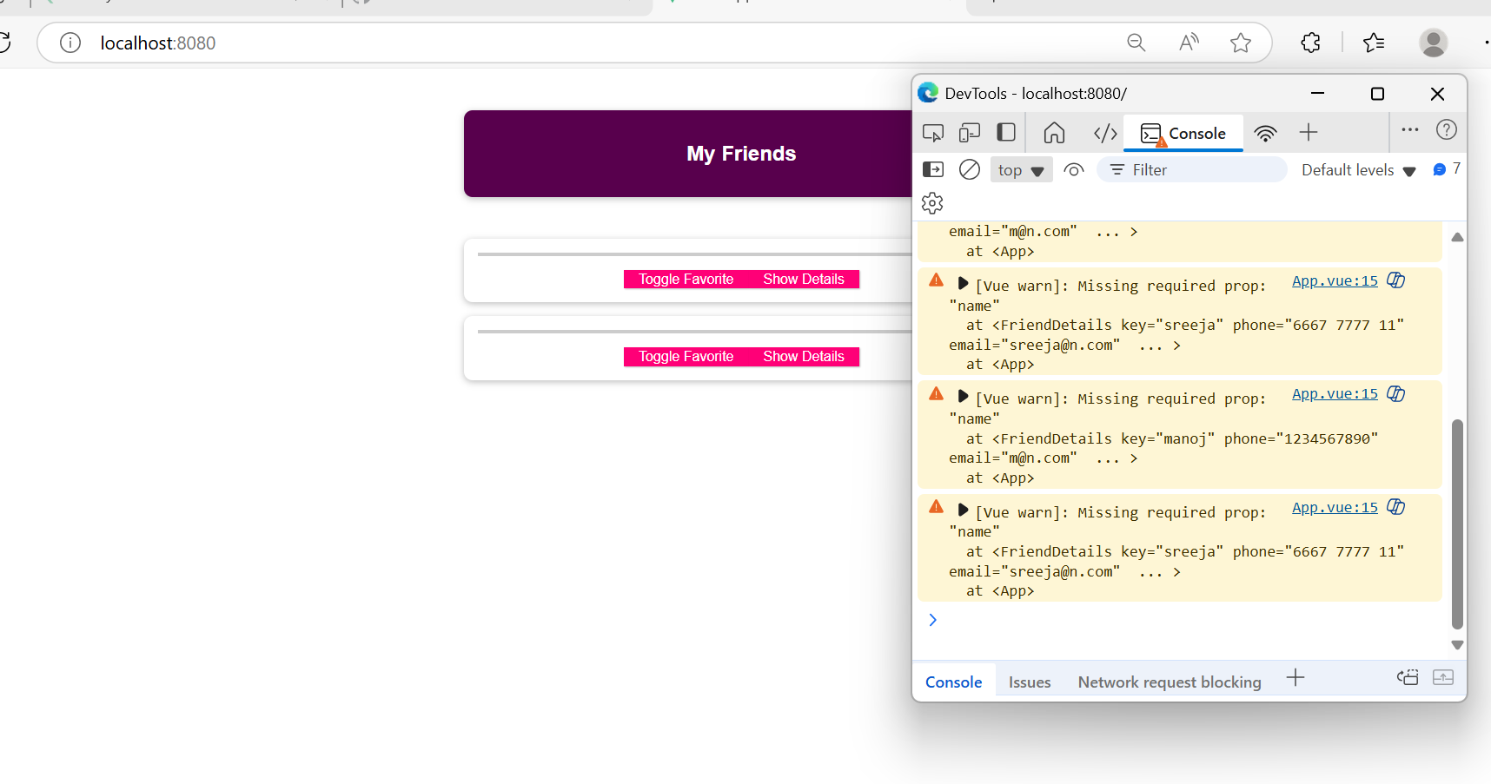

*In case of non-required property, we can add a default value for that property as below:*

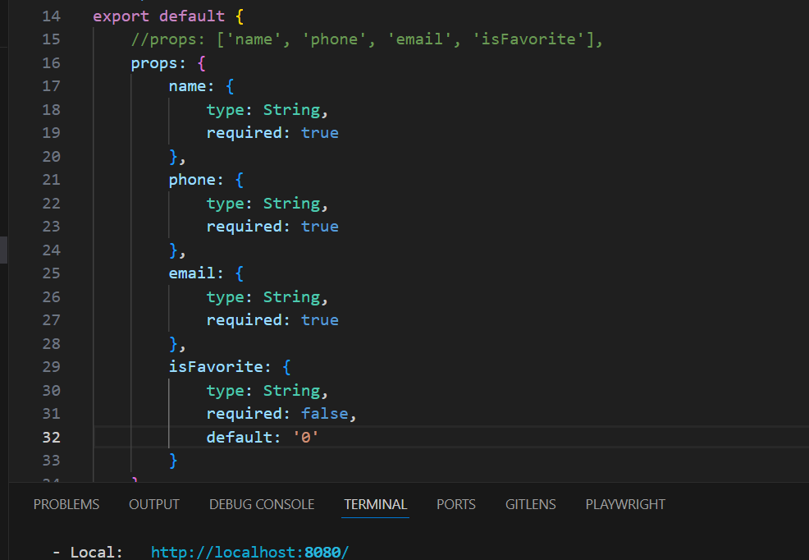

*Default can be a function also, which is used to perform some complex logic to get the value*

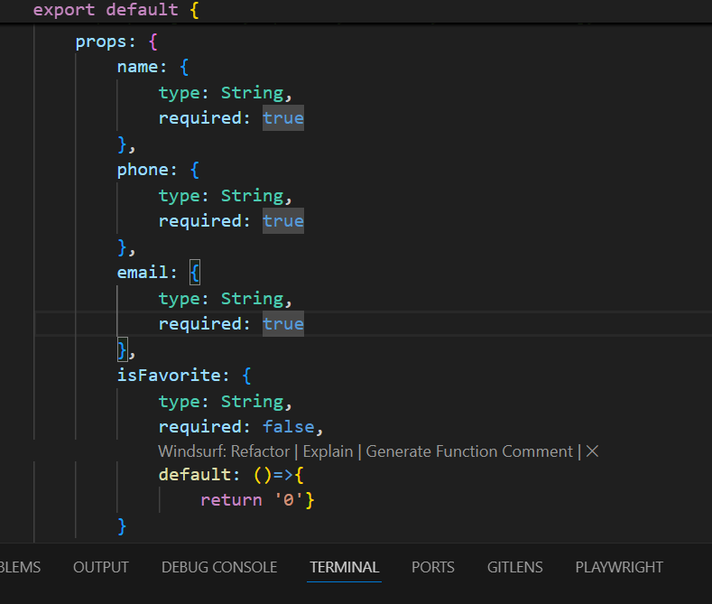

***Type 2:***

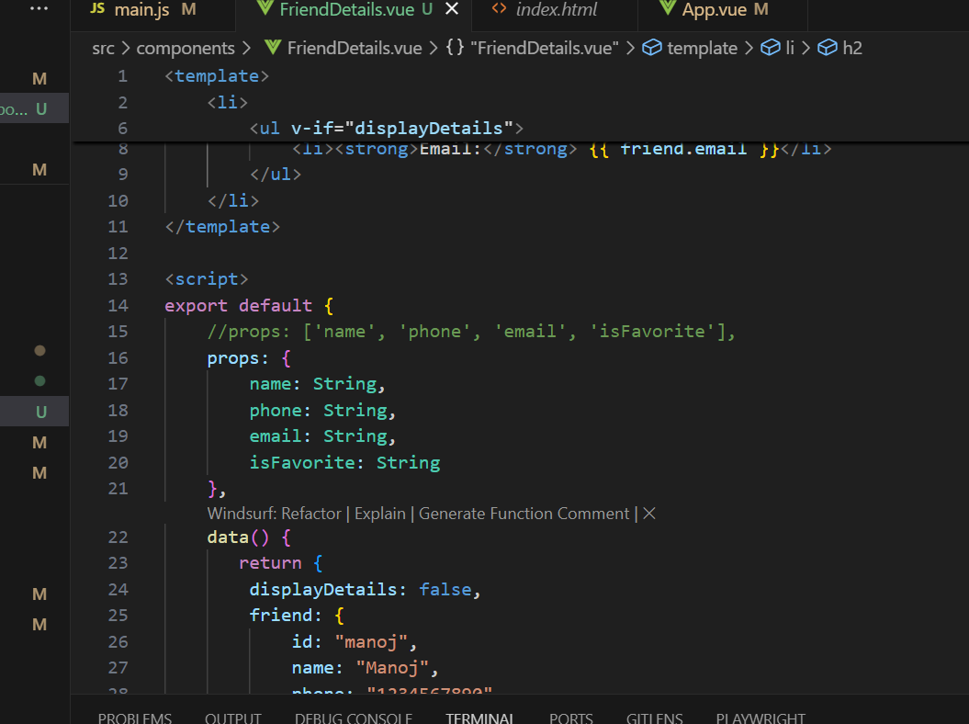

***Validator attribute:***

*The attribute can be used to validate whether the property has received only the allowed values. It takes the property value as the function parameter to validate the value*

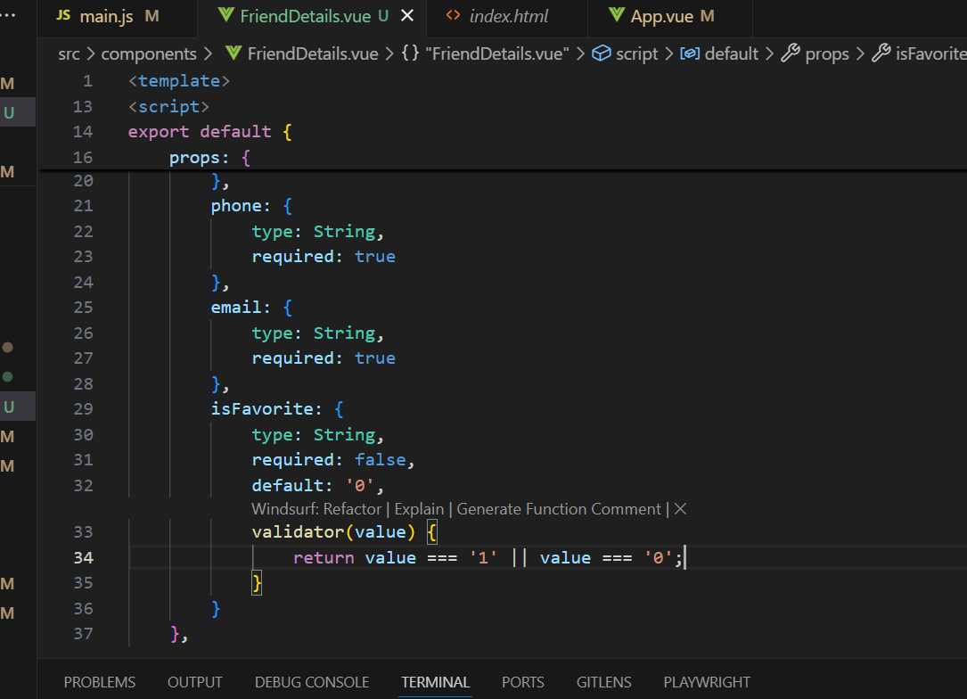

*On providing invalid value to the isFavorite attribute, validator failed warning is displayed in the console*

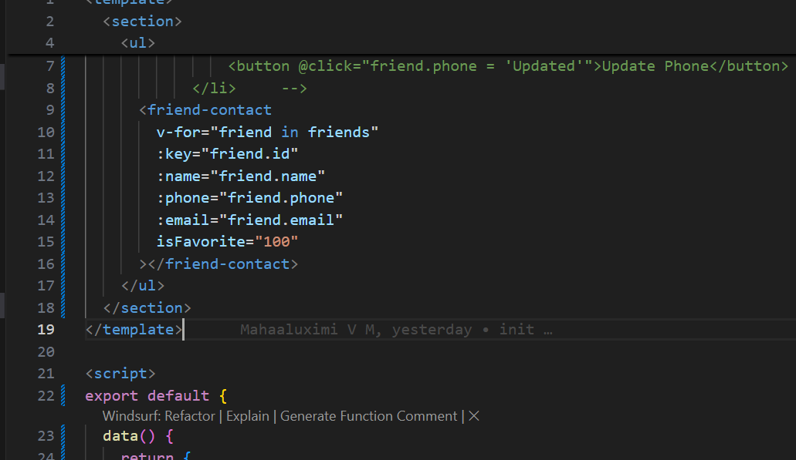

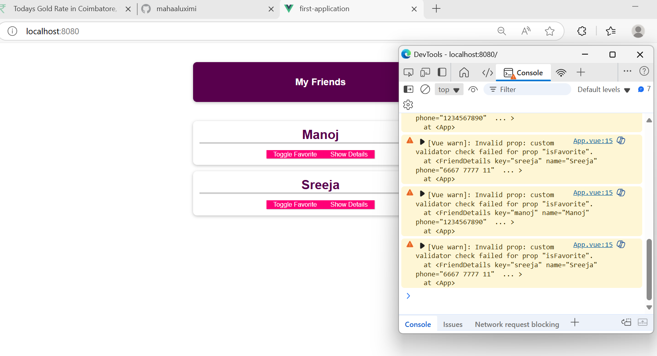

*Note: Always we need to pass string value if it is not bind using v:bind. If it is bound then we can pass anything including function, expression etc.*

*As we are sure that isFavorite will have only two values 0 and 1, so the type can be changed to Boolean and so the validation logic can also be removed*

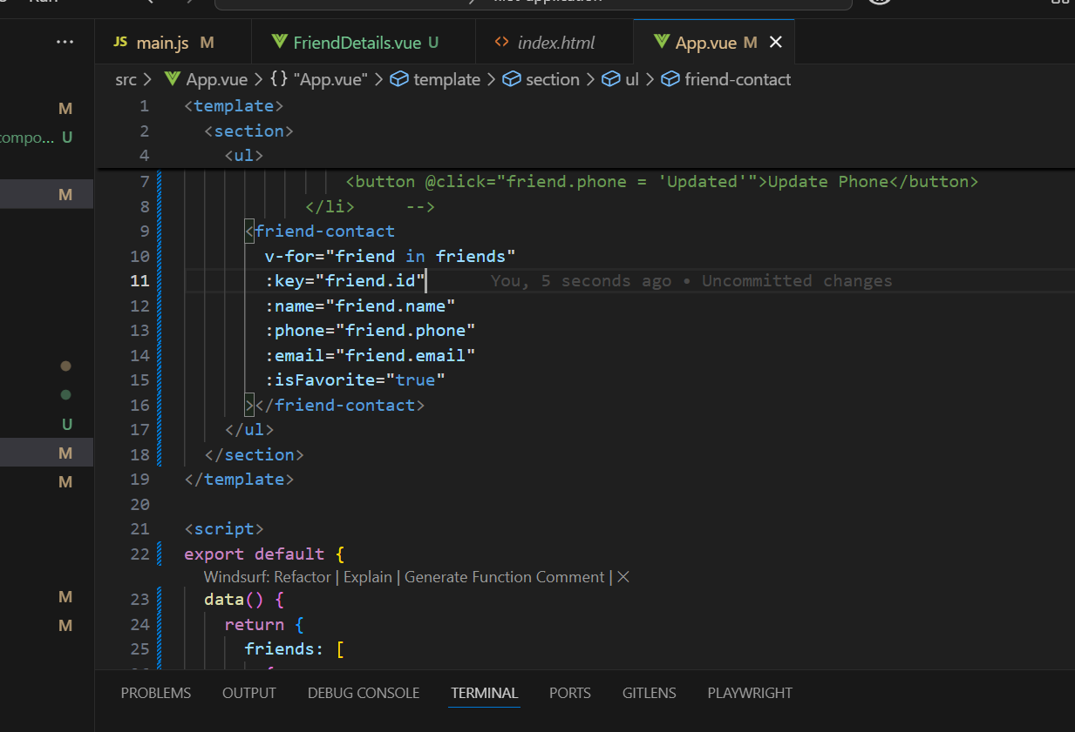

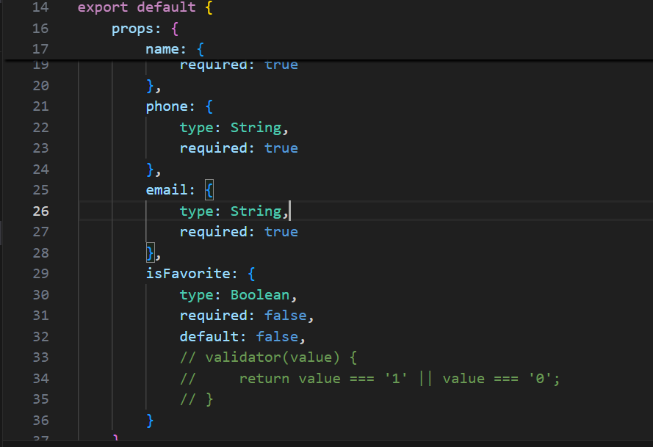

***To communicate from child to parent:***

*To accomplish this, on any event like button click etc in the child component it emits an event which the parent can listen to it event. To emit the event, Vue the inbuilt method $emit(xx) which requires a mandatory input which will be the custom event the parent can listen. This method can be invoked with this keyword and from the vue environment/appln, the first argument is the custom event and any additional arguments are the data being passed to the event.*

*this .$emit(xx)*

*where xx -> custom event*

***Parent: @toggle-favorite is the custom event parent is listening***

***Custom event is mapped to the method which needs to be executed (here is toggleFavorite)***

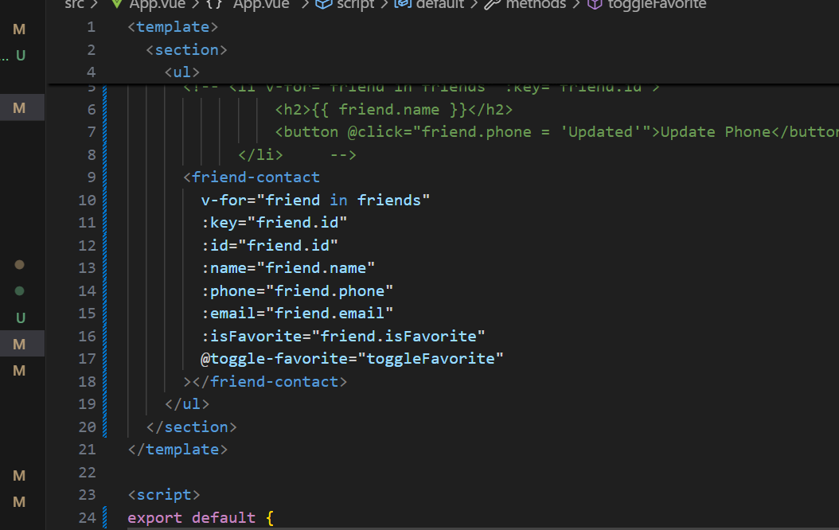

***Child:*** *Custom event is triggered from toggleFavorite method*

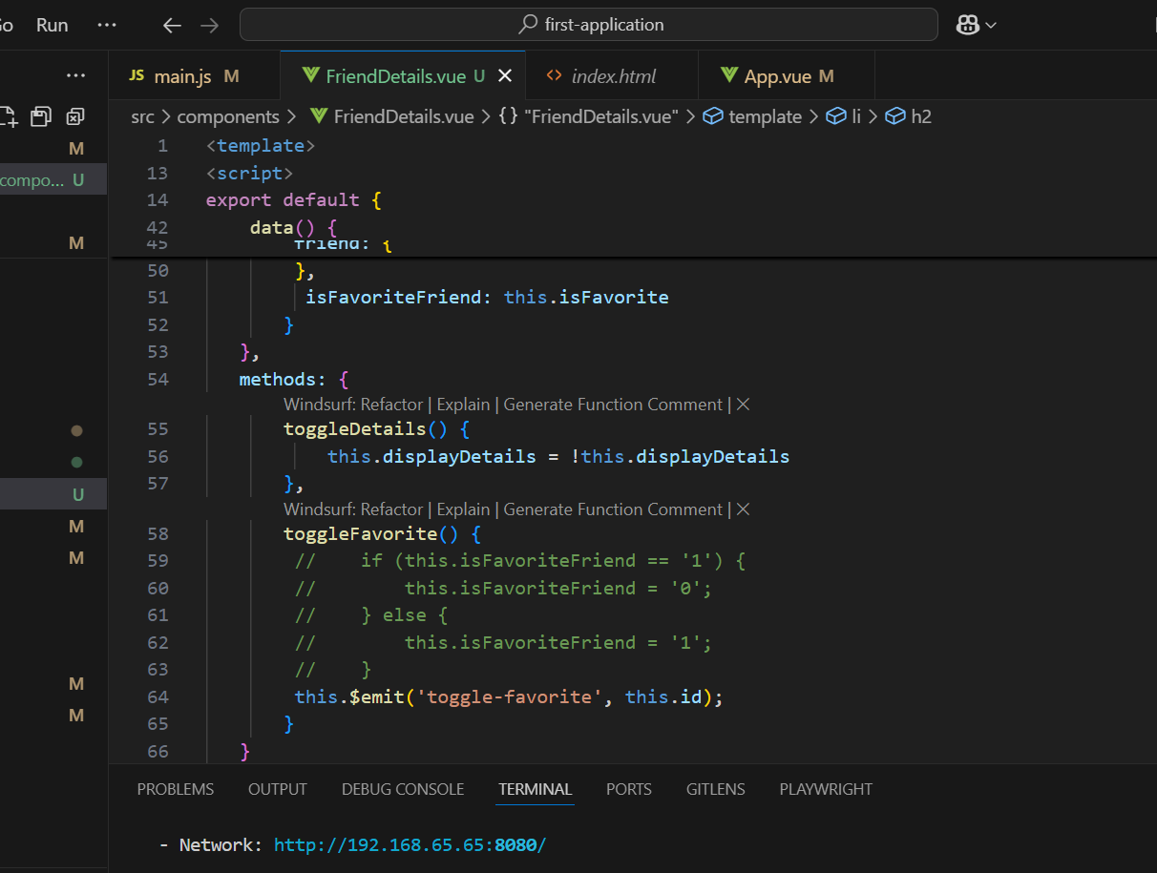

***Validation for the custom event emitted from child component:***

***Type 1:*** *Here just intimating the developer that the component emit the custom event with an identifier “toggle-favorite”*

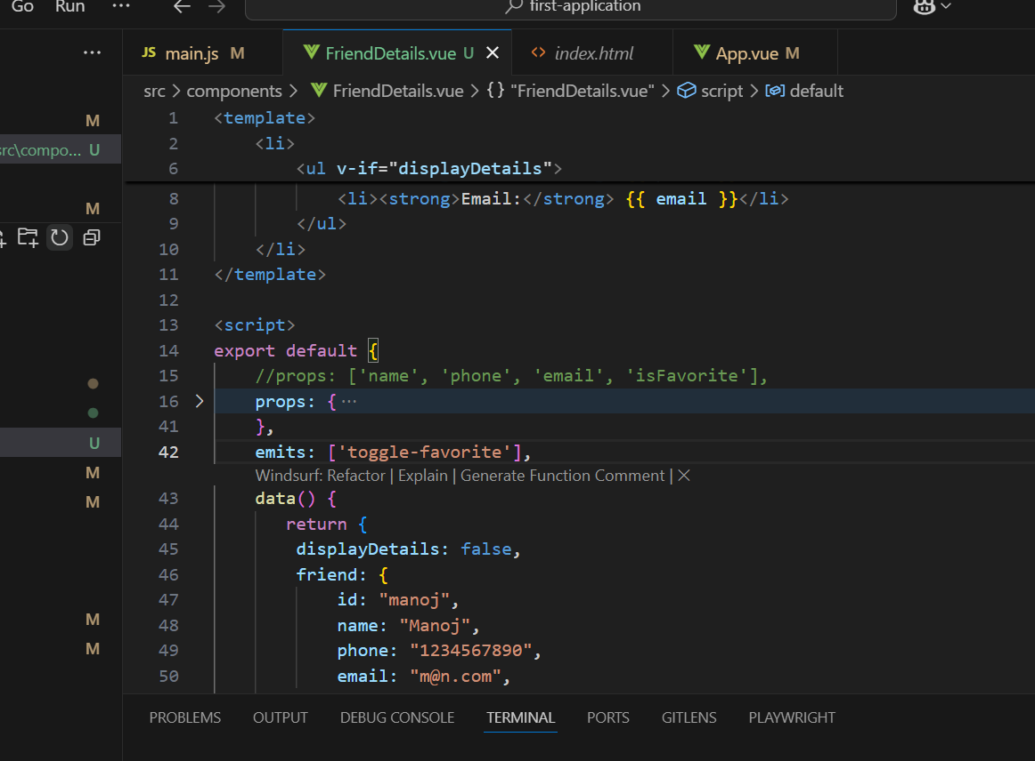

*Type 2:*

*y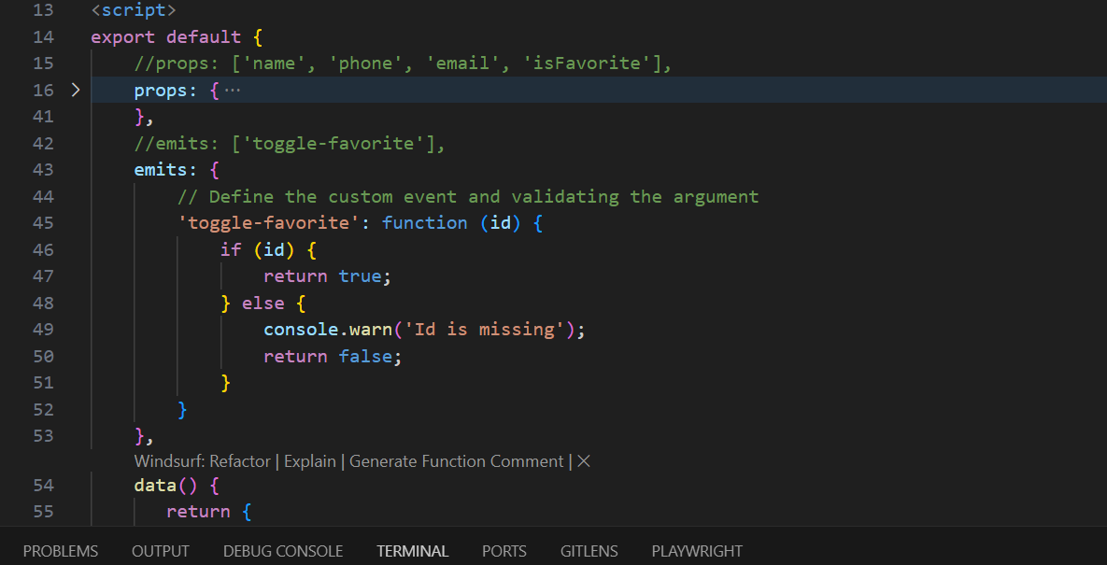*

***On removing the id:***

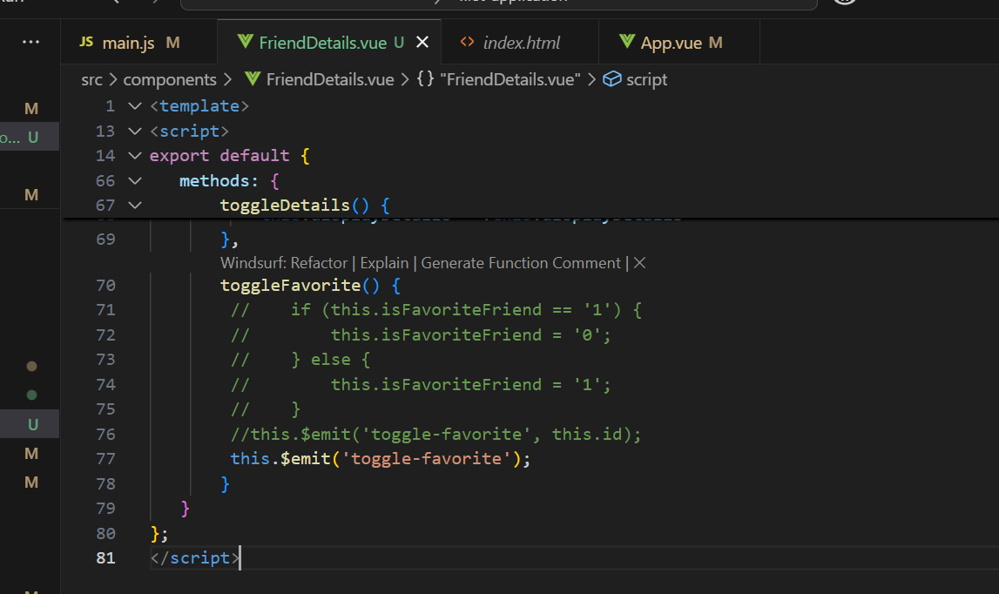

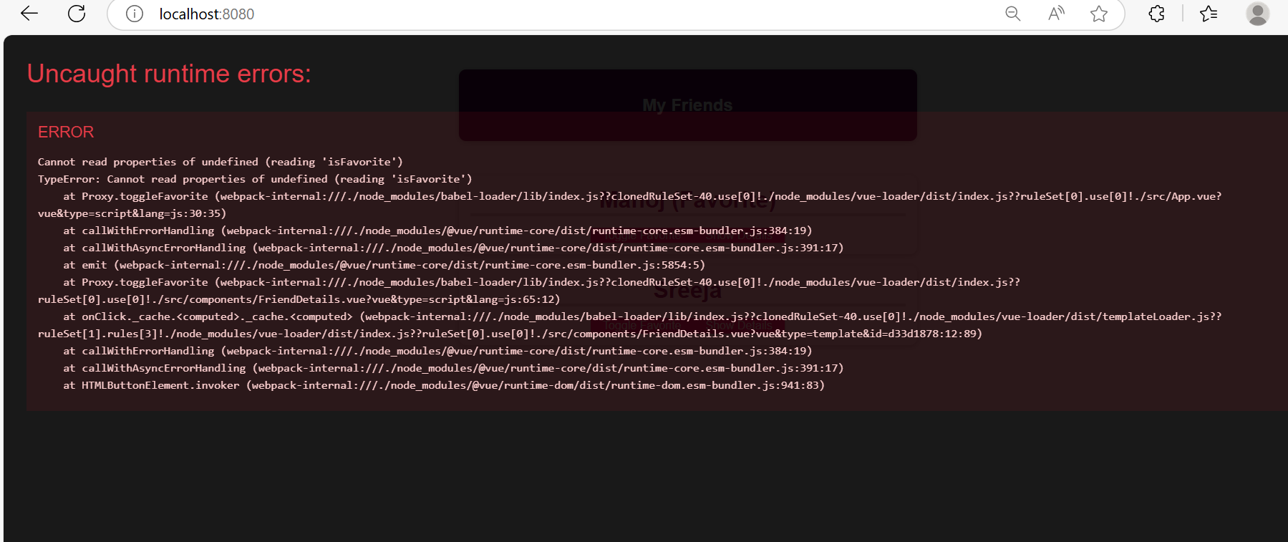

***Passing complete object as Props and accessing it:***

***Child Component***

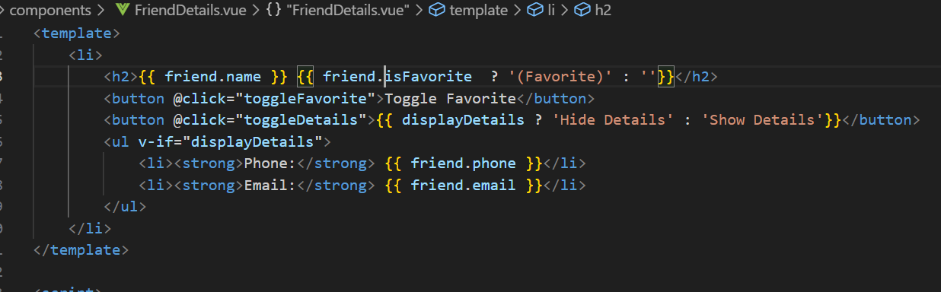

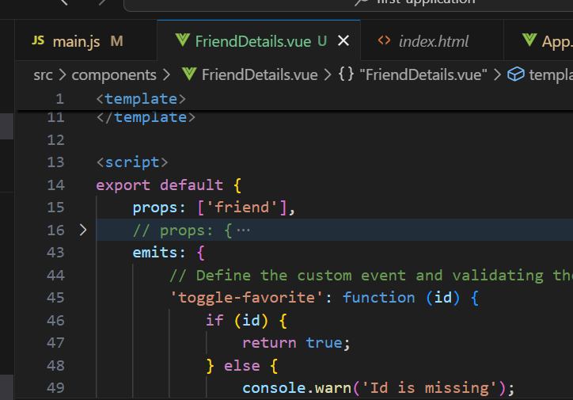

*Parent Component:*

<template>

  <section>

    <header><h1>My Friends</h1></header>

    <ul>

      <!-- <li v-for="friend in friends" :key="friend.id">

                <h2>{{ friend.name }}</h2>

                <button @click="friend.phone = 'Updated'">Update Phone</button>

            </li>     -->

      <!-- <friend-contact

        v-for="friend in friends"

        :key="friend.id"

        :id="friend.id"

        :name="friend.name"

        :phone="friend.phone"

        :email="friend.email"

        :isFavorite="friend.isFavorite"

        @toggle-favorite="toggleFavorite"

      ></friend-contact> -->

      <friend-contact

        v-for="friend in friends"

        :key="friend.id"

        :id="friend.id"

        :friend="friend"

        @toggle-favorite="toggleFavorite"

      ></friend-contact>

    </ul>

  </section>

</template>

<script>

export default {

  data() {

    return {

      friends: [

        {

          id: "manoj",

          name: "Manoj",

          phone: "1234567890",

          email: "m@n.com",

          isFavorite: true,

        },

        {

          id: "sreeja",

          name: "Sreeja",

          phone: "6667 7777 11",

          email: "sreeja@n.com",

          isFavorite: false,

        },

      ],

    };

  },

  methods: {

    toggleFavorite(id) {

      alert('clicked:', id);

      const friendObj = this.friends.find((f) => f.id === id);

      console.log(friendObj);

      friendObj.isFavorite = !friendObj.isFavorite;

    },

  },

};

</script>

@import url("https://fonts.googleapis.com/css2?family=Jost&display=swap");

<style>

* {

  box-sizing: border-box;

}

html {

  font-family: "Jost", sans-serif;

}

body {

  margin: 0;

}

header {

  box-shadow: 0 2px 8px rgba(0, 0, 0, 0.26);

  margin: 3rem auto;

  border-radius: 10px;

  padding: 1rem;

  background-color: #58004d;

  color: white;

  text-align: center;

  width: 90%;

  max-width: 40rem;

}

#app ul {

  margin: 0;

  padding: 0;

  list-style-type: none;

}

#app li,

#app form {

  box-shadow: 0 2px 8px rgba(0, 0, 0, 0.26);

  margin: 1rem auto;

  border-radius: 10px;

  padding: 1rem;

  text-align: center;

  width: 90%;

  max-width: 40rem;

}

#app h2 {

  font-size: 2rem;

  border-bottom: 4px solid #ccc;

  color: #58004d;

  margin: 0 0 1rem 0;

}

#app button {

  font: inherit;

  cursor: pointer;

  border: 1px solid #ff0077;

  background-color: #ff0077;

  color: white;

  padding: 0.05rem 1rem;

  box-shadow: 1px 1px 2px rgba(0, 0, 0, 0.26);

}

#app button:hover,

#app button:active {

  background-color: #ec3169;

  border-color: #ec3169;

  box-shadow: 1px 1px 4px rgba(0, 0, 0, 0.26);

}

</style>

Polyfill – must – jvfault – array one, filter, map, reduce, bind, promise polyfill

Note: Some components may not have any functionality or logic in it. Simply act as a pass through component like receiving and passing props to child or forwarding the received emitting events to the parent, the hierarchy to reach outer most parent might be more….so forward level of forward happens to reach the App.vue(outermost parent) . We have concepts to overcome this issue in vue.

To overcome this we have provide and inject:

**Provide and Inject:**

Provide is a property we have the Vue configuration to have the data consumed in more than components and also required to avoid prop drilling. If we have provided, then it must be listened in the component that requires it (inject).

**Type 1: Provide is provided as an object.**

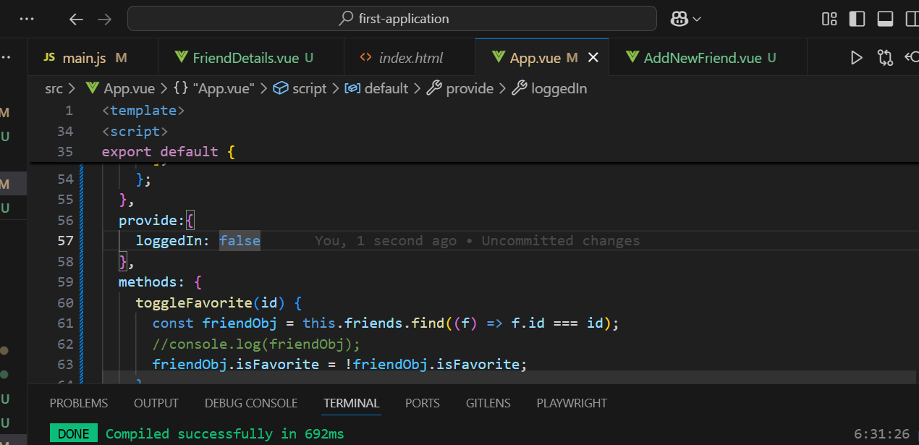

**Type 2: Provide is changed from object to function so that if the data gets changed from anywhere in the appln which is provided in provide property will also get updated. In type1 the data will not get updated.**

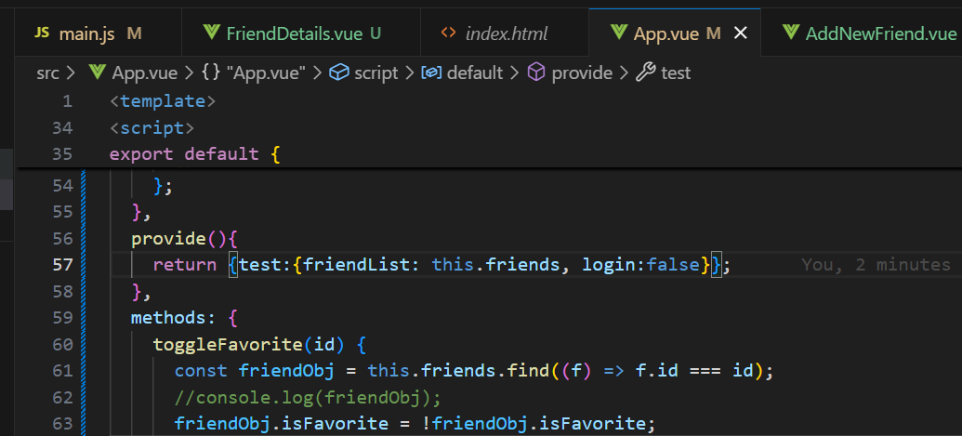

**Listen:**

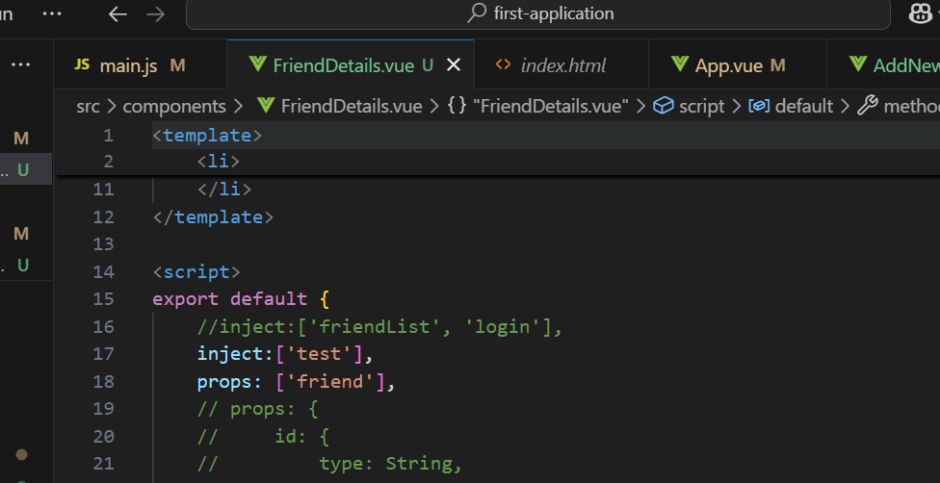

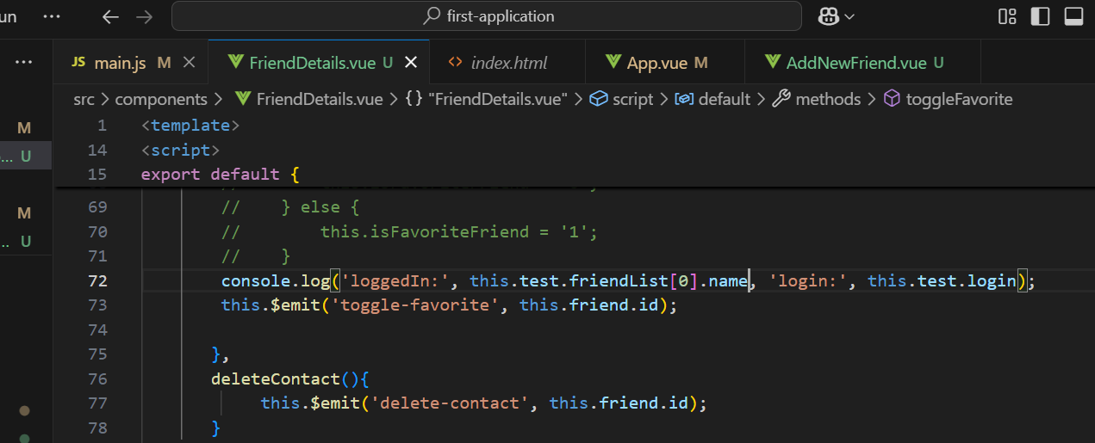

The inject ie listening can be done only in the child component. It can at any hierarchy level.

Note: we can specify which data is being provided in its ancestors and parents and not from the siblings in an array

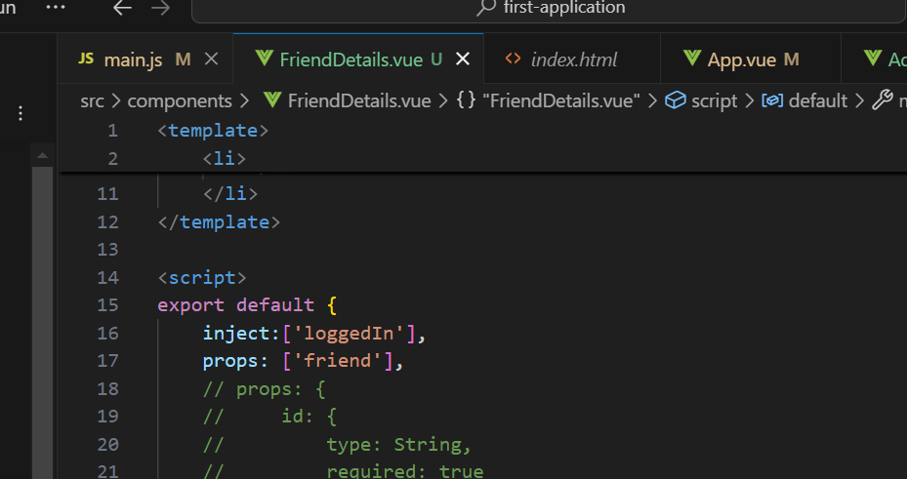

Accessing the provided data in Vue

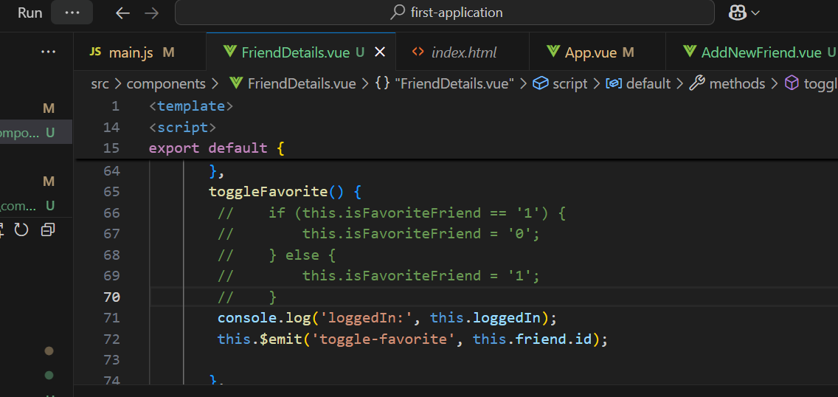

Providing methods/custom events in the “provide” property:

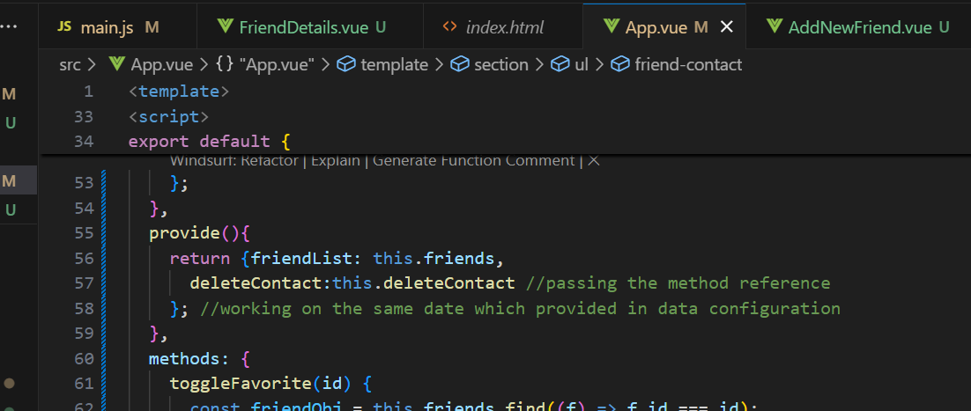

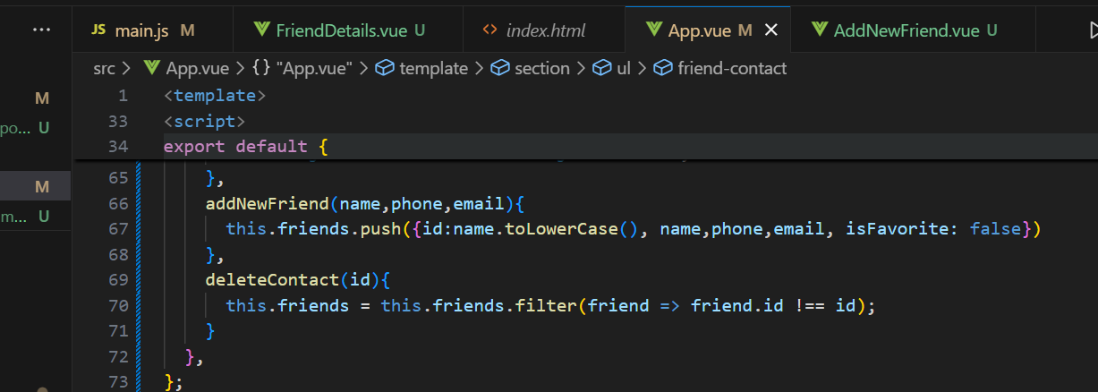

***Note:*** As the “deleteContact” method expects the “id” in the parameter, we need to pass it properly in the listening component while using it as below

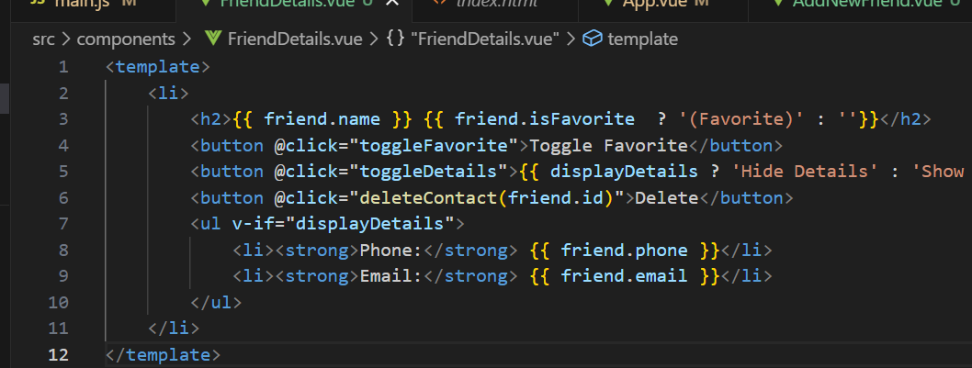

***Note: We should not replace props and custom events with provide and inject. We need to use this when u come across the pass through components which doesn’t have any functionality just forwards the received prop and events. As this concept reduces the redundant code as well as code base much cleaner***

*The main disadvantage of provide and inject is we need to find out in which it is being listened or used which is quite difficult in case of larger projects. So if there is lot of pass through components then use it otherwise go with props and events in case of 1 or 2.*

***Communication between sibling components:***

*If we need the neighbour components or sibling to communicate then we need to move the common data to the common parent and access from that parent. So always parent – child relationship exists.*

***Global vs Local Components:***

**Global components** are the ones that are registered in the main.js file and is available to all the components in the appln. The main disadvantage is the browser should download all the components during loading which would affect the performance of the appln. In case of very large applications the number components as well as the lines of code in each will increase and so the complexity too.

Also if the component is used only in one component then it is of no use to register globally. Those components can be registered locally in the component where it is being used. These components are called **local components**.

To register locally:

Need to import the components just after the script tag

Include the “components” property in the configuration to register the components that are to be used. It can be given any name, even if we component without “-“ but while using if we use with “-“ vue will automatically understand it

**Registered:**

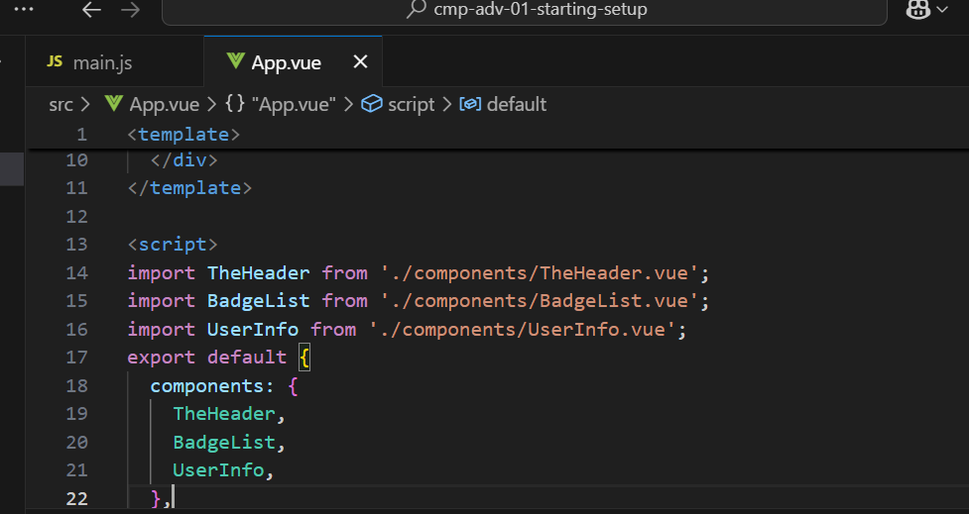

**Consumption:**

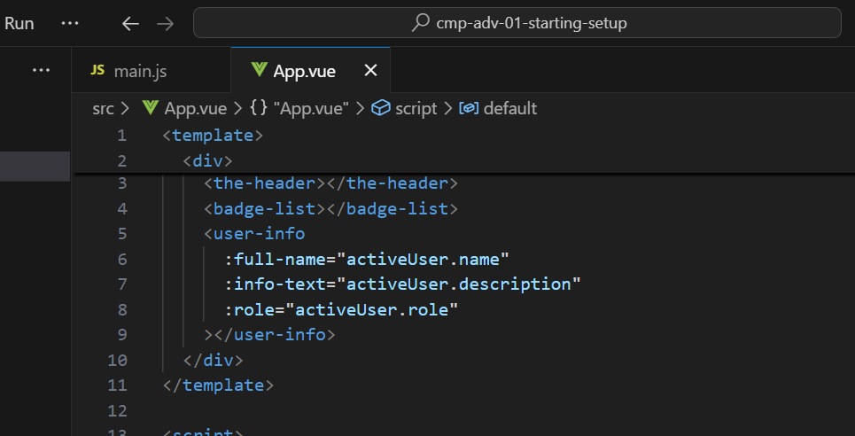

If we are not using the “-“ in the component tag, then we can do self-closing as below:

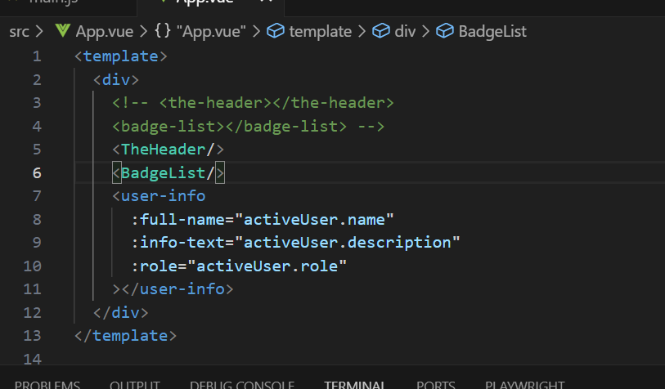

**Scoped Style:**

As we know, in Vue the styles are defined within the <Style> tag. Even if the style is defined in certain component for html elements it applies globally ( to all the elements in all the components) To make the styles specific to the component in which it is designed vue have the attribute “scoped” which needs to be added in the <Style> tag

***Note: In App.vue, we define the styles which should be applied globally.***

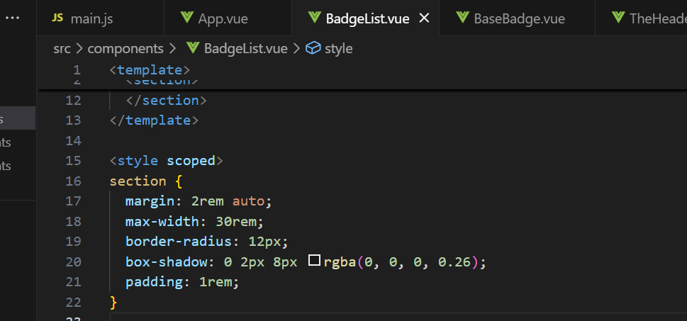

Each element has the attribute (Ex: data-v-9a9f6144) added after applying scoped. Each element will have its own attribute defined

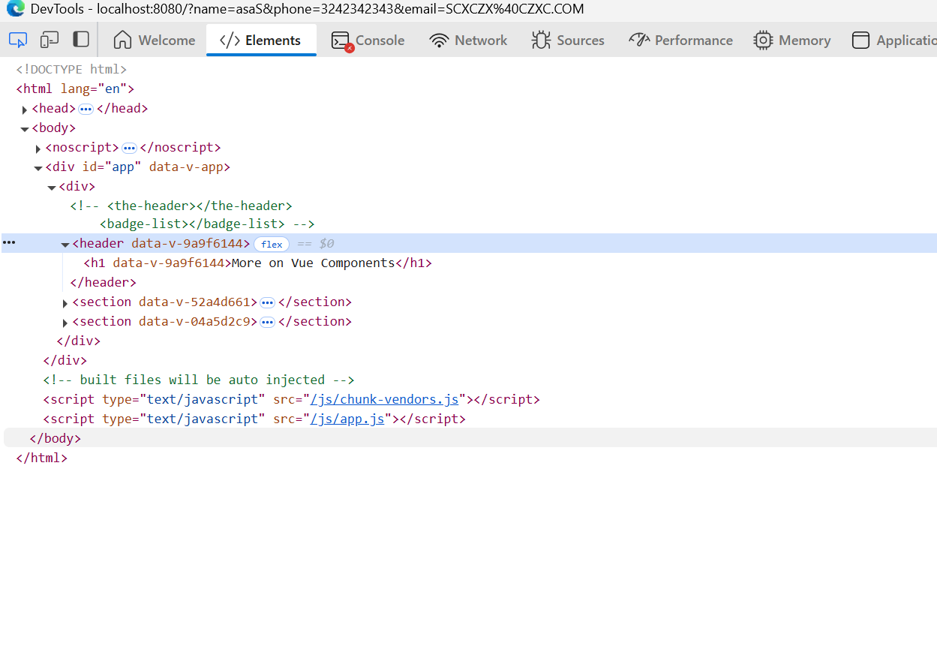

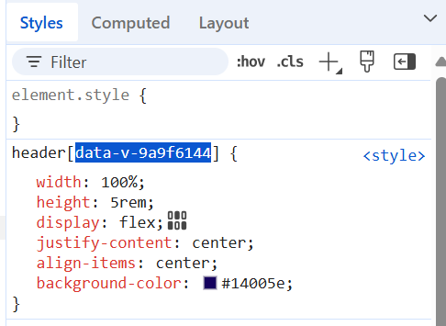.

**Slots(It is like props.children in react):**

Props are used to pass data whereas slots are required to allow space for html elements from the template from different or within same component.We can add any logic also in this component which might be common.It provides option to pass dynamic content between opening and closing tags.

*Note: Props won’t allow to pass html elements*

*If more than one elements having the same style and element structure, then we can use this concept to move the common structure to a different component (card component) which acts as a wrapper to the invoking classes.*

*These should be registered in main.js as it is being used by more than one component*

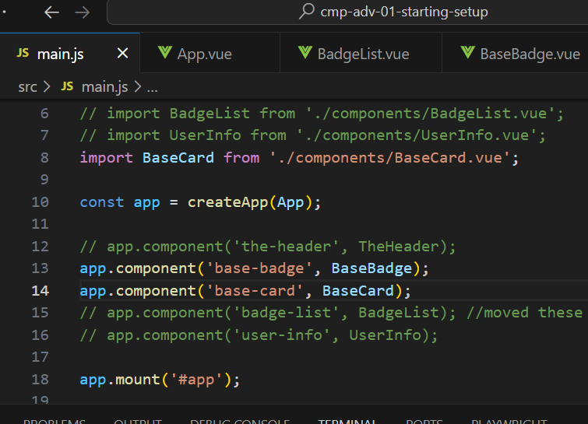

**Slot Component**

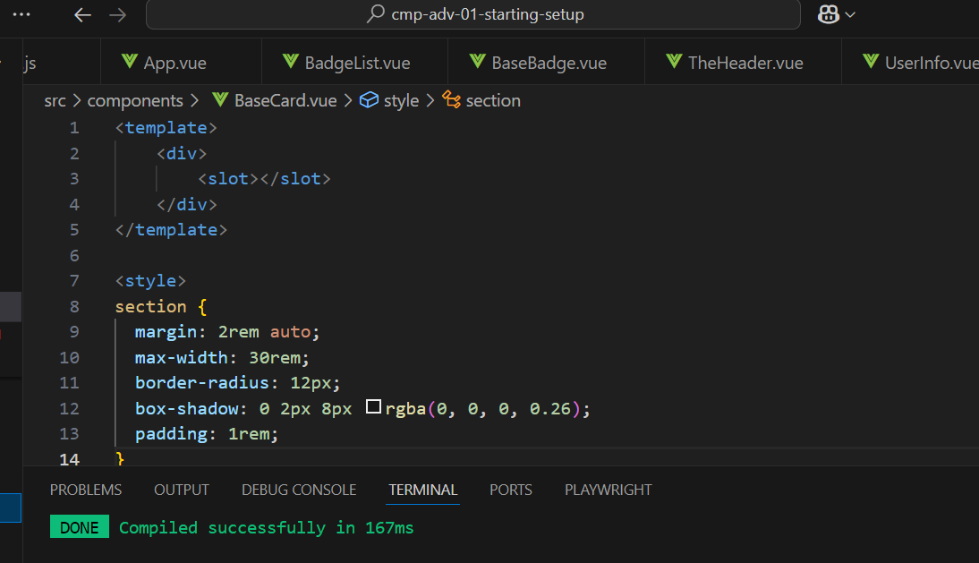

***Consuming slot(card/wrapper) component***

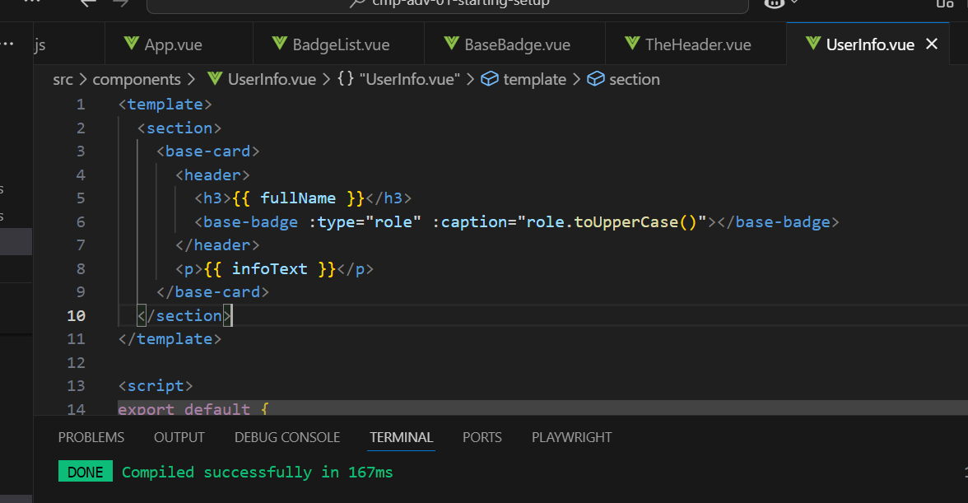

***Multiple Slots:***

*We can define multiple slots in a component. In such cases we need to give name for the slots in order to specify which html element structure should get into which slot. In this we can leave only one slot without name which will allow the default content to be mapped there.*

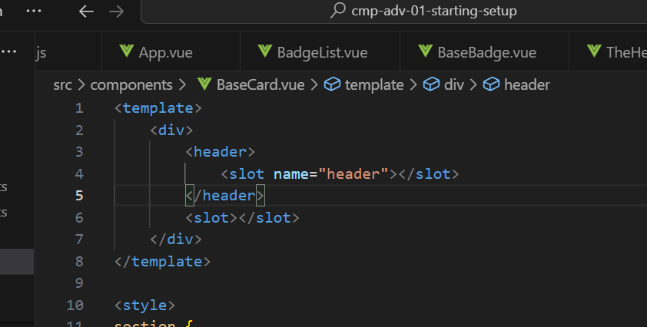

*Invoking the slot with name: For that we should use the <template> tag with v-slot attribute to invoke the named slot. Remaining content with the opening and close tag of the card component will get in to the default slot. There can be any number of slots.*

***v-slot: xxxxx where –> xxxxx is the name of the slot***

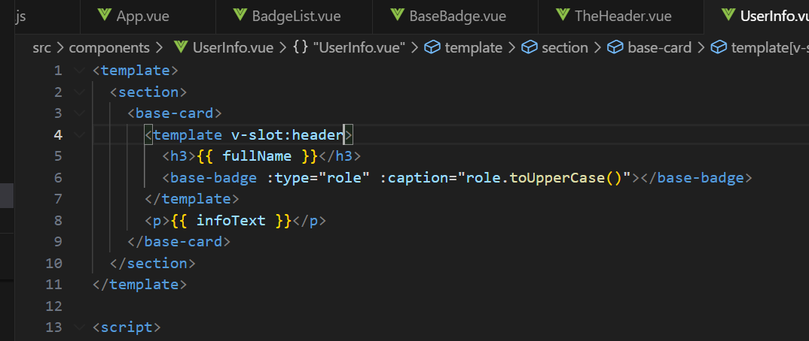

*To explicitly specify which gets into the default slot*

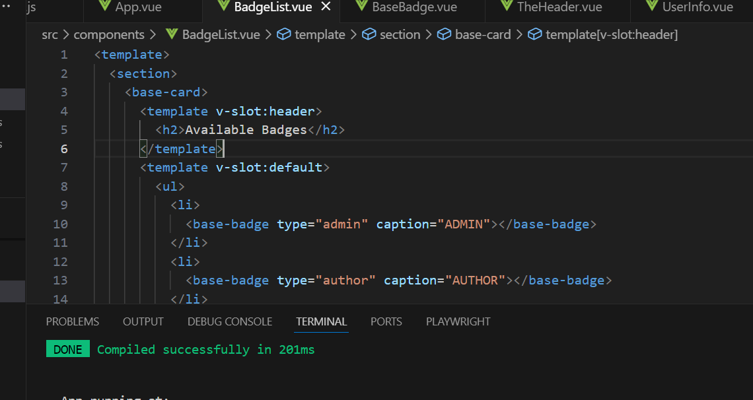

***Note:*** *while moving the elements to the card component then we need to move the styles too to that card component otherwise style will not be applied in case the style is a scoped style.*

***Default content in slot:***

*The content that it is given between <slot> tags is the default content which will be displayed if that particular slot is not invoked*

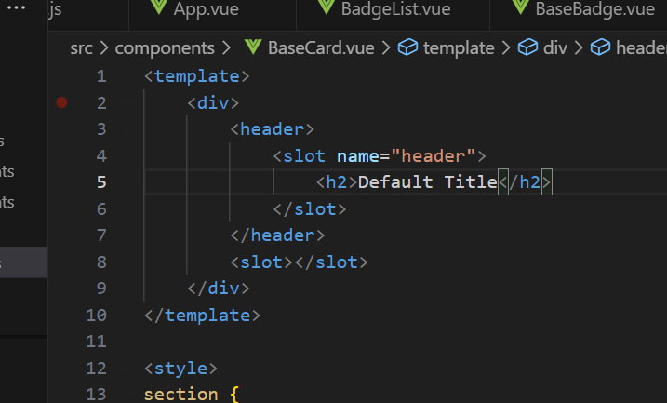

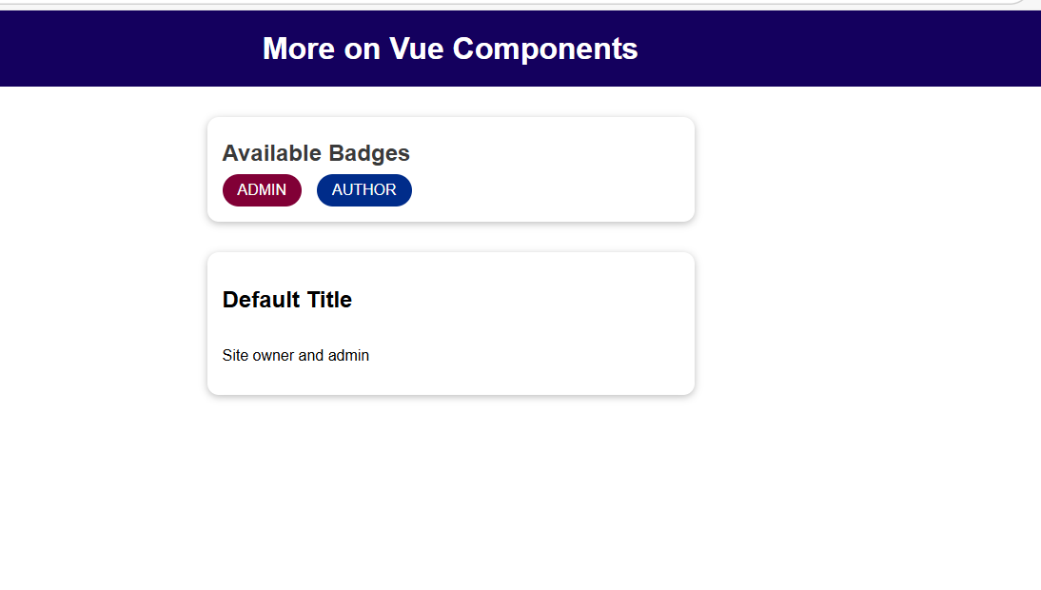

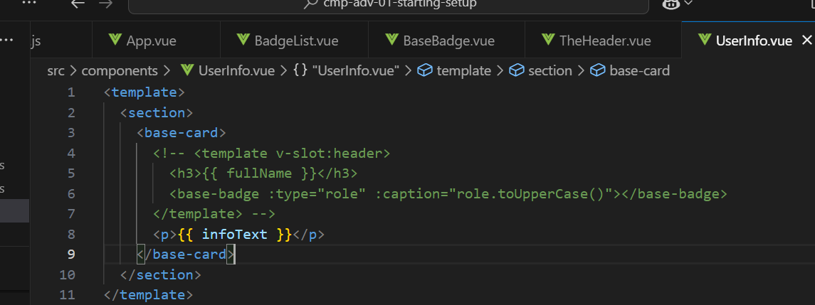

*On enabling the slot invocation*

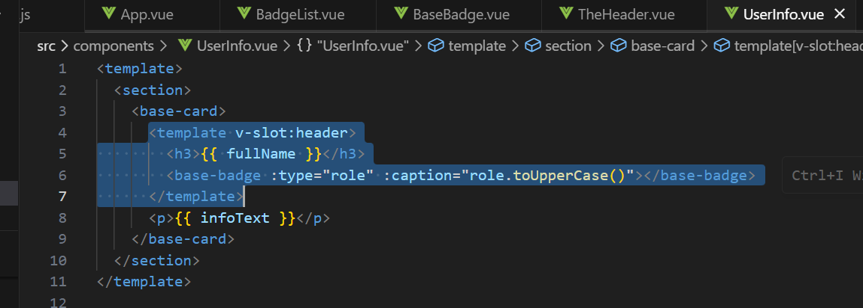

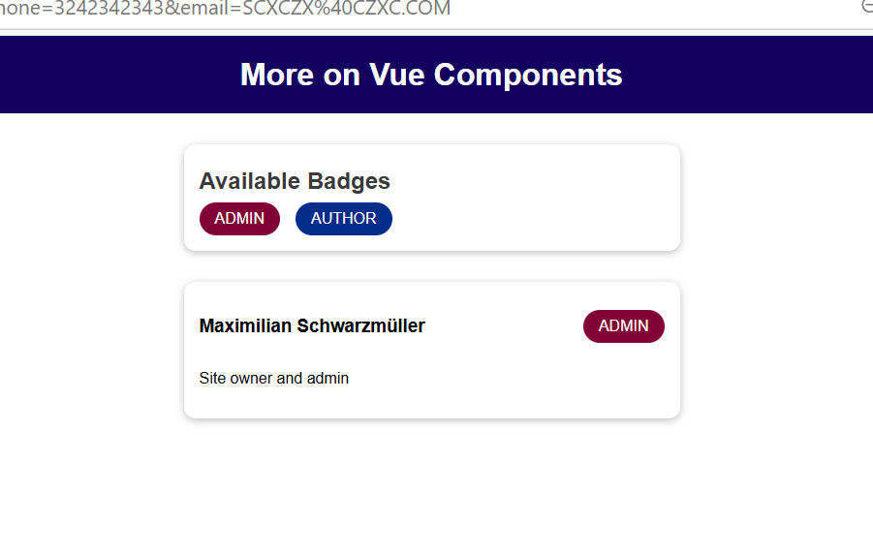

*Conditionally rendering the slot*

*If the slot is not invoked and the default content is not provided for display, in UI nothing will be displayed but when we inspected empty html elements will be generated. This should be avoided which can be accomplished by adding condition in the slot. If it is invoked then for that particular we get undefined which we check using the $slot attribute. $slot property holds information regarding what each slots defined in the component receive.*

*Syntax:*

***this.$slots -> gives info about each of the slot***

*For specific slot we can access with the name provide*

***this.$slots.xxxx -> where xxxx -> slot name***

***Example: this.$slots.header***

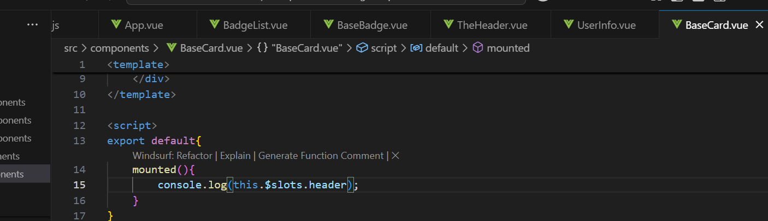

***Conditionally rendering the slot element***

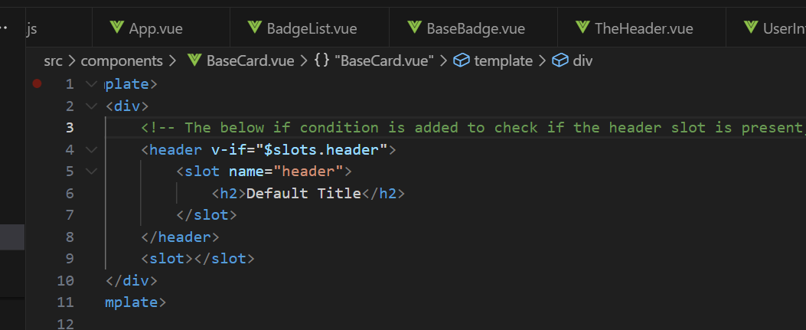

***Shorthand notation:***

***v-slot:header can be written as #header where header is the slot name***

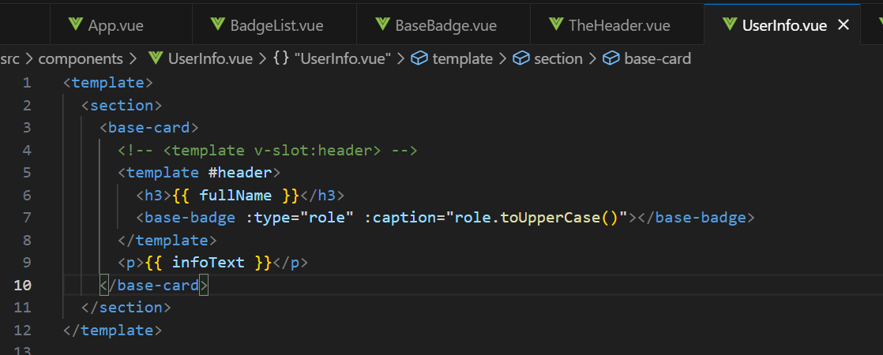

***Scoped Slot:***

*This is required when we want to have customized layout for different components then we can go for it.*

*For scoped slot we have data or functionality defined in the same card component, in vue we have the provision to pass the data to the invoking component*

*Scoped slot allows the data to be passed from the component to the component which passes the markup to the slot.*

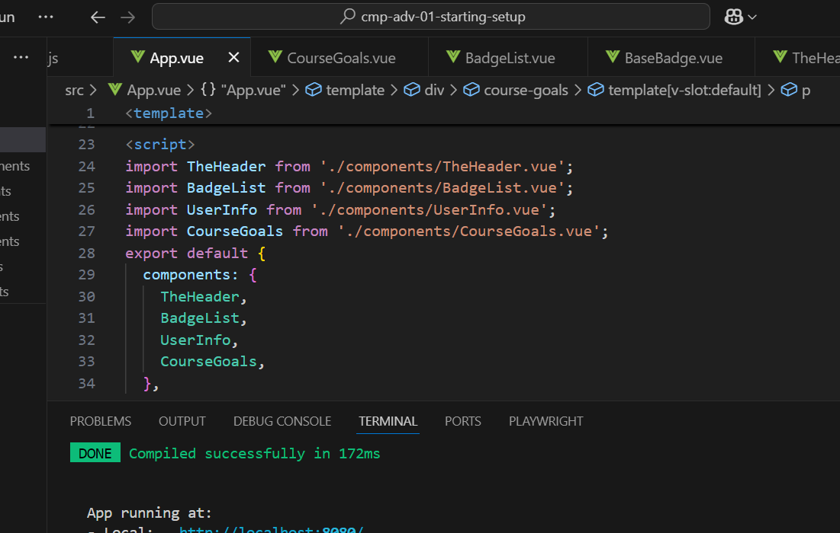

*Here the variable used to access the data passed from slot will always be an object and it contains all the props provided in the slot*

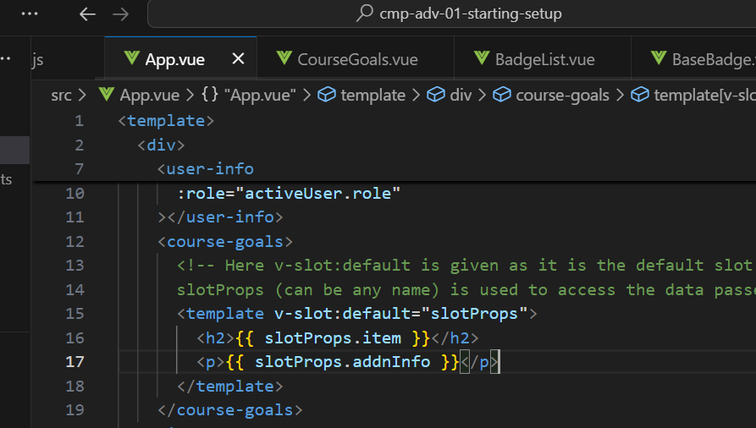

*If we are targeting just the default slot, then we can skip template and can include in the markup itself as below*

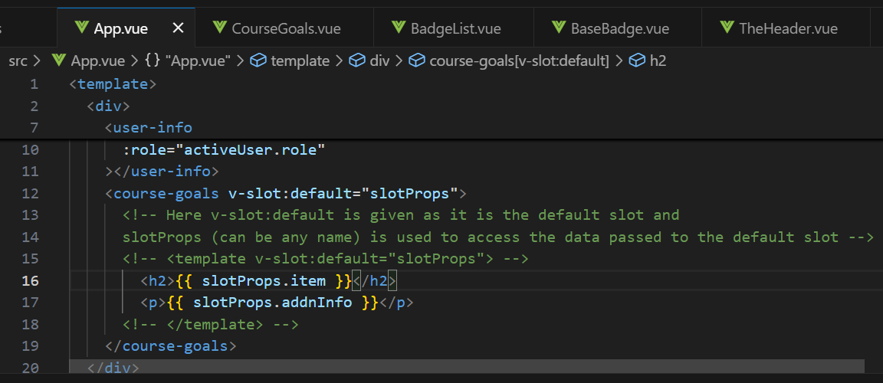

*Slot Component:*

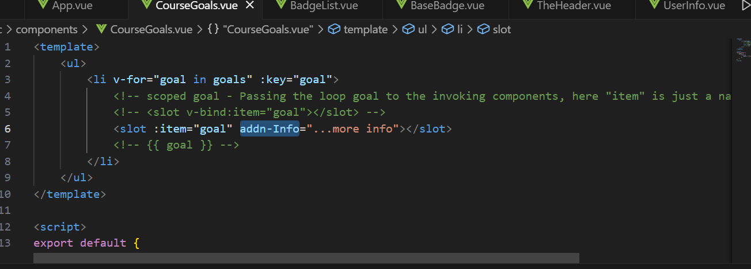

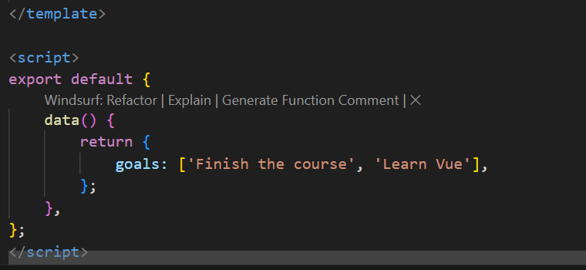

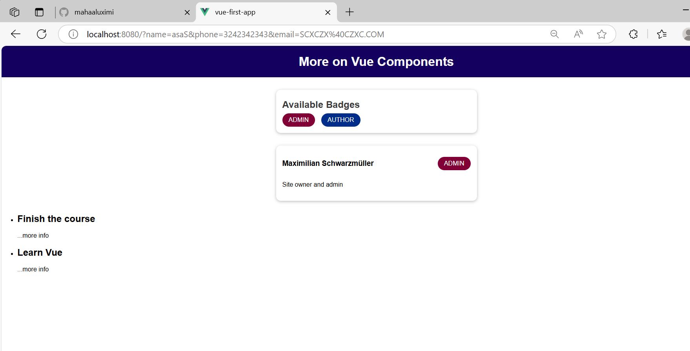

***Note: If a component is not exporting any data then it is of no use to have <script> tag and to export the data. In the background export and import are handled automatically.***

***Dynamic Components:***

*Vue provides the <component> component which will not display anything in the UI. It expects an attribute “is” in which we need to specify the component to be displayed in UI.*

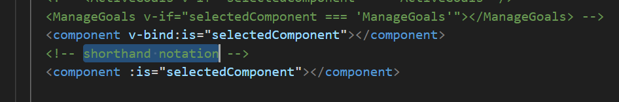

*While switching between different components with the “<component>” tag, the elements will be destroyed and if we come back new element is built and so the input or data provided during last time is lost. To retain the data vue provides a “keep-alive” component which should be used to wrap the <component>.*

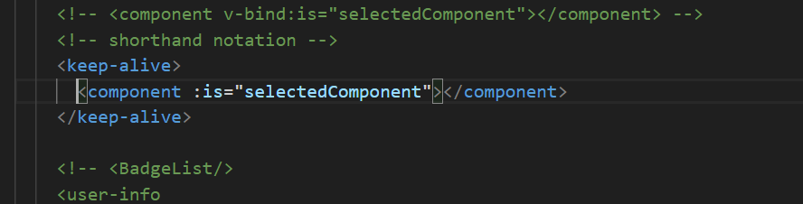

*Even after switch over the data is retained*

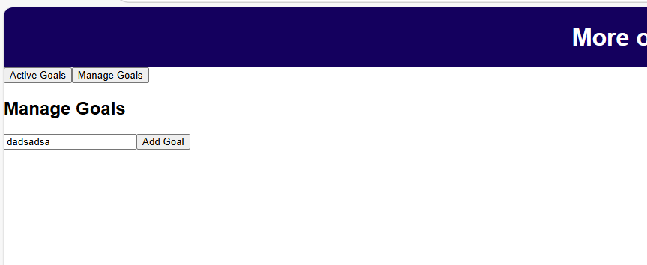

***Error Popup using “<dialog>” element***

*Define the Error component and invoke it conditionally*

***ErrorModal.vue***

<template>

    <dialog open>

        <slot></slot>

    </dialog>

</template>

<style scoped>

dialog {

  position: fixed;

  top: 20vh;

  width: 30rem;

  left: calc(50% - 15rem);

  margin: 0;

  box-shadow: 0 2px 8px rgba(0, 0, 0, 0.26);

  border-radius: 12px;

  padding: 1rem;

  background-color: white;

  z-index: 10;

}

</style>

***ManageGoals.vue***

*The ErrorModal is conditionally invoked*

<template>

    <h2>Manage Goals</h2>

    <div>

        <input type="text" ref="goalInput">

        <button @click="validateInput">Add Goal</button>

    </div>

    <error-modal v-if="isInvalid">

        <h2>Invalid Input</h2>

        <p>Please enter at least a few characters.</p>

    </error-modal>

</template>

<script>

import ErrorModal from './ErrorModal.vue';

export default {

    components: {

        ErrorModal,

    },

    data() {

        return {

            isInvalid: false,

        };

    },

    methods:{

        validateInput() {

            if (this.$refs.goalInput.value === '') {

                this.isInvalid = true;

            } else {

                this.isInvalid = false;

            }

        }

    }

};

</script>

*Adding “Confirm” functionality in the Error popup*

<template>

    <h2>Manage Goals</h2>

    <div>

        <input type="text" ref="goalInput">

        <button @click="validateInput">Add Goal</button>

    </div>

    <error-modal v-if="isInvalid">

        <h2>Invalid Input</h2>

        <p>Please enter at least a few characters.</p>

        <button @click="confirmError">Confirm</button>

    </error-modal>

</template>

<script>

import ErrorModal from './ErrorModal.vue';

export default {

    components: {

        ErrorModal,

    },

    data() {

        return {

            isInvalid: false,

        };

    },

    methods:{

        validateInput() {

            if (this.$refs.goalInput.value === '') {

                this.isInvalid = true;

            } else {

                this.isInvalid = false;

            }

        },

        confirmError() {

            this.isInvalid = false;

        }

    }

};

</script>

*In the above example the “dialog” element is formed nested inside the html hierarchy in the order of it is invoked but we expect the error element “dialog” to be an overlay of all the elements otherwise it will sometimes collapse the styling or accessibility issue. As a fact the error modal should reside below the root element and outside the main element of the appln*

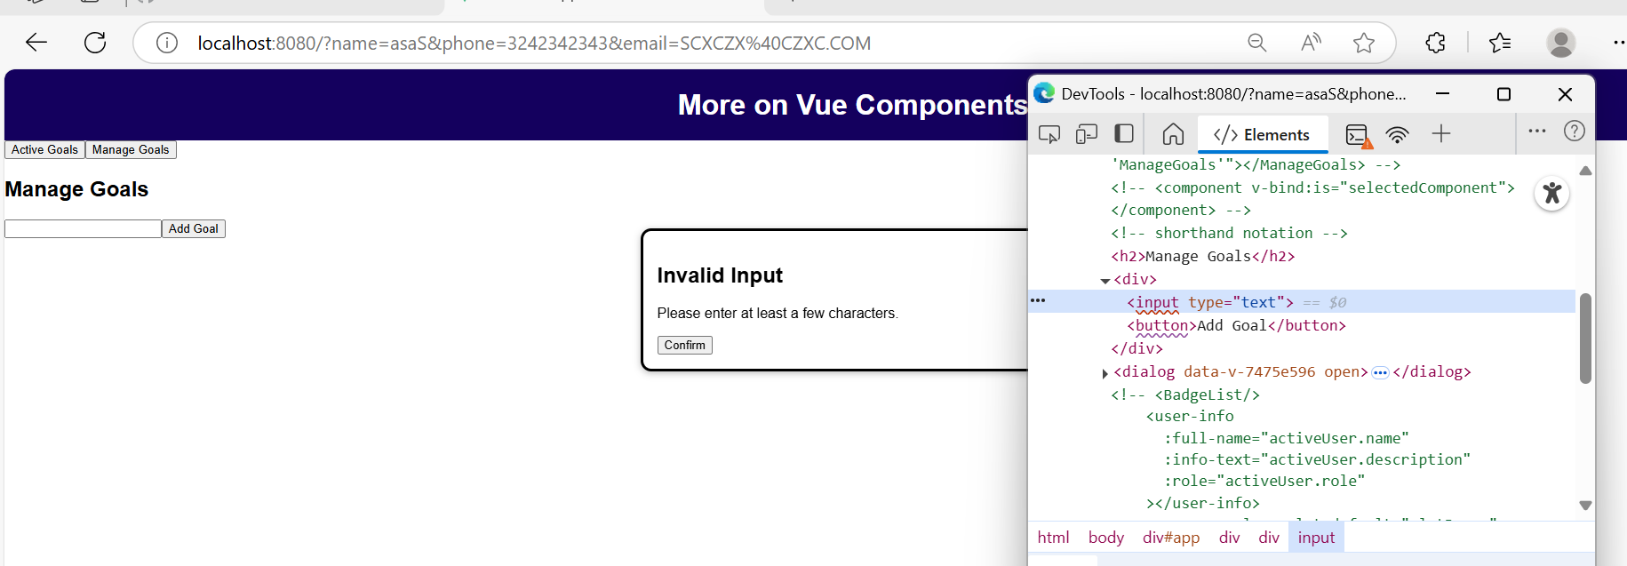

***Teleporting element:***

*The vue has the component “teleport” which helps to render the elements at the desired location the DOM tree. That is it helps to create semantically correct appln rather than just to develop better look and feel.*

*The component “teleport” expects an attribute “to” which holds the value of any css selector. This attributes specifies where the element to be rendered.*

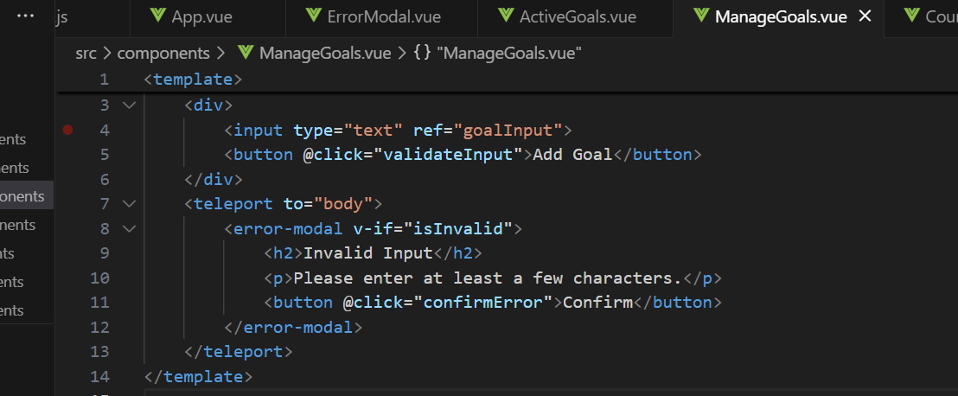

*Now the dialog is rendered directly inside “body” tag and not nested inside*

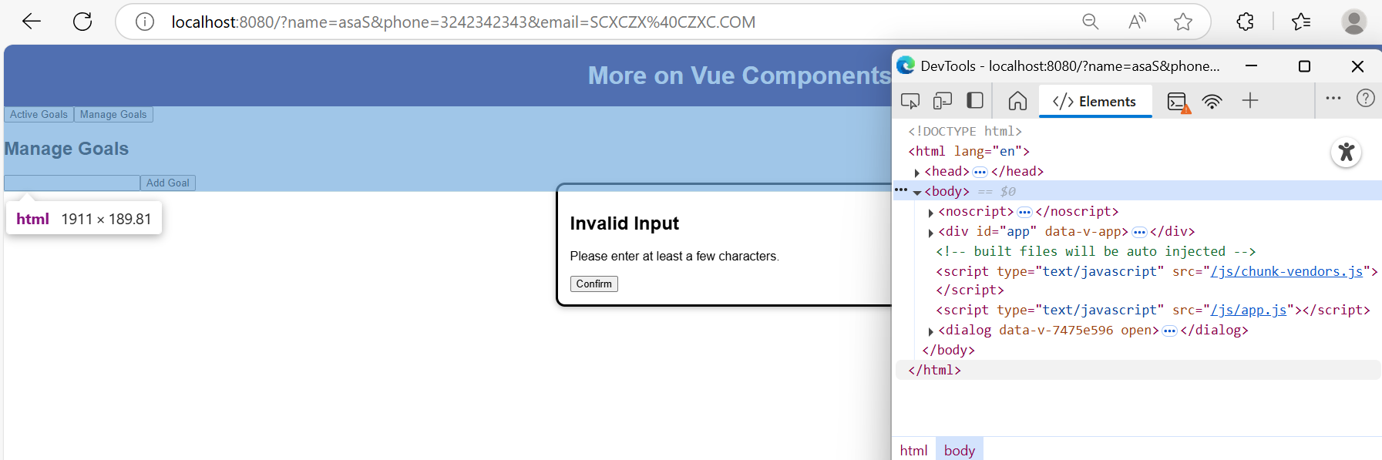

***Fragments:***

*In vue 2, multiple top level elements are not supported so a top level element “<div>” / “<section>” etc is added. This is called fragment. In vue 3, multiple top level elements are allowed.*

***Form Elements***

*Note: v-model -> it allow us to get the user input*

*v-on:input -> it is usual to get what the user has entered on every keystroke and is useful to validate the user input*

*Number type Input -> Even if the input type is set as “number”, the user input read by ref or by just javascript methods then it will be string only but when we bind that input with “v-model” then it automatically converts the user input of string type to number as it is of number type. Also we can force the v-model to convert the user input from string to number by giving “v-model.number”.*

*Note: In the console, the value is displayed in blue color then it is of number type. If displayed black, then it is of string type*

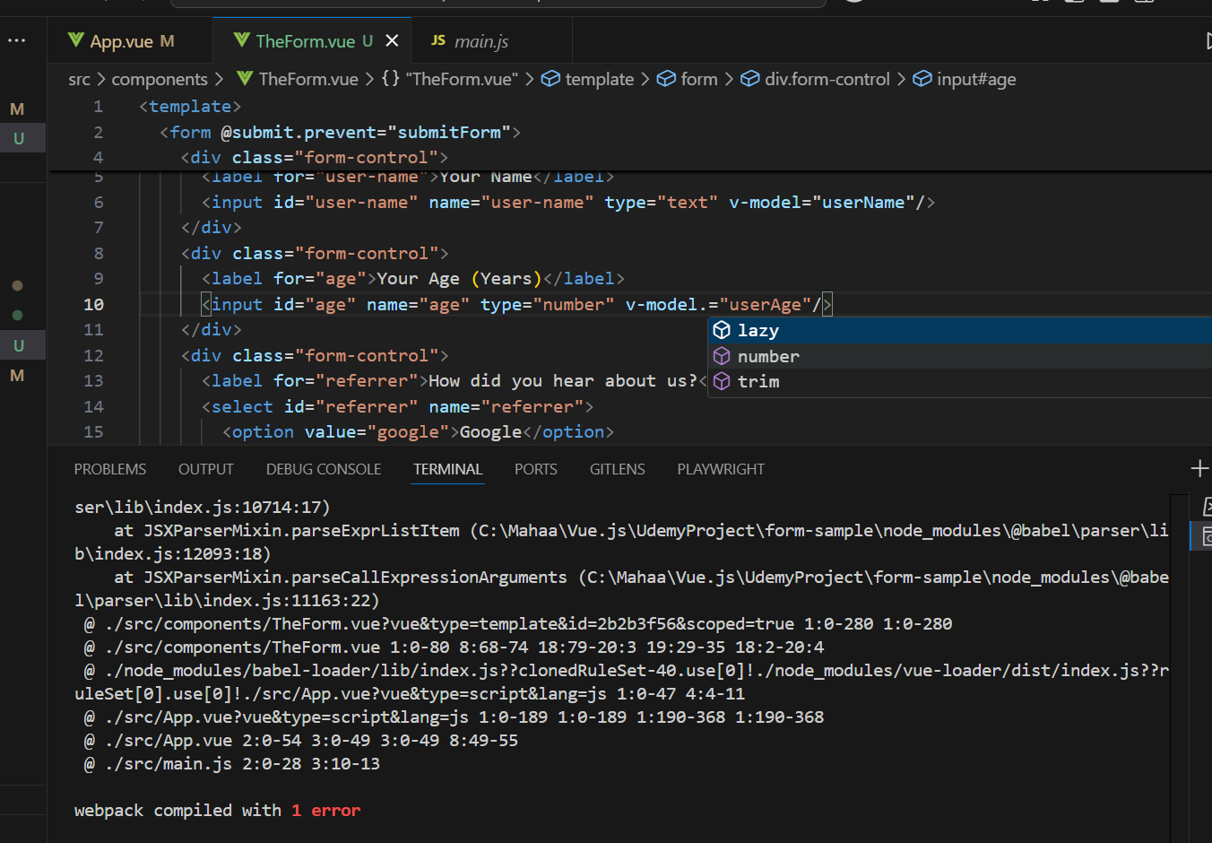

***Note: “lazy” -> specifies when to update the value, on every key stroke or little late.***

***“trim” -> specifies to remove the extra white space***

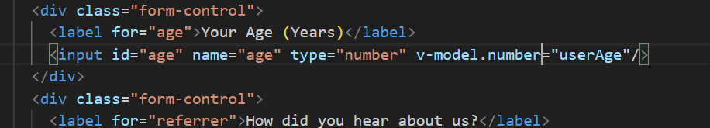

***v-model*** *-> works for “input”, “select”, “radio”, “checkbox”*

***For “checkbox”****, the default value should be an array and also we need to give the value attribute for each of the input field of type “checkbox” otherwise vue will not which has been selected and it always checks or unchecks all the elements together*

*Group of checkboxes we get the value as an array*

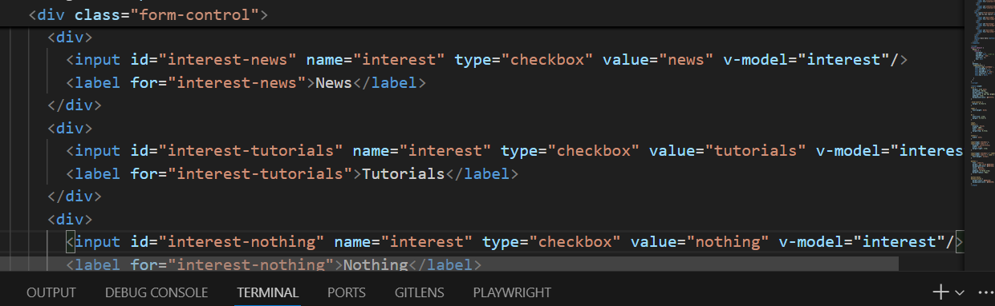

*Single checkbox means here too we can use v-model, but the value is either true or false. The default value can be given as false.*

*For radio type also we need give v-model as well as the value attribute for each of the input field*

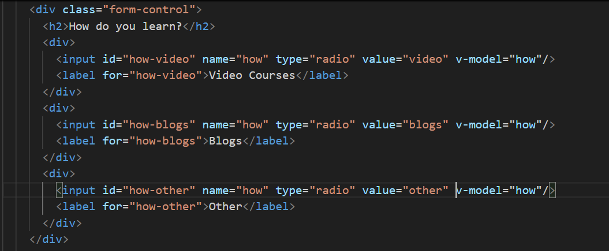

***Input Validation:***

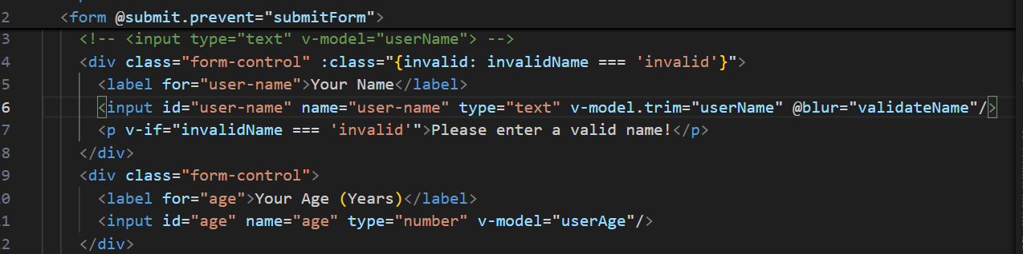

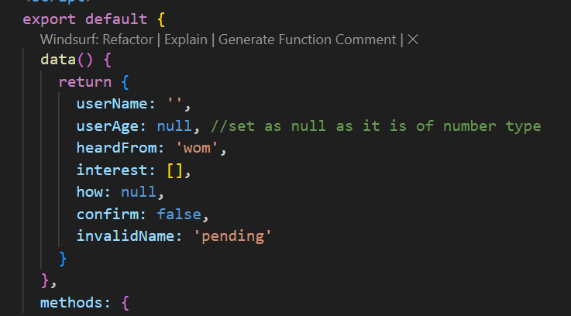

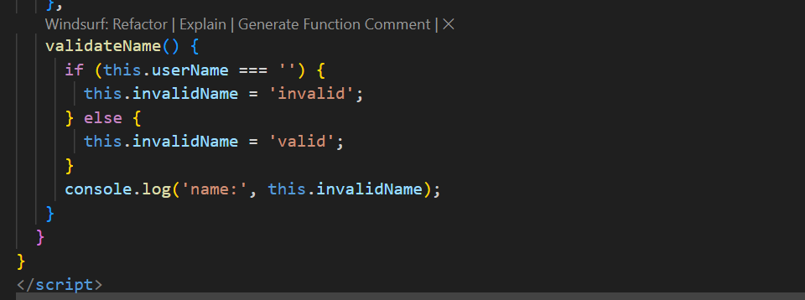

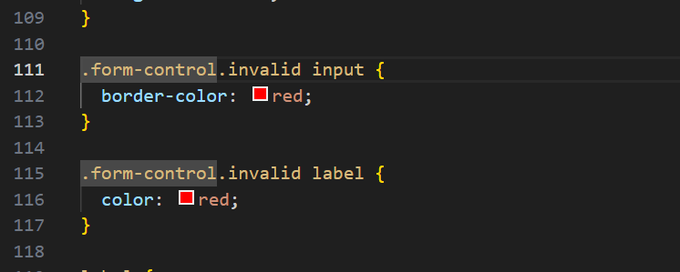

***Custom Component:***

***RatingControl.vue (custom component)***

<template>

    <p>RatingControl</p>

    <ul>

        <li :class="{active: activeOption === 'poor'}"><button type="button" @click="setActiveOption('poor')">Poor</button></li>

        <li :class="{active: activeOption === 'average'}"><button type="button" @click="setActiveOption('average')">Average</button></li>

        <li :class="{active: activeOption === 'great'}"><button type="button" @click="setActiveOption('great')">Great</button></li>

    </ul>

</template>

<script>

export default {

    data() {

        return {

            activeOption: null

        }

    },

    methods: {

        setActiveOption(option) {

            this.activeOption = option;

        }

    }

}

</script>

<style scoped>

.active{

    border-color: blue;

}

.active button{

    color: blue;

}

ul{

    list-style-type: none;

    margin: 0.5rem0;

    padding: 0;

    display: flex;

}

li{

    margin: 0 1rem;

    border: 1px solid #ccc;

    padding: 1rem;

    display: flex;

    justify-content: center;

    align-items: center;

}

button{

    font: inherit;

    border: none;

    background-color: transparent;

    cursor: pointer;

}

</style>

***Changes done to update the prop value when parent passes the updated value:***

<template>

    <p>RatingControl</p>

    <ul>

        <li :class="{active: activeOption === 'poor'}"><button type="button" @click="setActiveOption('poor')">Poor</button></li>

        <li :class="{active: activeOption === 'average'}"><button type="button" @click="setActiveOption('average')">Average</button></li>

        <li :class="{active: activeOption === 'great'}"><button type="button" @click="setActiveOption('great')">Great</button></li>

    </ul>

</template>

<script>

export default {

    props: ['modelValue'],

    emits: ['update:modelValue'], //custom event can be given any name like this "update:modelValue"

    //as the value set in the parent is not getting reflected in the child so commenting data

    // data() {

    //     return {

    //         activeOption: this.modelValue

    //     }

    // },

    //computed is added to return the value set in the parent

    computed:{

        activeOption(){

            return this.modelValue;

        }

    },

    methods: {

        setActiveOption(option) {

            this.activeOption = option;

            this.$emit('update:modelValue', option); //emitting custom event

        }

    }

}

</script>

<style scoped>

.active{

    border-color: blue;

}

.active button{

    color: blue;

}

ul{

    list-style-type: none;

    margin: 0.5rem0;

    padding: 0;

    display: flex;

}

li{

    margin: 0 1rem;

    border: 1px solid #ccc;

    padding: 1rem;

    display: flex;

    justify-content: center;

    align-items: center;

}

button{

    font: inherit;

    border: none;

    background-color: transparent;

    cursor: pointer;

}

</style>

***Alternative to computed property is in the if check itself we can use the prop value rather than the local data(in this can remove “computed” property too)***

<template>

    <p>RatingControl</p>

    <ul>

        <!-- local data is replaced with prop to check with the updated value -->

        <!-- <li :class="{active: activeOption === 'poor'}"><button type="button" @click="setActiveOption('poor')">Poor</button></li>

        <li :class="{active: activeOption === 'average'}"><button type="button" @click="setActiveOption('average')">Average</button></li>

        <li :class="{active: activeOption === 'great'}"><button type="button" @click="setActiveOption('great')">Great</button></li>  -->

        <li :class="{active: modelValue === 'poor'}"><button type="button" @click="setActiveOption('poor')">Poor</button></li>

        <li :class="{active: modelValue === 'average'}"><button type="button" @click="setActiveOption('average')">Average</button></li>

        <li :class="{active: modelValue === 'great'}"><button type="button" @click="setActiveOption('great')">Great</button></li>

    </ul>

</template>

<script>

export default {

    props: ['modelValue'],

    emits: ['update:modelValue'], //custom event can be given any name like this "update:modelValue"

    //as the value set in the parent is not getting reflected in the child so commenting data

    // data() {

    //     return {

    //         activeOption: this.modelValue

    //     }

    // },

    //computed is added to return the value set in the parent

    // computed:{

    //     activeOption(){

    //         return this.modelValue;

    //     }

    // },

    methods: {

        setActiveOption(option) {

            this.activeOption = option;

            this.$emit('update:modelValue', option); //emitting custom event

        }

    }

}

</script>

<style scoped>

.active{

    border-color: blue;

}

.active button{

    color: blue;

}

ul{

    list-style-type: none;

    margin: 0.5rem0;

    padding: 0;

    display: flex;

}

li{

    margin: 0 1rem;

    border: 1px solid #ccc;

    padding: 1rem;

    display: flex;

    justify-content: center;

    align-items: center;

}

button{

    font: inherit;

    border: none;

    background-color: transparent;

    cursor: pointer;

}

</style>

***TheForm.vue(consuming the custom component)***

*It would be good if we could use “v-model” attribute for the custom control too. We know that v-model is a shorthand notation for a combination of “v-bind:value”(binding value) and “v-on:onput” (input event).*

*Vue supports the v-model for custom component also. For that it expects specific prop as well as the event. We need to define that specific prop and event in the custom component. The invoking component should listen to the emitted event.*

*Here the special event and props are “update:modelValue” (event) and “modelValue”(prop)*

<template>

  <form @submit.prevent="submitForm">

    <!-- <input type="text" v-model="userName"> -->

    <div class="form-control" :class="{invalid: invalidName === 'invalid'}">

      <label for="user-name">Your Name</label>

      <input id="user-name" name="user-name" type="text" v-model.trim="userName" @blur="validateName"/>

      <p v-if="invalidName === 'invalid'">Please enter a valid name!</p>

    </div>

    <div class="form-control">

      <label for="age">Your Age (Years)</label>

      <input id="age" name="age" type="number" v-model="userAge"/>

    </div>

    <div class="form-control">

      <label for="referrer">How did you hear about us?</label>

      <select id="referrer" name="referrer" v-model="heardFrom">

        <option value="google">Google</option>

        <option value="wom">Word of mouth</option>

        <option value="newspaper">Newspaper</option>

      </select>

    </div>

    <div class="form-control">

      <h2>What are you interested in?</h2>

      <div>

        <input id="interest-news" name="interest" type="checkbox" value="news" v-model="interest"/>

        <label for="interest-news">News</label>

      </div>

      <div>

        <input id="interest-tutorials" name="interest" type="checkbox" value="tutorials" v-model="interest"/>

        <label for="interest-tutorials">Tutorials</label>

      </div>

      <div>

        <input id="interest-nothing" name="interest" type="checkbox" value="nothing" v-model="interest"/>

        <label for="interest-nothing">Nothing</label>

      </div>

    </div>

    <div class="form-control">

      <h2>How do you learn?</h2>

      <div>

        <input id="how-video" name="how" type="radio" value="video" v-model="how"/>

        <label for="how-video">Video Courses</label>

      </div>

      <div>

        <input id="how-blogs" name="how" type="radio" value="blogs" v-model="how"/>

        <label for="how-blogs">Blogs</label>

      </div>

      <div>

        <input id="how-other" name="how" type="radio" value="other" v-model="how"/>

        <label for="how-other">Other</label>

      </div>

      <div class="form-control">

        <!-- if the custom component has the below specified value(defined in custom component) and event then we use v-model -->

        <!-- <rating-control v-model="rating" v-bind:modelValue="" @update:modelValue=""></rating-control> -->

        <rating-control v-model="rating"></rating-control>

      </div>

      <div class="form-control">

        <input id="confirm" name="confirm" type="checkbox" v-model="confirm"/>

        <label for="confirm">Agree to terms and conditions</label>

      </div>

    </div>

    <div>

    <button>Save Data</button>

    </div>

  </form>

</template>

<script>

import RatingControl from './RatingControl.vue';

export default {

  components: {

    RatingControl

  },

  data() {

    return {

      userName: '',

      userAge: null, //set as null as it is of number type

      heardFrom: 'wom',

      interest: [],

      how: null,

      confirm: false,

      rating: null,

      invalidName: 'pending'

    }

  },

  methods: {

   submitForm() {

     console.log('userName:',  this.userName, this.userAge, this.heardFrom, this.interest, this.how, this.confirm, 'rating:', this.rating);

     this.userName = '';

     this.userAge = null;

     this.heardFrom = 'wom';

     this.interest = null;

     this.how = null;

     this.confirm = false;

     this.rating= null

   },

   validateName() {

     if (this.userName === '') {

       this.invalidName = 'invalid';

     } else {

       this.invalidName = 'valid';

     }

     console.log('name:', this.invalidName);

   }

  }

}

</script>

<style scoped>

form {

  margin: 2rem auto;

  max-width: 40rem;

  border-radius: 12px;

  box-shadow: 0 2px 8px rgba(0, 0, 0, 0.26);

  padding: 2rem;

  background-color: #ffffff;

}

.form-control {

  margin: 0.5rem 0;

}

.form-control.invalid input {

  border-color: red;

}

.form-control.invalid label {

  color: red;

}

label {

  font-weight: bold;

}

h2 {

  font-size: 1rem;

  margin: 0.5rem 0;

}

input,

select {

  display: block;

  width: 100%;

  font: inherit;

  margin-top: 0.5rem;

}

select {

  width: auto;

}

input[type='checkbox'],

input[type='radio'] {

  display: inline-block;

  width: auto;

  margin-right: 1rem;

}

input[type='checkbox'] + label,

input[type='radio'] + label {

  font-weight: normal;

}

button {

  font: inherit;

  border: 1px solid #0076bb;

  background-color: #0076bb;

  color: white;

  cursor: pointer;

  padding: 0.75rem 2rem;

  border-radius: 30px;

}

button:hover,

button:active {

  border-color: #002350;

  background-color: #002350;

}

</style>

***Http Request to Backend: (Firebase can used for dummy backend and it provide way more services)***

*Firebase is a backend service with pre-written logic and services along with database. Service offered by google.*

*So far we have stored the data in vue(locally in the computer) and will be lost after refresh.*

*Note: When the button is clicked inside a form, the form is submitted and the http request is made by the browser as a default behaviour. The browser sends the default request to the same url used to serve this page. In our local we don’t have code to receive and act accordingly. So the request goes void.*

*We can use axios third party package can be used to send the http request. Apart from this browser also provides built-in “fetch” method for sending the http request*

*FireBase: The url is nothing but the rest service provided by the firebase to hit the service. Internally firebase will process the request and store the data in the database. To the http url just add a json file name with extension*

*url :* [*https://viewhttpdemo-default-rtdb.firebaseio.com/*](https://viewhttpdemo-default-rtdb.firebaseio.com/)

*After adding Json:* [*https://viewhttpdemo-default-rtdb.firebaseio.com/survey.json*](https://viewhttpdemo-default-rtdb.firebaseio.com/survey.json)

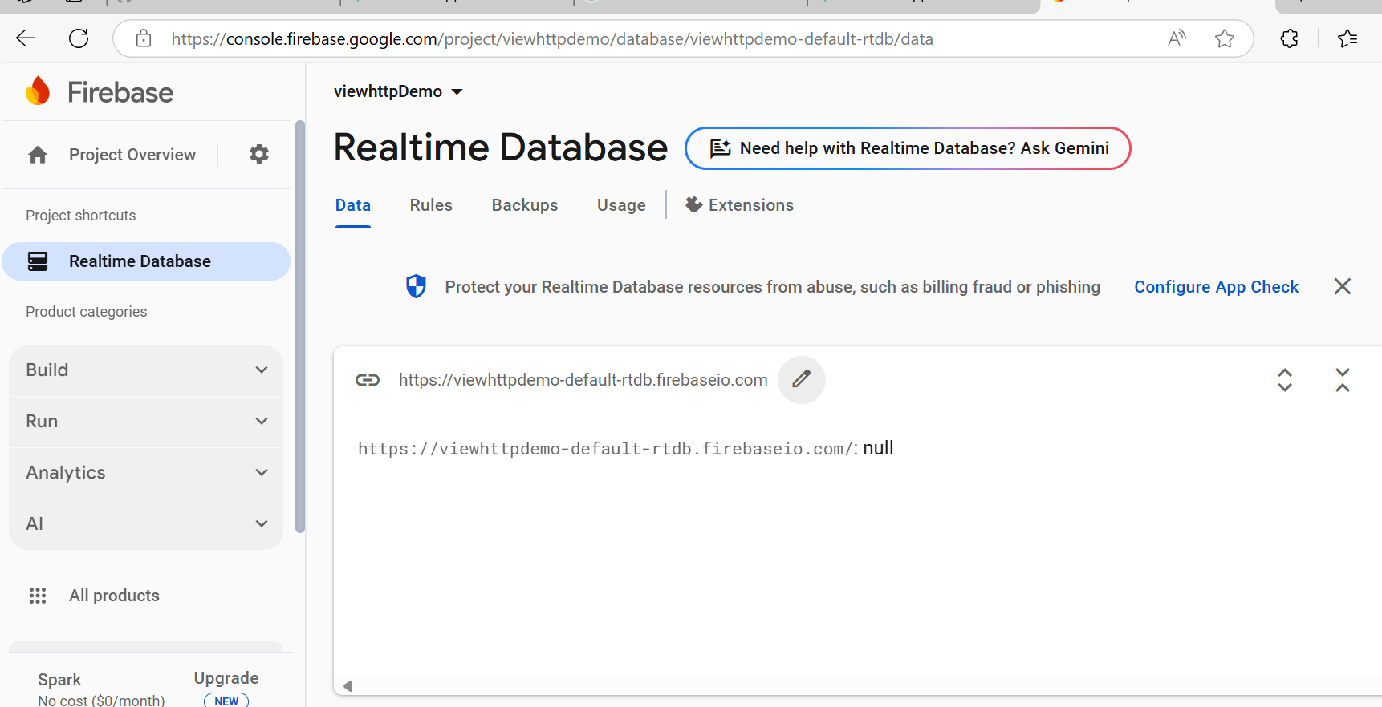

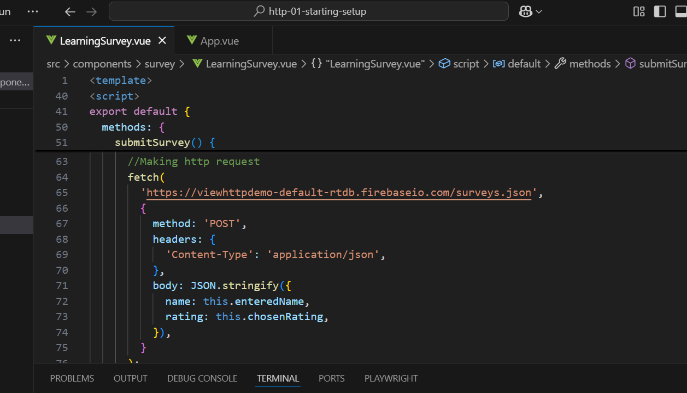

***http request using axios***

*With axios we need to write less code as it automatically sets the Content-Type header as well as converts the data to JSON*

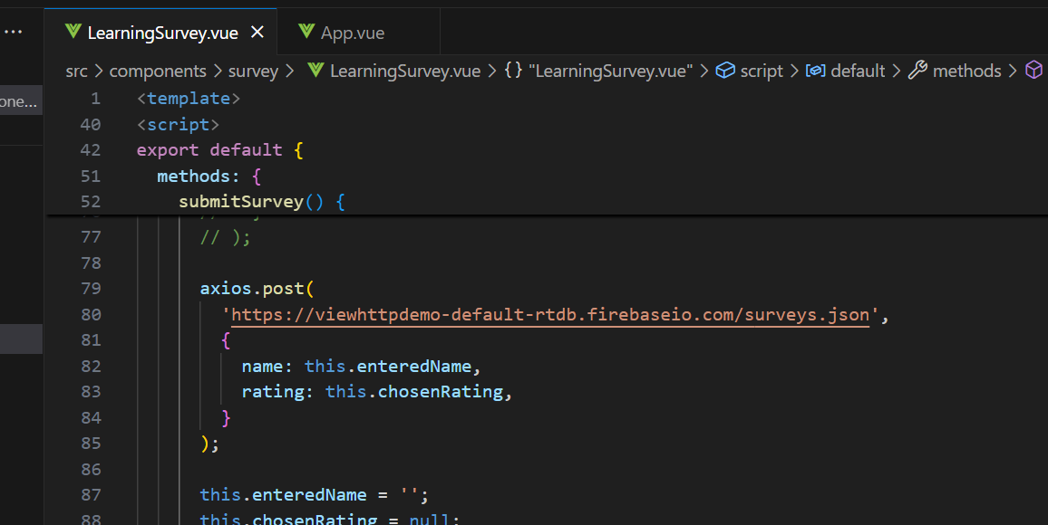

***After http post the data is stored in the database***

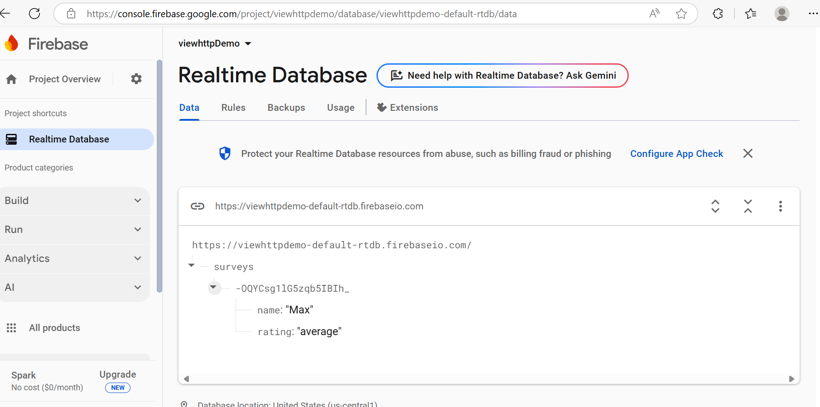

*Note: when you get error for “this” keyword stating undefined, then try replacing the normal function with the arrow function. Arrow function always have “this” associated with the context in which it was defined.*

***To call the api during the component loading***

*To accomplish this task we should use the “mounted” lifecycle method. Inside that method we can invoke the api during the rendering of the component*

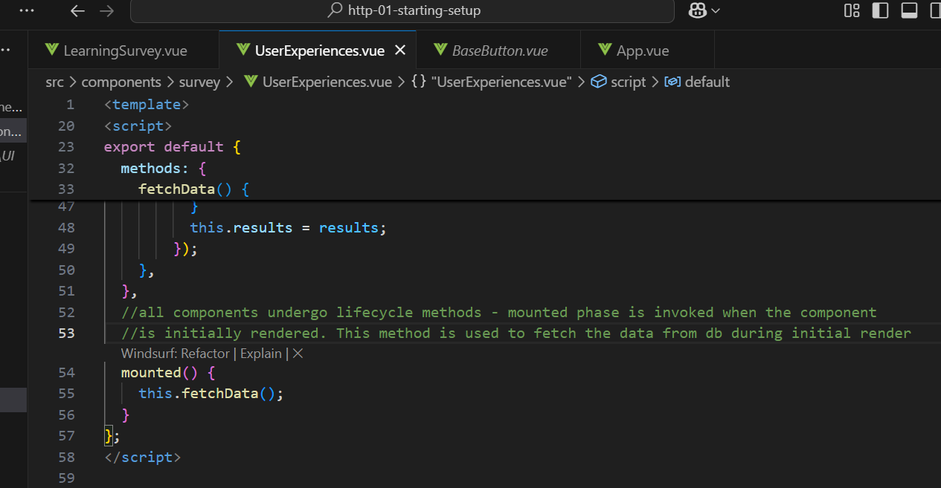

***To show Loading msg when the data fetch is in progress***

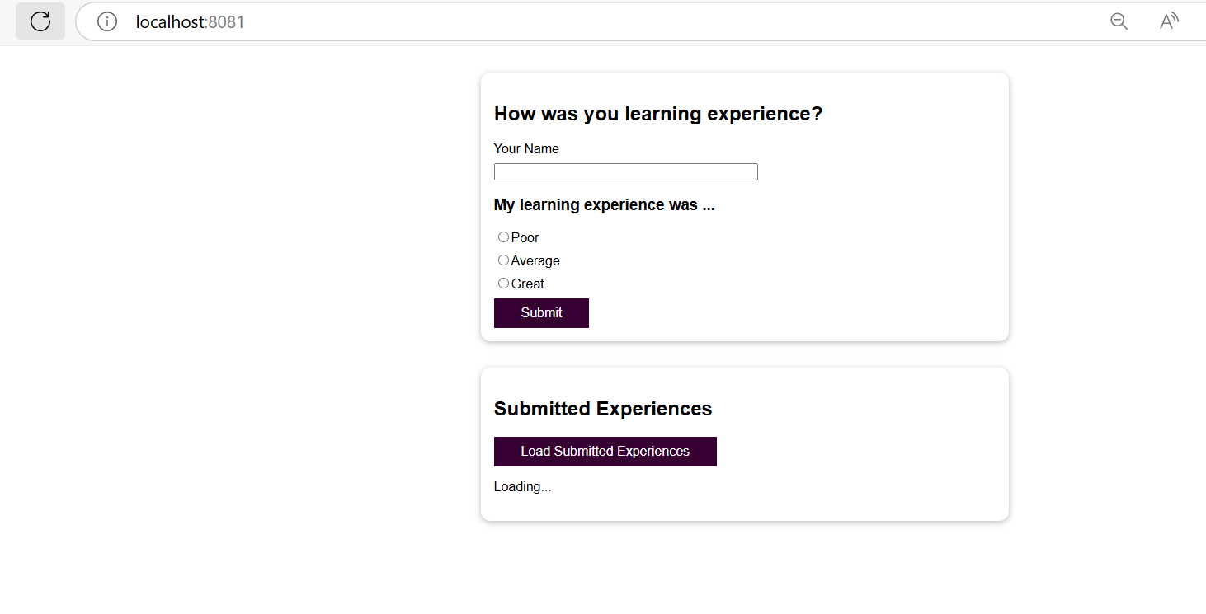

***isLoading attribute is created to handle api data fetch status***

<template>

  <section>

    <base-card>

      <h2>Submitted Experiences</h2>

      <div>

        <base-button @click="fetchData">Load Submitted Experiences</base-button>

      </div>

      <p v-if="isLoading">Loading...</p>

      <ul v-else>

        <survey-result

          v-for="result in results"

          :key="result.id"

          :name="result.name"

          :rating="result.rating"

        ></survey-result>

      </ul>

    </base-card>

  </section>

</template>

<script>

import SurveyResult from './SurveyResult.vue';

export default {

  components: {

    SurveyResult,

  },

  data() {

    return {

      results: [],

      isLoading: false,

      //error: null,

    };

  },

  methods: {

    fetchData() {

      console.log('Fetching data...');

      this.isLoading = true;

      fetch('https://viewhttpdemo-default-rtdb.firebaseio.com/surveys.json')

        .then((response) => {

          return response.json();

        })

        .then((data) => {

          this.isLoading = false;

          const results = [];

          for (const id in data) {

            results.push({

              id: id,

              name: data[id].name,

              rating: data[id].rating,

            });

          }

          this.results = results;

        });

    },

  },

  //all components undergo lifecycle methods - mounted phase is invoked when the component

  //is initially rendered. This method is used to fetch the data from db during initial render

  mounted() {

    this.fetchData();

  }

};

</script>

<style scoped>

ul {

  list-style: none;

  margin: 0;

  padding: 0;

}

</style>

***API call for get data using axios***

<template>

  <section>

    <base-card>

      <h2>Submitted Experiences</h2>

      <div>

        <base-button @click="fetchData">Load Submitted Experiences</base-button>

      </div>

      <p v-if="isLoading">Loading...</p>

      <p v-if="!isLoading && error">{{ error }}</p>

      <p v-else-if="!isLoading && (!results || results.length === 0)">No stored experiences found.Pls start adding some.</p> <p v-else-if="!isLoading && results.length === 0">No stored experiences found.Pls start adding some.</p>

      <ul v-else>

        <survey-result

          v-for="result in results"

          :key="result.id"

          :name="result.name"

          :rating="result.rating"

        ></survey-result>

      </ul>

    </base-card>

  </section>

</template>

<script>

import SurveyResult from './SurveyResult.vue';

import axios from 'axios';

export default {

  components: {

    SurveyResult,

  },

  data() {

    return {

      results: [],

      isLoading: false,

      error: null,

    };

  },

  methods: {

    fetchData() {

      console.log('Fetching data...');

      this.isLoading = true;

      this.error = null;

      // fetch('https://viewhttpdemo-default-rtdb.firebaseio.com/surveys.json')

      //   .then((response) => {

      //     return response.json();

      //   })

      //   .then((data) => {

      //     this.isLoading = false;

      //     const results = [];

      //     for (const id in data) {

      //       results.push({

      //         id: id,

      //         name: data[id].name,

      //         rating: data[id].rating,

      //       });

      //     }

      //     this.results = results;

      //   })

      //   .catch((error)=>{

      //     console.log(error);

      //     this.isLoading = false;

      //     this.error = 'Failed to fetch data - please try again later';

      //   })

//get using axios

        axios.get('https://viewhttpdemo-default-rtdb.firebaseio.com/surveys.json')

        .then((response) => {

          return response.data;

        })

        .then((data) => {

          this.isLoading = false;

          const results = [];

          for (const id in data) {

            results.push({

              id: id,

              name: data[id].name,

              rating: data[id].rating,

            });

          }

          this.results = results;

        })

        .catch((error)=>{

          console.log(error);

          this.isLoading = false;

          this.error = 'Failed to fetch data - please try again later';

        })

    },

  },

  //all components undergo lifecycle methods - mounted phase is invoked when the component

  //is initially rendered. This method is used to fetch the data from db during initial render

  mounted() {

    this.fetchData();

  }

};

</script>

<style scoped>

ul {

  list-style: none;

  margin: 0;

  padding: 0;

}

</style>

***Error Handling: when the api fails***

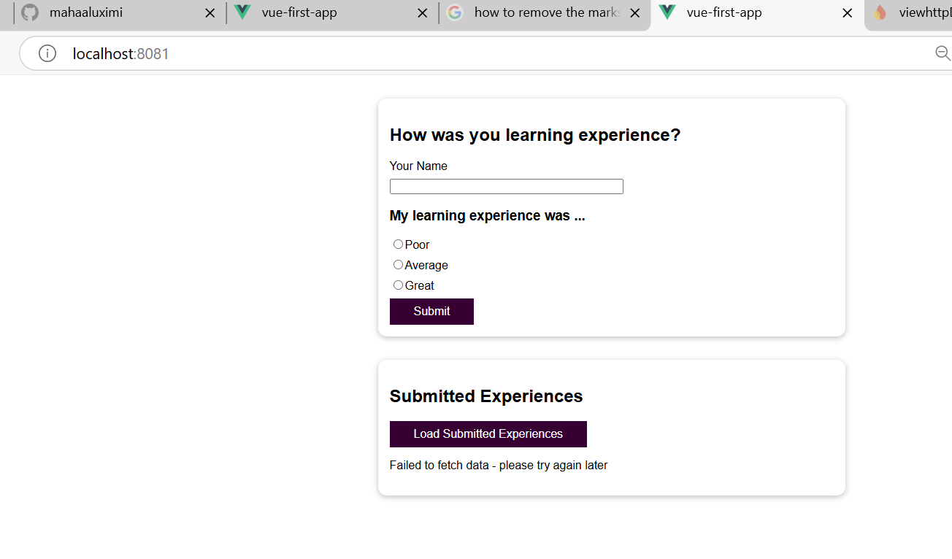

***For error handling, error property is created and catch block is included. Based on error property value conditional rendering is done***

***Note: url is manipulated to simulate the error***

<template>

  <section>

    <base-card>

      <h2>Submitted Experiences</h2>

      <div>

        <base-button @click="fetchData">Load Submitted Experiences</base-button>

      </div>

      <p v-if="isLoading">Loading...</p>

      <p v-if="!isLoading && error">{{ error }}</p>

      <p v-else-if="!isLoading && (!results || results.length === 0)">No stored experiences found.Pls start adding some.</p> <p v-else-if="!isLoading && results.length === 0">No stored experiences found.Pls start adding some.</p>

      <ul v-else>

        <survey-result

          v-for="result in results"

          :key="result.id"

          :name="result.name"

          :rating="result.rating"

        ></survey-result>

      </ul>

    </base-card>

  </section>

</template>

<script>

import SurveyResult from './SurveyResult.vue';

export default {

  components: {

    SurveyResult,

  },

  data() {

    return {

      results: [],

      isLoading: false,

      error: null,

    };

  },

  methods: {

    fetchData() {

      console.log('Fetching data...');

      this.isLoading = true;

      this.error = null;

      fetch('https://viewhttpdemo-default-rtdb.firebaseio.com')

        .then((response) => {

          return response.json();

        })

        .then((data) => {

          this.isLoading = false;

          const results = [];

          for (const id in data) {

            results.push({

              id: id,

              name: data[id].name,

              rating: data[id].rating,

            });

          }

          this.results = results;

        })

        .catch((error)=>{

          console.log(error);

          this.isLoading = false;

          this.error = 'Failed to fetch data - please try again later';

        })

    },

  },

  //all components undergo lifecycle methods - mounted phase is invoked when the component

  //is initially rendered. This method is used to fetch the data from db during initial render

  mounted() {

    this.fetchData();

  }

};

</script>

<style scoped>

ul {

  list-style: none;

  margin: 0;

  padding: 0;

}

</style>

***Error handling while sending the post http request***

*Catch block in post method as well as error property is created. The error message is displayed based on this error property value*

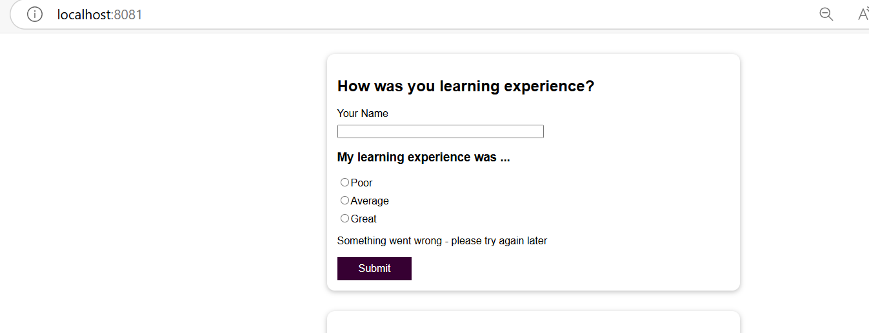

<template>

  <section>

    <base-card>

      <h2>How was you learning experience?</h2>

      <form @submit.prevent="submitSurvey">

        <div class="form-control">

          <label for="name">Your Name</label>

          <input type="text" id="name" name="name" v-model.trim="enteredName" />

        </div>

        <h3>My learning experience was ...</h3>

        <div class="form-control">

          <input type="radio" id="rating-poor" value="poor" name="rating" v-model="chosenRating" />

          <label for="rating-poor">Poor</label>

        </div>

        <div class="form-control">

          <input

            type="radio"

            id="rating-average"

            value="average"

            name="rating"

            v-model="chosenRating"

          />

          <label for="rating-average">Average</label>

        </div>

        <div class="form-control">

          <input type="radio" id="rating-great" value="great" name="rating" v-model="chosenRating" />

          <label for="rating-great">Great</label>

        </div>

        <p

          v-if="invalidInput"

        >One or more input fields are invalid. Please check your provided data.</p>

        <p v-if="error">{{ error }}</p>

        <div>

          <base-button>Submit</base-button>

        </div>

      </form>

    </base-card>

  </section>

</template>

<script>

import axios from 'axios';

export default {

  data() {

    return {

      enteredName: '',

      chosenRating: null,

      invalidInput: false,

      error: null,

    };

  },

  emits: ['survey-submit'],

  methods: {

    submitSurvey() {

      if (this.enteredName === '' || !this.chosenRating) {

        this.invalidInput = true;

        return;

      }

      this.invalidInput = false;

      // this.$emit('survey-submit', {

      //   userName: this.enteredName,

      //   rating: this.chosenRating,

      // });

      //Making http request

      // fetch(

      //   'https://viewhttpdemo-default-rtdb.firebaseio.com/surveys.json',

      //   {

      //     method: 'POST',

      //     headers: {

      //       'Content-Type': 'application/json',

      //     },

      //     body: JSON.stringify({

      //       name: this.enteredName,

      //       rating: this.chosenRating,

      //     }),

      //   }

      // );

      this.error = null;

      axios.post(

        'https://viewhttpdemo-default-rtdb.firebaseio.com',

        {

          name: this.enteredName,

          rating: this.chosenRating,

        }

      ).catch(error => {

        console.log(error);

        this.error = 'Something went wrong - please try again later';

      });

      this.enteredName = '';

      this.chosenRating = null;

    },

  },

};

</script>

<style scoped>

.form-control {

  margin: 0.5rem 0;

}

input[type='text'] {

  display: block;

  width: 20rem;

  margin-top: 0.5rem;

}

</style>

***Saving Data fails with the status code of 400 or 500***

*Note: success will have status code of 200 or 201*

<template>

  <section>

    <base-card>

      <h2>How was you learning experience?</h2>

      <form @submit.prevent="submitSurvey">

        <div class="form-control">

          <label for="name">Your Name</label>

          <input type="text" id="name" name="name" v-model.trim="enteredName" />

        </div>

        <h3>My learning experience was ...</h3>

        <div class="form-control">

          <input type="radio" id="rating-poor" value="poor" name="rating" v-model="chosenRating" />

          <label for="rating-poor">Poor</label>

        </div>

        <div class="form-control">

          <input

            type="radio"

            id="rating-average"

            value="average"

            name="rating"

            v-model="chosenRating"

          />

          <label for="rating-average">Average</label>

        </div>

        <div class="form-control">

          <input type="radio" id="rating-great" value="great" name="rating" v-model="chosenRating" />

          <label for="rating-great">Great</label>

        </div>

        <p

          v-if="invalidInput"

        >One or more input fields are invalid. Please check your provided data.</p>

        <p v-if="error">{{ error }}</p>

        <div>

          <base-button>Submit</base-button>

        </div>

      </form>

    </base-card>

  </section>

</template>

<script>

import axios from 'axios';

export default {

  data() {

    return {

      enteredName: '',

      chosenRating: null,

      invalidInput: false,

      error: null,

    };

  },

  emits: ['survey-submit'],

  methods: {

    submitSurvey() {

      if (this.enteredName === '' || !this.chosenRating) {

        this.invalidInput = true;

        return;

      }

      this.invalidInput = false;

      // this.$emit('survey-submit', {

      //   userName: this.enteredName,

      //   rating: this.chosenRating,

      // });

      //Making http request

      this.error = null;

      fetch(

        'https://viewhttpdemo-default-rtdb.firebaseio.com/surveys.json',

        {

          method: 'POST',

          headers: {

            'Content-Type': 'application/json',

          },

          body: JSON.stringify({

            name: this.enteredName,

            rating: this.chosenRating,

          }),

        }

      ).then((response) => {

        if (!response.ok) { //testing for status code

          //return response.json();

          throw new Error('Could not save data');

        }

      }).catch((error) => {

        console.log(error);

        this.error = error.message;

      });

      // axios.post(

      //   'https://viewhttpdemo-default-rtdb.firebaseio.com/surveys.json',

      //   {

      //     name: this.enteredName,

      //     rating: this.chosenRating,

      //   }

      // ).catch(error => {

      //   console.log(error);

      //   this.error = 'Something went wrong - please try again later';

      // });

      this.enteredName = '';

      this.chosenRating = null;

    },

  },

};

</script>

<style scoped>

.form-control {

  margin: 0.5rem 0;

}

input[type='text'] {

  display: block;

  width: 20rem;

  margin-top: 0.5rem;

}

</style>

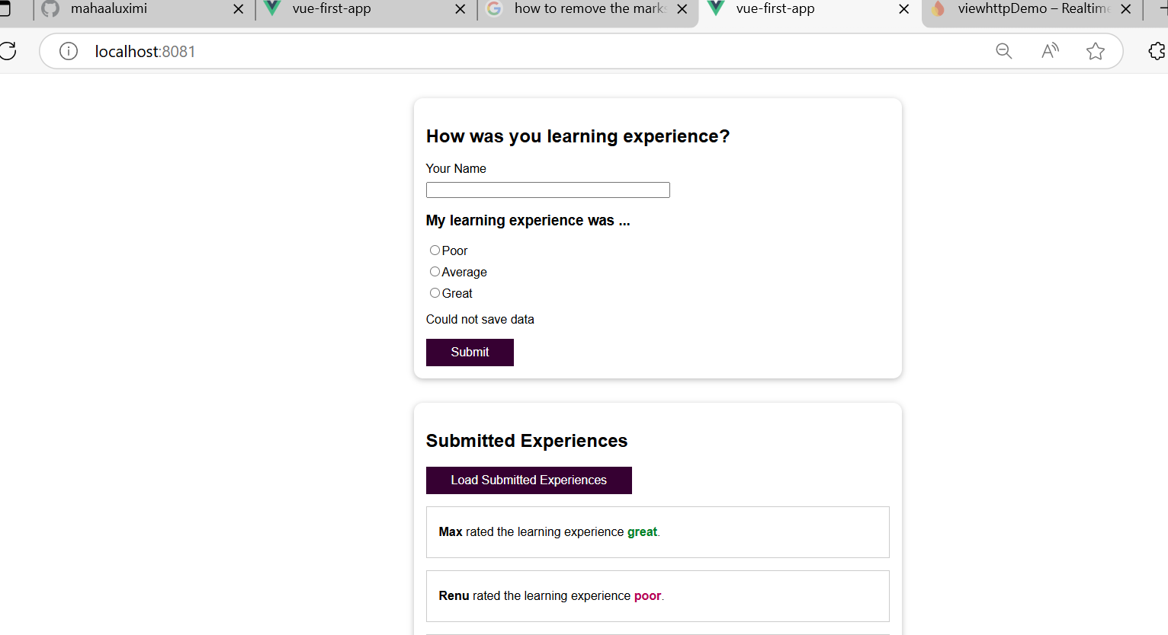

***Routing***

*The javascript running in the browser is responsible for what we see in the browser. Single Page Appln means we have only one html page in which all the screens are displayed whenever the url changes but the domain remains the same.*

*Vue application is a javascript driven web application. The single html page in the appln imports all the code (converted code – js code) These are handled by Vue CLI. Routing library enables us to bring different UI whenever the url changes.*

*For routing, we need to install the package “vue-router@next”*

***Command to install:***

*npm install –save vue-router@next*

*To handle routing we need to register the router with routings with our vue appl. For that we need to import “createRouter” component from “vue-router” package.*

*Syntax:*

*const router = createRouter({*

*history:*

*routes: []*

*})*

*Where*

*History -> attribute is used to specify how the history is to be maintained.When we navigate to a new page then the current url as well as the previous is maintained. So when clicks back button the previous url needs to be pulled in. To accomplish that we need to import the method “****createWebHistory****” from the package “vue-router”. Not always the browser is able to manipulate the browser memory to maintain this history. So we are using this method to emulate the browser to use the browser memory to store those details*

*Routes -> attribute is used to specify the routings to be register for use and it is an array. In this we specify which vue component needs to be loaded for the specific url (for which url).*

*In this array, we each url and it’s configuration as an object. The object consists of the “path” and the “component” attribute.*

*This router object created is then registered with the app using the* ***use()*** *method . Also we need to specify the placeholder where these components specified in the routing to be loaded when the url changes. For that we have vue component “router-view”. This acts a placeholder to load the components.*

*Once the components are registered in the router, then those components need not be registered as local or global components as based on url changes it automatically brings up the component.*

***Registering the routes in main.js***

import { createApp } from 'vue';

import { createRouter, createWebHistory } from 'vue-router';

import TeamsList from './components/teams/TeamsList.vue';

import UsersList from './components/users/UsersList.vue';

import App from './App.vue';

const app = createApp(App)

const router = createRouter({

    history: createWebHistory(),

    routes: [

        { path: '/', redirect: '/teams' },

        { path: '/teams', component: TeamsList },

        { path: '/users', component: UsersList },

    ]

})

app.use(router);

app.mount('#app');

***Specifying the placeholder for router component in App.vue (router-view)***

<template>

  <the-navigation @set-page="setActivePage"></the-navigation>

  <main>

    <!-- dynamic component is commented as now loading based on route - router-view

    <component :is="activePage"></component> -->

    <!-- Placehold to load components based on routes -->

    <router-view></router-view>

  </main>

</template>

<script>

// import TeamsList from './components/teams/TeamsList.vue';

// import UsersList from './components/users/UsersList.vue';

import TheNavigation from './components/nav/TheNavigation.vue';

export default {

  components: {

    TheNavigation,

    // TeamsList,

    // UsersList,

  },

  data() {

    return {

      activePage: 'teams-list',

      teams: [

        { id: 't1', name: 'Frontend Engineers', members: ['u1', 'u2'] },

        { id: 't2', name: 'Backend Engineers', members: ['u1', 'u2', 'u3'] },

        { id: 't3', name: 'Client Consulting', members: ['u4', 'u5'] },

      ],

      users: [

        { id: 'u1', fullName: 'Max Schwarz', role: 'Engineer' },

        { id: 'u2', fullName: 'Praveen Kumar', role: 'Engineer' },

        { id: 'u3', fullName: 'Julie Jones', role: 'Engineer' },

        { id: 'u4', fullName: 'Alex Blackfield', role: 'Consultant' },

        { id: 'u5', fullName: 'Marie Smith', role: 'Consultant' },

      ],

    };

  },

  provide() {

    return {

      teams: this.teams,

      users: this.users,

    };

  },

  methods: {

    setActivePage(page) {

      this.activePage = page;

    },

  },

};

</script>

<style>

* {

  box-sizing: border-box;

}

html {

  font-family: sans-serif;

}

body {

  margin: 0;

}

</style>

***Navigation with “router-link”:***

*The router-link component is a vue component which is like <a> (anchor tag) but this tag prevents the browser’s default behaviour of reloading the new page when the link is clicked and all the data will be lost.In the background it will be converted as anchor tag “<a>” and so styling should be done to anchor tag to apply to this router-link component.*

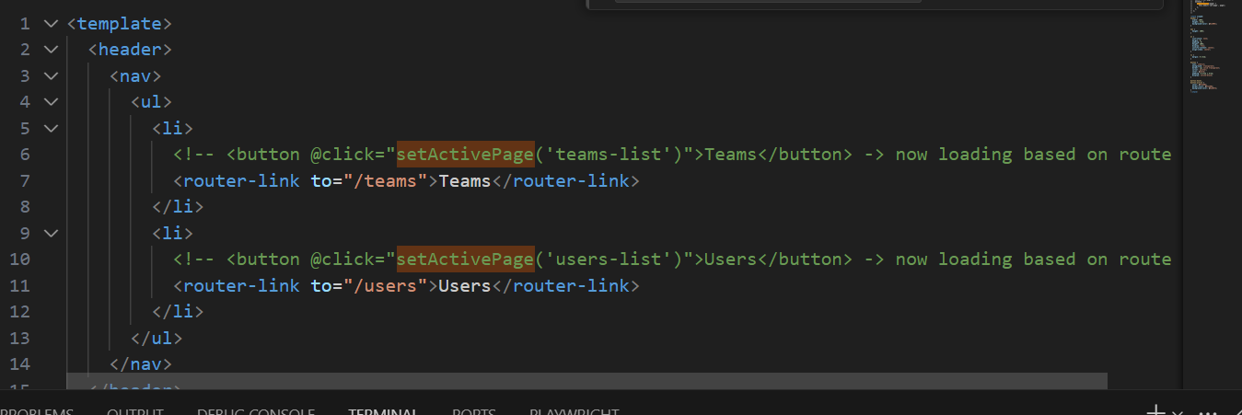

*We can anything between the starting and end tag <router-link> as it uses the “slot”. The “to” property it expects to specify the path to which it should be redirecting too*

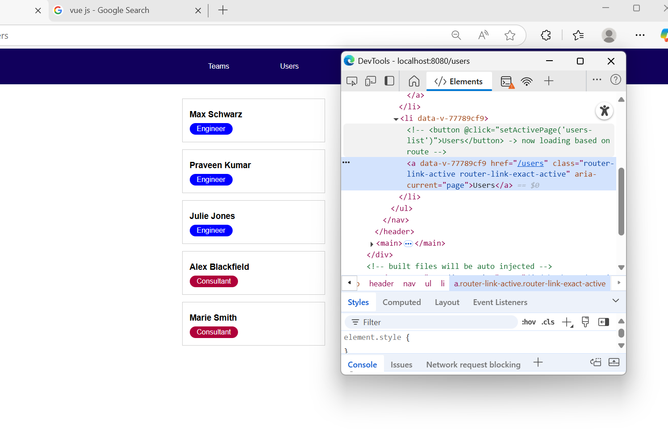

*The router-link component analysis the value in the href and bring up the component without bring a new html page.*

*The class “router-link-active” will apply to all links but “router-link-exact-active” will only be applied when the route exactly matches*

*You can override these two classes “router-link-active” and “router-link-exact-active” while configuring the routing using properties “linkActiveClass” and “linkExactActiveClass” respectively.*

***Before:***

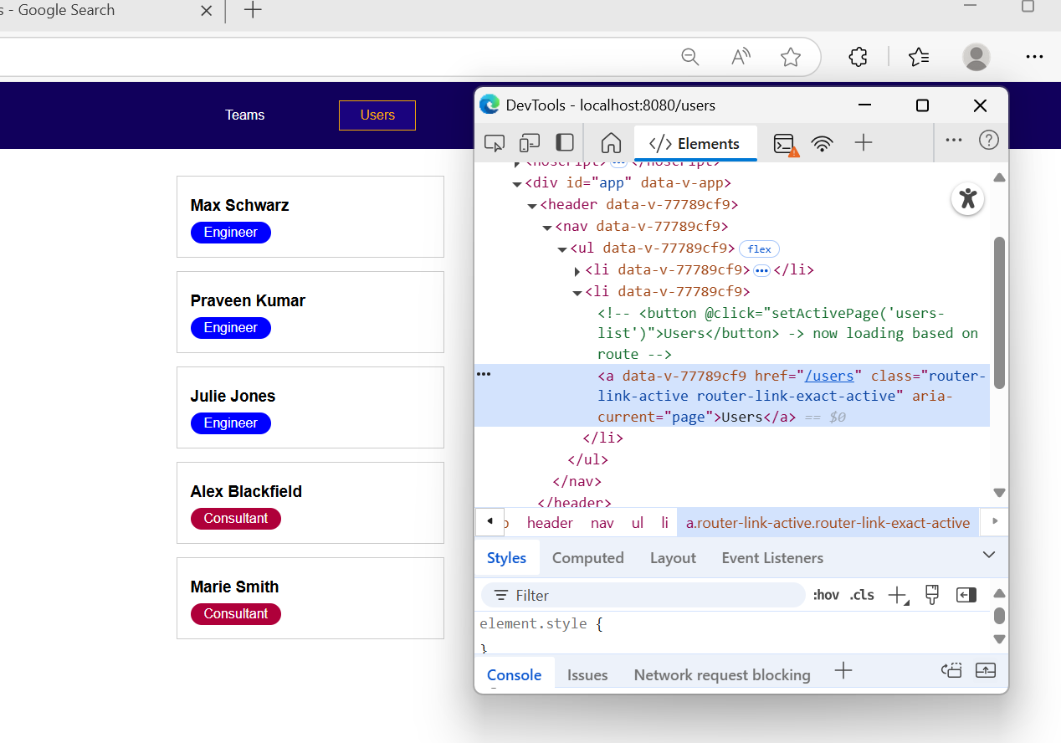

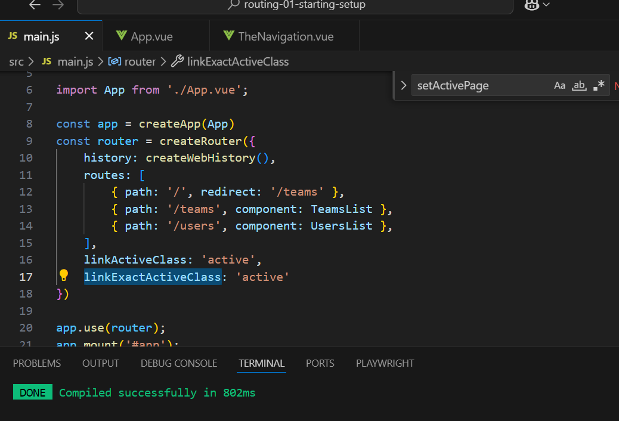

***After:*** *Now the classes are overridden, only active class is applied*

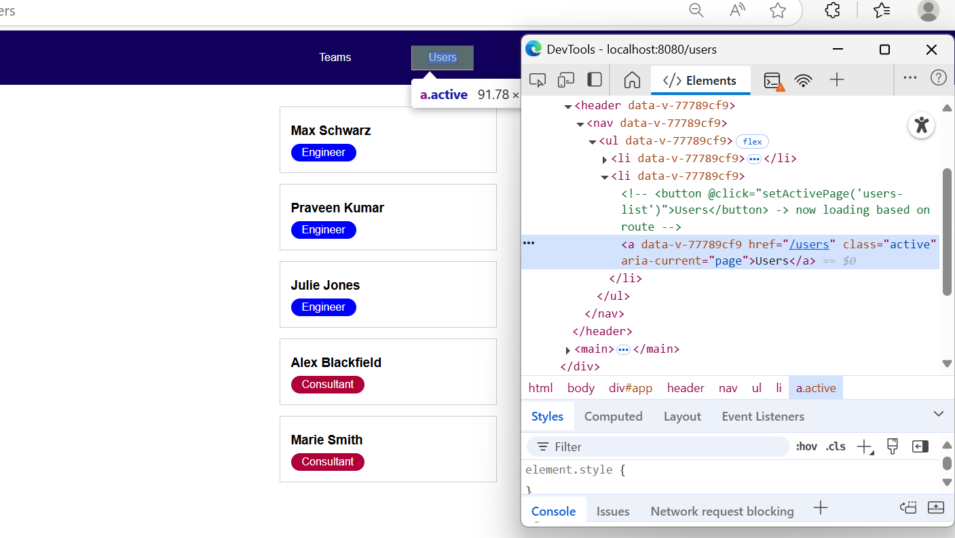

***Programmatic Navigation:***

*Since the router is registered,we can access the “$router” in which has the methods for navigation. This can be accessed using “this”*

* *To navigate to a url -> this.$router.push(xx)*

*Where xx – path as string*

* *To navigate forward -> this.$router.forward()*
* *To navigate backward -> this.$router.back()*

<template>

<!-- This button is to show programmatic navigation -->

  <button @click="confirmInput">Confirm</button>

  <ul>

    <user-item v-for="user in users" :key="user.id" :name="user.fullName" :role="user.role"></user-item>

  </ul>

</template>

<script>

import UserItem from './UserItem.vue';

export default {

  components: {

    UserItem,

  },

  inject: ['users'],

  methods: {

    confirmInput() {

      //do something like calling api etc

      //navigate to another page

      this.$router.push('/teams');

    },

  },

};

</script>

<style scoped>

ul {

  list-style: none;

  margin: 2rem auto;

  max-width: 20rem;

  padding: 0;

}

</style>

***Dynamic parameter in the route:***

*{ path: '/teams/:teamId', component: TeamMembers },*

*Where teamId -> is a dynamic route*

***To access the dynamic param passed:***

***Type 1:***

***this.$route.path*** *-> it will be like this “/teams/t1” . So we need to parse the url to get the param “t1”*

***Type 2:***

***this.$route.params*** *-> this contains all the route params used to get to this page.(passed in the url)*

***To access our specific param, access with the param id:***

***this.$route.params.xxx***

***where xxx -> is the param name.***

***Ex: this.$route.params.teamId***

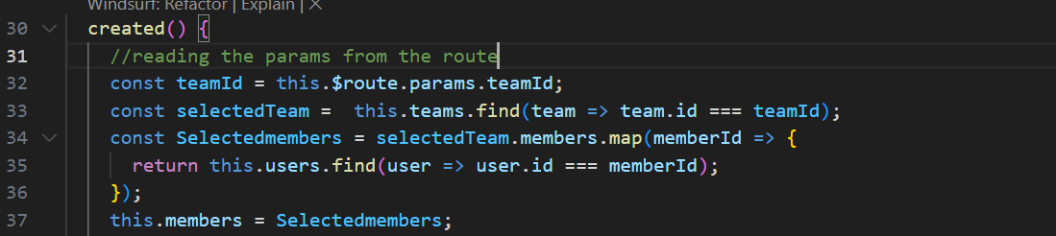

***TeamMemebers.vue***

<template>

  <section>

    <h2>{{ teamName }}</h2>

    <ul>

      <user-item

        v-for="member in members"

        :key="member.id"

        :name="member.fullName"

        :role="member.role"

      ></user-item>

    </ul>

  </section>

</template>

<script>

import UserItem from '../users/UserItem.vue';

export default {

  inject: ['teams', 'users'],

  components: {

    UserItem

  },

  data() {

    return {

     teamName: '',

     members: []

    };

  },

  //The component is created and initialized but not yet mounted

  created() {

    //reading the params from the route

    const teamId = this.$route.params.teamId;

    const selectedTeam =  this.teams.find(team => team.id === teamId);

    const Selectedmembers = selectedTeam.members.map(memberId => {

      return this.users.find(user => user.id === memberId);

    });

    this.members = Selectedmembers;

    this.teamName = selectedTeam.name;

  }

};

</script>

<style scoped>

section {

  margin: 2rem auto;

  max-width: 40rem;

  box-shadow: 0 2px 8px rgba(0, 0, 0, 0.26);

  padding: 1rem;

  border-radius: 12px;

}

h2 {

  margin: 0.5rem 0;

}

ul {

  list-style: none;

  margin: 0;

  padding: 0;

}

</style>

***TeamsItem.vue***

<template>

  <li>

    <h3>{{ name }}</h3>

    <div class="team-members">{{ memberCount }} Members</div>

    <!-- commented to have less logic in template -->

    <!-- <router-link :to="`/teams/${id}`" >View Members</router-link> -->

    <router-link :to="teamMemberLink" >View Members</router-link>

  </li>

</template>

<script>

export default {

  props: ['id', 'name', 'memberCount'],

  computed: {

    teamMemberLink() {

      //return this.$route.path + '/' + this.id;

       return '/teams/' + this.id;

    }

  }

};

</script>

<style scoped>

li {

  margin: 1rem 0;

  box-shadow: 0 2px 8px rgba(0, 0, 0, 0.26);

  border-radius: 12px;

  padding: 1rem;

}

li h3 {

  margin: 0.5rem 0;

  font-size: 1.25rem;

}

li .team-members {

  margin: 0.5rem 0;

}

a {

  text-decoration: none;

  color: white;

  display: inline-block;

  padding: 0.5rem 1.5rem;

  background-color: #11005c;

}

a:hover,

a:active {

  background-color: #220a8d;

}

</style>

***Updating Params Data with Watchers:***

***There could be a scenario where you will be on dynamic path “/teams/t1” and u want to navigate to /teams/t2 which also should be the same component but with different related to “t2” the dynamic param. The path changes but the data will not change.***

***When the dynamic param is “t1”***

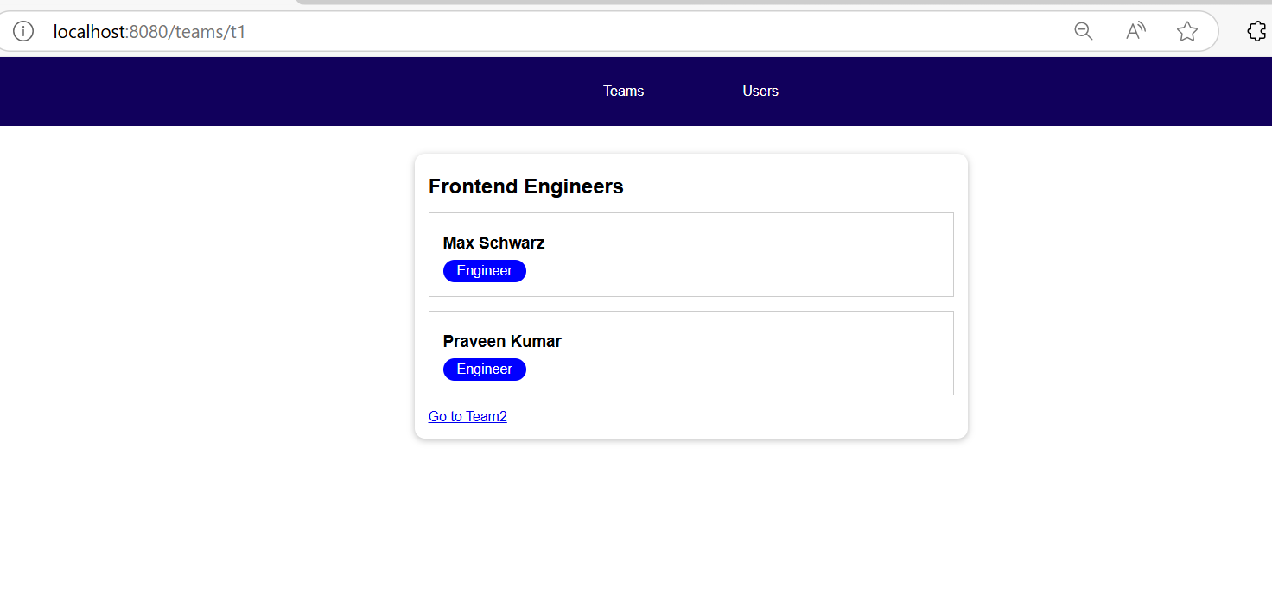

***Now on clicking “Go to Team2” -> url is changed but the content is not updated***

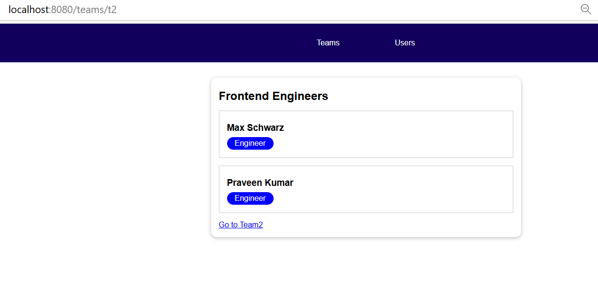

***To overcome this issue, we can add the “watch” method . Inside that we can watch “$route” method which always will have the new value. We can pass this new route to fetch the data as below.***

***Apart from created() method, the fetch is added in watch too, to trigger data update based on url change***

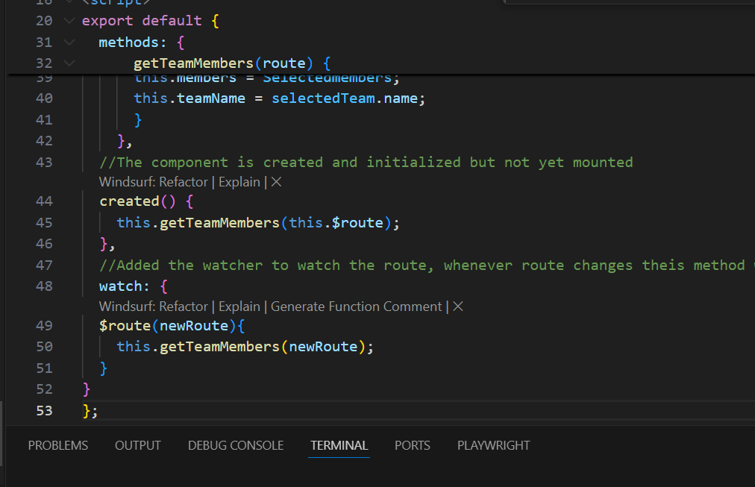

***TeamMembers.vue***

<template>

  <section>

    <h2>{{ teamName }}</h2>

    <ul>

      <user-item

        v-for="member in members"

        :key="member.id"

        :name="member.fullName"

        :role="member.role"

      ></user-item>

    </ul>

    <router-link to="/teams/t2">Go to Team2</router-link>

  </section>

</template>

<script>

import UserItem from '../users/UserItem.vue';

export default {

  inject: ['teams', 'users'],

  components: {

    UserItem

  },

  data() {

    return {

     teamName: '',

     members: []

    };

  },

  methods: {

      getTeamMembers(route) {

        //reading the params from the route

      const teamId = route.params.teamId;

      const selectedTeam =  this.teams.find(team => team.id === teamId);

      const Selectedmembers = selectedTeam.members.map(memberId => {

        return this.users.find(user => user.id === memberId);

      });

      this.members = Selectedmembers;

      this.teamName = selectedTeam.name;

      }

    },

  //The component is created and initialized but not yet mounted

  created() {

    this.getTeamMembers(this.$route);

  },

  //Added the watcher to watch the route, whenever route changes theis method will be invoked

  watch: {

  $route(newRoute){

    this.getTeamMembers(newRoute);

  }

}

};

</script>

<style scoped>

section {

  margin: 2rem auto;

  max-width: 40rem;

  box-shadow: 0 2px 8px rgba(0, 0, 0, 0.26);

  padding: 1rem;

  border-radius: 12px;

}

h2 {

  margin: 0.5rem 0;

}

ul {

  list-style: none;

  margin: 0;

  padding: 0;

}

</style>

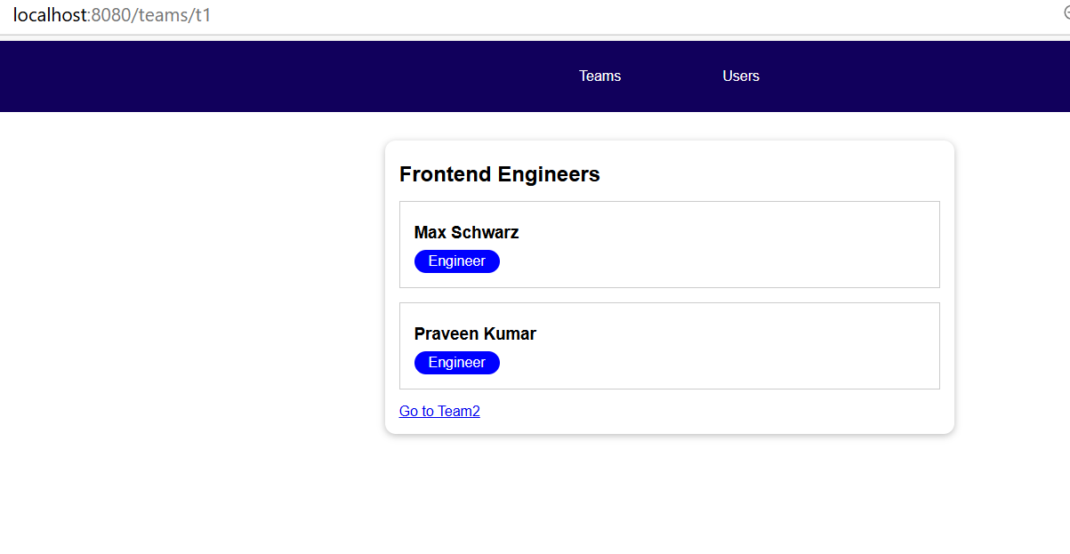

***Now on clicking “Go to Team2” the data is updated when the url is updated for the same component***

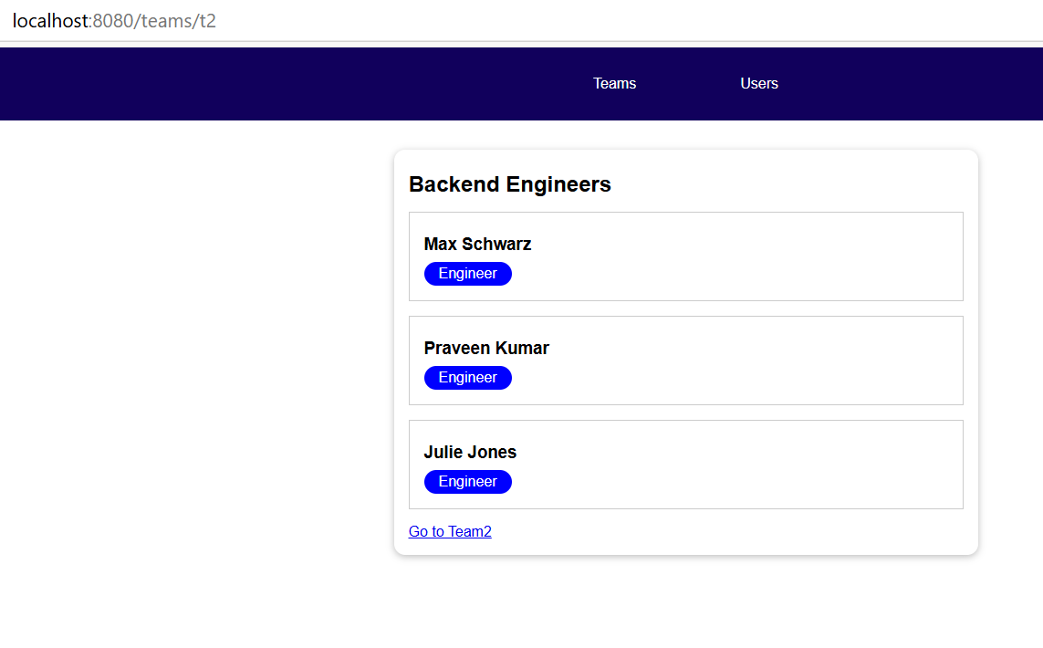

*But this solution also has a problem, we depend on the “$route” but if we embedded the component in the template of another component. To overcome this problem we should pass the param as props too and consume from the props instead $route.*

*To pass param as props we need to do configuration change while defining the route. Add “props” as true for this*

*As long as we pass in props too, it is not strictly tied with the routing*

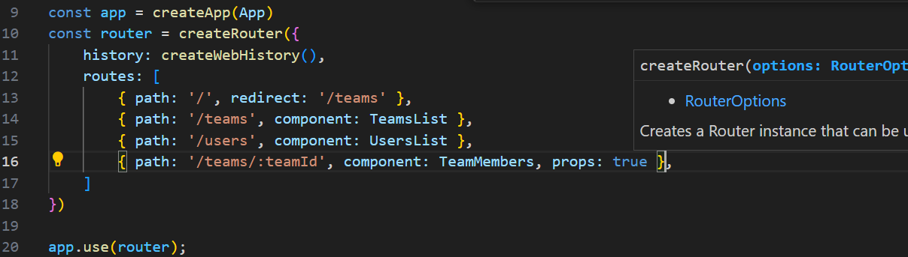

***TeamMembers.vue:***

<template>

  <section>

    <h2>{{ teamName }}</h2>

    <ul>

      <user-item

        v-for="member in members"

        :key="member.id"

        :name="member.fullName"

        :role="member.role"

      ></user-item>

    </ul>

    <router-link to="/teams/t2">Go to Team2</router-link>

  </section>

</template>

<script>

import UserItem from '../users/UserItem.vue';

export default {

  props: ['teamId'],

  inject: ['teams', 'users'],

  components: {

    UserItem

  },

  data() {

    return {

     teamName: '',

     members: []

    };

  },

  methods: {

      getTeamMembers(teamId) {

        //reading the params from the route

      const selectedTeam =  this.teams.find(team => team.id === teamId);

      const Selectedmembers = selectedTeam.members.map(memberId => {

        return this.users.find(user => user.id === memberId);

      });

      this.members = Selectedmembers;

      this.teamName = selectedTeam.name;

      }

    },

  //The component is created and initialized but not yet mounted

  created() {

    this.getTeamMembers(this.teamId);

  },

  //Added the watcher to watch the route, whenever route changes theis method will be invoked

  watch: {

  teamId(newId){

    this.getTeamMembers(newId);

  }

}

};

</script>

<style scoped>

section {

  margin: 2rem auto;

  max-width: 40rem;

  box-shadow: 0 2px 8px rgba(0, 0, 0, 0.26);

  padding: 1rem;

  border-radius: 12px;

}

h2 {

  margin: 0.5rem 0;

}

ul {

  list-style: none;

  margin: 0;

  padding: 0;

}

</style>

***Route Redirect:***

***Suppose you have just entered the domain and nothing, then we should have the logic to redirect to default url***

***In the below example when the path has just domain with or without “/” it should redirect to the url ‘/teams’***



***The above logic can be accomplished by giving the “alias” but the thing is the url will not change but we load different component which belong to different url.***



***Which behaviour is required either “alias” or “redirect” that depends on the application requirement.***

***Catch All (for all the invalid routes):***



***Instead of redirecting to the different url we can give a page not found screen***

***For that define a component for Page Not Found scenario and load that component as below***

***NotFound.vue:***

<template>

    <h1>Page Not Found</h1>

    <p>This page could not be found - maybe check out all our <router-link to="/teams">teams</router-link></p>

</template>

***Main.js:***

import { createApp } from 'vue';

import { createRouter, createWebHistory } from 'vue-router';

import TeamsList from './components/teams/TeamsList.vue';

import UsersList from './components/users/UsersList.vue';

import TeamMembers from './components/teams/TeamMembers.vue';

import NotFound from './components/nav/NotFound.vue';

import App from './App.vue';

const app = createApp(App)

const router = createRouter({

    history: createWebHistory(),

    routes: [

        { path: '/', redirect: '/teams' },

        { path: '/teams', component: TeamsList, alias: '/' },

        { path: '/users', component: UsersList },

        { path: '/teams/:teamId', component: TeamMembers, props: true },

        { path: '/:notFound(.*)', component: NotFound }, //to catch all invalid routes- this should be at the last

    ]

})

app.use(router);

app.mount('#app');

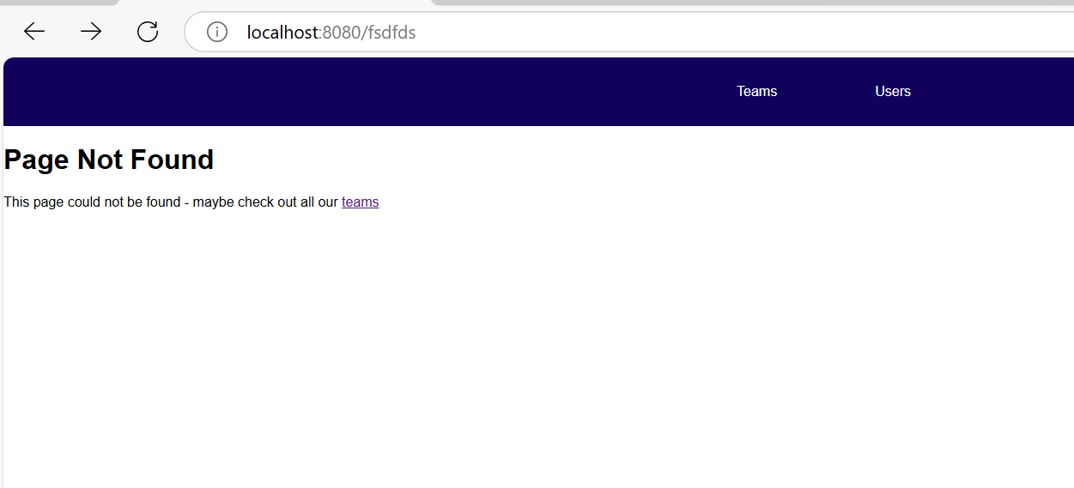

***Nested Routes:***

***To define nested routes we can use the children property while defining the route.***

***{***

***path: '/teams',***

***component: TeamsList,***

***children: [{ path: ':teamId', component: TeamMembers, props: true }],***

***},***

***The above is the nested route structure. In this the component is loaded on top of the main route component (ie) both exists. For this scenario we need to put the placeholder “<router-view></router-view>” in the main component***

***UI display for Nested routing***

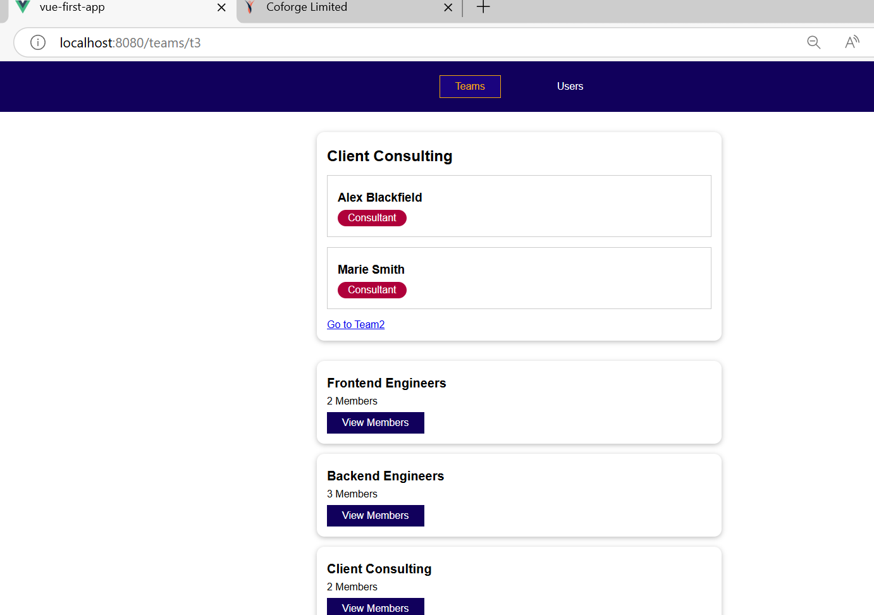

***Main.js: Defining the nested routes***

import { createApp } from 'vue';

import { createRouter, createWebHistory } from 'vue-router';

import TeamsList from './components/teams/TeamsList.vue';

import UsersList from './components/users/UsersList.vue';

import TeamMembers from './components/teams/TeamMembers.vue';

import NotFound from './components/nav/NotFound.vue';

import App from './App.vue';

const app = createApp(App);

const router = createRouter({

  history: createWebHistory(),

  routes: [

    { path: '/', redirect: '/teams' }, // these are main routes registered in the router

    //to define nested routes we can use children property

    {

      path: '/teams',

      component: TeamsList,

      children: [{ path: ':teamId', component: TeamMembers, props: true }],

    },

    { path: '/users', component: UsersList },

    //commented as to define as the nested routes

    // { path: '/teams/:teamId', component: TeamMembers, props: true }, //

    { path: '/:notFound(.*)', component: NotFound }, //to catch all invalid routes- this should be at the last

  ],

});

app.use(router);

app.mount('#app');

***TeamsList.vue***

*The “router-view” placeholder is placed in the parent component for the children component of the routing*

<template>

  <router-view></router-view>

  <ul>

    <teams-item

      v-for="team in teams"

      :key="team.id"

      :id="team.id"

      :name="team.name"

      :member-count="team.members.length"

    ></teams-item>

  </ul>

</template>

<script>

import TeamsItem from './TeamsItem.vue';

export default {

  components: {

    TeamsItem,

  },

  inject: ['teams'],

};

</script>

<style scoped>

ul {

  list-style: none;

  margin: 2rem auto;

  max-width: 40rem;

  padding: 0;

}

</style>

***But in the below syntax the component is loaded in a fresh page***

***{ path: '/teams/:teamId', component: TeamMembers, props: true },***

***UI display for this URL without nested routing***



***Named Routes:***

*All these while we were navigating programmatically using url (ie) path. In future if we need to modify the path, then we need to make changes in all the places from wherever this component*

*Invoked dynamically.*

*To overcome this issue, we have the name routes concept. We need to give name to each of the routes and while forming the dynamic routes we need to return object rather string to the “to” attribute of “<router-link>” component****. [return {name: 'team-members', params: {teamId: this.id}};]***

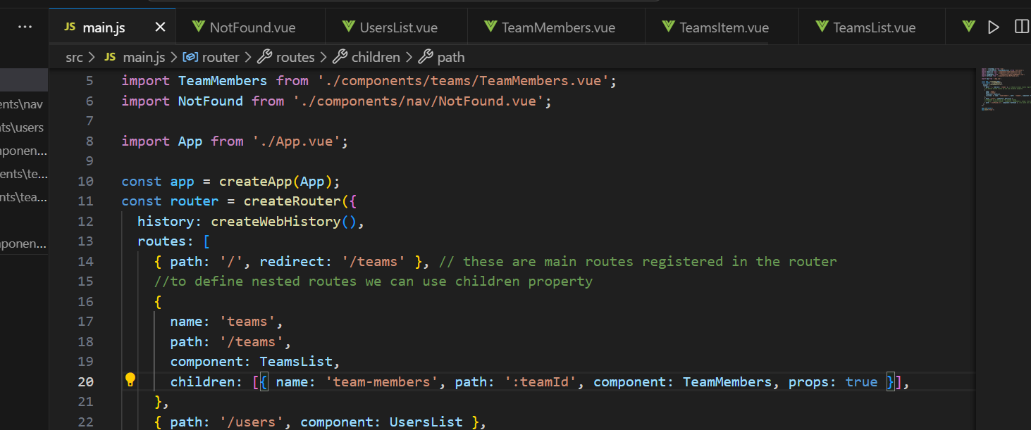

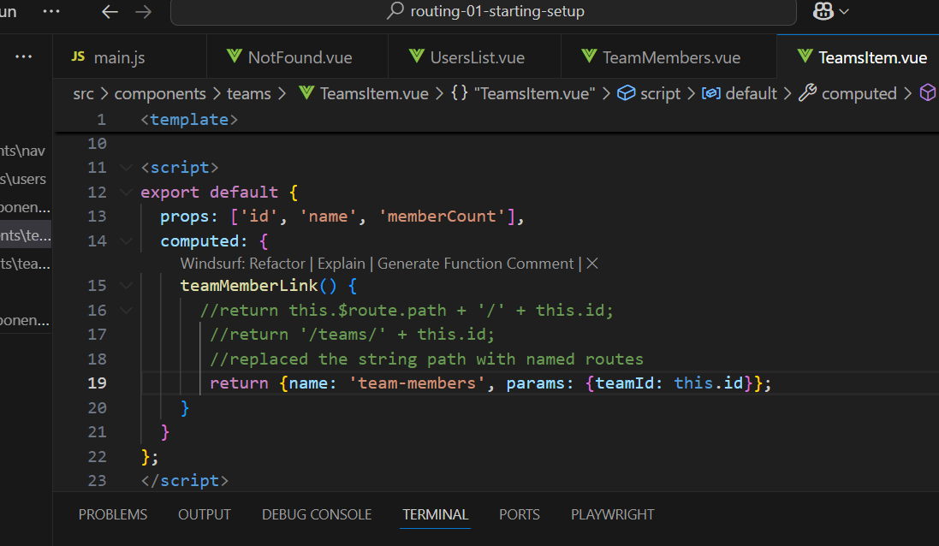

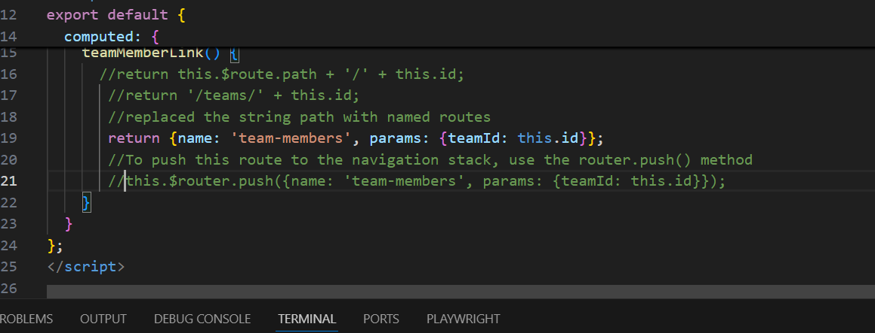

***Query Params:*** 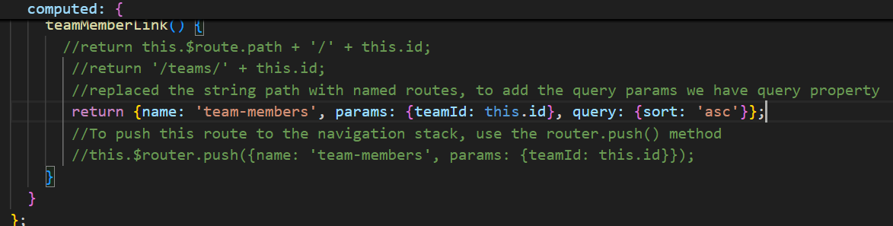

*To add the query params we have the property “query”*

*Note: query params can only be accessed using the “$router” and in case the component is embedded then it can’t be accessed*

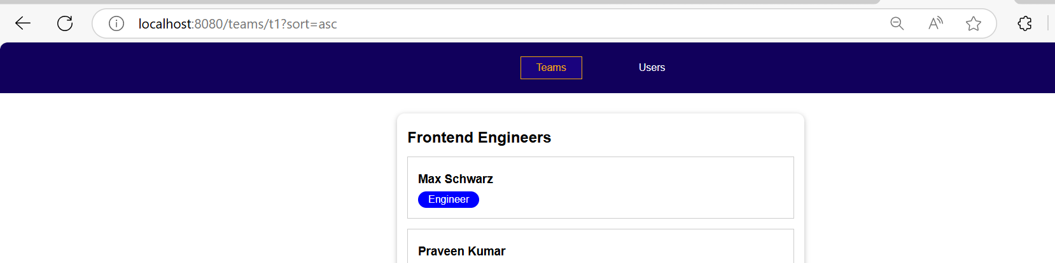

***Rendering Multiple Routes with Named Router views***

*Suppose we need to load more than one components for the same routing, then we can achieve by using the “components” property instead of “component” in which we specify more than component as a object where “key” of the object represents to which “<router-view>” slot the component should be loaded. The value for the key is the component. One of the “key” can default as “slot”.*

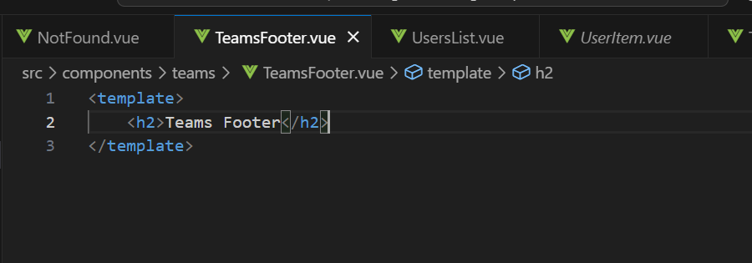

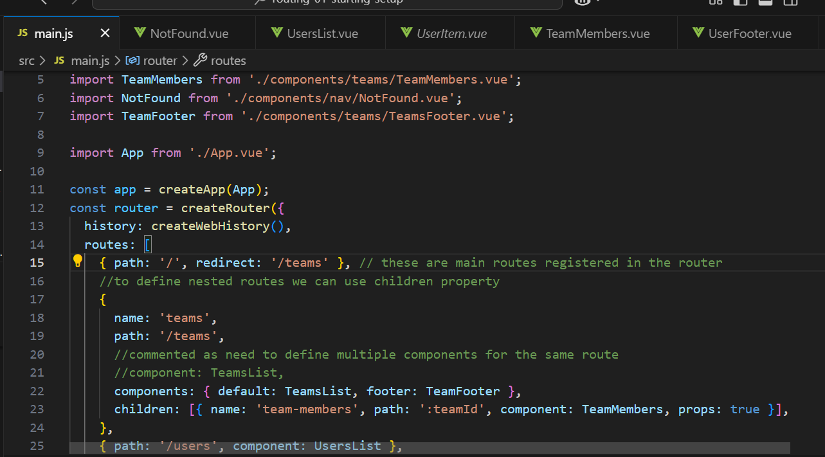

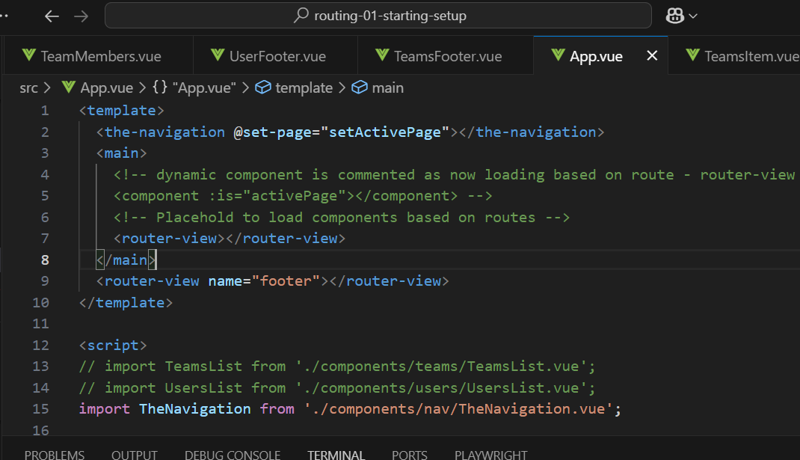

*The TeamsFooter.vue component is displayed*

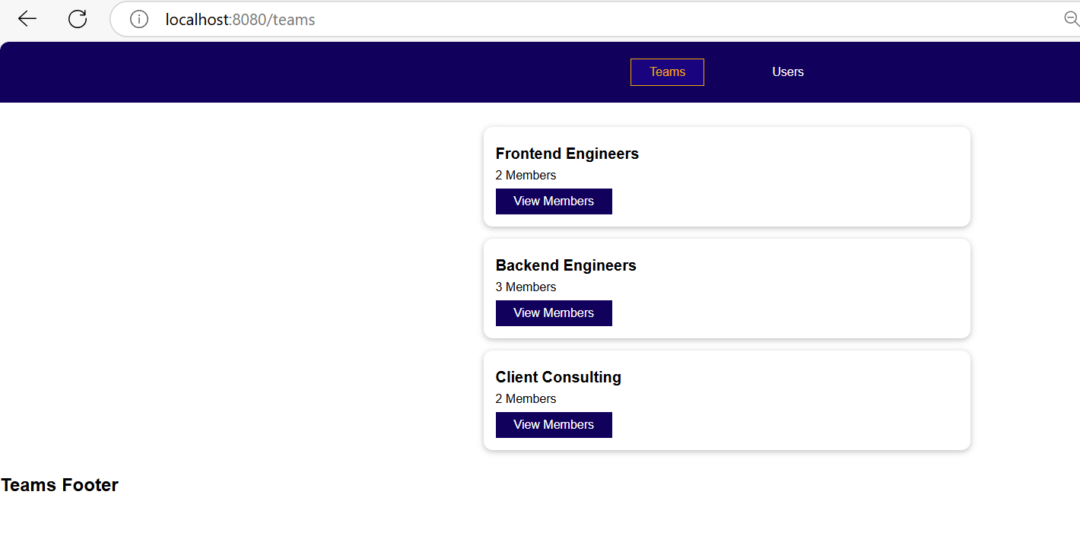

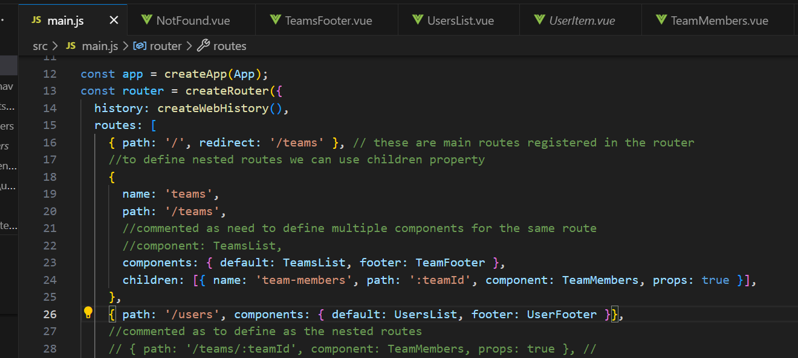

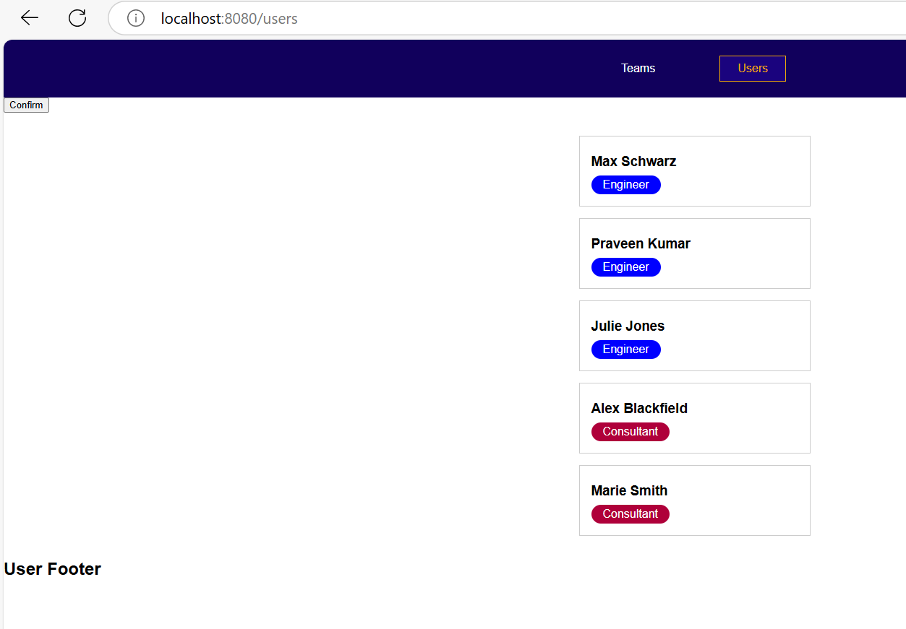

***Controlling Scroll Behavior:***

*In the router configuration, we need to use the “scrollBehavior” property which is a method, which will be invoked by vue whenever the url changes. This method receives 3 params by default “from”, “to” and “savedPosition”*

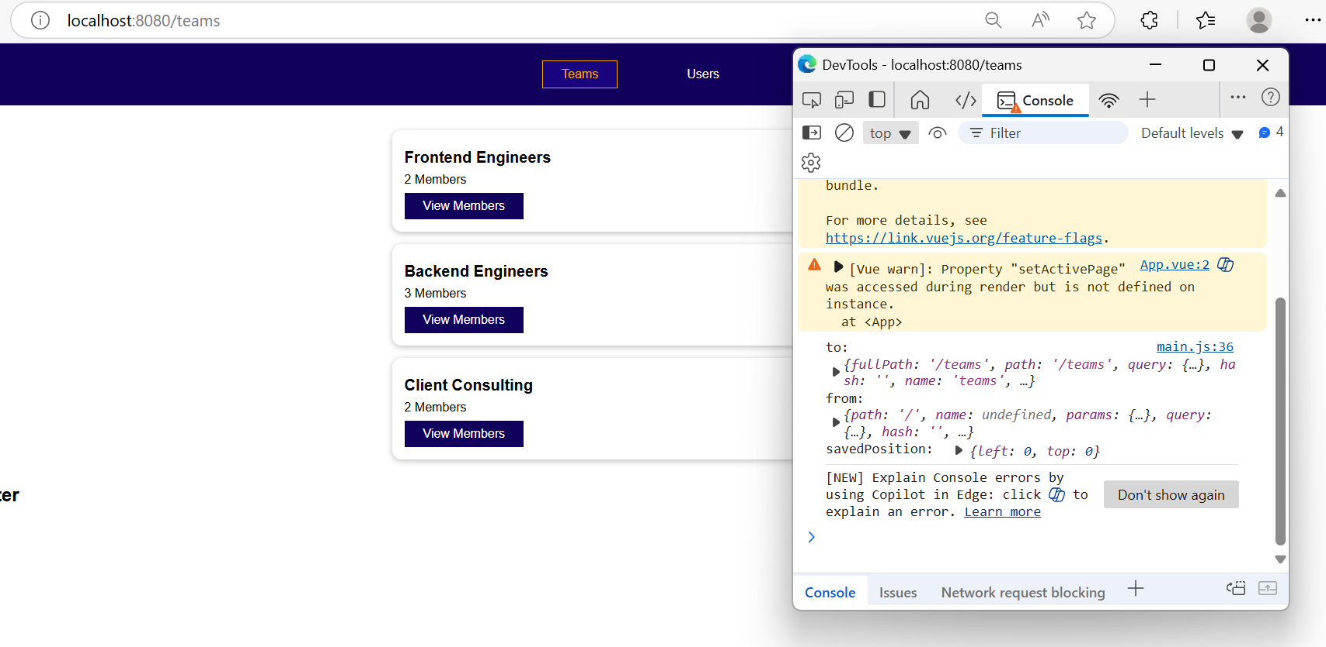

*Where to and from are nothing but $router output. “to” represents where we are navigating to and “from” represents from where are coming from.*

*If we have the value in the “savedPosition”, then we will return this from the method as we should return an object with to and from position otherwise we will return {to: 0, from: 0} which represents we need to go to top of the screen. “savedPosition” is considered as when we go back we should be taken to the same place ie location from where we have navigated.*

***Main.js:***

import { createApp } from 'vue';

import { createRouter, createWebHistory } from 'vue-router';

import TeamsList from './components/teams/TeamsList.vue';

import UsersList from './components/users/UsersList.vue';

import TeamMembers from './components/teams/TeamMembers.vue';

import NotFound from './components/nav/NotFound.vue';

import TeamFooter from './components/teams/TeamsFooter.vue';

import UserFooter from './components/users/UserFooter.vue';

import App from './App.vue';

const app = createApp(App);

const router = createRouter({

  history: createWebHistory(),

  routes: [

    { path: '/', redirect: '/teams' }, // these are main routes registered in the router

    //to define nested routes we can use children property

    {

      name: 'teams',

      path: '/teams',

      //commented as need to define multiple components for the same route

      //component: TeamsList,

      components: { default: TeamsList, footer: TeamFooter },

      children: [{ name: 'team-members', path: ':teamId', component: TeamMembers, props: true }],

    },

    { path: '/users', components: { default: UsersList, footer: UserFooter }},

    //commented as to define as the nested routes

    // { path: '/teams/:teamId', component: TeamMembers, props: true }, //

    { path: '/:notFound(.*)', component: NotFound }, //to catch all invalid routes- this should be at the last

  ],

  scrollBehavior(to, from, savedPosition) {

      if (savedPosition) {

        return savedPosition;

      }

      return { left: 0, top: 0 };

      //console.log("to: ", to, "from: ", from, "savedPosition: ", savedPosition);

    },

});

app.use(router);

app.mount('#app');

*Replace unused params with “_” . Here to and from are replaced with _ and _2 respectively*

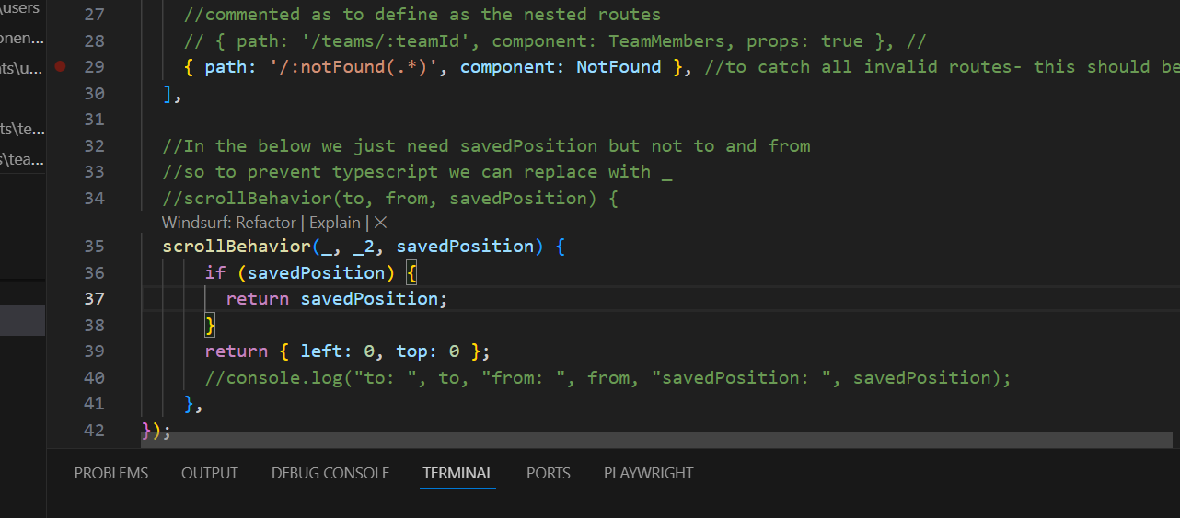

***Navigation Guard:***

*It is nothing but certain routes we may allow only authorised users. For that we have the method “beforeEach” which should called with router object. While navigating to any route this method is called before reaching it. ‘beforeEach’ is done globally for all the routes.*

*This methods takes a function as a parameter and this function has 3 params “to”, “from” and “next” . “to” and “from” nothing but $router details of the path from navigated and navigating to where “next” is the method which can be called to either allow to url or prohibit.*

* *next() or next(true) means allowed to navigate to that url*
* *next(false) means not allowed to navigate to that url.*

*In next() we can pass the path also to which we want to navigate always.*

*In next() we can also pass an object for routing like below*

next({name: 'team-members', params: {teamId: 't1'}});

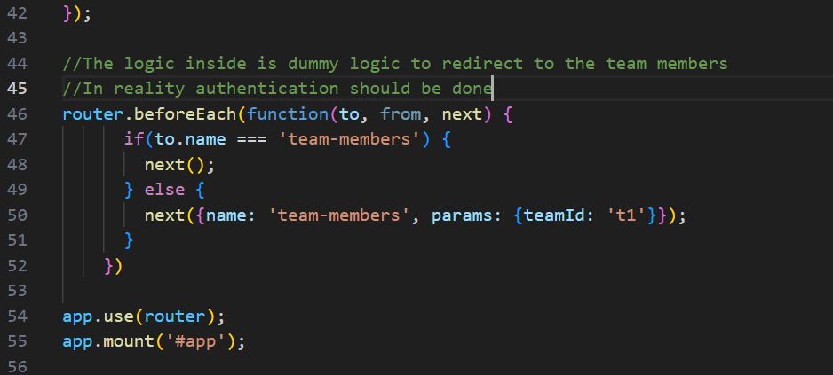

***Main.js***

import { createApp } from 'vue';

import { createRouter, createWebHistory } from 'vue-router';

import TeamsList from './components/teams/TeamsList.vue';

import UsersList from './components/users/UsersList.vue';

import TeamMembers from './components/teams/TeamMembers.vue';

import NotFound from './components/nav/NotFound.vue';

import TeamFooter from './components/teams/TeamsFooter.vue';

import UserFooter from './components/users/UserFooter.vue';

import App from './App.vue';

const app = createApp(App);

const router = createRouter({

  history: createWebHistory(),

  routes: [

    { path: '/', redirect: '/teams' }, // these are main routes registered in the router

    //to define nested routes we can use children property

    {

      name: 'teams',

      path: '/teams',

      //commented as need to define multiple components for the same route

      //component: TeamsList,

      components: { default: TeamsList, footer: TeamFooter },

      children: [{ name: 'team-members', path: ':teamId', component: TeamMembers, props: true }],

    },

    { path: '/users', components: { default: UsersList, footer: UserFooter }},

    //commented as to define as the nested routes

    // { path: '/teams/:teamId', component: TeamMembers, props: true }, //

    { path: '/:notFound(.*)', component: NotFound }, //to catch all invalid routes- this should be at the last

  ],

  //In the below we just need savedPosition but not to and from

  //so to prevent typescript we can replace with _

  //scrollBehavior(to, from, savedPosition) {

  scrollBehavior(_, _2, savedPosition) {

      if (savedPosition) {

        return savedPosition;

      }

      return { left: 0, top: 0 };

      //console.log("to: ", to, "from: ", from, "savedPosition: ", savedPosition);

    },

});

//The logic inside is dummy logic to redirect to the team members

//In reality authentication should be done

router.beforeEach(function(to, from, next) {

      if(to.name === 'team-members') {

        next();

      } else {

        next({name: 'team-members', params: {teamId: 't1'}});

      }

    })

app.use(router);

app.mount('#app');

***To perform check/authentication validation for individual route, we have “beforeEnter” method with same arguments. Argument functionalities are same as global one***

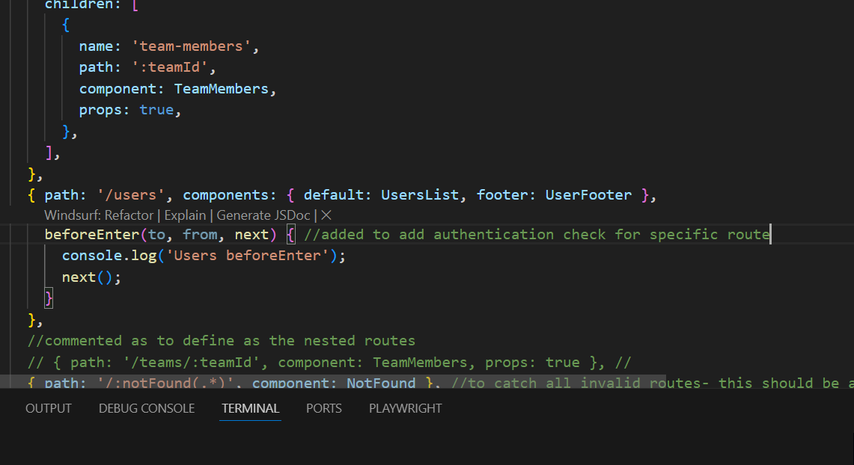

***Path level Navigation guard but doing in the component not in the route configuration***

***Note:”beforeRouterEnter” call is confirmed before navigating to this page***

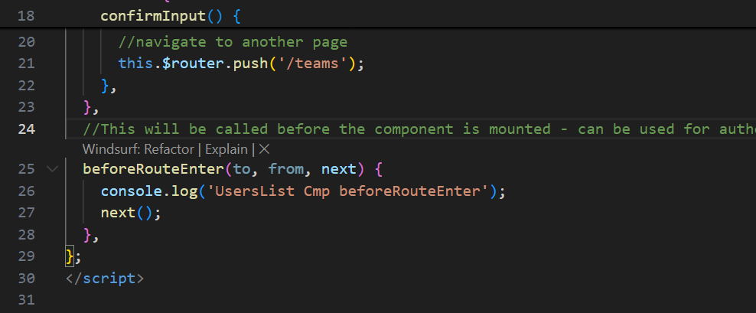

***Note: In all above 3 ways, we have to call the next() method manually to confirm the route or to redirect to different url.***

*Note: The order of execution will be global level -> router configuration level -> component level*

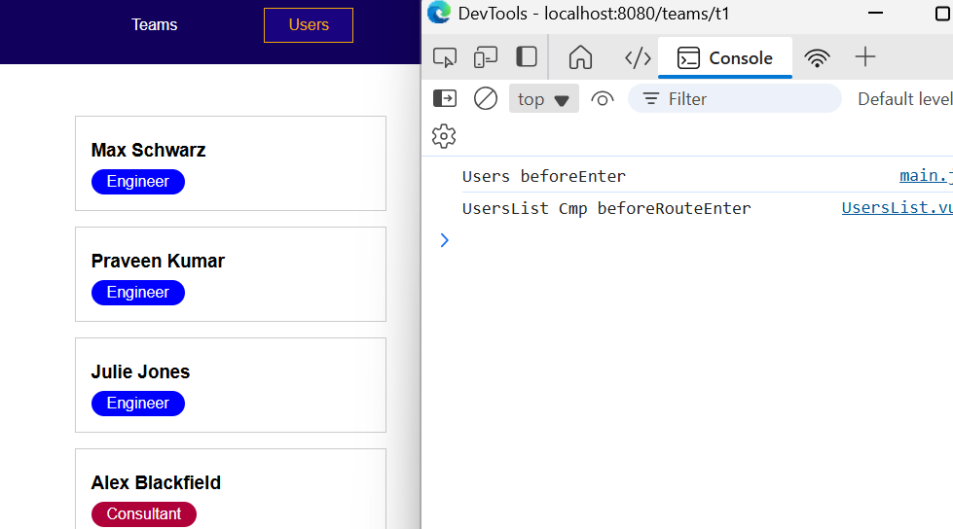

***Loading Guards:(Navigation Guard)***

*There would be scenarios like the path won’t be changed but the content will change say for different “id” the data are pulled. During that scenario the above 3 methods won’t be called as the path is not changed. To handle such scenarios we have beforeRouteUpdate() method which can be invoked inside the <script>. This method is invoked whenever the content of the page changes.*

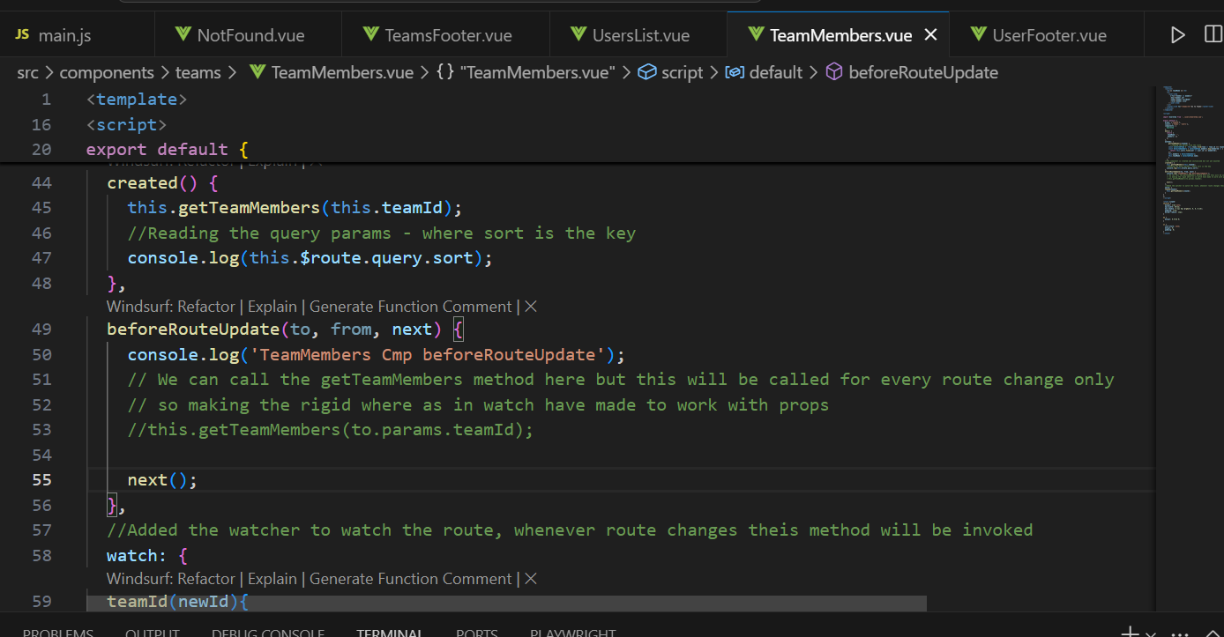

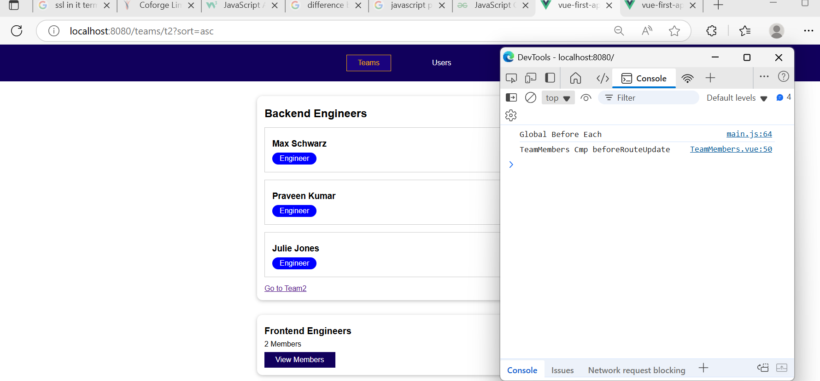

***afterEach():***

*This method we can call globally. This method is called after the route is confirmed by the above 4 before methods and no need to confirm. This method can’t control what is to be displayed in the screen.So we won’t have next() in this method.*

*We can use this method to statics data to the server like when the user navigated to which url, from where there navigating from etc.*

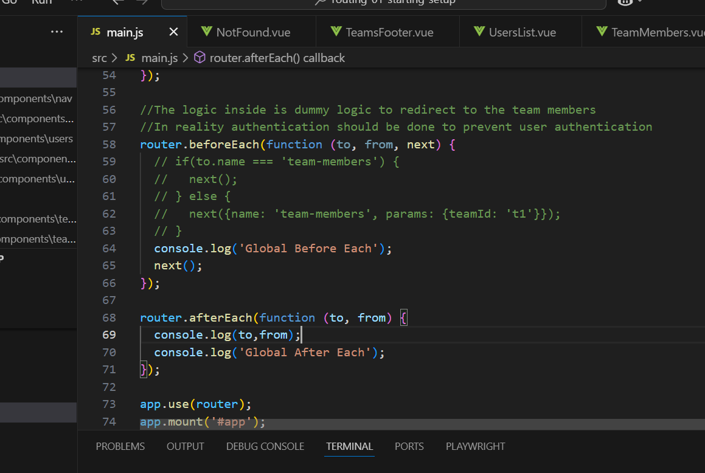

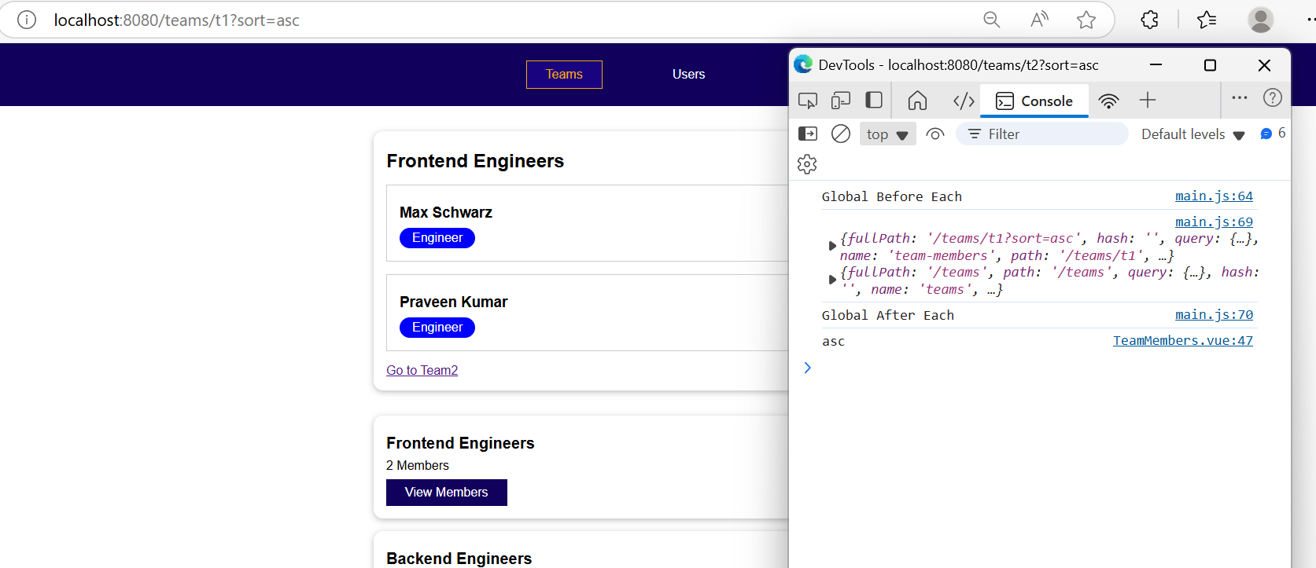

***Route Leave Guards:***

*The above all are route entering guards. This one will be called when leave the path or page*

***Unmounted:*** *(hook) This can be used but this method will be called only when the navigation ie leaving the page is confirmed. So we won’t have control make the user stay back in the same if we want. Say for example the page has some form which needs to be filled before leaving the page. Then we can’t use this method as it happens after the page switch is confirmed.*

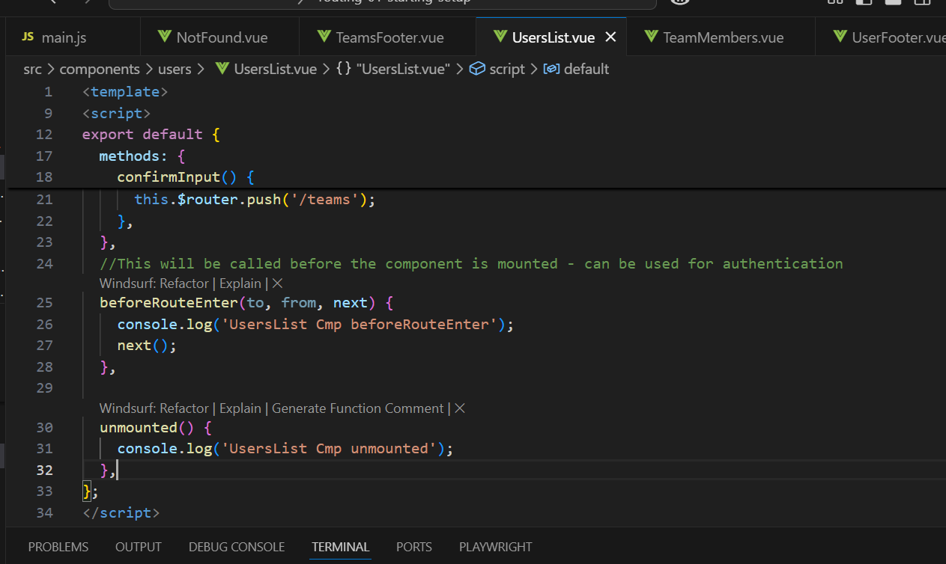

***beforeRouteLeave:***

*Say for example the page has some form which needs to be filled before leaving the page. Then we can use this method as it happens before the page switch is confirmed. This is called before “beforeEach” , “beforeEnter” and “beforeRouteEnter”.*

*This works even if we click “Back” button.*

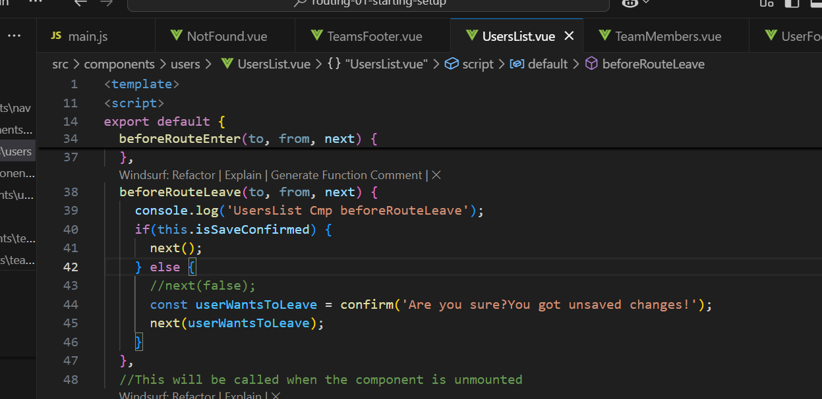

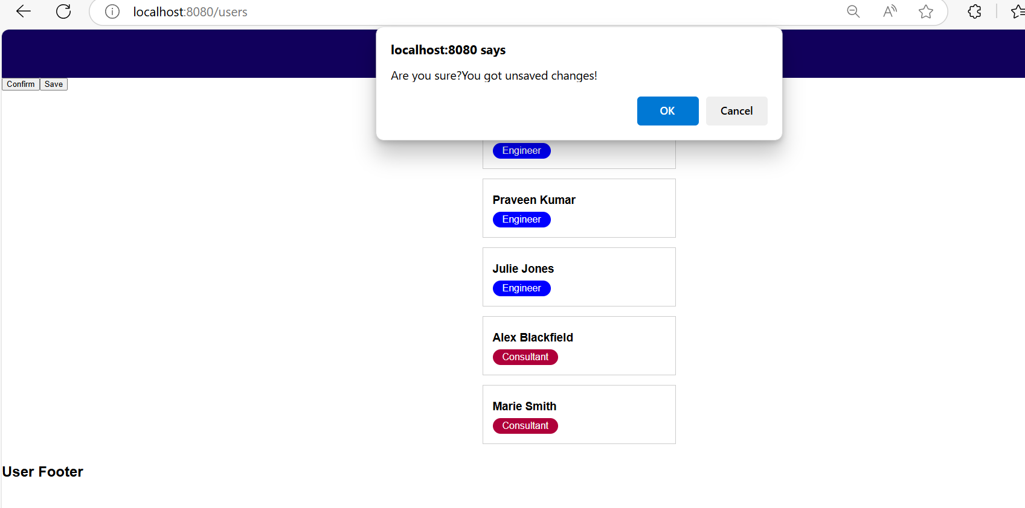

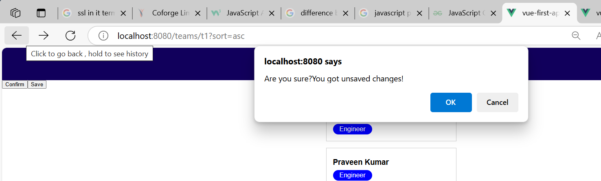

***UserList.vue***

<template>

<!-- This button is to show programmatic navigation -->

  <button @click="confirmInput">Confirm</button>

  <!-- Just a button to demo the beforeRouteLeave() method functionality -->

  <button @click="saveConfirmed">Save</button>

  <ul>

    <user-item v-for="user in users" :key="user.id" :name="user.fullName" :role="user.role"></user-item>

  </ul>

</template>

<script>

import UserItem from './UserItem.vue';

export default {

  components: {

    UserItem,

  },

  inject: ['users'],

  data() {

    return {isSaveConfirmed: false}

  },

  methods: {

    confirmInput() {

      //do something like calling api etc

      //navigate to another page

      this.$router.push('/teams');

    },

    saveConfirmed() {

      this.isSaveConfirmed = true;

      //this.$router.push('/teams');

    }

  },

  //This will be called before the component is mounted - can be used for authentication

  beforeRouteEnter(to, from, next) {

    console.log('UsersList Cmp beforeRouteEnter');

    next();

  },

  beforeRouteLeave(to, from, next) {

    console.log('UsersList Cmp beforeRouteLeave');

    if(this.isSaveConfirmed) {

      next();

    } else {

      //next(false);

      const userWantsToLeave = confirm('Are you sure?You got unsaved changes!');

      next(userWantsToLeave);

    }

  },

  //This will be called when the component is unmounted

  unmounted() {

    console.log('UsersList Cmp unmounted');

  },

};

</script>

<style scoped>

ul {

  list-style: none;

  margin: 2rem auto;

  max-width: 20rem;

  padding: 0;

}

</style>

***Route Metadata:***

*This will be very useful when we use in conjunction with the navigation guard. This can hold any data and need to be configured in the route configuration.*

*We can access in all the places where we can access $router object and also in the navigation guards where we get “to” and “from” that also “$router” sort of thing only*

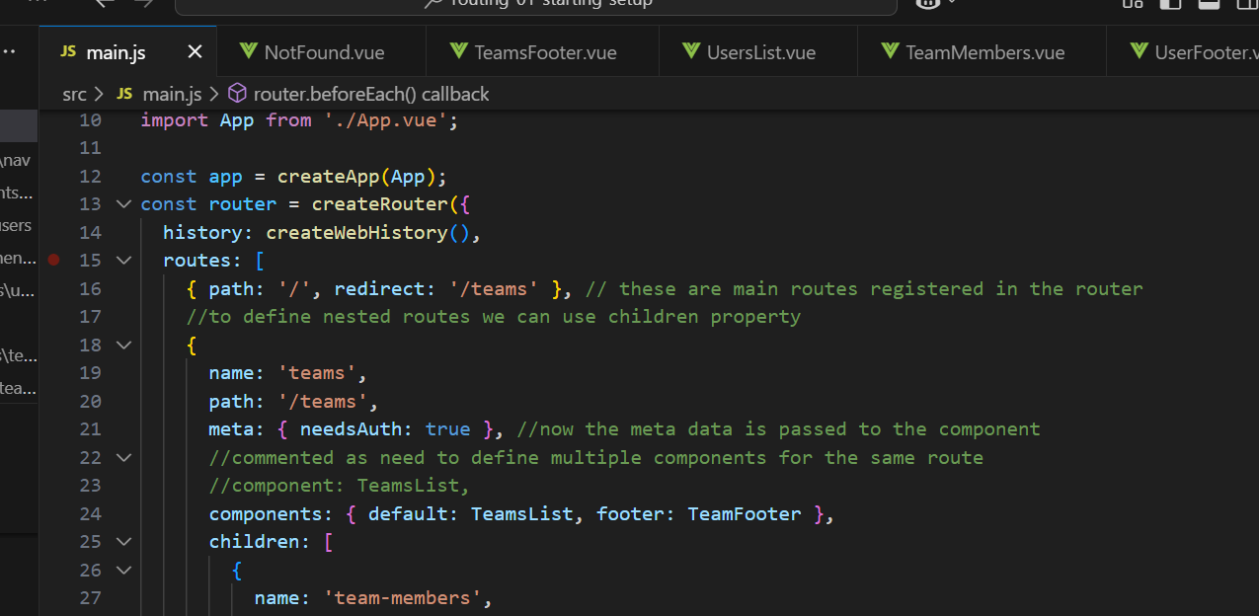

***Access of metadata***

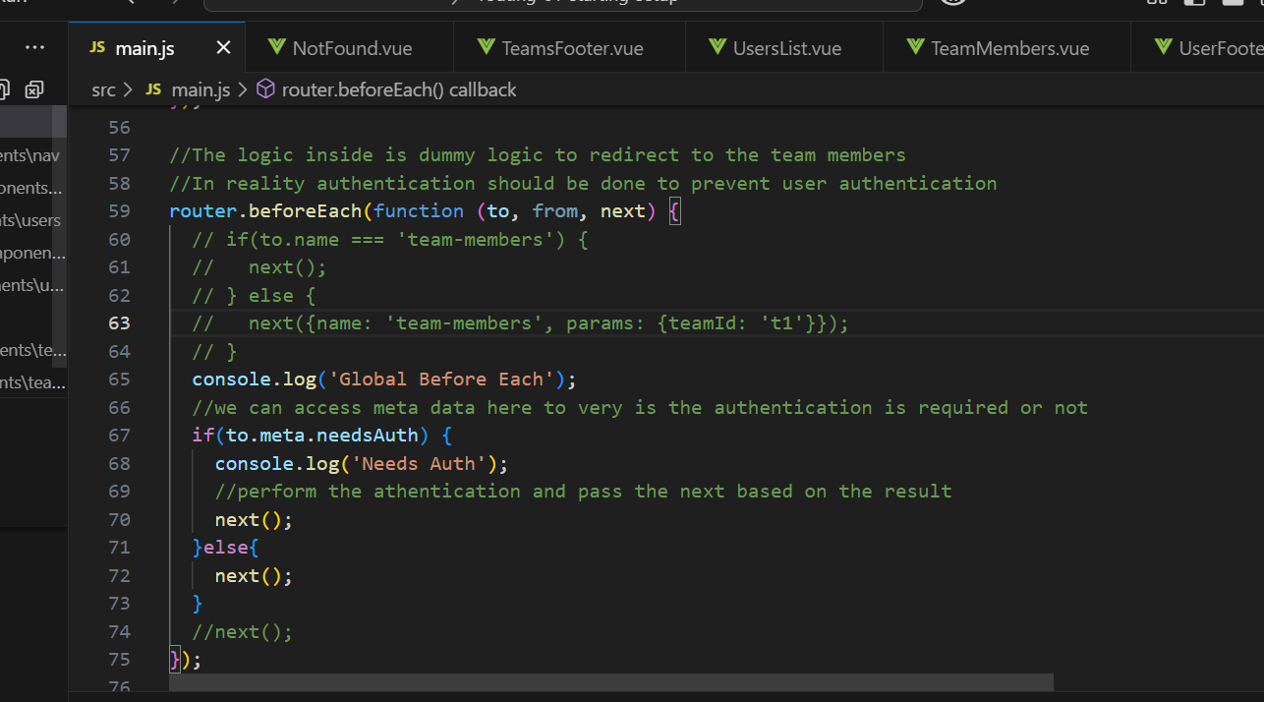

***Main.js***

import { createApp } from 'vue';

import { createRouter, createWebHistory } from 'vue-router';

import TeamsList from './components/teams/TeamsList.vue';

import UsersList from './components/users/UsersList.vue';

import TeamMembers from './components/teams/TeamMembers.vue';

import NotFound from './components/nav/NotFound.vue';

import TeamFooter from './components/teams/TeamsFooter.vue';

import UserFooter from './components/users/UserFooter.vue';

import App from './App.vue';

const app = createApp(App);

const router = createRouter({

  history: createWebHistory(),

  routes: [

    { path: '/', redirect: '/teams' }, // these are main routes registered in the router

    //to define nested routes we can use children property

    {

      name: 'teams',

      path: '/teams',

      meta: { needsAuth: true }, //now the meta data is passed to the component

      //commented as need to define multiple components for the same route

      //component: TeamsList,

      components: { default: TeamsList, footer: TeamFooter },

      children: [

        {

          name: 'team-members',

          path: ':teamId',

          component: TeamMembers,

          props: true,

        },

      ],

    },

    { path: '/users', components: { default: UsersList, footer: UserFooter },

      beforeEnter(to, from, next) { //added to add authentication check for specific route

        console.log('Users Route beforeEnter');

        next();

      }

    },

    //commented as to define as the nested routes

    // { path: '/teams/:teamId', component: TeamMembers, props: true }, //

    { path: '/:notFound(.*)', component: NotFound }, //to catch all invalid routes- this should be at the last

  ],

  //In the below we just need savedPosition but not to and from

  //so to prevent typescript we can replace with _

  //scrollBehavior(to, from, savedPosition) {

  scrollBehavior(_, _2, savedPosition) {

    if (savedPosition) {

      return savedPosition;

    }

    return { left: 0, top: 0 };

    //console.log("to: ", to, "from: ", from, "savedPosition: ", savedPosition);

  },

});

//The logic inside is dummy logic to redirect to the team members

//In reality authentication should be done to prevent user authentication

router.beforeEach(function (to, from, next) {

  // if(to.name === 'team-members') {

  //   next();

  // } else {

  //   next({name: 'team-members', params: {teamId: 't1'}});

  // }

  console.log('Global Before Each');

  //we can access meta data here to very is the authentication is required or not

  if(to.meta.needsAuth) {

    console.log('Needs Auth');

    //perform the athentication and pass the next based on the result

    next();

  }else{

    next();

  }

  //next();

});

router.afterEach(function (to, from) {

  console.log(to,from);

  console.log('Global After Each');

});

app.use(router);

app.mount('#app');

***Folder Structure:***

*The “pages” folder is introduced to differentiate which components are loaded as pages for route and which are embedded into components. This is not mandatory but it looks cleaner and neater.*

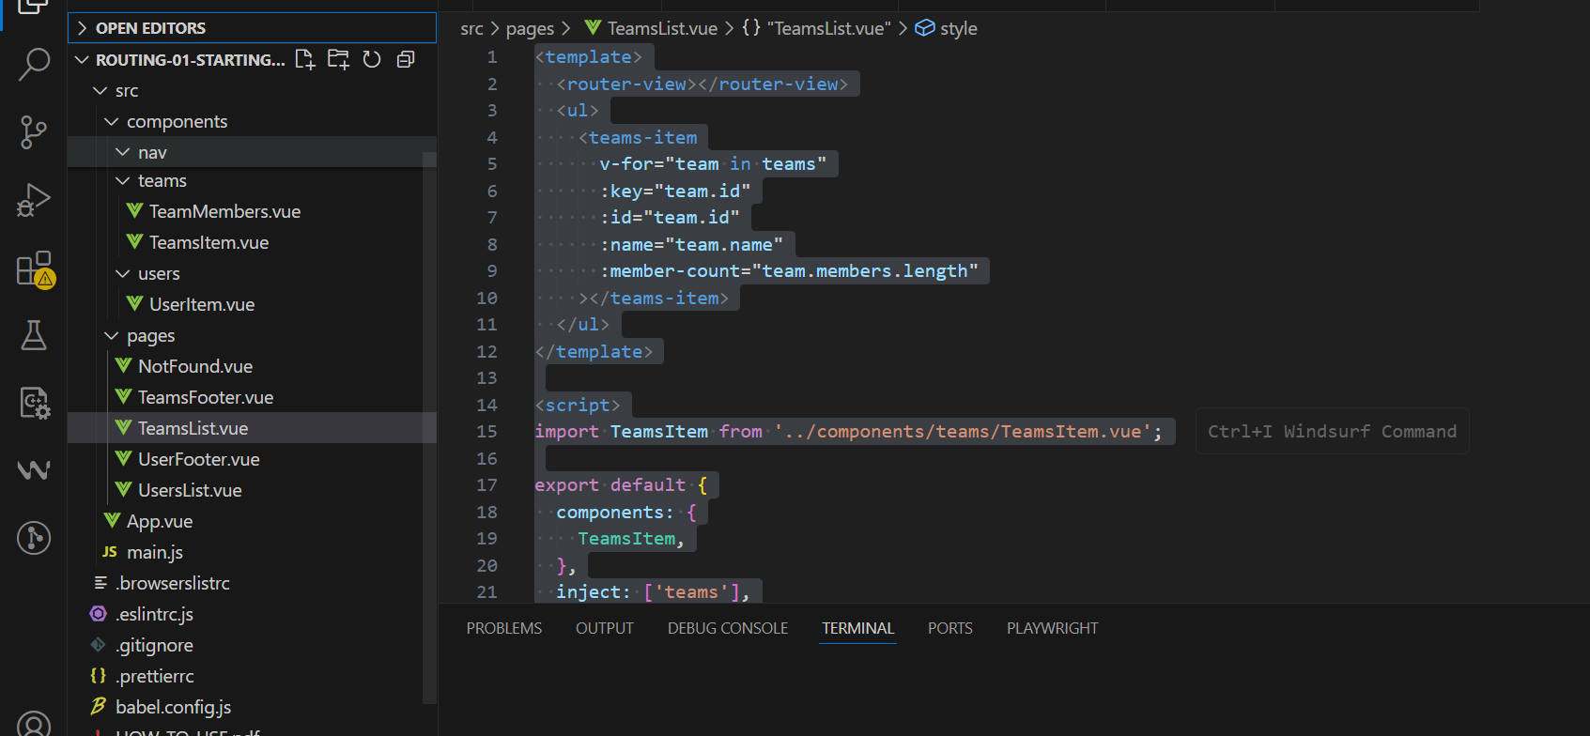

*With all the routing logic in main.js file, it became cumbersome so we will move code related to routing to different page and export the router object as a default. If so then we can import the router object in main.js*

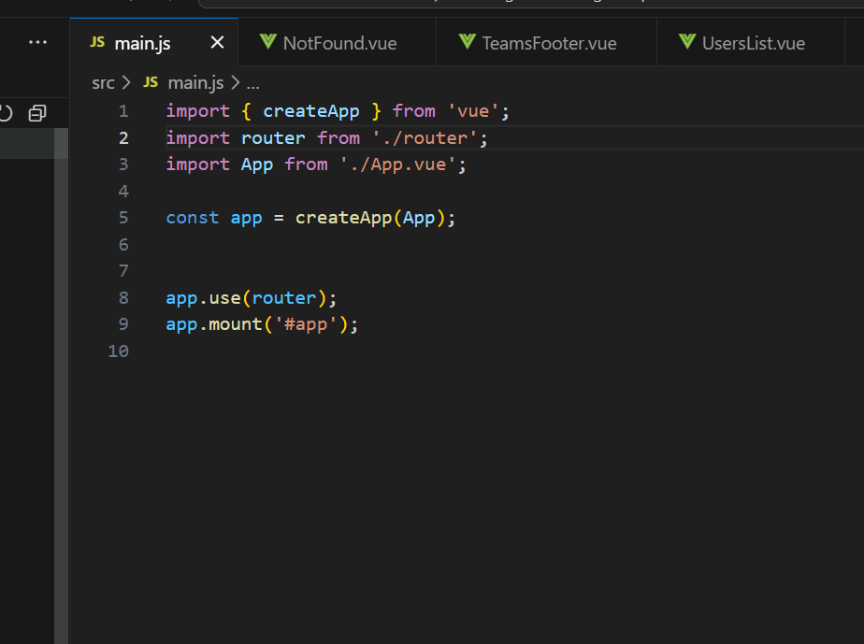

***Router.js***

import { createRouter, createWebHistory } from 'vue-router';

import TeamsList from './pages/TeamsList.vue';

import UsersList from './pages/UsersList.vue';

import TeamMembers from './components/teams/TeamMembers.vue';

import NotFound from './pages/NotFound.vue';

import TeamFooter from './pages/TeamsFooter.vue';

import UserFooter from './pages/UserFooter.vue';

const router = createRouter({

  history: createWebHistory(),

  routes: [

    { path: '/', redirect: '/teams' }, // these are main routes registered in the router

    //to define nested routes we can use children property

    {

      name: 'teams',

      path: '/teams',

      meta: { needsAuth: true }, //now the meta data is passed to the component

      //commented as need to define multiple components for the same route

      //component: TeamsList,

      components: { default: TeamsList, footer: TeamFooter },

      children: [

        {

          name: 'team-members',

          path: ':teamId',

          component: TeamMembers,

          props: true,

        },

      ],

    },

    { path: '/users', components: { default: UsersList, footer: UserFooter },

      beforeEnter(to, from, next) { //added to add authentication check for specific route

        console.log('Users Route beforeEnter');

        next();

      }

    },

    //commented as to define as the nested routes

    // { path: '/teams/:teamId', component: TeamMembers, props: true }, //

    { path: '/:notFound(.*)', component: NotFound }, //to catch all invalid routes- this should be at the last

  ],

  //In the below we just need savedPosition but not to and from

  //so to prevent typescript we can replace with _

  //scrollBehavior(to, from, savedPosition) {

  scrollBehavior(_, _2, savedPosition) {

    if (savedPosition) {

      return savedPosition;

    }

    return { left: 0, top: 0 };

    //console.log("to: ", to, "from: ", from, "savedPosition: ", savedPosition);

  },

});

//The logic inside is dummy logic to redirect to the team members

//In reality authentication should be done to prevent user authentication

router.beforeEach(function (to, from, next) {

  // if(to.name === 'team-members') {

  //   next();

  // } else {

  //   next({name: 'team-members', params: {teamId: 't1'}});

  // }

  console.log('Global Before Each');

  //we can access meta data here to very is the authentication is required or not

  if(to.meta.needsAuth) {

    console.log('Needs Auth');

    //perform the athentication and pass the next based on the result

    next();

  }else{

    next();

  }

  //next();

});

router.afterEach(function (to, from) {

  console.log(to,from);

  console.log('Global After Each');

});

export default router;

***Vuex:***

*It is a library for managing global state. State is nothing but data, whenever data changes, few triggers has to be happened which affects the UI.*

*State Types:*

*1) Global State – It affects multiple components / entire appln*

*2) Local State – It affects the component and it’s child via props.*

*With “provide” and “inject” we can handle the state being managed and consumed in more than one components. But the drawback with this approach is, maintaining a kind of global state is a not good practise. Also the file becomes cumbersome. Also possibility of missing updates for scenarios or duplicate data may be maintained (say same data can be maintained in different component due to unawareness of data being maintained).*

*By using Vuex, we are outsourcing the state management, also we can predict state management/flow due to clearly defined dataflow rules. So it is less error prone.*

***Install cmd:***

***npm install –save vuex@next***

*Note: ‘@next’ is added at the end of vuex to install the latest version*

*Now can create a store using “createStore” method of vuex.*

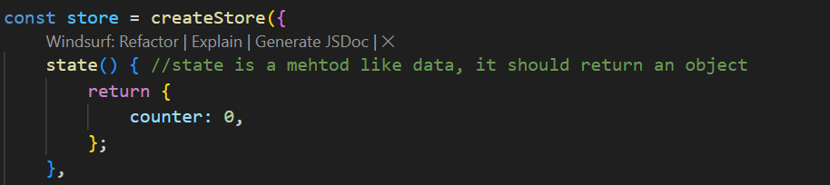

*Once the store is created need to be associated with the Application using the “run()” method.*

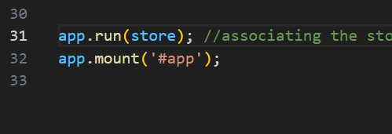

*Now any component in the application can access the store directly as well as modify it as shown below. But it is not as per vuex ethics. This direct handling may result in error as we can update from any where in the application.*

***$store.state.xxx***

***Where xxx – the state object property name***

*$store will have “state” object which in turn have access to all the states defined. For appln there can be only one store.*

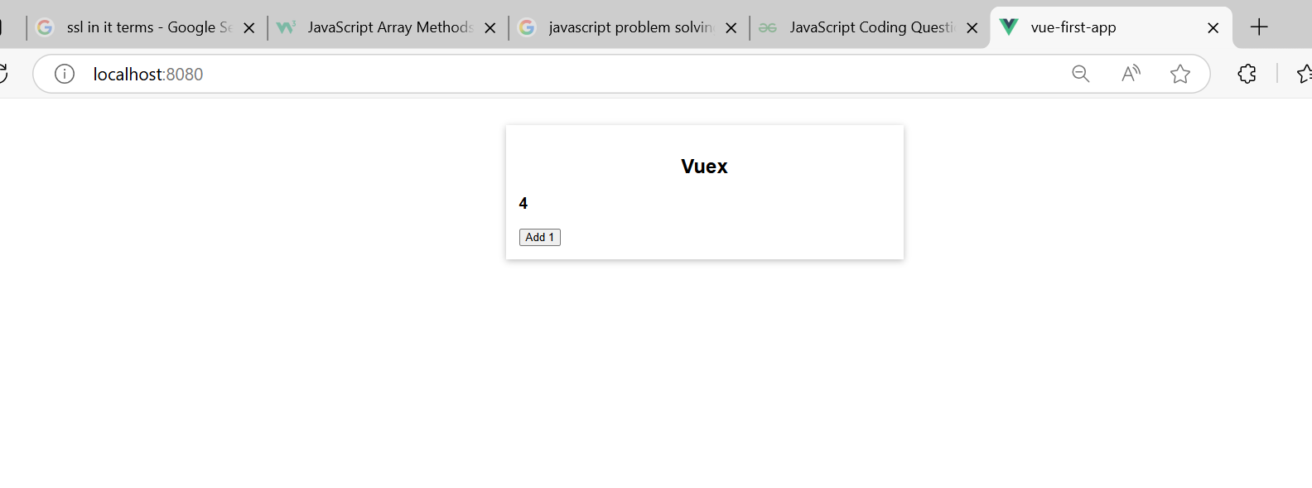

***Accessing the state from store:***

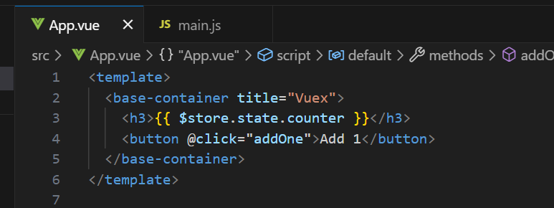

***Modifying the state in the component***

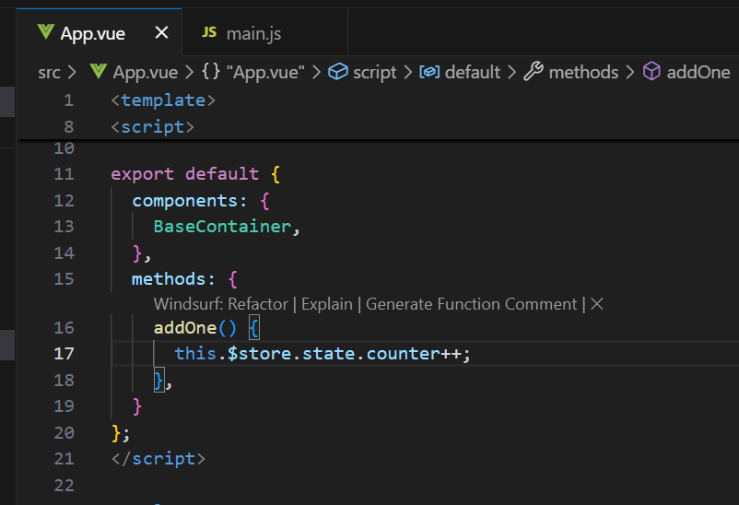

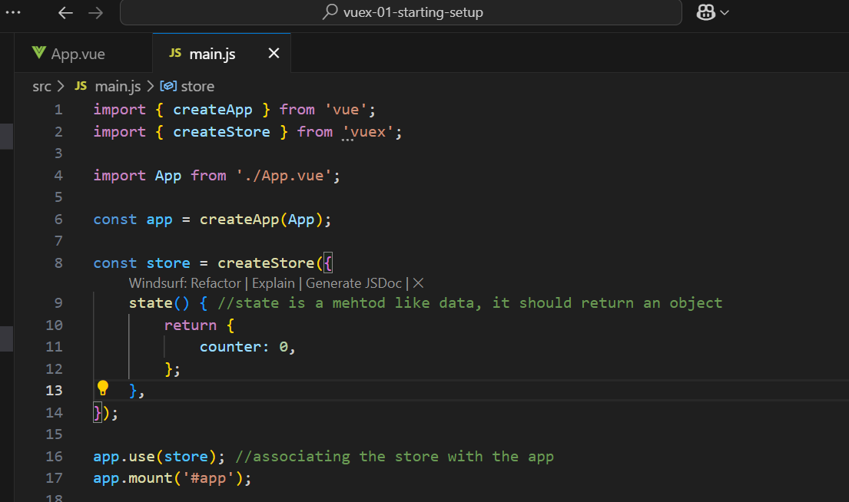

***The store can be accessed from anywhere in the component***

*Now the state “counter” is accessed from different component and the new component is invoked*

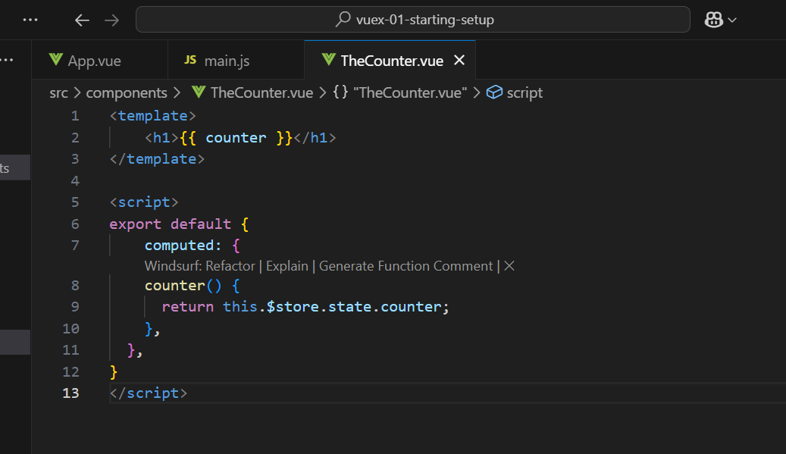

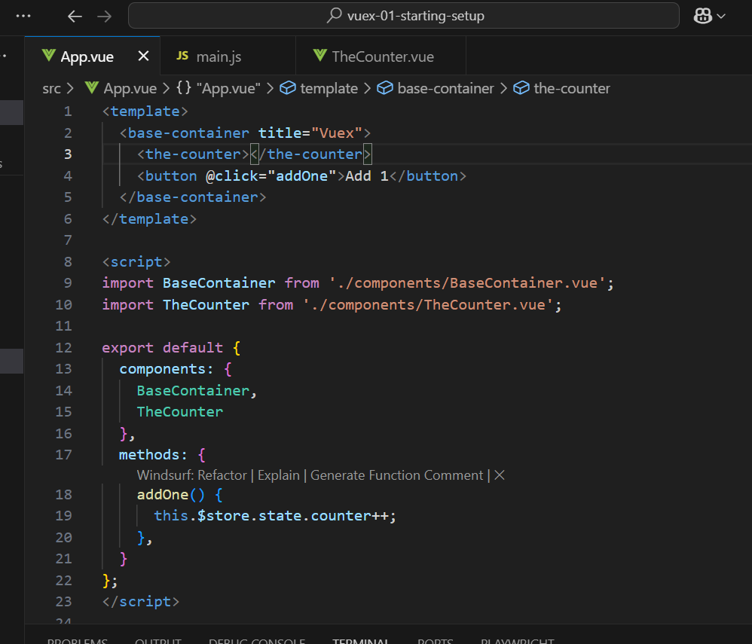

***Ethics of using Vuex:***

*We should have central data store where we have the state associated/defined. The components should not directly access the data store but they should access only via “mutations”(build-in feature). Mutations are clearly defined methods which have the logic to update state. Components can update by triggering the mutations.*

*If we handle from components directly , we may be udating from different components with different logic , then in future if changes are required then we need to make the changes everywhere which is tedious and cumbersome.*

***Main.js***

import { createApp } from 'vue';

import { createStore } from 'vuex';

import App from './App.vue';

const app = createApp(App);

const store = createStore({

    state() { //state is a mehtod like data, it should return an object

        return {

            counter: 0,

        };

    },

    mutations: {

        increment(state) { //mutation methods get the current state in the parameter

            state.counter++;

        },

    },

});

app.use(store); //associating the store with the app

app.mount('#app');

***Modifying the state using the mutation method: (App.vue)***

<template>

  <base-container title="Vuex">

    <the-counter></the-counter>

    <button @click="addOne">Add 1</button>

  </base-container>

</template>

<script>

import BaseContainer from './components/BaseContainer.vue';

import TheCounter from './components/TheCounter.vue';

export default {

  components: {

    BaseContainer,

    TheCounter

  },

  methods: {

    addOne() {

      // Commenting as we shouldn't update state directly from component

      //this.$store.state.counter++;

      this.$store.commit('increment'); //commit is built-in method and takes the method name as argument

    },

  }

};

</script>

<style>

* {

  box-sizing: border-box;

}

html {

  font-family: sans-serif;

}

body {

  margin: 0;

}

</style>

***Mutation method with Param:***

*Mutation methods always accepts 2 arguments. The 1st is the current state, the 2nd is the payload which can be string/number/object anything.*

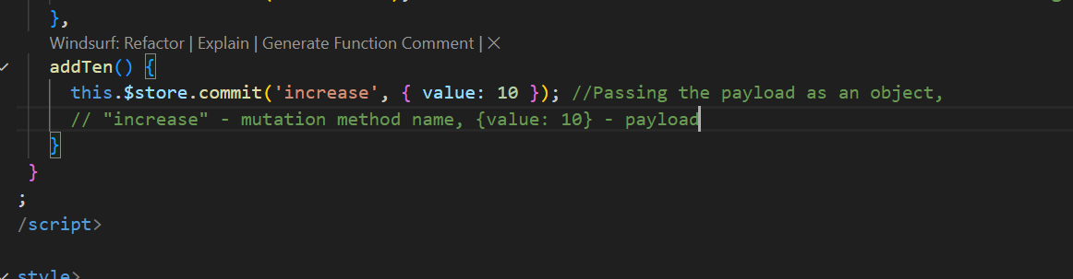

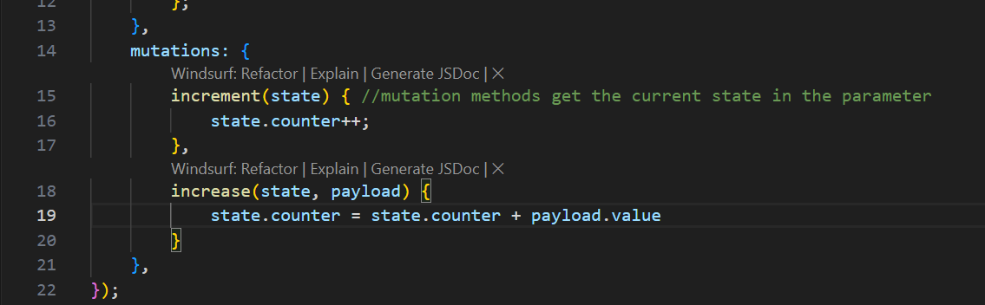

***Main.js***

import { createApp } from 'vue';

import { createStore } from 'vuex';

import App from './App.vue';

const app = createApp(App);

const store = createStore({

    state() { //state is a mehtod like data, it should return an object

        return {

            counter: 0,

        };

    },

    mutations: {

        increment(state) { //mutation methods get the current state in the parameter

            state.counter++;

        },

        increase(state, payload) {

            state.counter = state.counter + payload.value

        }

    },

});

app.use(store); //associating the store with the app

app.mount('#app');

import { createApp } from 'vue';

import { createStore } from 'vuex';

import App from './App.vue';

const app = createApp(App);

const store = createStore({

    state() { //state is a mehtod like data, it should return an object

        return {

            counter: 0,

        };

    },

    mutations: {

        increment(state) { //mutation methods get the current state in the parameter

            state.counter++;

        },

        increase(state, payload) {

            state.counter = state.counter + payload.value

        }

    },

});

app.use(store); //associating the store with the app

app.mount('#app');

***Two different ways of calling mutation method with params***

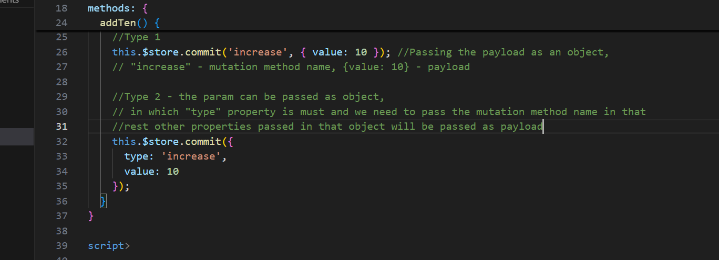

***Getters:***

*Like “mutations” are used to update the state, “getters” are used to get the state. This is because as per vuex ethics no components can directly access the store neither for read nor update.*

*Note: All the getters are methods and while invoking we can invoke with this.$store.state.xxx*

*Where xxx – getter name without parenthesis.*

*As usual it takes two params, the first is the state for which value is required, another param is another getter method which we may to manipulate the data or to apply some logic.*

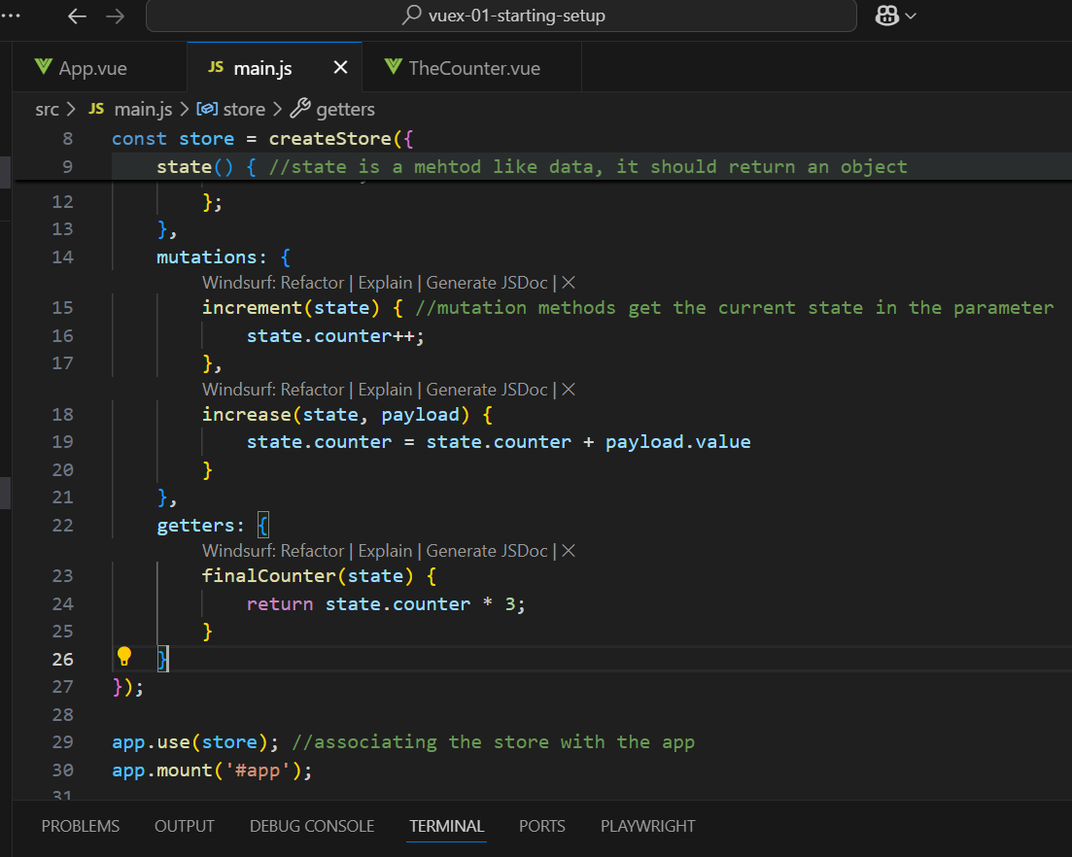

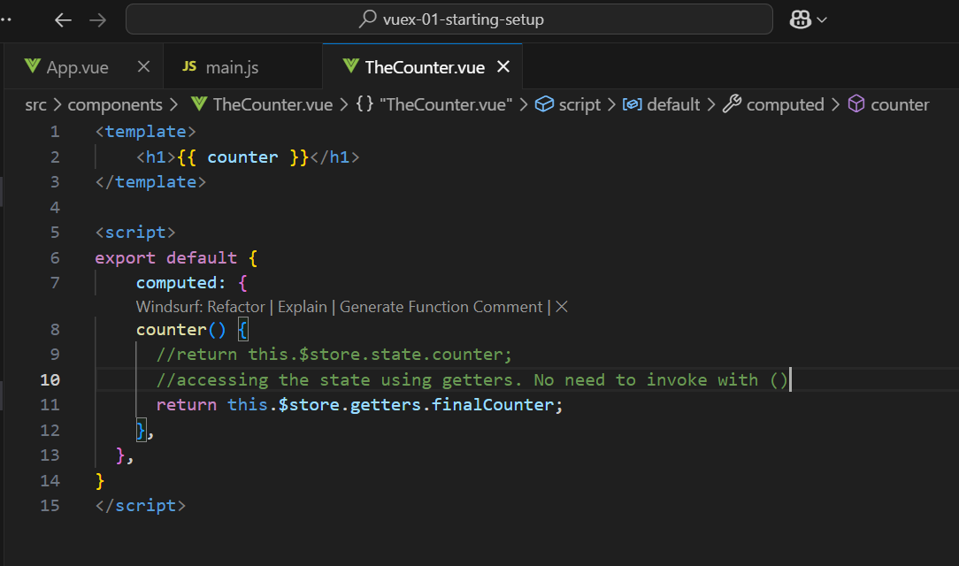

***One Getter dependent on another getter:***

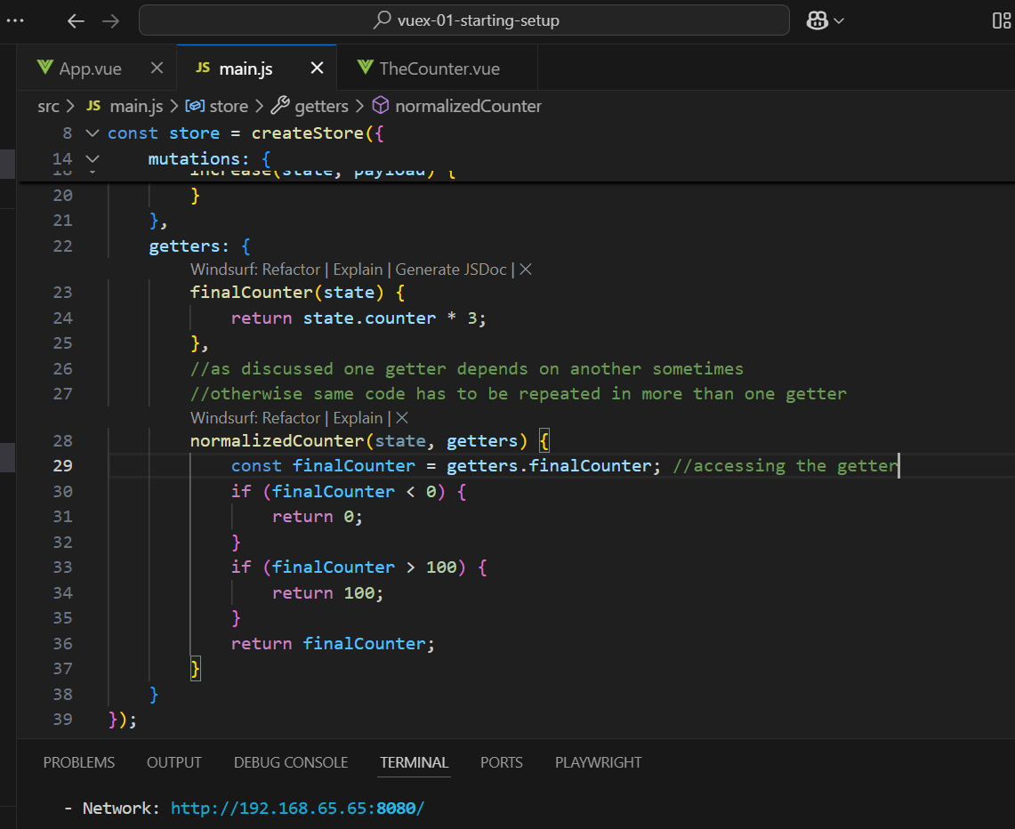

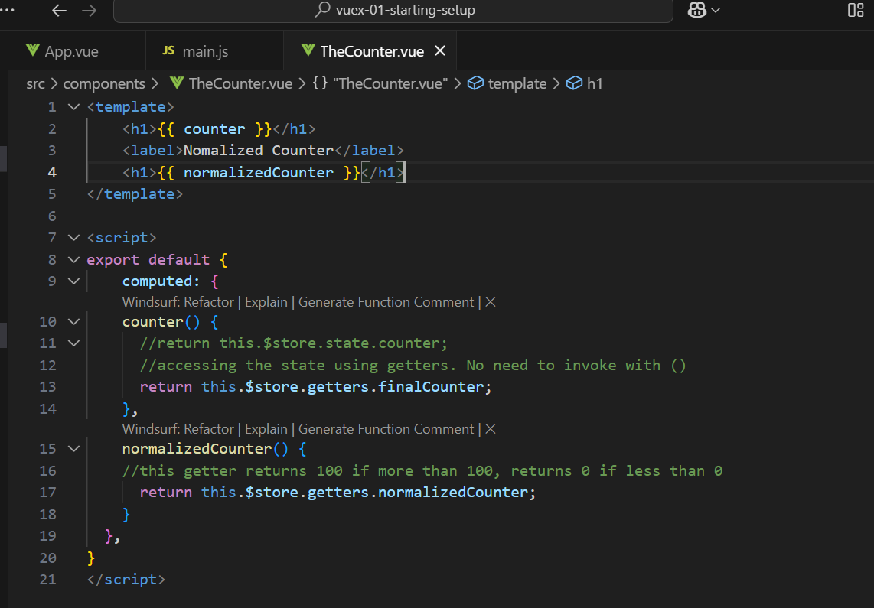

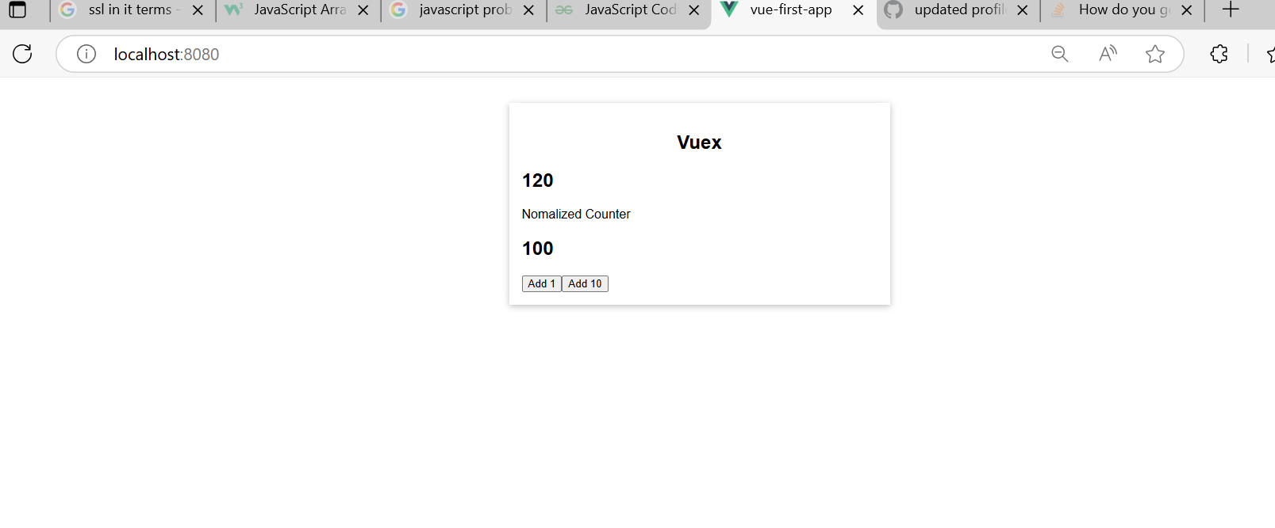

***Running Async code with actions:***

*Inside mutation only synchronous code / logic is allowed, asynchronous code like sending http request is not allowed. The execution should be performed one by one without any delay. The logic behind this is because for every mutation methods the latest state is required.*

*To overcome this issue, components should invoke “actions” which in turn will commit the “mutations”. The actions will take care of the asynchronous call.*

*It is always best practise to call mutations via action from the component even if it is not asynchronous. This is because just to avoid accident running of asynchronous tasks in mutations.*

*It is always good practise to name the actions same as the name of the mutation method which it is going to commit.*

*Accessing the actions in the component is exactly same as mutation methods except one change. Instead of “commit” we need to use “dispatch”. Invoking , passing arguments everything remains as such.*

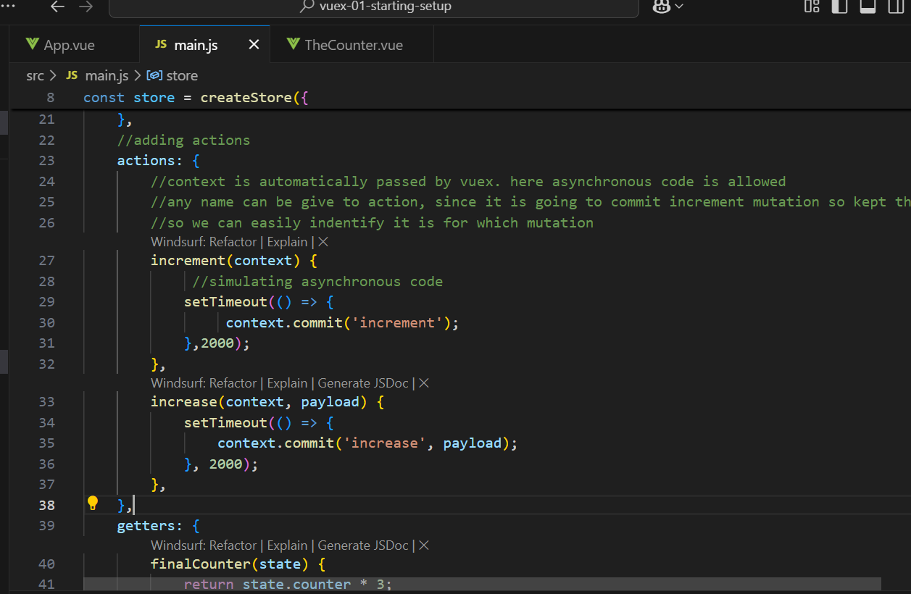

***Invoking actions:***

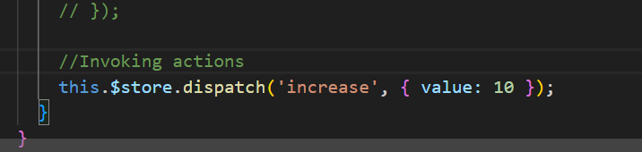

***App.vue***

<template>

  <base-container title="Vuex">

    <the-counter></the-counter>

    <button @click="addOne">Add 1</button>

    <button @click="addTen">Add 10</button>

  </base-container>

</template>

<script>

import BaseContainer from './components/BaseContainer.vue';

import TheCounter from './components/TheCounter.vue';

export default {

  components: {

    BaseContainer,

    TheCounter

  },

  methods: {

    addOne() {

      // Commenting as we shouldn't update state directly from component

      //this.$store.state.counter++;

      //this.$store.commit('increment'); //commit is built-in method and takes the method name as argument

      //invoking actions

      this.$store.dispatch('increment');

    },

    addTen() {

      //Type 1

      //this.$store.commit('increase', { value: 10 }); //Passing the payload as an object,

      // "increase" - mutation method name, {value: 10} - payload

      //Type 2 - the param can be passed as object,

      // in which "type" property is must and we need to pass the mutation method name in that

      //rest other properties passed in that object will be passed as payload

      // this.$store.commit({

      //   type: 'increase',

      //   value: 10

      // });

      //Invoking actions

      this.$store.dispatch('increase', { value: 10 });

    }

  }

};

</script>

<style>

* {

  box-sizing: border-box;

}

html {

  font-family: sans-serif;

}

body {

  margin: 0;

}

</style>

***Context Object:***

*This object has the following details*

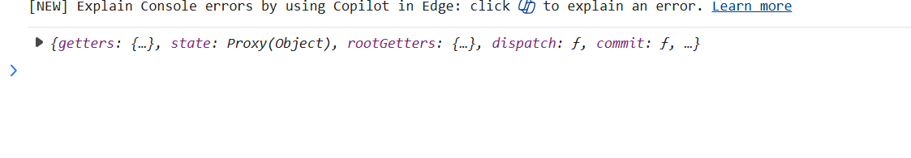

*Sometime from actions we may need to dispatch another mutation after successful completion or on error. Sometimes we need to access state , so getters may be useful. Only thing “state “ shouldn’t be manipulated from here, that should be done via mutations only*

***Mapper Helpers:***

***MapGetters:***

*This is a utility function which is used to get the state. This method returns an object which consist of all the getters we need*

***To invoke the mapGetters:***

***…mapGetters([xxx])***

*Where xxx -> is the name of the getter we want. We can pass any number of getters we in the array.*

*As we are spreading the array we can use result by specifying the getter name itself. As a result mapGetters will create the computed method for us to fetch the state*

***TheCounter.vue***

<template>

    <h1>{{ finalCounter }}</h1>

    <label>Nomalized Counter</label>

    <h1>{{ normalizedCounter }}</h1>

</template>

<script>

import { mapGetters } from 'vuex';

export default {

    computed: {

    // counter() {

      //return this.$store.state.counter;

      //accessing the state using getters. No need to invoke with ()

      //Here we do nothing except accessing the state

      //return this.$store.getters.finalCounter;

      //console.log('getters:', mapGetters(['finalCounter']));

       //-> mapGetters utility takes argument as an array which contains the

      //name of the getters

      ...mapGetters(['finalCounter', 'normalizedCounter'])

    },

    // normalizedCounter() {

    // //this getter returns 100 if more than 100, returns 0 if less than 0

    //   return this.$store.getters.normalizedCounter;

    // },

}

</script>

***mapActions:***

*In methods, we are writing methods to dispatch the action but vuex is providing the “mapActions” helper (built-in) to dispatch. As an argument we need to pass the mutations we need. mapActions will create those methods for us.*

*This we need to do inside the methods object*

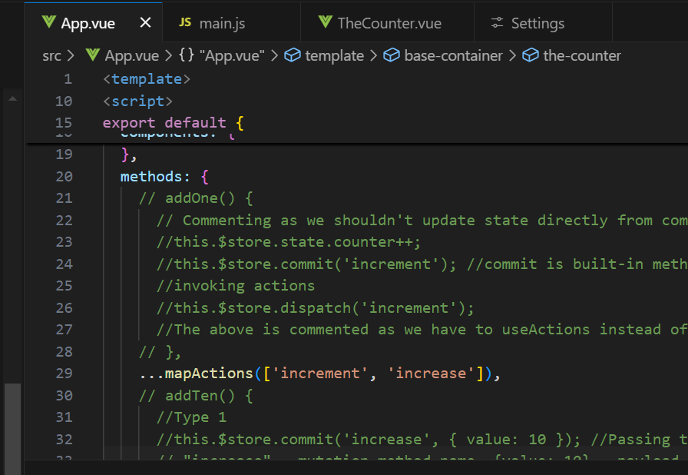

***App.vue:***

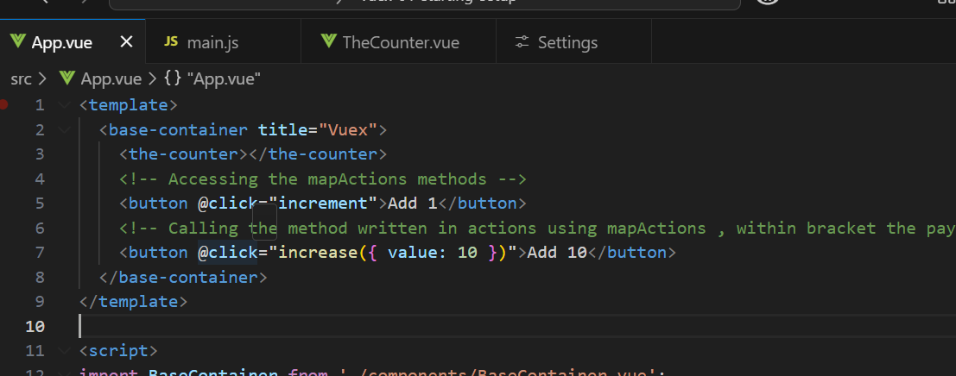

*Two different ways of providing inputs to the method. The same applies to mapGetters*

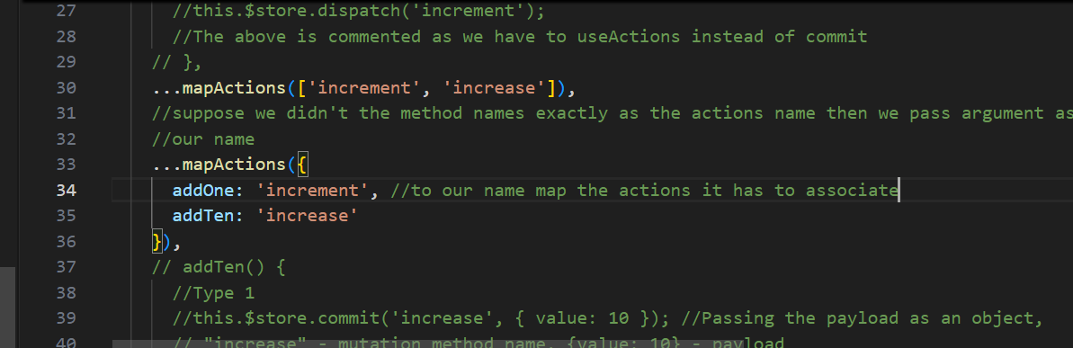

***Store Module:***

*As the store keeps on growing vuex has provided the concept creating store modules to keep it modular and manageable. If we are not splitting into modules means there is only one module in the appln(the root module).*

*The module is nothing but the regular javaScript object but it has the same features or properties we pass to create the store. Then this module can be associated with the root module via the attribute “modules”.*

***Main.js:***

import { createApp } from 'vue';

import { createStore } from 'vuex';

import App from './App.vue';

const app = createApp(App);

//store module

const counterModule = {

    state() {

        return {

            counter: 0,

        };

    },

    mutations: {

         increment(state) { //mutation methods get the current state in the parameter

           state.counter++;

        },

        increase(state, payload) {

            state.counter = state.counter + payload.value

        },

    },

    actions: {

        increment(context) {

             //simulating asynchronous code

             console.log(context);

            setTimeout(() => {

                 context.commit('increment');

            },2000);

        },

        increase(context, payload) {

            setTimeout(() => {

                context.commit('increase', payload);

            }, 2000);

        },

    },

    getters:{

        finalCounter(state) {

            return state.counter * 3;

        },

        //as discussed one getter depends on another sometimes

        //otherwise same code has to be repeated in more than one getter

        normalizedCounter(state, getters) {

            const finalCounter = getters.finalCounter; //accessing the getter

            if (finalCounter < 0) {

                return 0;

            }

            if (finalCounter > 100) {

                return 100;

            }

            return finalCounter;

        },

    }

}

//All the modules are merged with the root module and stored in the store via the attribute "modules"

const store = createStore({

    modules: {

        numbers: counterModule //property name u can give anything u want but associate with the intented module

    },

    state() { //state is a mehtod like data, it should return an object

        return {

            isLogged: false,

        };

    },

    mutations: {

        login(state) {

            state.isLogged = true;

        },

        logout(state) {

            state.isLogged = false;

        }

    },

    //adding actions

    actions: {

        //context is automatically passed by vuex. here asynchronous code is allowed

        //any name can be give to action, since it is going to commit increment mutation so kept the same

        //so we can easily indentify it is for which mutation

        login(context) {

            context.commit('login');``

        },

        logout(context) {

            context.commit('logout');

        }

    },

    getters: {

        isLogged(state) {

            return state.isLogged;

        }

    }

});

app.use(store); //associating the store with the app

app.mount('#app');

*The* ***state/mutations/getters/actions*** *defined within the module is local to that module(local state). Inside the module we can’t access root module* ***state/mutations/getters/actions.***

***If we want to access the root module state/……… the getters can get two more arguments “rootState” and “rootGetters”.***

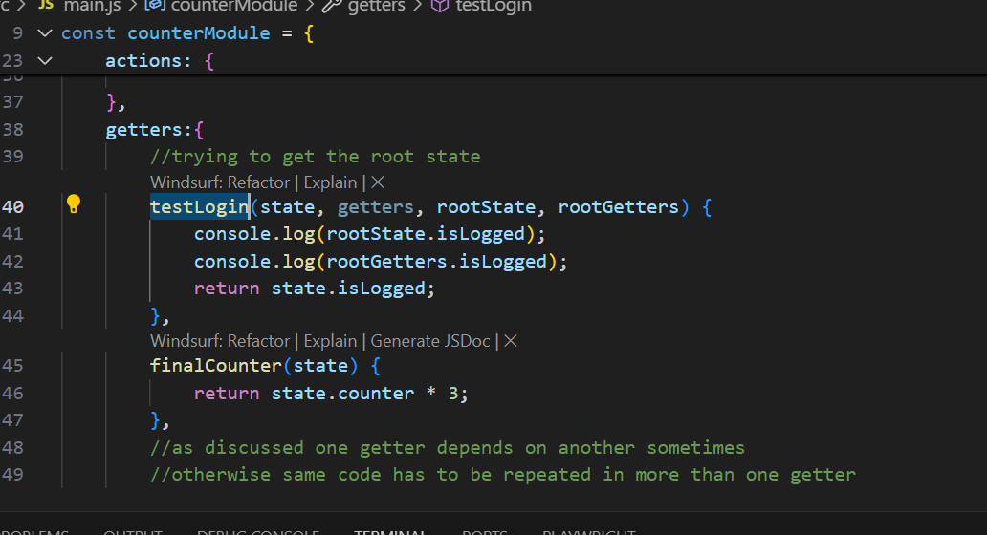

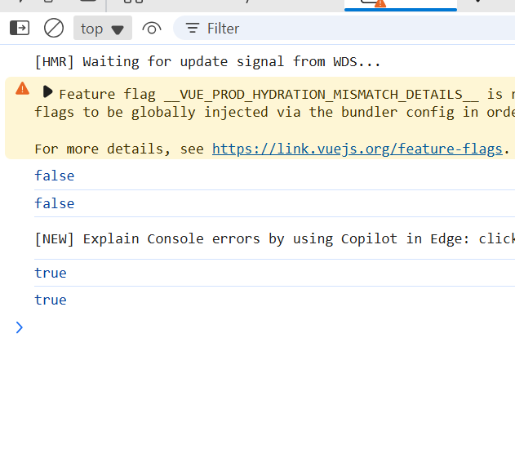

***Namespaced Module:***

*If the application grows and we may have more modules. In more than one module, the same state/getter/mutation etc would have been defined. Then after merging with the root module, then it is difficult to identify or call them as in the same name two may there. So which one to call.*

*So giving* ***namespace: true*** *in the module definition, we make everything inside the module as completely local and separated from rest others.*

*To access the getters and actions we need to include the identifier of the module (ie the property name given while associating with the root store). For the below example, the identifier is “****numbers****”.*

***Setting namespace to module:***

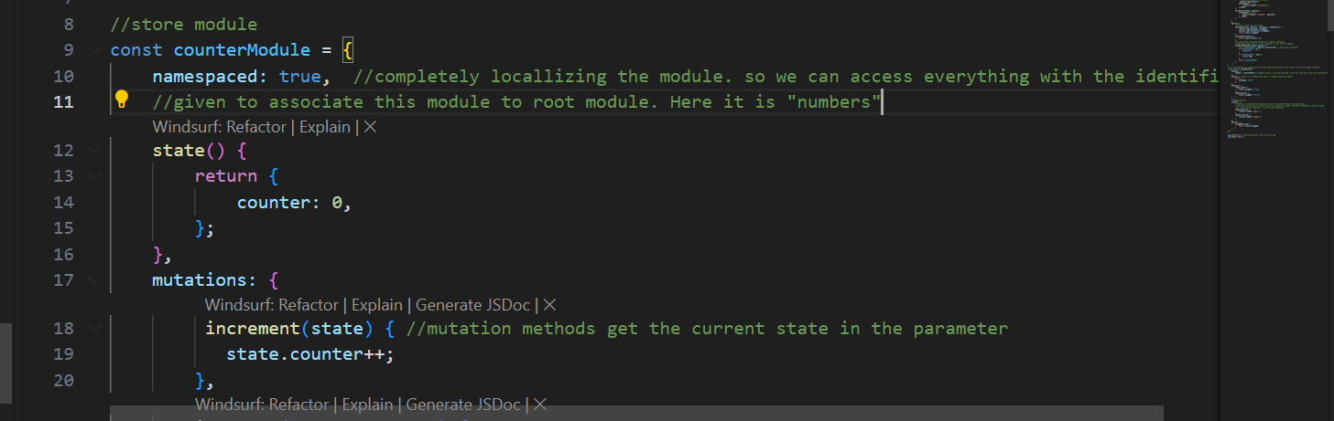

***For getters:***

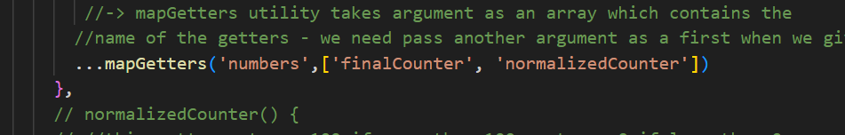

***For actions:***

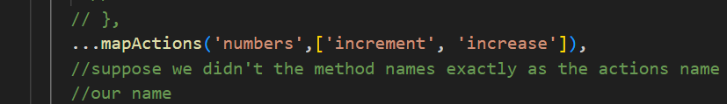

*Another syntax for mapActions*

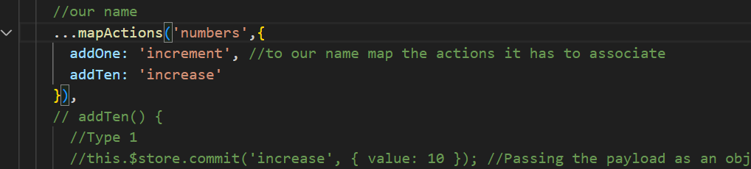

***For direct access of getters:***

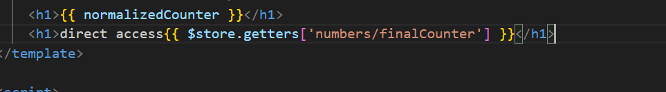

***For direct dispatch actions: Need to include the identifier before action. Here it is ‘numbers’***

*this.$store.dispatch('numbers/increase', { value: 10 });*

***Same applies to commit also***

*this.$store.commit({*

*type: 'numbers/increase',*

*value: 10*

*});*

***Same applies to dispatch too***

*this.$store.dispatch({*

*type: 'numbers/increase',*

*value: 10})*

***Folder Structure:***

***Type 1:***

*Move all the store related from main.js to store.js and export the store as default so that can be imported in main.js*

***Type 2:***

*Create a separate folder for “store” and inside that create files for each props say for “mutations”, “getters”, mutations etc and also index.js file*

*Move the base store creation logic to index.js from main.js file . Then move the actions, mutations and getters of root to the respective files of same name at the same level.*

*Similarly move the module related code to respective folder and files in it(same as root module)*

*Note: we need to export objects by default from each of the files say getters, mutations and actions so that we can import in the index.js*

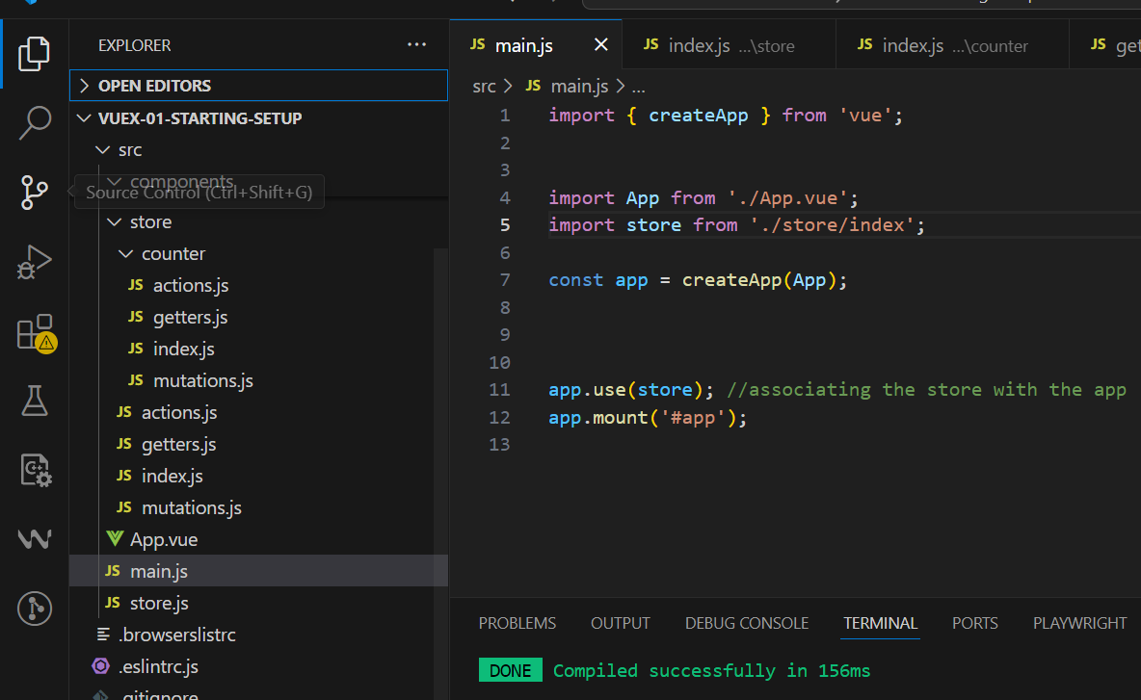

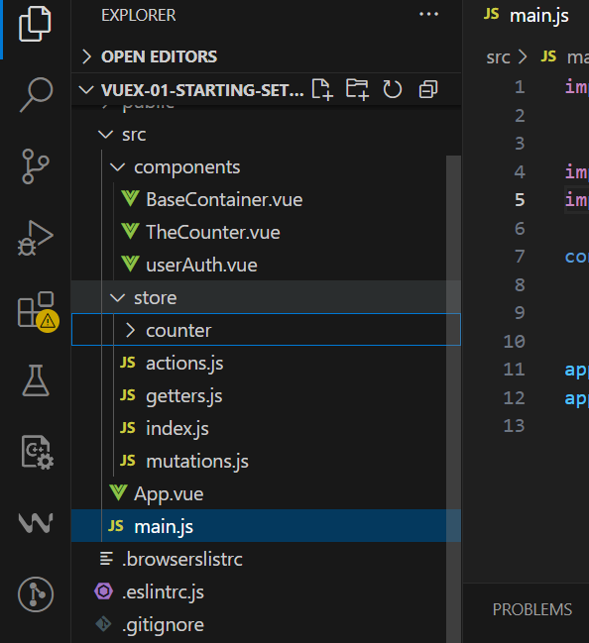

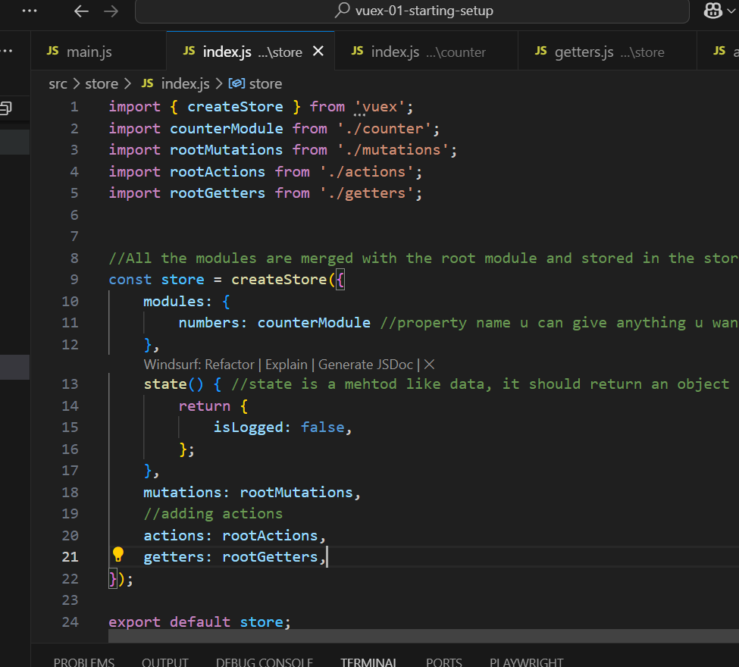

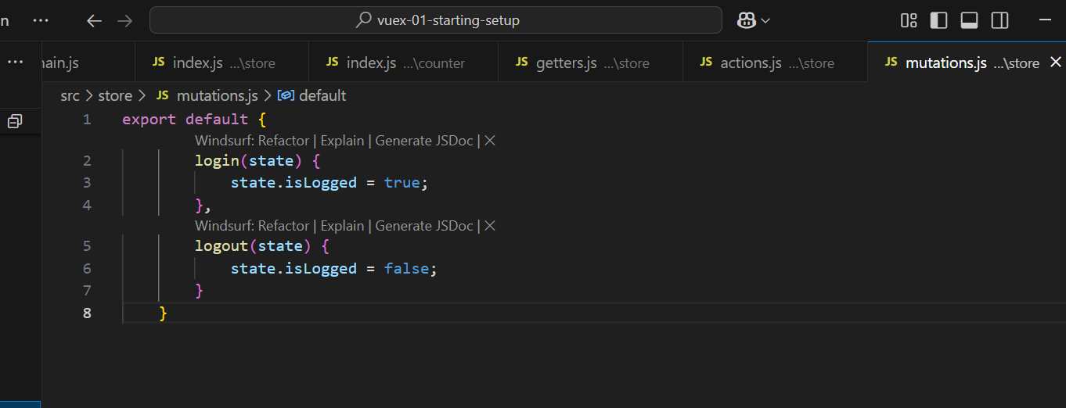

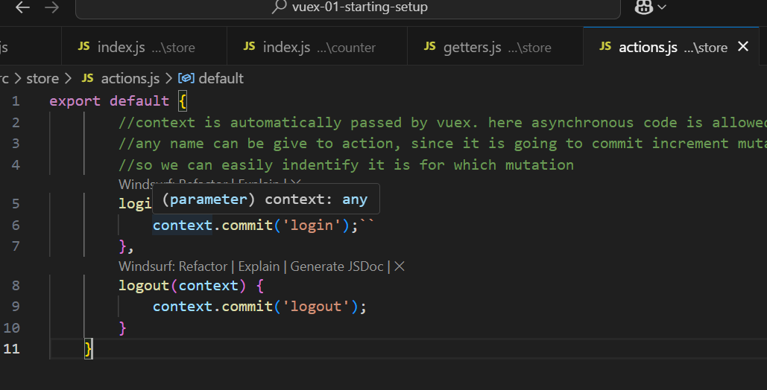

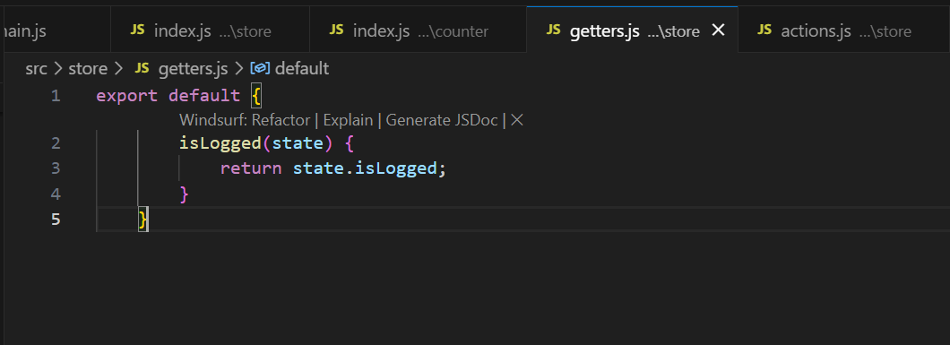

***Authentication:***

*In traditional appln, frontend will send a request to backend(server) for authentication. After verification, server generates a session id, stores in it as well as send to the client, so that link is maintained. Whenever the request is made the session id sent along with it.*

*Whereas in SPA(single page applications) the backend is completely detached from frontend. During login the client sends request to the server for authentication. After validation it sends the token back to the client. It won’t store anything related to user in the server. Whenever the request is made the token is sent along with it. The server only will validate the token and allow actions if matches otherwise denies.*

***Rules setup in Firebase base on authentication***

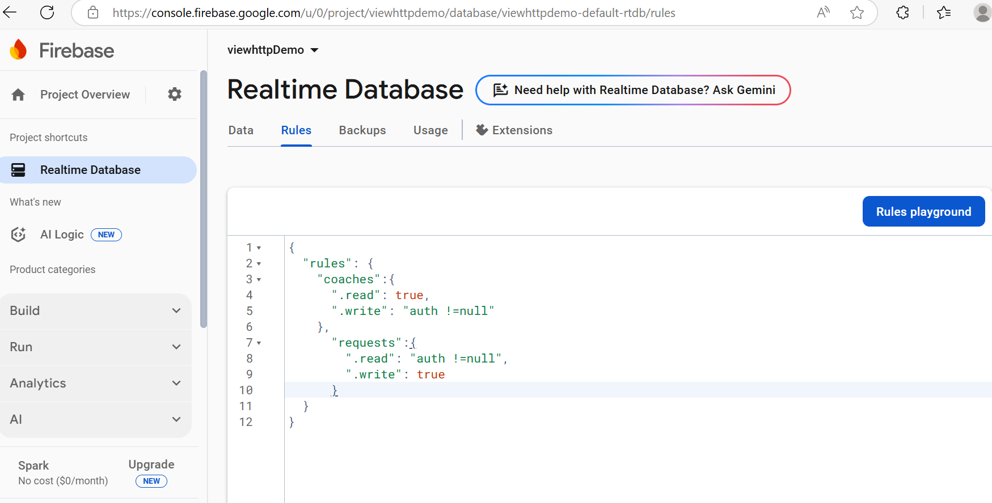

*To test the authentication, we need to enable email authentication in firebase.*

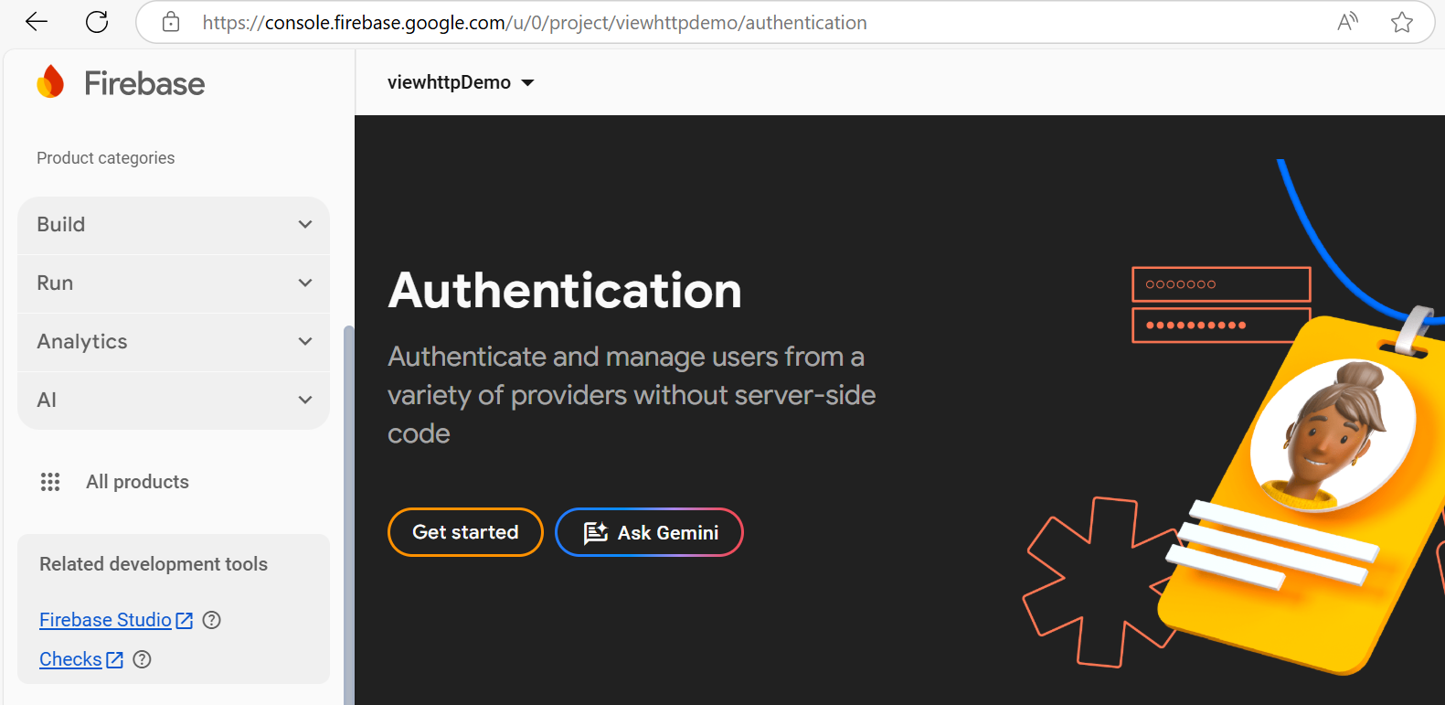

*As we are using email and password. Set authentication for email*

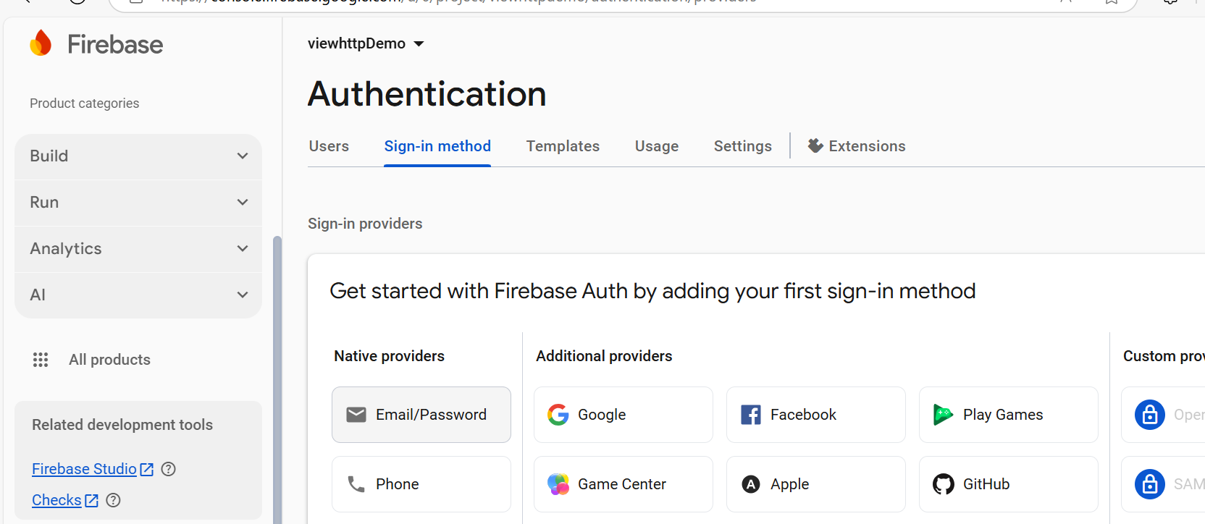

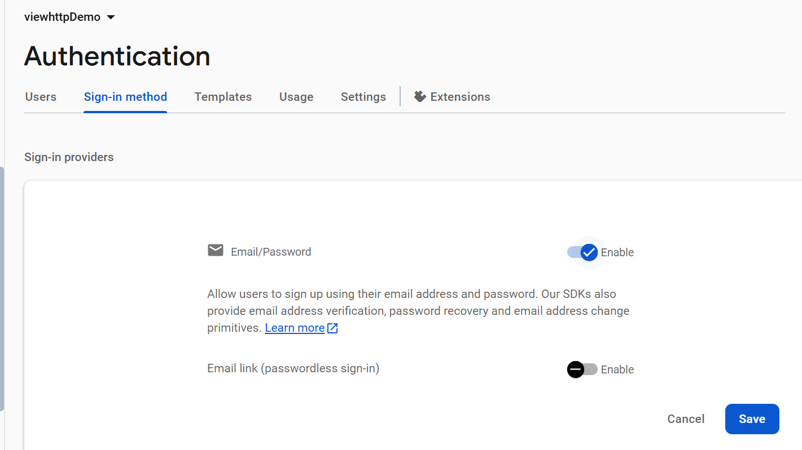

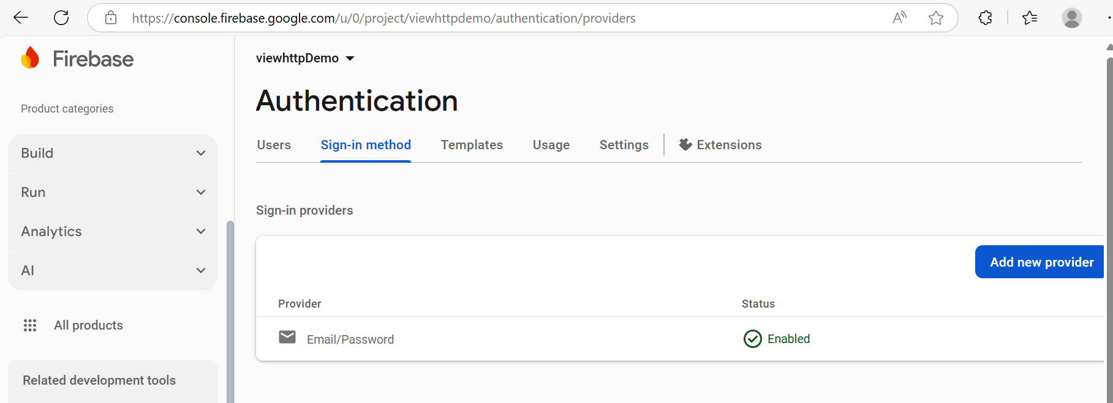

*Then we need to create the signup and login using the API provided firebase., otherwise validation/authentication won’t work. Search for firebase api for email and password validation*

***URL for SignUP:*** https://identitytoolkit.googleapis.com/v1/accounts:signUp?key=[API_KEY]

***For this API_KEY***

*Project Settings > Web API Key*

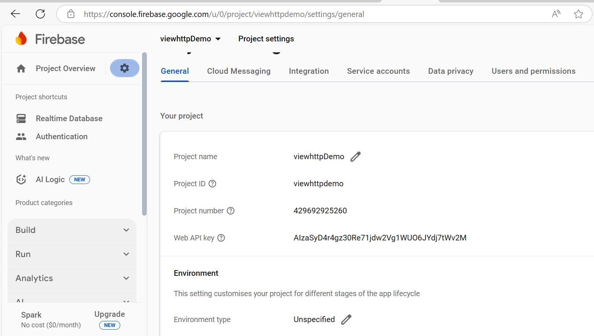

***On Signing Up: (Response from Firebase)***

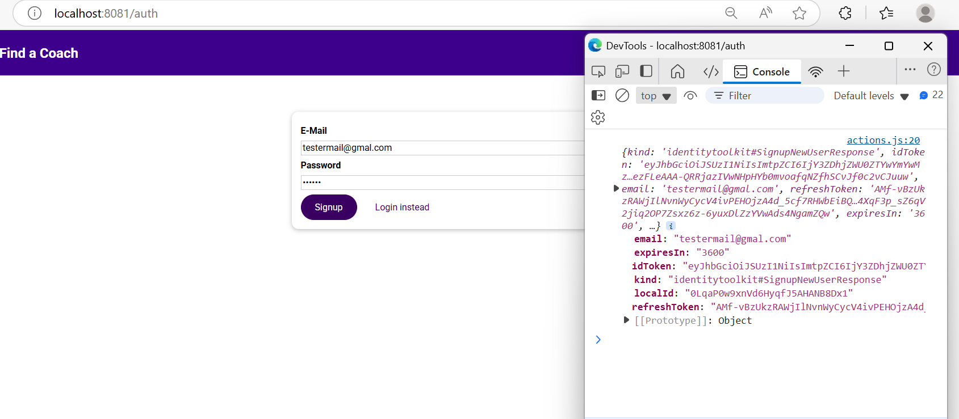

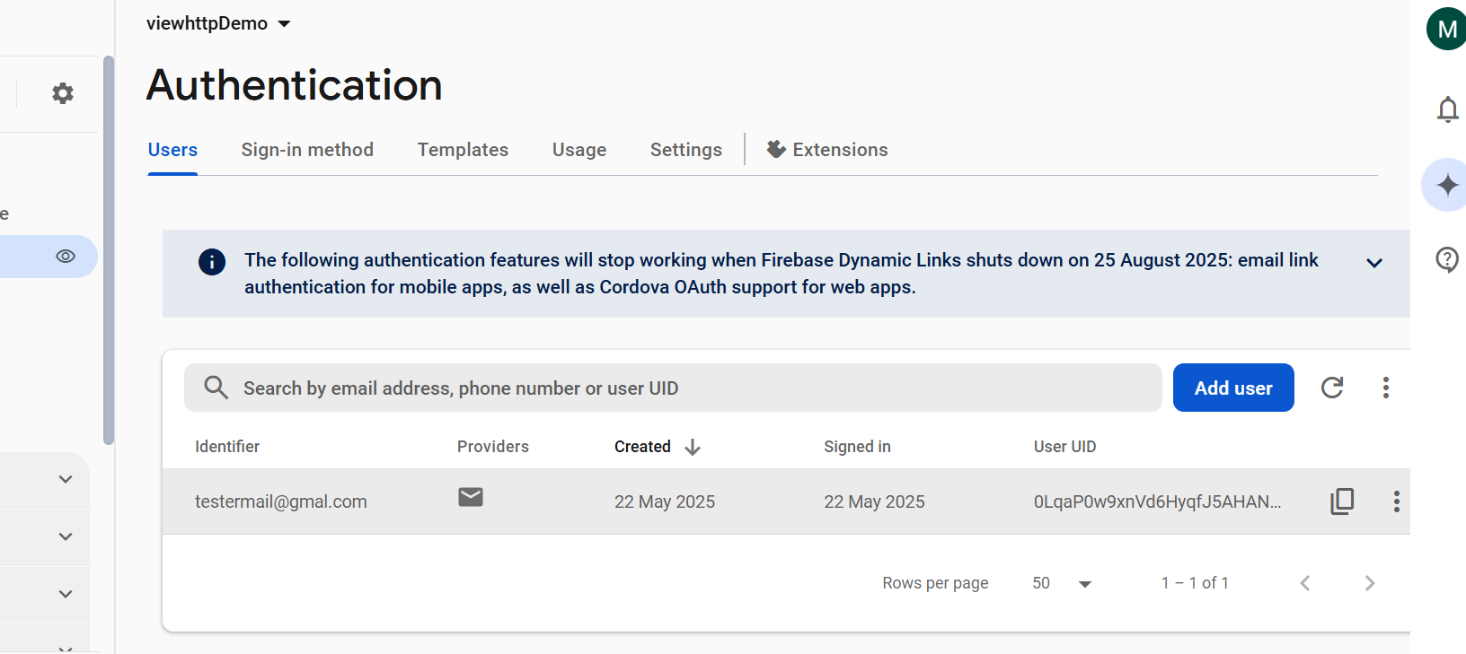

***Authentication for routes:(routes.js)***

import { createRouter, createWebHistory } from 'vue-router';

import CoachDetail from './pages/coaches/CoachDetail.vue';

import CoachesList from './pages/coaches/CoachesList.vue';

import CoachRegistation from './pages/coaches/CoachRegistration.vue';

import ContactCoach from './pages/requests/ContactCoach.vue';

import RequestsReceived from './pages/requests/RequestsReceived.vue';

import NotFound from './pages/NotFound.vue';

import UsrAuth from './pages/auth/UsrAuth.vue'

//To access the store in js file we just need to import the store

import store from './store/index.js';

const router = createRouter({

  history: createWebHistory(),

  routes: [

    { path: '/', redirect: '/coaches' },

    { path: '/coaches', component: CoachesList },

    {

      path: '/coaches/:id',

      component: CoachDetail,

      props: true,

      children: [

        { path: 'contact', component: ContactCoach } // /coaches/c1/contact

      ]

    },

    { path: '/register', component: CoachRegistation, meta: { requiresAuth: true } },

    { path: '/requests', component: RequestsReceived, meta: { requiresAuth: true } },

    { path: '/:notFound(.*)', component: NotFound },

    {path: '/auth', component: UsrAuth, meta: { requiresUnauth: true }},

  ]

});

router.beforeEach(function(to, _, next) {

  if (to.meta.requiresAuth && !store.getters.isAuthenticated) {

    next('/auth');

  } else if (to.meta.requiresUnauth && store.getters.isAuthenticated) {

    next('/coaches');

  } else {

    next();

  }

});

export default router;

***Options API:***

* *The limitations are the code that should be together logically is split across multiple properties (ie. Data, computed, methods, watch, etc)*
* *Reusing logic across components can be tricky or cumbersome*

***Composition API:***

*We bundle all our logic into a single method called “setup”*

*In setup method – we club the logics of data, computed, watch, methods. Apart from this life cycle methods too vary*

*To handle the “data” property in Composition API, vue has provided the “ref” method, which is invoked inside the “setup” method. The ref method returns the object with the value property ie a reference to the value not for the DOM element and which can be consumed in the template.(ie) it returns a reactive object with value property which when modified vue can recognize/watch those changes and make the changes in the (template) UI accordingly*

*As ref returns a value it has to be stored in constant. “setup” method runs very early during the initialization phase. “this” doesn’t represent the config data as in “options api”.*

*Note: Whatever we have defined inside the “setup” method will not be available outside for access. To access we need to return everything defined as an object*

*Inside setup , the return of the ref() method can be stored in const as the setup method runs only once. Even if we simulate the value change, it will not reflect in the UI. So we need to change the* ***value*** *property of that object and not that object directly. That’s why we call it is reactive value.*

*Note: while accessing in template we no need to access with “value” as Vue will drill down the object to that property and so can access with name alone ie with ref alone. Vue will do the rest*

*The datatype to be passed to ref() method as a initial value can be anything like string/boolen/object/……… The value passed will stored in the value property.*

***App.vue (Type 1)***

<template>

  <section class="container">

    <h2>{{ userName }}</h2>

  </section>

</template>

<script>

import { ref } from 'vue';

export default {

  //Options API syntax

  // data() {

  //   return {

  //     userName: 'Maximilian',

  //   };

  // },

  //Composition API syntax

  setup() {

    const userName = ref('Maximilian');

    //we need to change the value property to get the changes reflected

    setTimeout(() => {

      userName.value = 'Max';

    }, 2000);

    return { userName };

  },

};

</script>

<style>

* {

  box-sizing: border-box;

}

html {

  font-family: sans-serif;

}

body {

  margin: 0;

}

.container {

  margin: 3rem auto;

  max-width: 30rem;

  border-radius: 12px;

  box-shadow: 0 2px 8px rgba(0, 0, 0, 0.26);

  padding: 1rem;

  text-align: center;

}

</style>

***Type 2: (setup() method is replaced with setup attribute in <script> tag and no return is required in this type***

<template>

  <section class="container">

    <h2>{{ userName }}</h2>

  </section>

</template>

<script setup>

import { ref } from 'vue';

  //Composition API syntax

    const userName = ref('Maximilian');

    //we need to change the value property to get the changes

    setTimeout(() => {

      userName.value = 'Max';

    }, 2000);

</script>

<style>

* {

  box-sizing: border-box;

}

html {

  font-family: sans-serif;

}

body {

  margin: 0;

}

.container {

  margin: 3rem auto;

  max-width: 30rem;

  border-radius: 12px;

  box-shadow: 0 2px 8px rgba(0, 0, 0, 0.26);

  padding: 1rem;

  text-align: center;

}

</style>

***The update of the value is not reflecting as we are exposing just the value and not the reference***

<template>

  <section class="container">

    <h2>{{ userName }}</h2>

    <h3>Age: {{ age }}</h3>

  </section>

</template>

<script>

import { ref } from 'vue';

export default {

 setup(){

  //Composition API syntax

  //clubbing below into a single object and creating ref

    // const userName = ref('Maximilian');

    // const age = ref(31);

    const user = ref({

      name: 'Maximilian',

      age: 31

    });

    //we need to change the value property to get the changes

    //Note in this the value will not get reflected after 2 seconds

    //This is because we are exposing not a ref just the value after drilling to it's lower lever.

    setTimeout(() => {

      user.value.name = 'Max';

      user.value.age = 32;

    }, 2000);

    return {userName: user.value.name, age: user.value.age};

 }

}

</script>

<style>

* {

  box-sizing: border-box;

}

html {

  font-family: sans-serif;

}

body {

  margin: 0;

}

.container {

  margin: 3rem auto;

  max-width: 30rem;

  border-radius: 12px;

  box-shadow: 0 2px 8px rgba(0, 0, 0, 0.26);

  padding: 1rem;

  text-align: center;

}

</style>

***To overcome the above issue, we can return the ref “user” and in the template we can access as an object.***

<template>

  <section class="container">

    <h2>{{ user.name }}</h2>

    <h3>Age: {{ user.age }}</h3>

  </section>

</template>

<script>

import { ref } from 'vue';

export default {

 setup(){

  //Composition API syntax

  //clubbing below into a single object and creating ref

    // const userName = ref('Maximilian');

    // const age = ref(31);

    const user = ref({

      name: 'Maximilian',

      age: 31

    });

    //we need to change the value property to get the changes

    //Note in this the value will not get reflected after 2 seconds

    //This is because we are exposing not a ref just the value after drilling to it's lower lever.

    setTimeout(() => {

      user.value.name = 'Max';

      user.value.age = 32;

    }, 2000);

    return {user};

 }

}

</script>

<style>

* {

  box-sizing: border-box;

}

html {

  font-family: sans-serif;

}

body {

  margin: 0;

}

.container {

  margin: 3rem auto;

  max-width: 30rem;

  border-radius: 12px;

  box-shadow: 0 2px 8px rgba(0, 0, 0, 0.26);

  padding: 1rem;

  text-align: center;

}

</style>

***reactive – this is only for the object whereas “ref” is for all datatypes.***

*When we create with reactive, then it will not wrap another object as in ref, so we can access like normal objects, no need of value as in ref.*

*When we dump the object we could see just proxy and other functions where as in case if ref we could see “value” property, getters and setters.*

<template>

  <section class="container">

    <h2>{{ user.name }}</h2>

    <h3>Age: {{ user.age }}</h3>

  </section>

</template>

<script>

import { reactive } from 'vue';

export default {

 setup(){

  //Composition API syntax

  //clubbing below into a single object and creating ref

    // const userName = ref('Maximilian');

    // const age = ref(31);

    const user = reactive({

      name: 'Maximilian',

      age: 31

    });

    //we need to change the value property to get the changes

    //Note in this the value will not get reflected after 2 seconds

    //This is because we are exposing not a ref just the value after drilling to it's lower lever.

    setTimeout(() => {

      user.name = 'Max';

      user.age = 32;

    }, 2000);

    return {user};

 }

}

</script>

<style>

* {

  box-sizing: border-box;

}

html {

  font-family: sans-serif;

}

body {

  margin: 0;

}

.container {

  margin: 3rem auto;

  max-width: 30rem;

  border-radius: 12px;

  box-shadow: 0 2px 8px rgba(0, 0, 0, 0.26);

  padding: 1rem;

  text-align: center;

}

</style>

***To check whether the variable or object is reactive we have the following methods (Helper methods)***

* *isRef -> ref type*
* *isReactive -> reactive type*

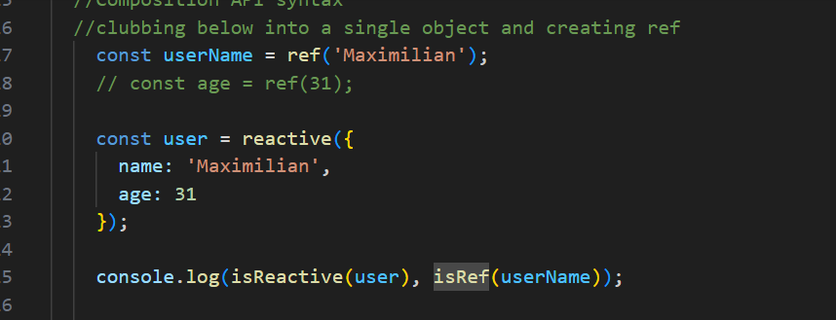

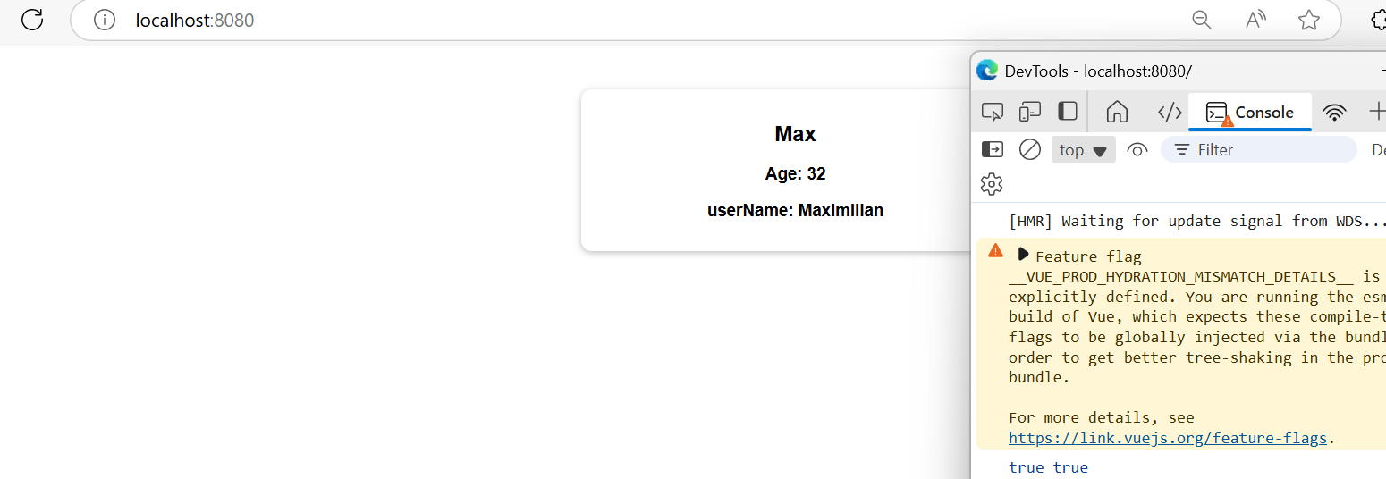

***toRefs***

*This can be used to convert not only the objects to reference but also the inner properties of an also converted to reference.*

*Now the value is updated*

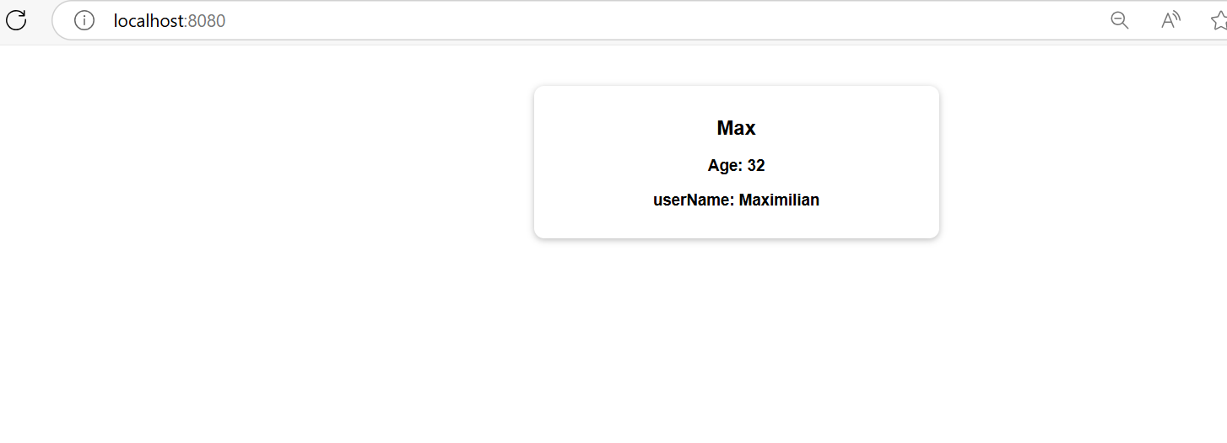

<template>

  <section class="container">

    <h2>{{ name }}</h2>

    <h3>Age: {{ age }}</h3>

    <h3>userName: {{ userName }}</h3>

  </section>

</template>

<script>

import { isReactive, reactive, ref, isRef, toRefs } from 'vue';

export default {

 setup(){

  //Composition API syntax

  //clubbing below into a single object and creating ref

    const userName = ref('Maximilian');

    // const age = ref(31);

    const user = reactive({

      name: 'Maximilian',

      age: 31

    });

    console.log(isReactive(user), isRef(userName));

    const userRef = toRefs(user);

    //we need to change the value property to get the changes

    //Note in this the value will not get reflected after 2 seconds

    //This is because we are exposing not a ref just the value after drilling to it's lower lever.

    setTimeout(() => {

      user.name = 'Max';

      user.age = 32;

    }, 2000);

    return {name: userRef.name, age: userRef.age, userName};

 }

}

</script>

<style>

* {

  box-sizing: border-box;

}

html {

  font-family: sans-serif;

}

body {

  margin: 0;

}

.container {

  margin: 3rem auto;

  max-width: 30rem;

  border-radius: 12px;

  box-shadow: 0 2px 8px rgba(0, 0, 0, 0.26);

  padding: 1rem;

  text-align: center;

}

</style>

***Options API to Composition API:***

* *Data() replaced with ref() and reactive()*
* *Methods are replaced with functions defined inside the setup function. Even functions needs to be exposed or returned as one of the property in object*
* *Computed properties are replaced with computed function*

***Functions without parameters:***

<template>

  <section class="container">

    <h2>{{ user.name }}</h2>

    <h3>Age: {{ user.age }}</h3>

    <h3>userName: {{ userName }}</h3>

    <button @click="setUserAge">Change Age</button>

  </section>

</template>

<script>

import { reactive, ref } from 'vue';

export default {

 setup(){

  //Composition API syntax

  //clubbing below into a single object and creating ref

    const userName = ref('Maximilian');

    // const age = ref(31);

    const user = reactive({

      name: 'Maximilian',

      age: 31

    });

    //we need to change the value property to get the changes

    //Note in this the value will not get reflected after 2 seconds

    //This is because we are exposing not a ref just the value after drilling to it's lower lever.

    function setUserAge() {

      user.age = 29;

    }

    return {user, userName, setUserAge};

 }

}

</script>

<style>

* {

  box-sizing: border-box;

}

html {

  font-family: sans-serif;

}

body {

  margin: 0;

}

.container {

  margin: 3rem auto;

  max-width: 30rem;

  border-radius: 12px;

  box-shadow: 0 2px 8px rgba(0, 0, 0, 0.26);

  padding: 1rem;

  text-align: center;

}

</style>

***Functions with params***

<template>

  <section class="container">

    <h2>{{ user.name }}</h2>

    <h3>Age: {{ user.age }}</h3>

    <h3>userName: {{ userName }}</h3>

    <button @click="setUserAge(40)">Change Age</button>

  </section>

</template>

<script>

import { reactive, ref } from 'vue';

export default {

 setup(){

  //Composition API syntax

  //clubbing below into a single object and creating ref

    const userName = ref('Maximilian');

    // const age = ref(31);

    const user = reactive({

      name: 'Maximilian',

      age: 31

    });

    //we need to change the value property to get the changes

    //Note in this the value will not get reflected after 2 seconds

    //This is because we are exposing not a ref just the value after drilling to it's lower lever.

    function setUserAge(age) {

      console.log('called');

      user.age = age;

    }

    return {user, userName, setUserAge};

 }

}

</script>

<style>

* {

  box-sizing: border-box;

}

html {

  font-family: sans-serif;

}

body {

  margin: 0;

}

.container {

  margin: 3rem auto;

  max-width: 30rem;

  border-radius: 12px;

  box-shadow: 0 2px 8px rgba(0, 0, 0, 0.26);

  padding: 1rem;

  text-align: center;

}

</style>

***Computed Functions:***

*The value returned by the computed functions is a computed property which is a ref but is read only we can't change the value.*

*Also we need to store the value returned by computed function in a variable to use it. Computed function is executed whenever the dependencies change*

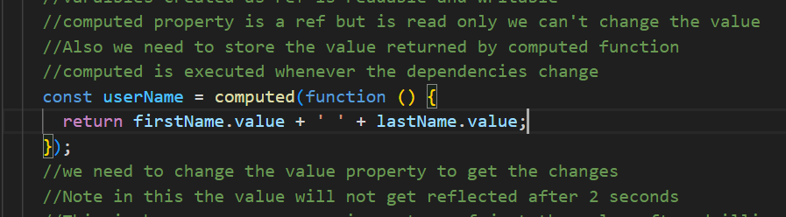

***App.vue***

<template>

  <section class="container">

    <h2>{{ user.name }}</h2>

    <h3>Age: {{ user.age }}</h3>

    <h3>userName: {{ userName }}</h3>

    <button @click="setUserAge(40)">Change Age</button>

    <input type="text" placeholder="First Name" @input="setFirstName"/>

    <input type="text" placeholder="Last Name" @input="setLastName">

  </section>

</template>

<script>

import { reactive, ref, computed } from 'vue';

export default {

 setup(){

  //Composition API syntax

  //clubbing below into a single object and creating ref

    //const userName = ref('Maximilian');

    // const age = ref(31);

    const user = reactive({

      name: 'Maximilian',

      age: 31

    });

    const firstName = ref('');

    const lastName = ref('');

    //varaibles created as ref is readable and writable

    //computed property is a ref but is read only we can't change the value

    //Also we need to store the value returned by computed function

    //computed is executed whenever the dependencies change

    const userName = computed(function () {

      return firstName.value + ' ' + lastName.value;

    });

    //we need to change the value property to get the changes

    //Note in this the value will not get reflected after 2 seconds

    //This is because we are exposing not a ref just the value after drilling to it's lower lever.

    function setUserAge(age) {

      console.log('called');

      user.age = age;

    }

    function setFirstName(event) {

      firstName.value = event.target.value;

    }

    function setLastName(event) {

      lastName.value = event.target.value;

    }

    return {user, userName, setUserAge, setFirstName, setLastName};

 }

}

</script>

<style>

* {

  box-sizing: border-box;

}

html {

  font-family: sans-serif;

}

body {

  margin: 0;

}

.container {

  margin: 3rem auto;

  max-width: 30rem;

  border-radius: 12px;

  box-shadow: 0 2px 8px rgba(0, 0, 0, 0.26);

  padding: 1rem;

  text-align: center;

}

</style>

***Two way binding (v-model)***

*For v-model too, we can just refer the ref object, vue itself will drill down to the value and update it.*

<template>

  <section class="container">

    <h2>{{ user.name }}</h2>

    <h3>Age: {{ user.age }}</h3>

    <h3>userName: {{ userName }}</h3>

    <button @click="setUserAge(40)">Change Age</button>

    <input type="text" placeholder="First Name" v-model="firstName"/>

    <input type="text" placeholder="Last Name" v-model="lastName">

  </section>

</template>

<script>

import { reactive, ref, computed } from 'vue';

export default {

 setup(){

  //Composition API syntax

  //clubbing below into a single object and creating ref

    //const userName = ref('Maximilian');

    // const age = ref(31);

    const user = reactive({

      name: 'Maximilian',

      age: 31

    });

    const firstName = ref('');

    const lastName = ref('');

    //varaibles created as ref is readable and writable

    //computed property is a ref but is read only we can't change the value

    //Also we need to store the value returned by computed function

    //computed is executed whenever the dependencies change

    const userName = computed(function () {

      return firstName.value + ' ' + lastName.value;

    });

    //we need to change the value property to get the changes

    //Note in this the value will not get reflected after 2 seconds

    //This is because we are exposing not a ref just the value after drilling to it's lower lever.

    function setUserAge(age) {

      console.log('called');

      user.age = age;

    }

    return {user, userName, setUserAge, firstName, lastName};

 }

}

</script>

<style>

* {

  box-sizing: border-box;

}

html {

  font-family: sans-serif;

}

body {

  margin: 0;

}

.container {

  margin: 3rem auto;

  max-width: 30rem;

  border-radius: 12px;

  box-shadow: 0 2px 8px rgba(0, 0, 0, 0.26);

  padding: 1rem;

  text-align: center;

}

</style>

***Watch:***

*Watch we use to watch a variable. So we need to create with the same of the variable which is to be tracked. Watch can be used to perform some background works like calling API or updating another variable when the tracking variable changes. Watch always receives the new value as method argument.*

*In composition API, the watch allows us to setup watcher inside the setup function. This Watch allows to include multiple data for tracking unlike the Options API.*

***Syntax:***

***Single variable:***

*watch(xx, oldValue, newValue)*

*where xx -> variable that is to be tracked. Even computed property also can be entered for tracking in this.*

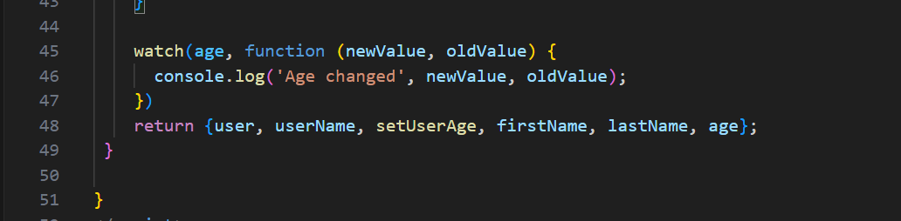

***Multiple variable:***

*watch([xx,yy], [oldvalues],[newvalues])*

*where*

*[xx, yy] – array of variables to be tracked. There can be any of values in the array*

*[oldValues] – array of old values of each of variable to be tracked*

*[newValues] – array of new values of each of variable to be tracked*

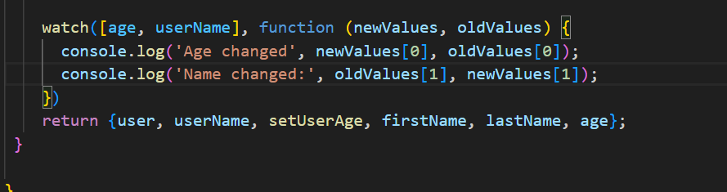

***App.vue:***

<template>

  <section class="container">

    <h2>{{ user.name }}</h2>

    <h3>Age: {{ age }}</h3>

    <h3>userName: {{ userName }}</h3>

    <button @click="setUserAge(40)">Change Age</button>

    <input type="text" placeholder="First Name" v-model="firstName"/>

    <input type="text" placeholder="Last Name" v-model="lastName">

  </section>

</template>

<script>

import { reactive, ref, computed, watch} from 'vue';

export default {

 setup(){

  //Composition API syntax

  //clubbing below into a single object and creating ref

    //const userName = ref('Maximilian');

    const age = ref(31);

    const user = reactive({

      name: 'Maximilian',

      age: 31

    });

    const firstName = ref('');

    const lastName = ref('');

    //varaibles created as ref is readable and writable

    //computed property is a ref but is read only we can't change the value

    //Also we need to store the value returned by computed function

    //computed is executed whenever the dependencies change

    const userName = computed(function () {

      return firstName.value + ' ' + lastName.value;

    });

    //we need to change the value property to get the changes

    //Note in this the value will not get reflected after 2 seconds

    //This is because we are exposing not a ref just the value after drilling to it's lower lever.

    function setUserAge(modified) {

      console.log('called');

      age.value = modified;

    }

    watch([age, userName], function (newValues, oldValues) {

      console.log('Age changed', newValues[0], oldValues[0]);

      console.log('Name changed:', oldValues[1], newValues[1]);

    })

    return {user, userName, setUserAge, firstName, lastName, age};

 }

}

</script>

<style>

* {

  box-sizing: border-box;

}

html {

  font-family: sans-serif;

}

body {

  margin: 0;

}

.container {

  margin: 3rem auto;

  max-width: 30rem;

  border-radius: 12px;

  box-shadow: 0 2px 8px rgba(0, 0, 0, 0.26);

  padding: 1rem;

  text-align: center;

}

</style>

***Template Ref (HTML Element Ref)***

*For this we need to create the ref for the element using the same ref() method by passing a value as null inside the setup method.*

*Then set to html element using the “ref” attribute*

***To access the value using ref of HTML element:***

***xxxx.value.value***

*where xxxx – name of the reference variable*

*The value attribute of “xxxx” stores the reference to the input element and the input element will have the value property to access value. So only “value.value” is used to access the value in the HTML element.*

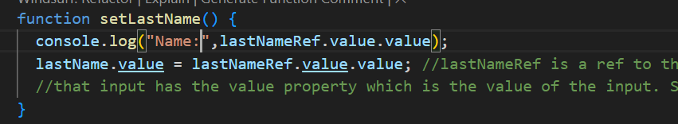

**

<template>

  <section class="container">

    <h2>{{ user.name }}</h2>

    <h3>Age: {{ age }}</h3>

    <h3>userName: {{ userName }}</h3>

    <button @click="setUserAge(40)">Change Age</button>

    <input type="text" placeholder="First Name" v-model="firstName"/>

    <input type="text" placeholder="Last Name" ref="lastNameRef"/>

    <button @click="setLastName">Set Last Name</button>

  </section>

</template>

<script>

import { reactive, ref, computed, watch} from 'vue';

export default {

 setup(){

  //Composition API syntax

  //clubbing below into a single object and creating ref

    //const userName = ref('Maximilian');

    const age = ref(31);

    const user = reactive({

      name: 'Maximilian',

      age: 31

    });

    const firstName = ref('');

    const lastName = ref('');

    const lastNameRef = ref(null);

    //varaibles created as ref is readable and writable

    //computed property is a ref but is read only we can't change the value

    //Also we need to store the value returned by computed function

    //computed is executed whenever the dependencies change

    const userName = computed(function () {

      return firstName.value + ' ' + lastName.value;

    });

    //we need to change the value property to get the changes

    //Note in this the value will not get reflected after 2 seconds

    //This is because we are exposing not a ref just the value after drilling to it's lower lever.

    function setUserAge(modified) {

      console.log('called');

      age.value = modified;

    }

    function setLastName() {

      console.log("Name:",lastNameRef.value.value);

      lastName.value = lastNameRef.value.value; //lastNameRef is a ref to the input which is stored in the value property.

      //that input has the value property which is the value of the input. So only we are using "lastNameRef.value.value"

    }

    watch([age, userName], function (newValues, oldValues) {

      console.log('Age changed', newValues[0], oldValues[0]);

      console.log('Name changed:', oldValues[1], newValues[1]);

    })

    return {user, userName, setUserAge, firstName, lastName, age, setLastName, lastNameRef};

 }

}

</script>

<style>

* {

  box-sizing: border-box;

}

html {

  font-family: sans-serif;

}

body {

  margin: 0;

}

.container {

  margin: 3rem auto;

  max-width: 30rem;

  border-radius: 12px;

  box-shadow: 0 2px 8px rgba(0, 0, 0, 0.26);

  padding: 1rem;

  text-align: center;

}

</style>

***Props in composition API:***

*Both Options API and Composition API have the same logic*

***UserData.vue***

<template>

<h2> {{ name }} </h2>

<h3> {{ age }} </h3>

</template>

<script>

export default {

    props: ['name', 'age'],

};

</script>

***App.vue:***

<template>

  <section class="container">

    <!-- <h2>{{ user.name }}</h2>

    <h3>Age: {{ age }}</h3> -->

    <UserData :name="user.name" :age="age"></UserData>

    <h3>userName: {{ userName }}</h3>

    <button @click="setUserAge(40)">Change Age</button>

    <input type="text" placeholder="First Name" v-model="firstName"/>

    <input type="text" placeholder="Last Name" ref="lastNameRef"/>

    <button @click="setLastName">Set Last Name</button>

  </section>

</template>

<script>

import { reactive, ref, computed, watch} from 'vue';

import UserData from './components/UserData.vue';

export default {

   components: {

    UserData

  },

 setup(){

  //Composition API syntax

  //clubbing below into a single object and creating ref

    //const userName = ref('Maximilian');

    const age = ref(31);

    const user = reactive({

      name: 'Maximilian',

      age: 31

    });

    const firstName = ref('');

    const lastName = ref('');

    const lastNameRef = ref(null);

    //varaibles created as ref is readable and writable

    //computed property is a ref but is read only we can't change the value

    //Also we need to store the value returned by computed function

    //computed is executed whenever the dependencies change

    const userName = computed(function () {

      return firstName.value + ' ' + lastName.value;

    });

    //we need to change the value property to get the changes

    //Note in this the value will not get reflected after 2 seconds

    //This is because we are exposing not a ref just the value after drilling to it's lower lever.

    function setUserAge(modified) {

      console.log('called');

      age.value = modified;

    }

    function setLastName() {

      console.log("Name:",lastNameRef.value.value);

      lastName.value = lastNameRef.value.value; //lastNameRef is a ref to the input which is stored in the value property.

      //that input has the value property which is the value of the input. So only we are using "lastNameRef.value.value"

    }

    watch([age, userName], function (newValues, oldValues) {

      console.log('Age changed', newValues[0], oldValues[0]);

      console.log('Name changed:', oldValues[1], newValues[1]);

    })

    return {user, userName, setUserAge, firstName, lastName, age, setLastName, lastNameRef};

 }

}

</script>

<style>

* {

  box-sizing: border-box;

}

html {

  font-family: sans-serif;

}

body {

  margin: 0;

}

.container {

  margin: 3rem auto;

  max-width: 30rem;

  border-radius: 12px;

  box-shadow: 0 2px 8px rgba(0, 0, 0, 0.26);

  padding: 1rem;

  text-align: center;

}

</style>

*Note: We can use both Options API and Composition API in a single project. Ie we can use Options API in one component and Options API in another component of the same appln.*

*To access props within setup:*

*The setup will always have the props object in the argument. If the component has not received any prop, then it will be empty. The props object itself reactive, so whenever changes happen in the props, changes will take place in the component accordingly. Say in computed property any property is dependent on this changed prop, then that property will be recalculated.*

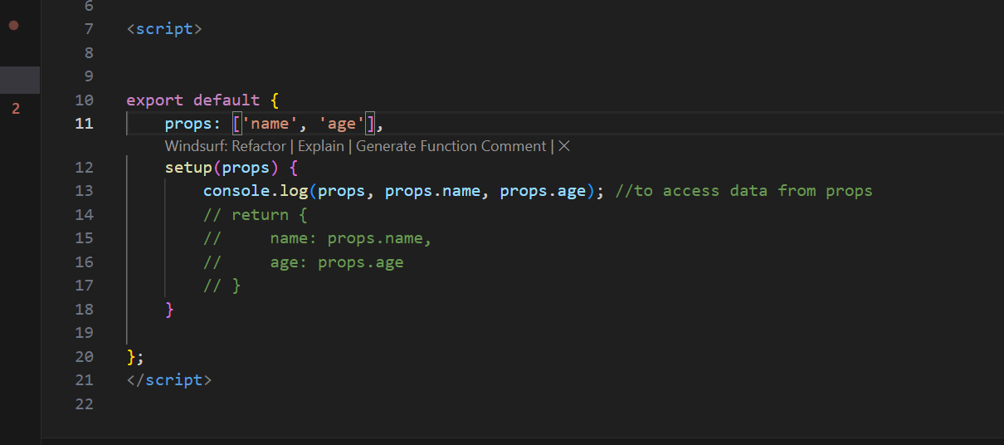

***Another parameter the setup() method receives is the “context” and is required now.***

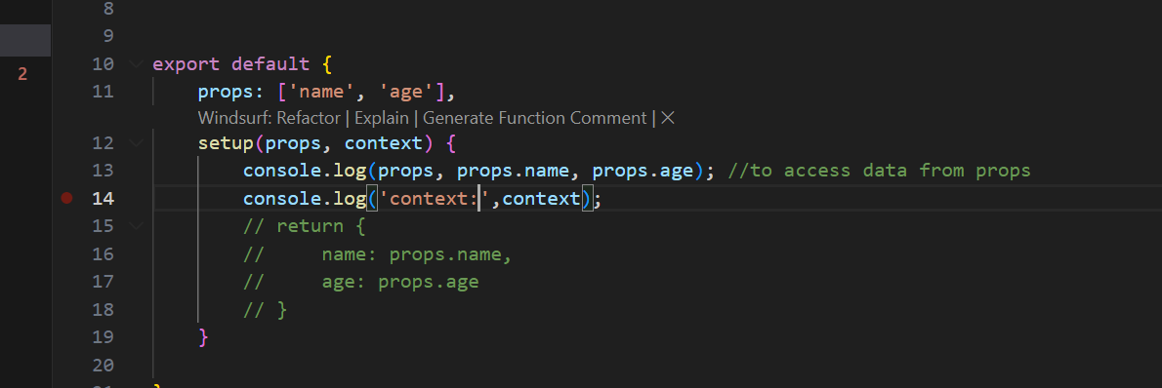

*The context has the following*

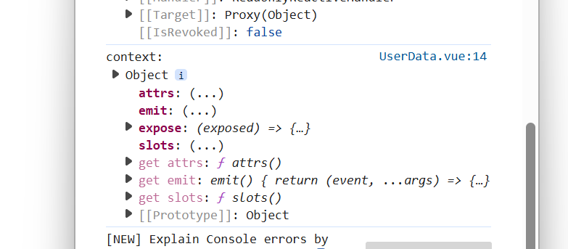

*Where attrs – is the false proof attribute. Ie if any attribute is not defined then it is called false prrof attribute*

*Slots -> provides the slots defined in that component*

*Emit -> used for emitting custom events*

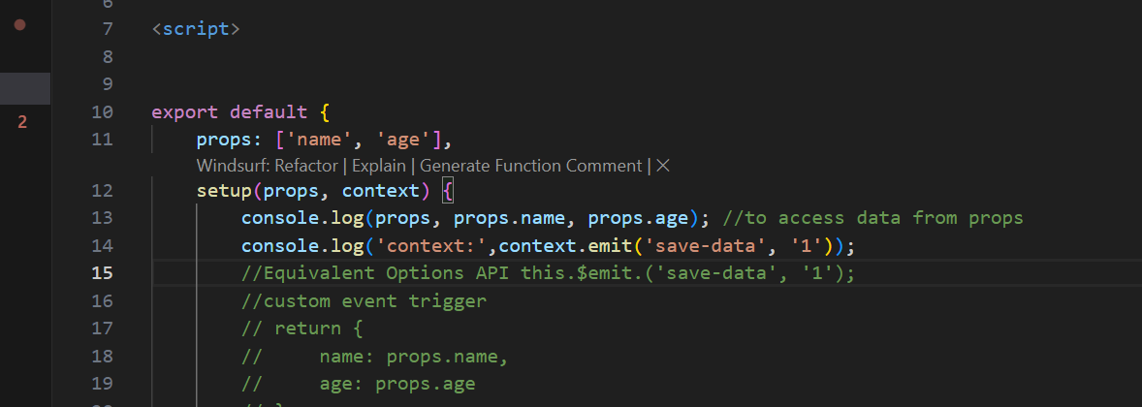

*Provide and Inject:*

*Provide is a method which should be imported from vue. It has to be defined inside setup() method.*

*Syntax:*

*provide(xx,yy)*

*xx – key of our choice (identifier used to access the provider)*

*yy -> actual value that is to be provided.*

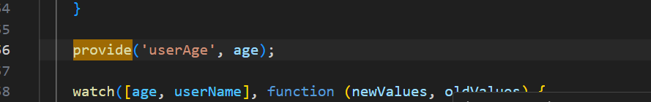

*Inject is a method use to access the provided objects*

*Inject(xx) ---🡪 xx – identifier used during providing*

*The output received has to be assigned to a variable and returned to expose*

***Life Cycle Methods:***

* *onBeforeMount*
* *onMounted*
* *onBeforeUpdate*
* *onUpdated*
* *onBeforeUnmount*
* *onUnmounted*

*In composition API we don’t have equivalent to beforeCreate() and created() methods as “setup()” method itself runs at the same time ie initialization.*

*All these lifecycle methods have to be included in the setup() method*

<template>

  <section class="container">

    <!-- <h2>{{ user.name }}</h2>

    <h3>Age: {{ age }}</h3> -->

    <UserData :name="userName" ></UserData>

    <h3>userName: {{ userName }}</h3>

    <button @click="setUserAge(40)">Change Age</button>

    <input type="text" placeholder="First Name" v-model="firstName"/>

    <input type="text" placeholder="Last Name" ref="lastNameRef"/>

    <button @click="setLastName">Set Last Name</button>

  </section>

</template>

<script>

import { reactive, ref, computed, watch, provide, onBeforeMount, onMounted, onBeforeUpdate, onUpdated, onBeforeUnmount, onUnmounted} from 'vue';

import UserData from './components/UserData.vue';

export default {

   components: {

    UserData

  },

 setup(){

  //Composition API syntax

  //clubbing below into a single object and creating ref

    //const userName = ref('Maximilian');

    const age = ref(31);

    const user = reactive({

      name: 'Maximilian',

      age: 31

    });

    const firstName = ref('');

    const lastName = ref('');

    const lastNameRef = ref(null);

    //varaibles created as ref is readable and writable

    //computed property is a ref but is read only we can't change the value

    //Also we need to store the value returned by computed function

    //computed is executed whenever the dependencies change

    const userName = computed(function () {

      return firstName.value + ' ' + lastName.value;

    });

    //we need to change the value property to get the changes

    //Note in this the value will not get reflected after 2 seconds

    //This is because we are exposing not a ref just the value after drilling to it's lower lever.

    function setUserAge(modified) {

      console.log('called');

      age.value = modified;

    }

    function setLastName() {

      console.log("Name:",lastNameRef.value.value);

      lastName.value = lastNameRef.value.value; //lastNameRef is a ref to the input which is stored in the value property.

      //that input has the value property which is the value of the input. So only we are using "lastNameRef.value.value"

    }

    provide('userAge', age);

    watch([age, userName], function (newValues, oldValues) {

      console.log('Age changed', newValues[0], oldValues[0]);

      console.log('Name changed:', oldValues[1], newValues[1]);

    })

    onBeforeMount(function () {

      console.log('onBeforeMount');

    })

    onMounted(function () {

      console.log('onMounted');

    })

    onBeforeUpdate(function () {

      console.log('onBeforeUpdate');

    })

    onUpdated(function () {

      console.log('onUpdated');

    })

    onBeforeUnmount(function () {

      console.log('onBeforeUnmount');

    })

    onUnmounted(function () {

      console.log('onUnmounted');

    })

    return {user, userName, setUserAge, firstName, lastName, age, setLastName, lastNameRef};

 }

}

</script>

<style>

* {

  box-sizing: border-box;

}

html {

  font-family: sans-serif;

}

body {

  margin: 0;

}

.container {

  margin: 3rem auto;

  max-width: 30rem;

  border-radius: 12px;

  box-shadow: 0 2px 8px rgba(0, 0, 0, 0.26);

  padding: 1rem;

  text-align: center;

}

</style>

***Routing – Compostion API***

*If we need to navigation to same page we are in but with different data then to accomplish this by moving all dynamic data to computed() method.*

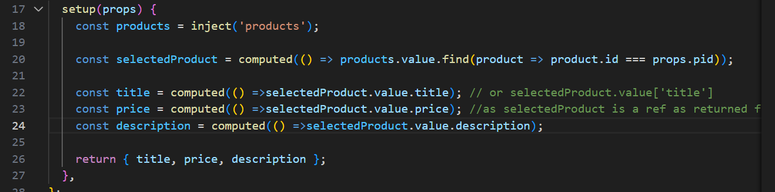

*Since in composition API we don’t have “this” we can’t access the dynamic route params using “this.$route.params.xxx” where xxx – dynamic param*

*So overcome this issue we can enable “props=true” while setting the router*

**

*Accessing the data*

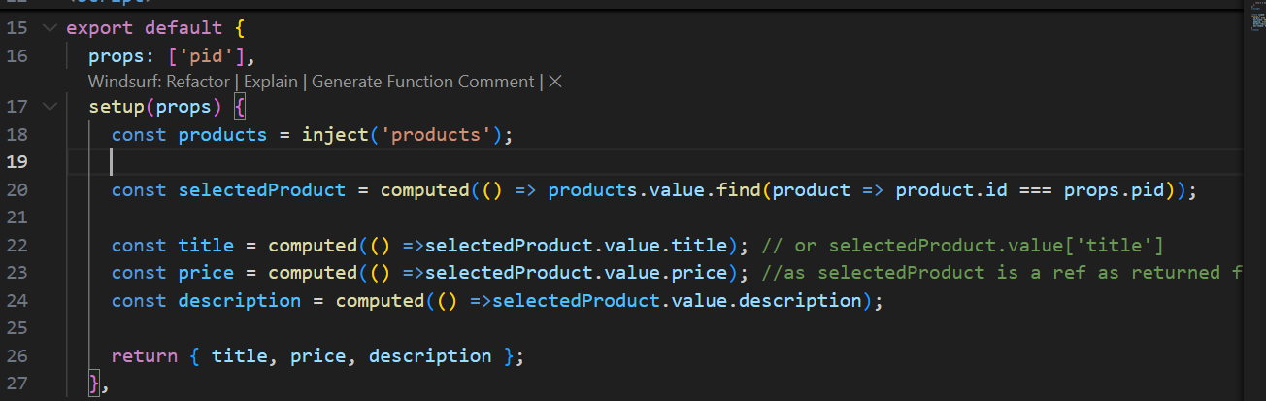

<template>

  <section>

    <h2>{{ title }}</h2>

    <h3>${{ price}}</h3>

    <p>{{ description}}</p>

    <!-- Since below is going to load in the same page data will not update so move

    all the data extracting logic to the computed property of the component -->

    <router-link to="/products/p2">Product 2</router-link>

  </section>

</template>

<script>

import {  inject, computed } from 'vue';

export default {

  props: ['pid'],

  setup(props) {

    const products = inject('products');

    const selectedProduct = computed(() => products.value.find(product => product.id === props.pid));

    const title = computed(() =>selectedProduct.value.title); // or selectedProduct.value['title']

    const price = computed(() =>selectedProduct.value.price); //as selectedProduct is a ref as returned from computed method so we need to use value property to access the value

    const description = computed(() =>selectedProduct.value.description);

    return { title, price, description };

  },

};

</script>

<style scoped>

section {

  margin: 3rem auto;

  max-width: 40rem;

  padding: 1rem;

  border-radius: 12px;

  box-shadow: 0 2px 8px rgba(0, 0, 0, 0.26);

}

</style>

**Composable or Hooks or Custom composition functions:**

*A***composable***is a function that leverages***Vue's***Composition API to encapsulate and reuse stateful logic.*

*We can use “useRoute” hook from vue-router access the same details we get while using this.$route. This hooks return a reactive object. Since it is reactive we can watch it / enclose with computed properties*

*useRoute is useful to read all url related details like path,query.params etc…*

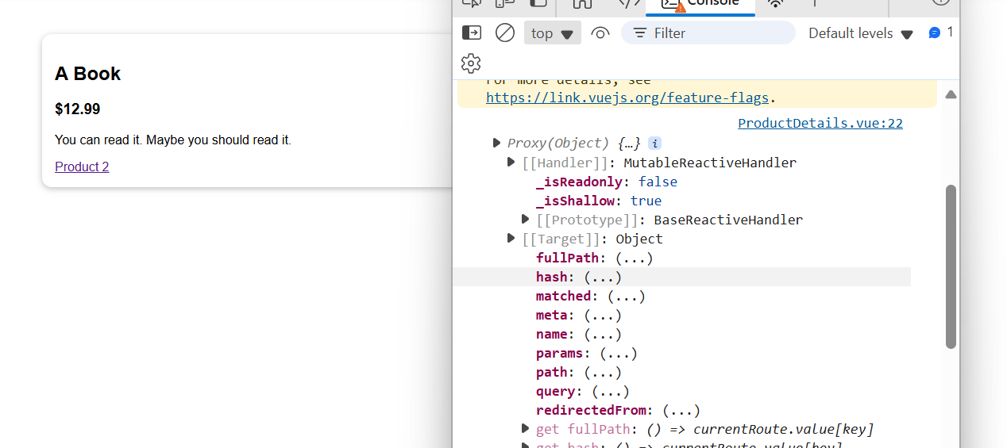

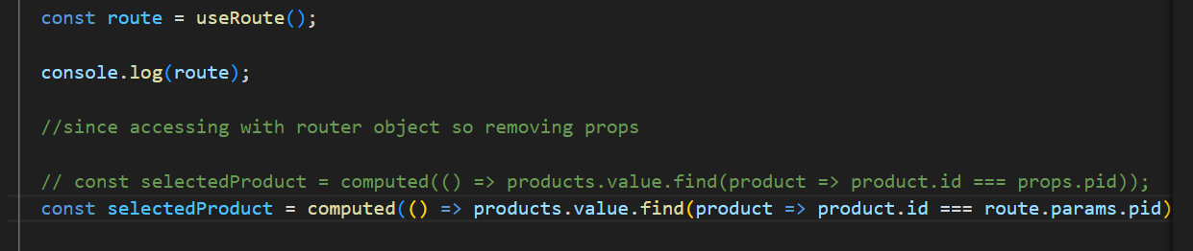

***ProductDetails.vue***

<template>

  <section>

    <h2>{{ title }}</h2>

    <h3>${{ price}}</h3>

    <p>{{ description}}</p>

    <!-- Since below is going to load in the same page data will not update so move

    all the data extracting logic to the computed property of the component -->

    <router-link to="/products/p2">Product 2</router-link>

  </section>

</template>

<script>

import {  inject, computed } from 'vue';

import { useRoute } from 'vue-router';

export default {

  props: ['pid'],

  setup() {

    const products = inject('products');

    const route = useRoute();

    console.log(route);

    //since accessing with router object so removing props

    // const selectedProduct = computed(() => products.value.find(product => product.id === props.pid));

    const selectedProduct = computed(() => products.value.find(product => product.id === route.params.pid));

    const title = computed(() =>selectedProduct.value.title); // or selectedProduct.value['title']

    const price = computed(() =>selectedProduct.value.price); //as selectedProduct is a ref as returned from computed method so we need to use value property to access the value

    const description = computed(() =>selectedProduct.value.description);

    return { title, price, description };

  },

};

</script>

<style scoped>

section {

  margin: 3rem auto;

  max-width: 40rem;

  padding: 1rem;

  border-radius: 12px;

  box-shadow: 0 2px 8px rgba(0, 0, 0, 0.26);

}

</style>

***useRouter*** *-> this hook is useful to programmatically navigate to the desired url*

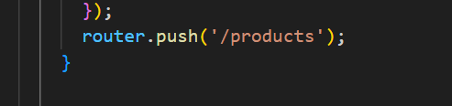

***AddProduct.vue***

<template>

  <section>

    <h2>Add a products</h2>

    <form @submit.prevent="submitForm">

      <div>

        <label for="title">Title</label>

        <input type="text" id="title" v-model="enteredTitle" />

      </div>

      <div>

        <label for="price">Price</label>

        <input type="number" id="price" v-model.number="enteredPrice" />

      </div>

      <div>

        <label for="description">Description</label>

        <textarea rows="5" id="description" v-model="enteredDescription"></textarea>

      </div>

      <button>Add Product</button>

    </form>

  </section>

</template>

<script>

import { ref, inject } from 'vue';

import { useRouter } from 'vue-router';

export default {

  setup() {

    const addProduct = inject('addProduct');

    const router = useRouter();

    const enteredTitle = ref('');

    const enteredPrice = ref(null);

    const enteredDescription = ref('');

    function submitForm() {

      addProduct({

        title: enteredTitle,

        description: enteredDescription,

        price: enteredPrice,

      });

      router.push('/products');

    }

    return {

      enteredTitle,

      enteredPrice,

      enteredDescription,

      submitForm,

    };

  },

};

</script>

<style scoped>

section {

  margin: 3rem auto;

  max-width: 40rem;

  padding: 1rem;

  border-radius: 12px;

  box-shadow: 0 2px 8px rgba(0, 0, 0, 0.26);

}

input,

label,

textarea {

  display: block;

  width: 100%;

}

label {

  font-weight: bold;

}

input,

textarea {

  font: inherit;

  margin-bottom: 0.5rem;

}

button {

  font: inherit;

  background-color: #570080;

  border: 1px solid #570080;

  color: white;

  padding: 0.5rem 1.5rem;

  cursor: pointer;

}

button:hover,

button:active {

  background-color: #220031;

  border-color: #220031;

}

</style>

***Vuex: Rest other functionality can be used as usual other than specified below***

***useStore() ->*** *This hook is used to access the getters, actions etc. an alternative to “this.$store”*

***main.js:***

import { createApp } from 'vue';

import { createStore } from 'vuex';

import App from './App.vue';

const store = createStore({

  state() {

    return {

      counter: 0

    }

  },

  mutations: {

    increment(state) {

      state.counter++;

    }

  },

  actions: {

    increment(context) {

      context.commit('increment');

    }

  },

  getters: {

    counter(state) {

      return state.counter

    }

  }

});

const app = createApp(App);

app.use(store);

app.mount('#app');

***TheCounter.vue***

<template>

  <h2>{{ counter }}</h2>

</template>

<script>

import { computed } from 'vue';

import { useStore } from 'vuex';

export default {

  setup() {

    const store = useStore();

    const counter = computed(() => store.getters.counter);

    return { counter };

  },

};

</script>

***CounterCenter.vue***

<template>

  <button @click="inc">Increment</button>

</template>

<script>

import { useStore } from 'vuex';

export default {

  setup() {

    const store = useStore();

    function inc() {

      store.dispatch('increment');

    }

    return { inc };

  },

};

</script>

***Mixins: (Options API)***

*Through mixins we can share whatever we have in options like data, methods, watch etc but can’t share components as it needs to be registered where it is used*

***Mixin file:***

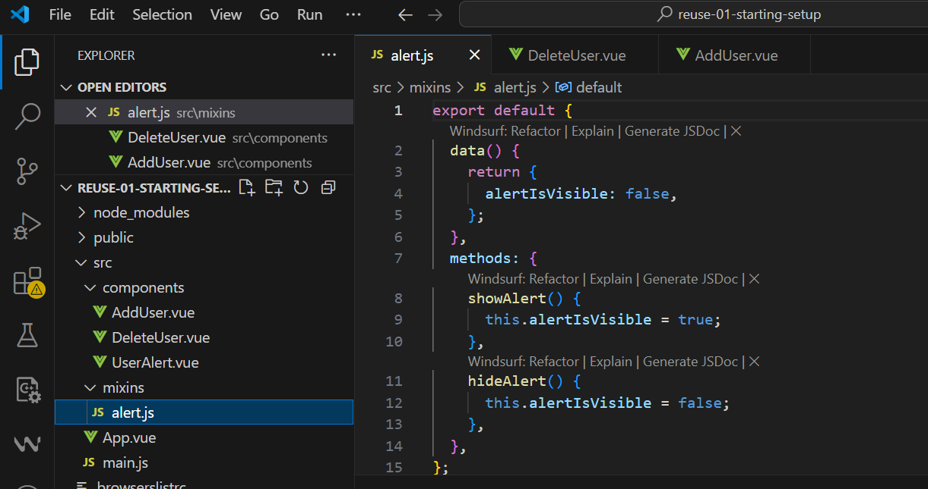

***Importing the mixins:***

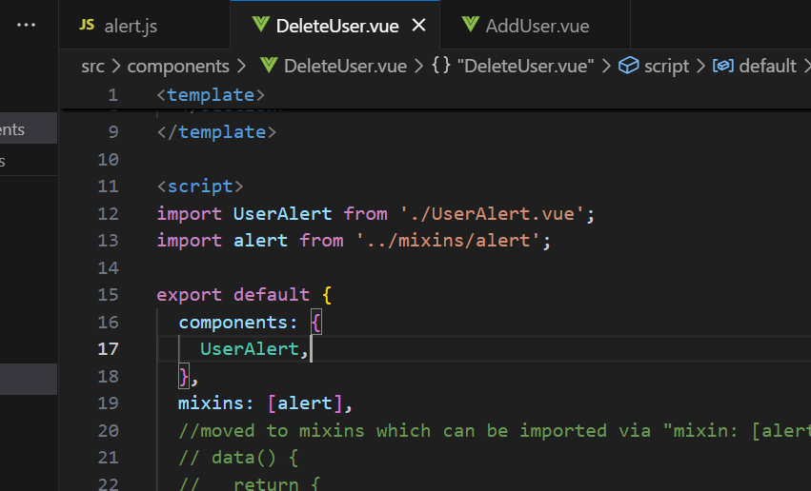

*DeleteUser.vue*

<template>

  <user-alert v-if="alertIsVisible" title="Delete the User?" @close="hideAlert">

    <p>Do you want to continue with deleting a user?</p>

  </user-alert>

  <section>

    <h2>Delete a User</h2>

    <button @click="showAlert">Delete User</button>

  </section>

</template>

<script>

import UserAlert from './UserAlert.vue';

import alert from '../mixins/alert';

export default {

  components: {

    UserAlert,

  },

  mixins: [alert],

  //moved to mixins which can be imported via "mixin: [alert]"

  // data() {

  //   return {

  //     alertIsVisible: false,

  //   };

  // },

  // methods: {

  //   showAlert() {

  //     this.alertIsVisible = true;

  //   },

  //   hideAlert() {

  //     this.alertIsVisible = false;

  //   },

  // },

};

</script>

***Mixin Merge:***

*In mixin all the common logics are moved to a file and returned as an object with properties*

*If the mixin has the data setup as well as the component too has the data setup, mixin will merge both the data setup and returns the merge one.*

*If in mixin as well as well as in component if the same variable exists, then for that variable the value provided in the component takes precedence over the mixin setup.*

*For ex: “alertIsVisible = false” in mixin file, and in component “alertIsVisible = true”, after merge the final value of “alertIsVisible” is true.*

***DeleteUser.vue:***

<template>

  <user-alert v-if="alertIsVisible" :title="title" @close="hideAlert">

    <p>Do you want to continue with deleting a user?</p>

  </user-alert>

  <section>

    <h2>Delete a User</h2>

    <button @click="showAlert">Delete User</button>

  </section>

</template>

<script>

import UserAlert from './UserAlert.vue';

import alert from '../mixins/alert';

export default {

  components: {

    UserAlert,

  },

  mixins: [alert],

  data() {

    return {

      title: 'Delete User?',

    };

  }

  //moved to mixins which can be imported via "mixin: [alert]"

  // data() {

  //   return {

  //     alertIsVisible: false,

  //   };

  // },

  // methods: {

  //   showAlert() {

  //     this.alertIsVisible = true;

  //   },

  //   hideAlert() {

  //     this.alertIsVisible = false;

  //   },

  // },

};

</script>

*The provided title is displayed*

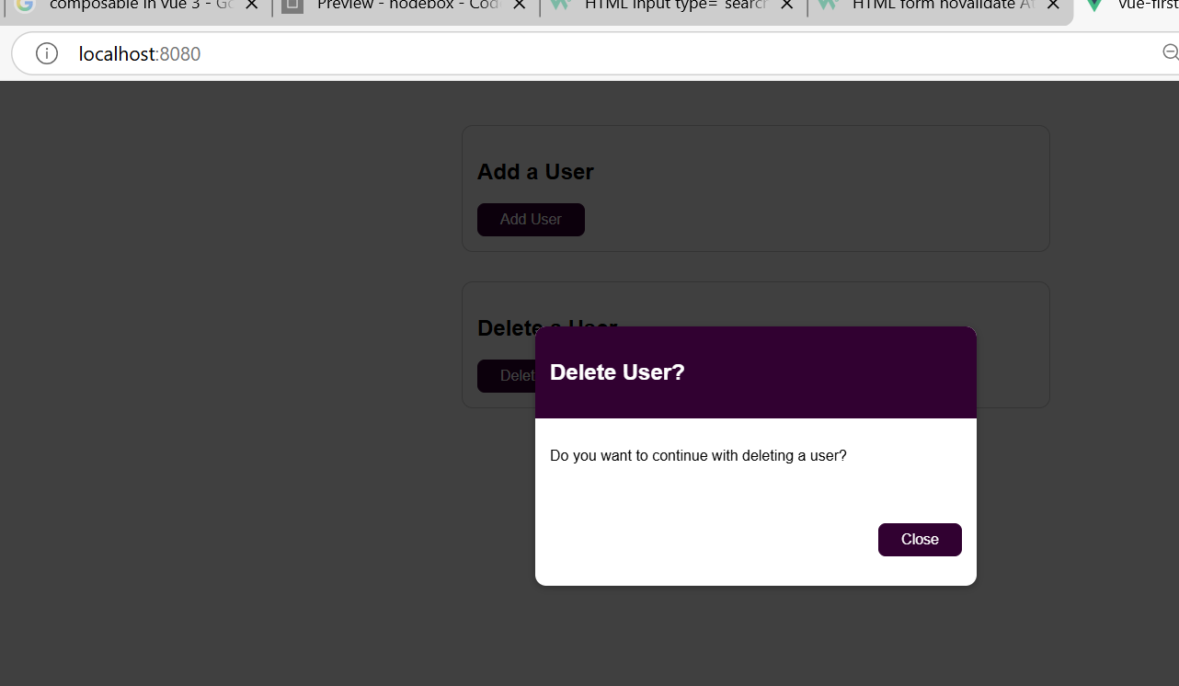

***Global Mixins:***

*These are mixins that applies to all the components in the appln. It should be registered with app in main.js file.*

***Logger.js (global mixin)***

export default{

    mounted() {

        console.log('Component mounted.');

    }

}

***main.js:***

import { createApp } from 'vue';

import App from './App.vue';

import loggerMixin from './mixins/logger';

const app = createApp(App)

app.mixin(loggerMixin);

app.mount('#app');

***Disadvantages of Mixin:***

*In case of very big applns it difficult to understand form where the functionality is comings.*

*Also merging of mixins has to be taken care of properly*

***Custom Hooks/Custom Composables:***

*In this all the common logics can be moved to function and it can be exported. The function name should begin with “use” as in hooks. Then this method has to be consumed wherever required*

***Alert.js (hook)***

import { ref } from 'vue';

const useAlert=()=>{

const alertIsVisible = ref(false);

    function showAlert() {

      alertIsVisible.value = true;

    }

    function hideAlert() {

      alertIsVisible.value = false;

    }

    return {

      alertIsVisible,

      showAlert,

      hideAlert,

    };

}

export default useAlert;

***Consuming the hook:***

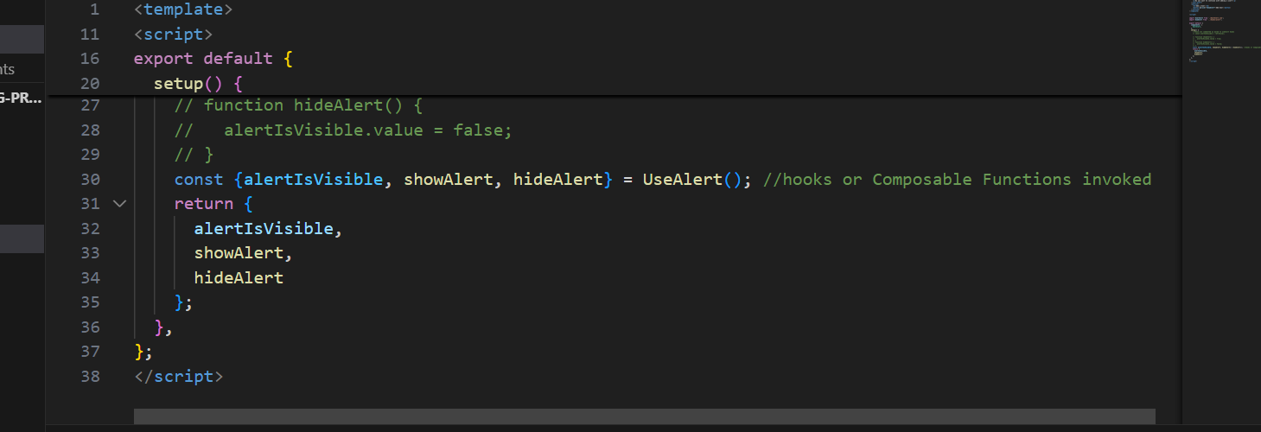

***AddUser.vue:***

<template>

  <user-alert v-if="alertIsVisible" title="Add a User?" @close="hideAlert">

    <p>Do you want to continue with adding a user?</p>

  </user-alert>

  <section>

    <h2>Add a User</h2>

    <button @click="showAlert">Add User</button>

  </section>

</template>

<script>

import UserAlert from './UserAlert.vue';

import UseAlert from '../hooks/alert';

export default {

  components: {

    UserAlert,

  },

  setup() {

    //These are commented as moved to useAlert hooks

    // const alertIsVisible = ref(false);

    // function showAlert() {

    //   alertIsVisible.value = true;

    // }

    // function hideAlert() {

    //   alertIsVisible.value = false;

    // }

    const {alertIsVisible, showAlert, hideAlert} = UseAlert(); //hooks or Composable Functions invoked

    return {

      alertIsVisible,

      showAlert,

      hideAlert

    };

  },

};

</script>

***In the invoked component we can additional data/computed/watch function too***

*“alertTitle” variable added in the component*

<template>

  <user-alert v-if="alertIsVisible" :title="alertTitle" @close="hideAlert">

    <p>Do you want to continue with adding a user?</p>

  </user-alert>

  <section>

    <h2>Add a User</h2>

    <button @click="showAlert">Add User</button>

  </section>

</template>

<script>

import UserAlert from './UserAlert.vue';

import UseAlert from '../hooks/alert';

import { ref } from 'vue';

export default {

  components: {

    UserAlert,

  },

  setup() {

    //These are commented as moved to useAlert hooks

    // const alertIsVisible = ref(false);

    // function showAlert() {

    //   alertIsVisible.value = true;

    // }

    // function hideAlert() {

    //   alertIsVisible.value = false;

    // }

    const alertTitle = ref('Add User?');

    const {alertIsVisible, showAlert, hideAlert} = UseAlert(); //hooks or Composable Functions invoked

    return {

      alertTitle,

      alertIsVisible,

      showAlert,

      hideAlert

    };

  },

};

</script>

*We can pass as many arguments also required to the hook as it is defined by us(****initialVisibility param is added****)*

import { ref } from 'vue';

const useAlert=(initialVisibility = false)=>{

const alertIsVisible = ref(initialVisibility);

    function showAlert() {

      alertIsVisible.value = true;

    }

    function hideAlert() {

      alertIsVisible.value = false;

    }

    return {

      alertIsVisible,

      showAlert,

      hideAlert,

    };

}

export default useAlert;

***Invoking with argument***

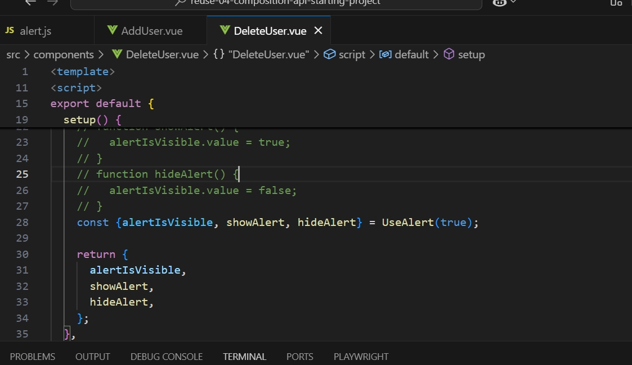

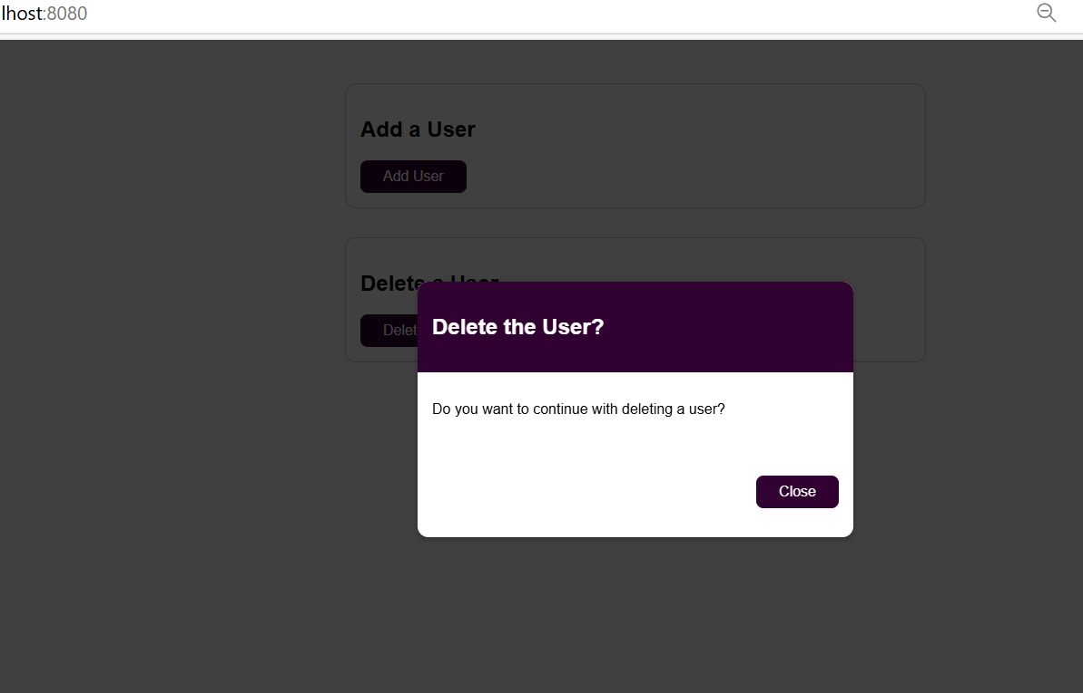

***Hooks vs Mixins:***

* *In mixin, it is difficult to identify which data or methods are defined by which mixin whereas in hooks can easily identify.*
* *Hooks are flexible to configure. We can add params to the hooks.*

***Interview Questions:***

* *Purpose of setup attribute using in <script setup >*

*In Vue.js, the <script setup> syntax is a part of the Composition API, introduced in Vue 3. The setup attribute is used to define the setup function for a Vue component.*

*The setup function is a special function in Vue that is called when the component is initialized. It's where you can define the component's reactive state, computed properties, and methods.*

*When you use <script setup>, the setup function is implicitly defined, and you can directly define your component's logic inside the script block.*

*<script setup> is a compile-time syntactic sugar for using Composition API inside Single-File Components (SFCs). It is the recommended syntax if you are using both SFCs and Composition API. It provides a number of advantages over the normal <script> syntax:*

* + *More succinct code with less boilerplate*
  + *Ability to declare props and emitted events using pure TypeScript*
  + *Better runtime performance (the template is compiled into a render function in the same scope, without an intermediate proxy)*
  + *Better IDE type-inference performance (less work for the language server to extract types from code)*

***Example:***

*<template>*

*<div>{{ count }}</div>*

*</template>*

*<script setup>*

*import { ref } from 'vue'*

*const count = ref(0)*

*function increment() {*

*count.value++*

*}*

*</script>*

*In this example, the setup function is implicitly defined, and we can directly define the count reactive state and the increment method.*

*The benefits of using <script setup> include:*

*Simplified syntax: You don't need to explicitly define the setup function.*

*Improved readability: Your component's logic is defined in a single block.*

*Better support for TypeScript: The setup function is automatically typed.*

*Note that the setup attribute is only available in Vue 3 and later versions. In Vue 2, you would need to use the data function to define the component's state.*

***Code Splitting – Route Based Lazy Loading:***

*Code splitting and lazy loading are techniques used to optimize Vue 3 applications by reducing the initial bundle size and improving loading performance. Code splitting involves dividing the application code into smaller chunks that can be loaded on demand, while lazy loading defers the loading of non-critical resources until they are needed.*

*When a appln is loaded, big app configuration downloads and all the components are bundled into couple of different files.For vuejs, it downloads all the files and loads into browser memeory.*

*It seems to be very slow when there are multiple routes (say hundreds of routes). For the desktop or web browser to download it takes sometime, that too in slower n/w it takes 3 -5 seconds which is incredibly slow. Lazy*

***Instead of this***

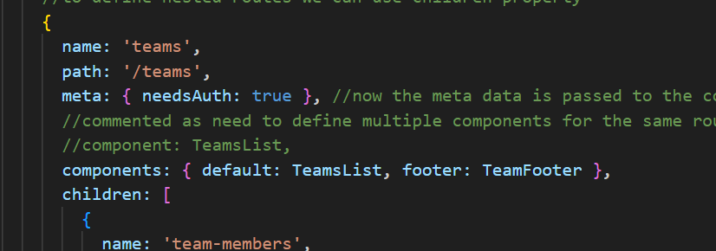

***We need to import as before for Lazy loading***

 { path: '/test', component: ()=> import('./components/teams/TeamMembers.vue'),

*Route splitting is that for each route separate chunks is created and pulled in only when the route is requested. This reduces javascript bundle size and increases the screen performance and also very important for SEO(search engine optimization)*

***Component Lazy loading:***

*In large applications, we may need to divide the app into smaller chunks and only load a component from the server when it's needed.*

*In Vue.js, defineAsyncComponent is a function that allows you to define a component that is loaded asynchronously. This can be useful for optimizing the performance of your application by loading components only when they are needed.*

***import { defineAsyncComponent } from 'vue'***

***const AsyncComponent = defineAsyncComponent({***

***loader: () => import('./AsyncComponent.vue'),***

***delay: 200,***

***timeout: 3000,***

***errorComponent: ErrorComponent,***

***loadingComponent: LoadingComponent***

***})***

*In this example, we define an async component called AsyncComponent. The loader function is used to load the component asynchronously. In this case, we're using the import function to load a Vue component from a file called AsyncComponent.vue.*

*The other options are:*

* *delay: The delay in milliseconds before the component is loaded.*
* *timeout: The timeout in milliseconds before the component is considered failed to load.*
* *errorComponent: The component to display if the async component fails to load.*
* *loadingComponent: The component to display while the async component is loading.*
* *isSuspensible: to let the component always control its own loading state or not. By default it is true for Async component, it means the Suspense” component handle the loading or error state. To override this default behaviour we need to set it as false.*

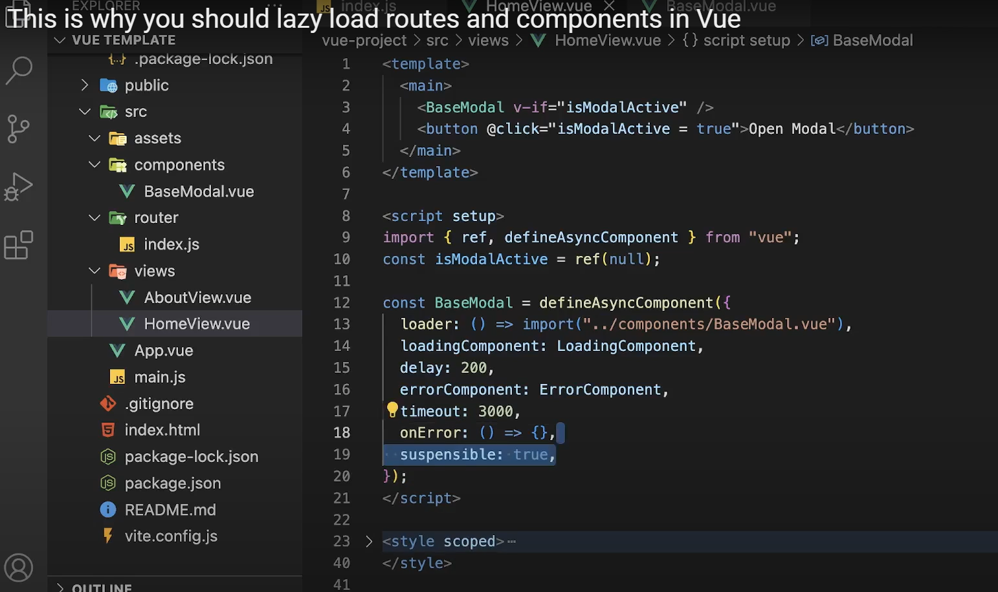

***Handling Asynchronous Components:***

*If there is some api call handled in a component, then that should be wrapped with <Suspense> component*

*Instead of conditionally rendering different components we can just use Suspense component to display fallback content.*

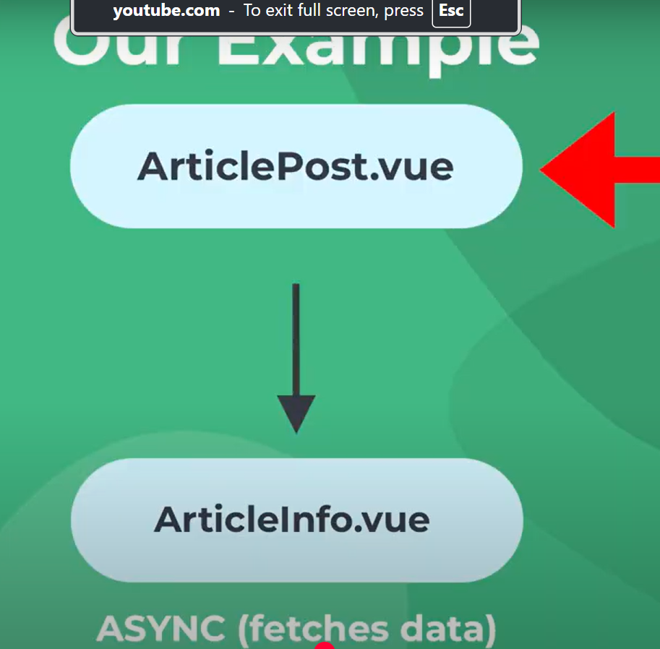

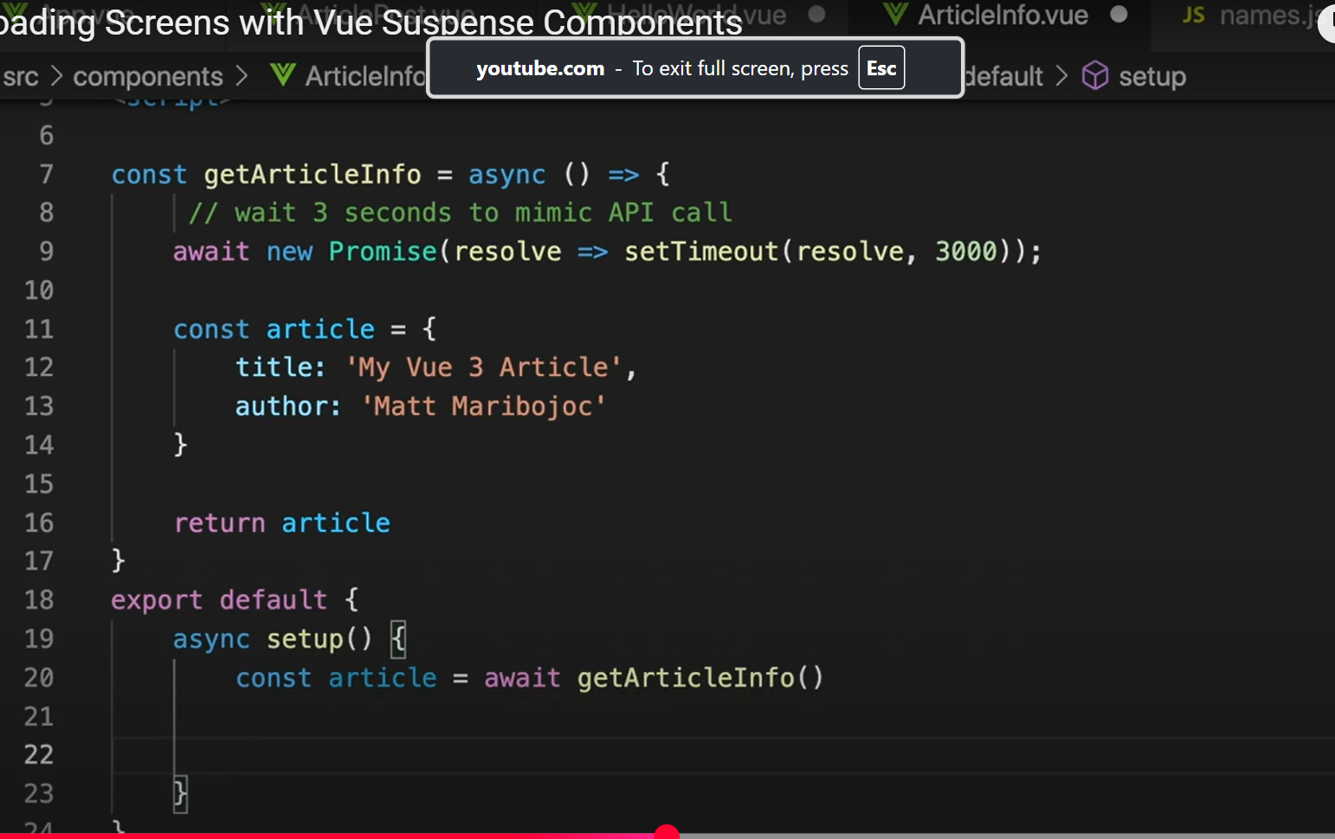

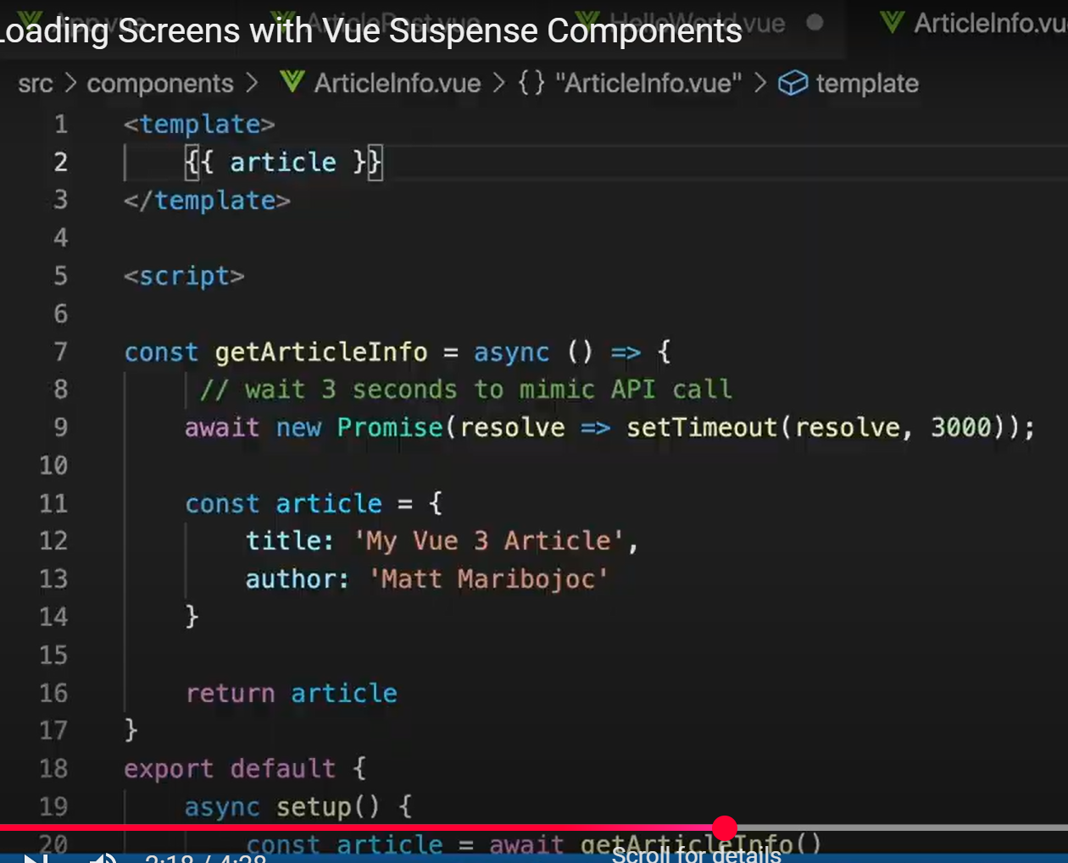

***Implementing Suspense for the asynchronous component “ArticleInfo”***

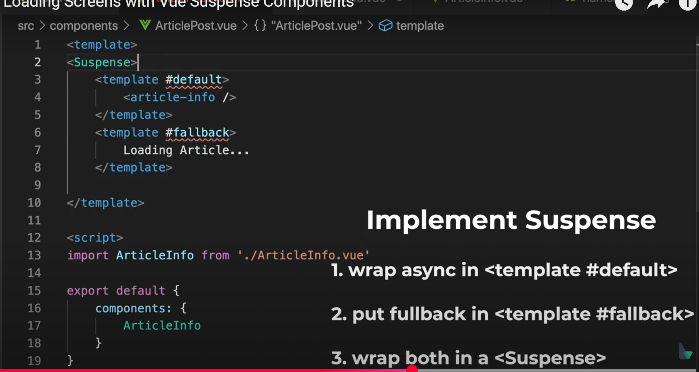

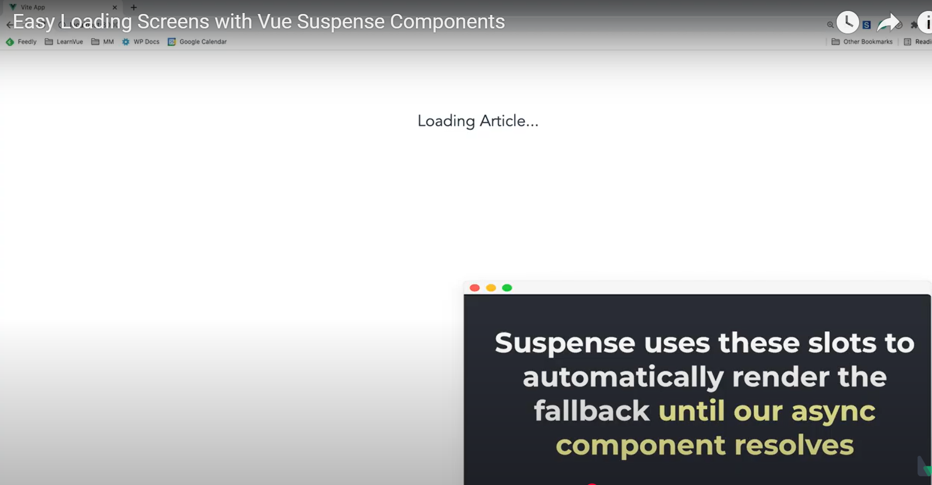

***The suspense component uses the fallback slot until the default slot is ready to go. The default slot is called when the component resolves.*** 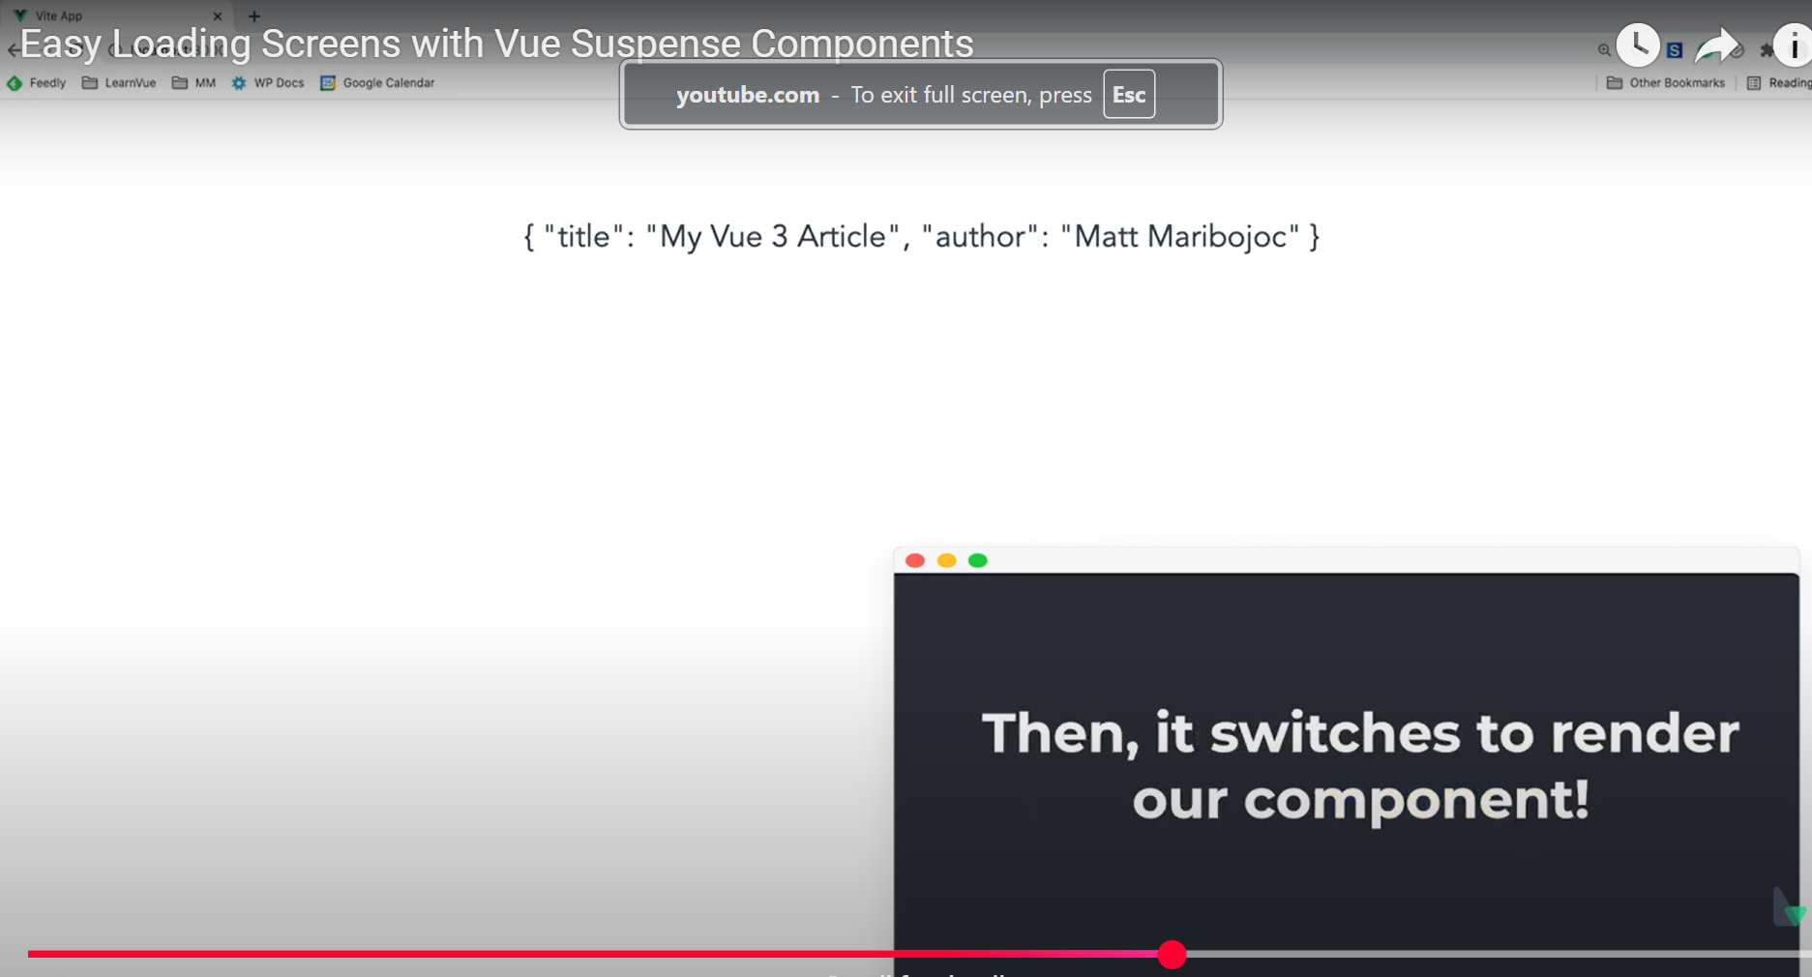

***Another important feature of Suspense component is Error handling:***

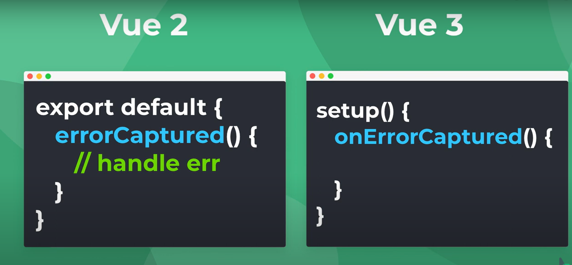



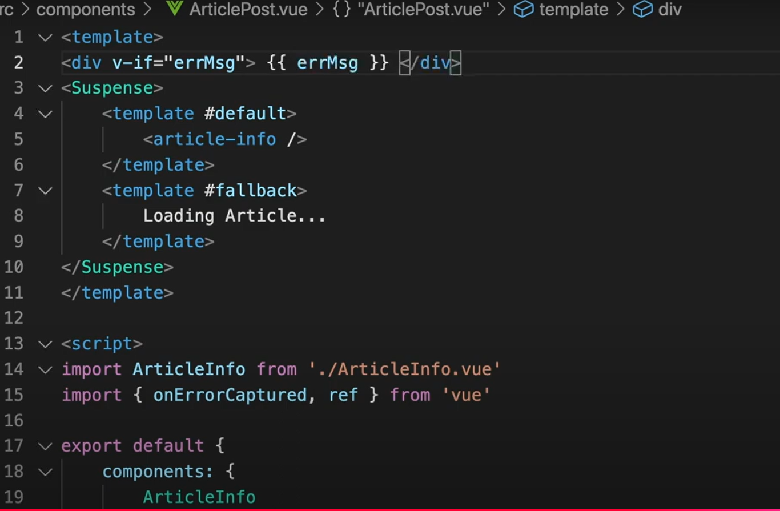

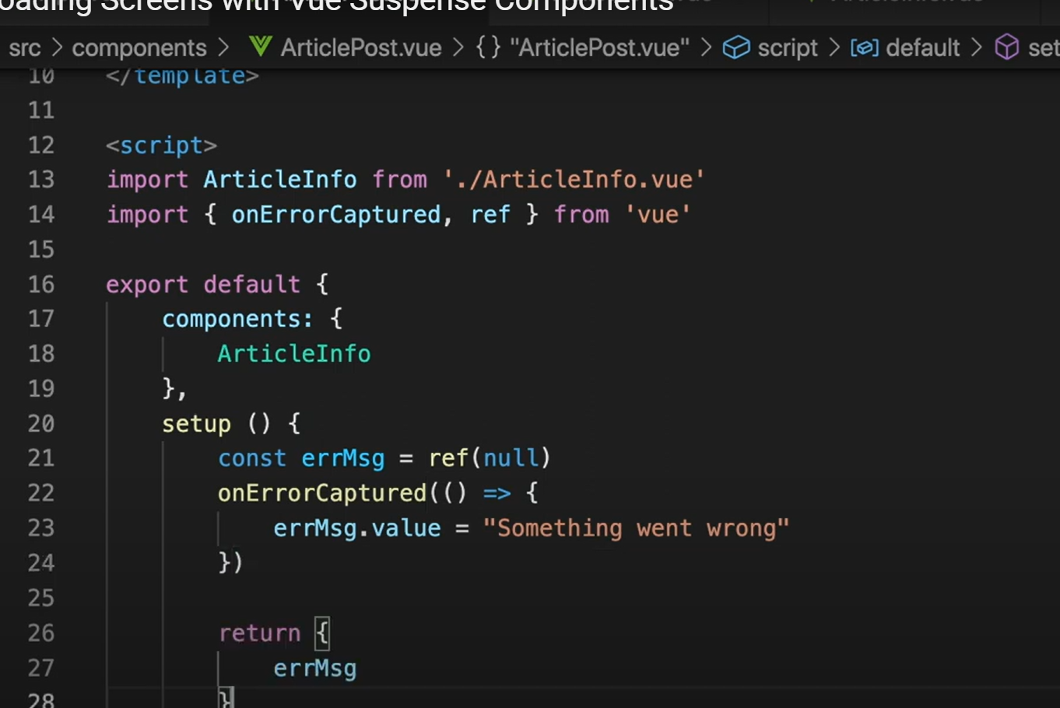



***WGT:***

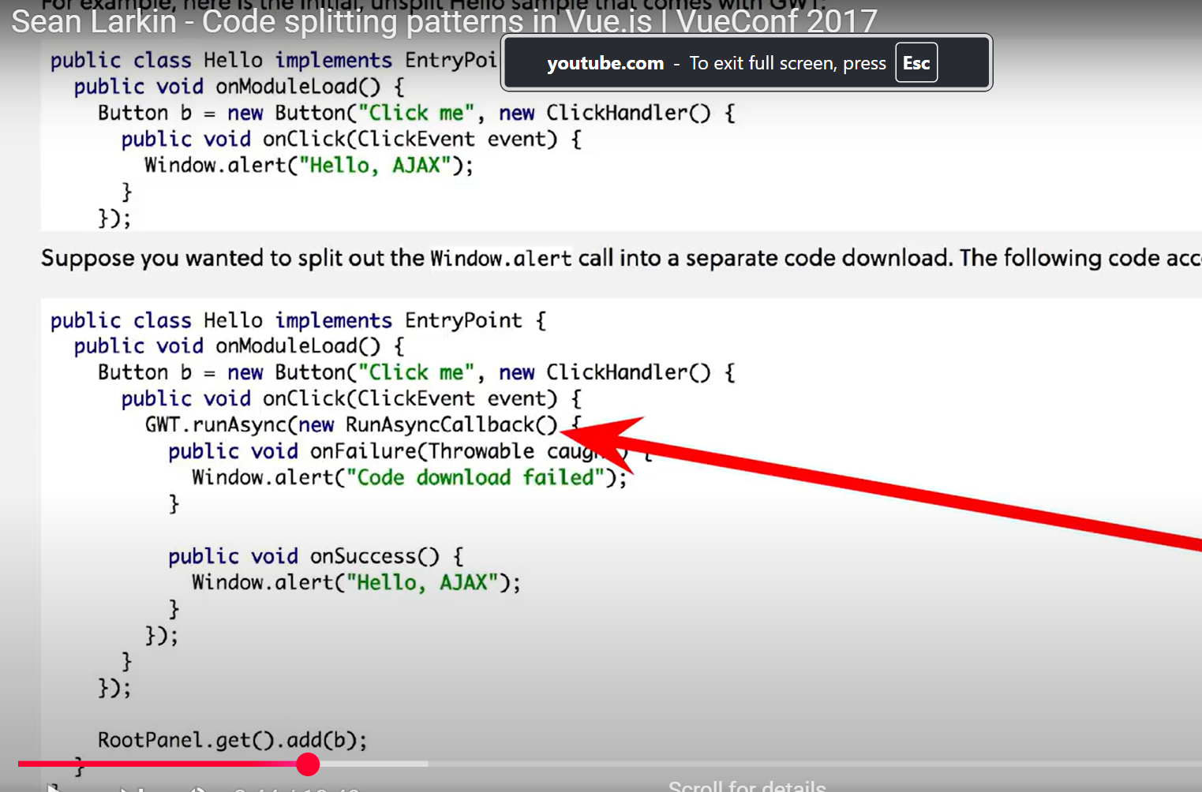

***Dynamic import:***

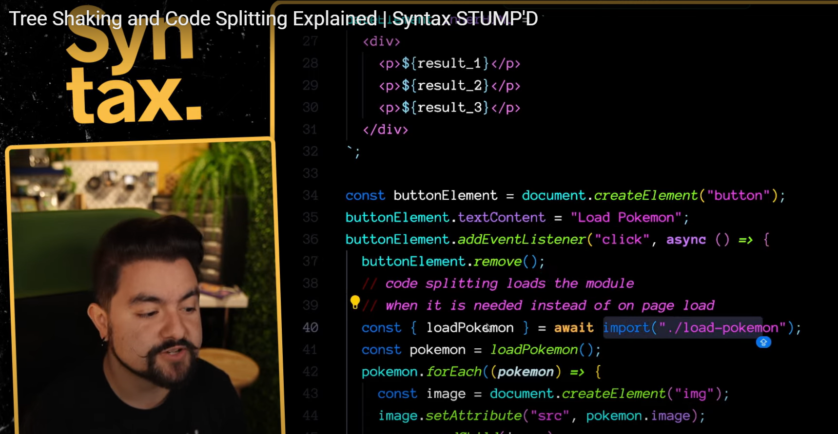

***In the above, the loadPokeman function is imported only if the button is clicked.***

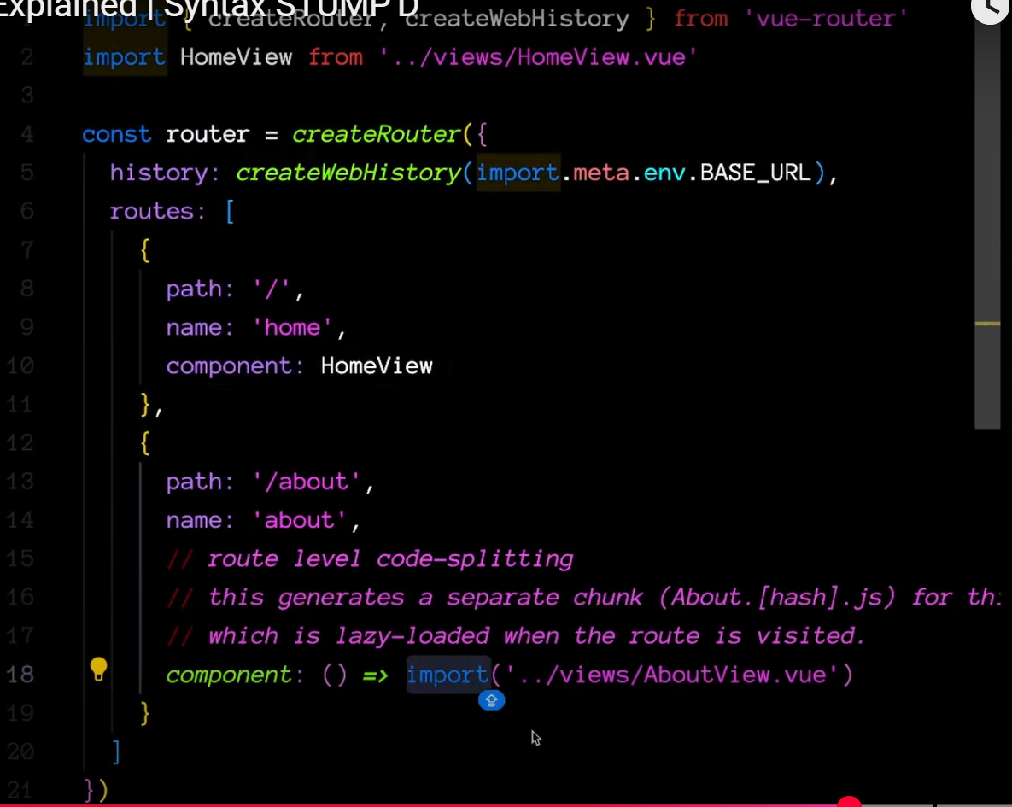

***While bundling multiple bundles are created and only the initial bundle loaded when the application starts. Rest other bundles are loaded only when it is required.***

Code Splitting Explained

Code splitting is a technique used in web development, particularly with JavaScript applications, to divide a large codebase into smaller, more manageable chunks. Instead of loading the entire application's code at once, only the necessary portions are loaded when needed. This helps to:

* **Reduce initial load time:**

Users see content faster as they don't have to wait for the entire application bundle to download.

* **Improve performance:**

Smaller bundles lead to faster parsing and execution by the browser, resulting in quicker page loads and better overall performance.

* **Optimize resource utilization:**

Only loading code that's needed for the current page or interaction reduces unnecessary resource usage.

* **Enable better caching:**

Once a chunk is loaded, it can be cached by the browser, benefiting subsequent visits or navigations.

Common Techniques for Code Splitting

* **Dynamic Imports:**

React, for example, supports code splitting natively via dynamic imports, where you import a module only when it's needed, according to Medium.

* **Bundlers:**

Tools like Webpack, Rollup, and Parcel can automate code splitting by analyzing dependency trees and creating chunks based on specified rules.

* **Route-based Splitting:**

In applications with multiple routes, code can be split based on the route, so only the code needed for a specific route is loaded when the user navigates to it.

* **Lazy Loading:**

This involves deferring the loading of non-essential resources until they are actually needed, further enhancing performance.

Examples

* **React:** Dynamic imports can be used to load components only when they are rendered on a specific route.
* **Next.js:** Code splitting is often done by route, and it's supported out-of-the-box.
* **Web applications:** You can split the code for different parts of your application, such as "above the fold" and "below the fold" content, to optimize loading.

In Summary

Code splitting is a valuable technique for optimizing web applications, especially for large and complex projects. It allows for a faster initial load time, improved performance, and efficient resource utilization. While "WGT" isn't a standard term in this context, the general principles of code splitting, such as dynamic imports, bundlers, route-based splitting, and lazy loading, are widely used to achieve these benefits.

## Bundling

Most React apps will have their files “bundled” using tools like [Webpack](https://webpack.js.org/), [Rollup](https://rollupjs.org/) or [Browserify](http://browserify.org/). Bundling is the process of following imported files and merging them into a single file: a “bundle”. This bundle can then be included on a webpage to load an entire app at once.

#### Example

**App:**

// app.js

import { add } from './math.js';

console.log(add(16, 26)); // 42

// math.js

export function add(a, b) {

return a + b;

}

**Bundle:**

function add(a, b) {

return a + b;

}

console.log(add(16, 26)); // 42

**Note:**

Your bundles will end up looking a lot different than this.

If you’re using [Create React App](https://create-react-app.dev/), [Next.js](https://nextjs.org/), [Gatsby](https://www.gatsbyjs.org/), or a similar tool, you will have a Webpack setup out of the box to bundle your app.

If you aren’t, you’ll need to set up bundling yourself. For example, see the [Installation](https://webpack.js.org/guides/installation/) and [Getting Started](https://webpack.js.org/guides/getting-started/) guides on the Webpack docs.

## Code Splitting

Bundling is great, but as your app grows, your bundle will grow too. Especially if you are including large third-party libraries. You need to keep an eye on the code you are including in your bundle so that you don’t accidentally make it so large that your app takes a long time to load.

To avoid winding up with a large bundle, it’s good to get ahead of the problem and start “splitting” your bundle. Code-Splitting is a feature supported by bundlers like [Webpack](https://webpack.js.org/guides/code-splitting/), [Rollup](https://rollupjs.org/guide/en/#code-splitting) and Browserify (via [factor-bundle](https://github.com/browserify/factor-bundle)) which can create multiple bundles that can be dynamically loaded at runtime.

Code-splitting your app can help you “lazy-load” just the things that are currently needed by the user, which can dramatically improve the performance of your app. While you haven’t reduced the overall amount of code in your app, you’ve avoided loading code that the user may never need, and reduced the amount of code needed during the initial load.

## import()

The best way to introduce code-splitting into your app is through the dynamic import() syntax.

**Before:**

import { add } from './math';

console.log(add(16, 26));

**After:**

import("./math").then(math => {

console.log(math.add(16, 26));

});

When Webpack comes across this syntax, it automatically starts code-splitting your app. If you’re using Create React App, this is already configured for you and you can [start using it](https://create-react-app.dev/docs/code-splitting/) immediately. It’s also supported out of the box in [Next.js](https://nextjs.org/docs/advanced-features/dynamic-import).

If you’re setting up Webpack yourself, you’ll probably want to read Webpack’s [guide on code splitting](https://webpack.js.org/guides/code-splitting/). Your Webpack config should look vaguely [like this](https://gist.github.com/gaearon/ca6e803f5c604d37468b0091d9959269).

When using [Babel](https://babeljs.io/), you’ll need to make sure that Babel can parse the dynamic import syntax but is not transforming it. For that you will need [@babel/plugin-syntax-dynamic-import](https://classic.yarnpkg.com/en/package/@babel/plugin-syntax-dynamic-import).

## React.lazy

The React.lazy function lets you render a dynamic import as a regular component.

**Before:**

import OtherComponent from './OtherComponent';

**After:**

const OtherComponent = React.lazy(() => import('./OtherComponent'));

This will automatically load the bundle containing the OtherComponent when this component is first rendered.

React.lazy takes a function that must call a dynamic import(). This must return a Promise which resolves to a module with a default export containing a React component.

The lazy component should then be rendered inside a Suspense component, which allows us to show some fallback content (such as a loading indicator) while we’re waiting for the lazy component to load.

Lazy loading is a performance optimization technique where resources (like images or components) are only loaded when they are needed, rather than all at once. Dynamic imports, on the other hand, are a way to load modules asynchronously at runtime. While lazy loading helps optimize page load times by delaying the loading of non-critical resources, dynamic imports provide a way to conditionally load modules, and can be used to implement lazy loading in frameworks like React.

# 3 Types Of State Management in Vue Js

In today’s world of front-end applications and their component-based architectures, components will most often need to share data amongst themselves to be displayed or used to achieve certain functionality. Keeping data synced and up-to-date amongst components in a modern front-end application can quickly become a tedious and frustrating task if not tackled using a battle-tested strategy.

**Props**

VueJS shares data between multiple components through the use of props. You can pass data from a parent component to its child component using props. However, props are **unidirectional**. We can pass props from parent to child to grandchild and so on, but not the other way around. If you need to pass data from child to parent, you need to use [Vue custom events](https://vuejs.org/v2/guide/components-custom-events.html).

# Limitation of props and Custom Events

Using props and custom events, we only can pass data to parent and child or vice versa, not to other components.

Now comes the question, “**How do we pass data if two components aren’t directly related to each other, for example, sibling components?”.**

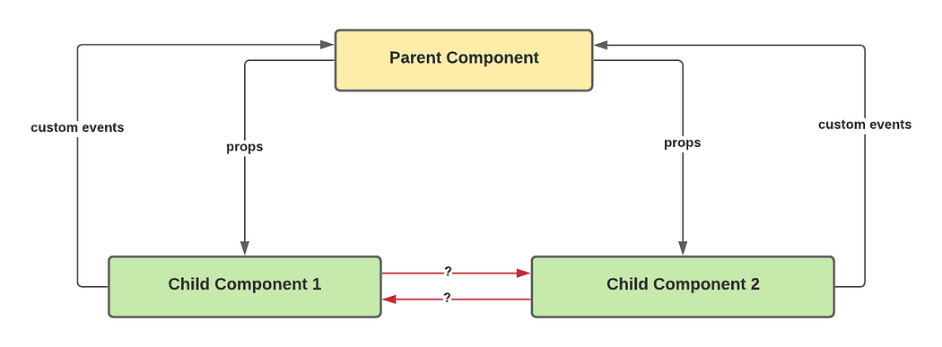

Let’s look at three ways we can manage application-wide state in VueJS applications.

1. Using a global EventBus.
2. Using a simple global store.
3. Using the Vuex library.

**1. Using a global EventBus**

Usually, components that don’t have a direct relationship cannot listen to custom events fired from each other. Therefore, they cannot pass data between them. However, this can be achieved by an EventBus. An EventBus follows a **publisher/subscriber**pattern. If the isolated components know the EventBus, they can subscribe to specific events. A publisher can publish events to the EventBus, and all subscribers of that event will get notified when the event is published.

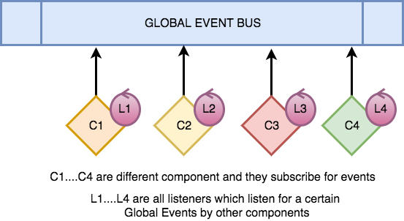

EventBus solves cross-component state management by helping to communicate data between components. However, EventBus has a few disadvantages.

**Disadvantages Of Event Bus**

* There is no centralized state management mechanism. It leads to data inconsistencies in large applications.
* As the application grows, it’ll be much harder to track state changes as we can’t keep track of how the state changed or which components reacted to it.

**2. Using a simple global store**

One of the main disadvantages of the EventBus was the lack of centralized state management. This issue gets solved if we introduce a global store every component can access. In this method, we try to place our data in a global store instead of within single components. The methods that mutate the data within the store will also be placed in the store itself.

Let’s have a look at an example store.

import { reactive } from “vue”;export const store = {  
 state: reactive({  
 movies: [‘Harry Potter’, ‘BAHUBALI’, ‘Interstellar’, ‘RRR’, ‘PUSPA’]  
 }),  
 addMovie(newMovie) {  
 this.state.movies.push(newMovie);  
 }  
};

You can see how the data array and the method to update are included within the store. One unique thing about this is using “reactive” from Vue to define the state object. This function is used to define a reactive state from a JavaScript object. When this state changes, all components that refer to this state will re-render.

The isolated components will talk to each other through the store. However, they still don’t directly communicate with each other. Therefore the components are loosely coupled. The store method addMovies will directly mutate the state. This is also known as store mutation. If one component wants to update the data, it should immediately act on the store method addMovies The data displaying component will only think about getting the store value. It does not care about the store method.

Using a simple global store makes your state and component updates more manageable than the EventBus.

**3. Using Vuex state management library**

Vuex is a **state management pattern + library** for Vue.js applications. It serves as a centralized store for all the components in an application.

This is very similar to the Flux pattern developed by Facebook. The main part of Vuex is the Vuex Store. The Vuex store consists of 4 objects.

**State** — Vuex uses a **single state tree** — that is, this single object contains all your application-level state and serves as the “single source of truth.”

**Getters** — Responsible for performing calculations or manipulations to store state before having that information accessible to components.

**Actions** — Responsible for calling mutations can be used to perform all asynchronous/complex logic before calling mutations. Here, the Actions are invoked using the store.dispatch() function.

**Mutations** — Functions responsible for directly mutating the state (As a common practice, mutations are named in capital letters. e.g., ADD_MOVIE). To invoke a mutation handler, the store.commit() function needs to be called. Mutations must always be synchronous.

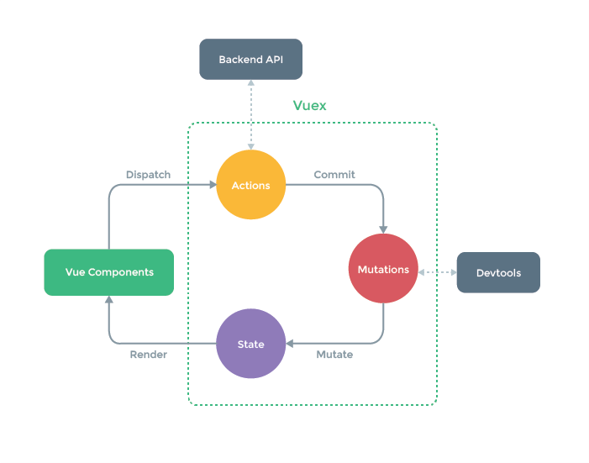

As you can see, Vuex is an advanced extension of the simple global store we defined in the previous method. Further, Vuex can be integrated with VueJS dev tools that allow time travel debugging.

Vuex solves most problems that we faced with the previous methods. Some of them are as follows.

* A centralized store that leads to consistent, shareable data across any component.
* Adds structure on how state changes.
* It simplifies monitoring
* Enables time-travel debugging and performance benchmarking

**State Management Libraries:**

For Vue 3, [Pinia](https://pinia.vuejs.org/) is the recommended state management library by the Vue core team. It's designed specifically for Vue 3, leveraging the Composition API for simplicity and type safety. [Vuex](https://vuex.vuejs.org/) is also a viable option, but Pinia is considered the more modern and preferred solution.

While less commonly used for Vue 3, libraries like Zustand or XState can also be used for state management, though they may not offer the same level of integration and support as Pinia.

**Composable:**

A **composable** is a function that leverages **Vue's** Composition API to encapsulate and reuse stateful logic. It's a way to extract and share code across multiple components without duplication.

### **Top-level bindings are exposed to template**[**​**](https://vuejs.org/api/sfc-script-setup#top-level-bindings-are-exposed-to-template)

When using <script setup>, any top-level bindings (including variables, function declarations, and imports) declared inside <script setup> are directly usable in the template:

vue

<script setup>

// variable

const msg = 'Hello!'

// functions

function log() {

console.log(msg)

}

</script>

<template>

<button @click="log">{{ msg }}</button>

</template>

Imports are exposed in the same fashion. This means you can directly use an imported helper function in template expressions without having to expose it via the methods option:

vue

<script setup>

import { capitalize } from './helpers'

</script>

<template>

<div>{{ capitalize('hello') }}</div>

</template>

## defineProps() & defineEmits()[​](https://vuejs.org/api/sfc-script-setup#defineprops-defineemits)

To declare options like props and emits with full type inference support, we can use the defineProps and defineEmits APIs, which are automatically available inside <script setup>:

vue

<script setup>

const props = defineProps({

foo: String

})

const emit = defineEmits(['change', 'delete'])

// setup code

</script>

* defineProps and defineEmits are **compiler macros** only usable inside <script setup>. They do not need to be imported, and are compiled away when <script setup> is processed.
* defineProps accepts the same value as the props option, while defineEmits accepts the same value as the emits option.
* defineProps and defineEmits provide proper type inference based on the options passed.

### Using <script setup>[**​**](https://vuejs.org/guide/typescript/composition-api#using-script-setup)

When using <script setup>, the defineProps() macro supports inferring the props types based on its argument:

vue

<script setup lang="ts">

const props = defineProps({

foo: { type: String, required: true },

bar: Number

})

props.foo // string

props.bar // number | undefined

</script>

This is called "runtime declaration", because the argument passed to defineProps() will be used as the runtime props option.

However, it is usually more straightforward to define props with pure types via a generic type argument:

vue

<script setup lang="ts">

const props = defineProps<{

foo: string

bar?: number

}>()

</script>

This is called "type-based declaration". The compiler will try to do its best to infer the equivalent runtime options based on the type argument. In this case, our second example compiles into the exact same runtime options as the first example.

You can use either type-based declaration OR runtime declaration, but you cannot use both at the same time.

We can also move the props types into a separate interface:

vue

<script setup lang="ts">

interface Props {

foo: string

bar?: number

}

const props = defineProps<Props>()

</script>

This also works if Props is imported from an external source. This feature requires TypeScript to be a peer dependency of Vue.

### **Without <script setup>**[**​**](https://vuejs.org/guide/typescript/composition-api#without-script-setup)**(defineComponent())**

If not using <script setup>, it is necessary to use defineComponent() to enable props type inference. The type of the props object passed to setup() is inferred from the props option.

ts

import { defineComponent } from 'vue'

export default defineComponent({

props: {

message: String

},

setup(props) {

props.message // <-- type: string

}

})

### Complex prop types[**​**](https://vuejs.org/guide/typescript/composition-api#complex-prop-types)

With type-based declaration, a prop can use a complex type much like any other type:

vue

<script setup lang="ts">

interface Book {

title: string

author: string

year: number

}

const props = defineProps<{

book: Book

}>()

</script>

For runtime declaration, we can use the PropType utility type:

ts

import type { PropType } from 'vue'

const props = defineProps({

book: Object as PropType<Book>

})

This works in much the same way if we're specifying the props option directly:

ts

import { defineComponent } from 'vue'

import type { PropType } from 'vue'

export default defineComponent({

props: {

book: Object as PropType<Book>

}

})

The props option is more commonly used with the Options API, so you'll find more detailed examples in the guide to [TypeScript with Options API](https://vuejs.org/guide/typescript/options-api#typing-component-props). The techniques shown in those examples also apply to runtime declarations using defineProps().

**v-memo:**

The v-memo directive in Vue 3 is used for performance optimization by memoizing a subtree of the template. It tells Vue to skip re-rendering a part of the DOM unless specific dependencies change, improving performance, especially in complex UIs or large lists.

***Example:***

<template>

<h1>v-memo Example</h1>

<p>Click the button to randomly replace pink circles with blue circles.</p>

<p>Click the area with circles to re-render using the v-memo directive.</p>

<button v-on:click="addBlue">Replace Circles</button>

Circles replaced: {{ blueCircNmbr }}

<div id="wrapper" v-on:click="this.updateProp++">

<div

v-for="x in circle"

:style="{ backgroundColor: x.color }"

:key="x.key"

v-memo="[updateProp]"

></div>

</div>

</template>

<script>

export default {

data() {

return {

circle: [],

blueCircNmbr: 0,

updateProp: 0

};

},

mounted() {

for (let i = 0; i < 2000; i++) {

this.circle.push({

color: 'pink',

key: i

})

}

},

methods: {

addBlue() {

for (let i = 0; i < 1000; i++) {

let that = this;

setTimeout(function () {

let index = Math.floor(Math.random() * that.circle.length);

let blueCircEl = {

color: 'blue',

key: index

};

that.circle.splice(index, 1, blueCircEl);

that.blueCircNmbr++;

}, 20 * i);

}

}

}

}

</script>

<style scoped>

#wrapper {

margin-top: 10px;

display: flex;

flex-wrap: wrap;

border: solid transparent 1px;

cursor: pointer;

}

#wrapper:hover {

border: solid black 1px;

}

#wrapper > div {

margin: 2px;

width: 10px;

height: 10px;

border: solid black 1px;

border-radius: 10px;

}

</style>

Webpack is a powerful, open-source JavaScript module bundler. It takes various assets like JavaScript, CSS, and images and transforms them into a single or multiple optimized bundles that can be deployed to a browser or server.

In React development, Webpack plays a crucial role. It handles the complexities of modern web development by:

* **Bundling:**

Combining all your React components, libraries, and other assets into a single file or multiple files. This reduces the number of HTTP requests and improves loading times.

* **Code Transformation:**

Using loaders, Webpack can transform code written in JSX, TypeScript, or other languages into standard JavaScript that browsers can understand.

* **Optimization:**

Webpack optimizes code by minifying it, removing unused code (tree-shaking), and providing caching mechanisms. This results in smaller bundle sizes and faster application performance.

* **Development Server:**

Webpack can be used with a development server that provides features like live reloading, which automatically updates the browser when you make changes to your code.

* **Plugin Ecosystem:**

Webpack has a rich plugin ecosystem that allows for customization and extension of its functionality.

* **Dependency Management**:

Webpack manages dependencies between modules, ensuring that they are loaded in the correct order.

While tools like Create React App abstract away the need to directly configure Webpack, understanding how it works can be beneficial for advanced configurations and performance optimization.

***Applying color theme for the application***

To apply a global theme in a Vue 3 project, you can either use CSS variables and a theme switcher, or leverage a framework like Vuetify. CSS variables allow for dynamic theming, while Vuetify offers pre-built themes and simplifies the process.

Using CSS Variables and a Theme Switcher:

1. **1. Define CSS Variables:**

Create a CSS file (e.g., src/assets/styles.css) and define your theme variables using the -- prefix (e.g., --primary-color: #007bff;).

1. **2. Apply Variables:**

Import this CSS file into your main.js or App.vue to make the styles global.

1. **3. Create a Theme Switcher:**

Build a component that allows users to select a theme. This component should update the CSS variables on the document.documentElement or a relevant element, using document.documentElement.style.setProperty() or setAttribute() with a data-theme attribute.

1. **4. Implement Theme Logic:**

Implement logic to persist the user's theme choice (e.g., using localStorage).

1. **5. Adapt Styles:**

Use the CSS variables within your components and styles.

**Using Vuetify**:

1. **Install Vuetify:** Use npm install vuetify to install the library.
2. **Configure Vuetify:** In your main.js or plugins/vuetify.js, configure Vuetify, specifying the defaultTheme (e.g., dark) and custom themes.
3. **Import Vuetify Styles:** Import Vuetify's CSS into your main.js.
4. **Use Vuetify Components:** Vuetify components are automatically themed based on the configured themes.

**Using CSS Variables and a Theme Switcher**

***Style.css***

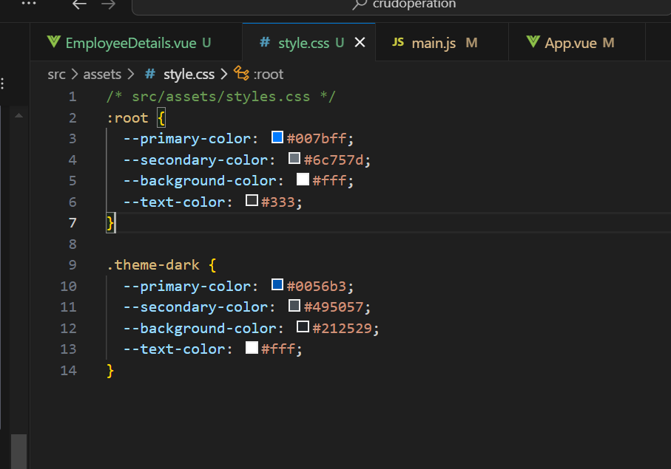

***Importing the stylesheet in main.js***

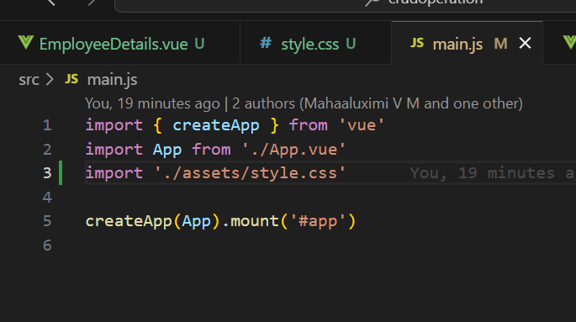

***App.vue***

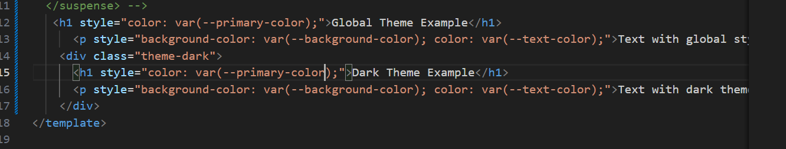

<template>

  <img alt="Vue logo" src="./assets/logo.png">

  <!-- <HelloWorld msg="Welcome to Your Vue.js App"/> -->

  <!-- <suspense>

    <template #default>

      <EmployeeDetails />

    </template>

    <template #fallback>

      <p>Loading...</p>

    </template>

  </suspense> -->

   <h1 style="color: var(--primary-color);">Global Theme Example</h1>

      <p style="background-color: var(--background-color); color: var(--text-color);">Text with global styles</p>

    <div class="theme-dark">

      <h1 style="color: var(--primary-color);">Dark Theme Example</h1>

      <p style="background-color: var(--background-color); color: var(--text-color);">Text with dark theme styles</p>

    </div>

</template>

<script>

// import { defineAsyncComponent } from 'vue'

//import EmployeeDetails from './components/EmployeeDetails.vue'

// const EmployeeDetails = defineAsyncComponent({

//   loader: () => import('./components/EmployeeDetails.vue'),

//   loadingComponent: {

//     template: '<p>Loading...</p>'

//   },

//   delay: 2000,

//   timeout: 3000});

// export default {

//   name: 'App',

//   components: {

//     EmployeeDetails

//   }

// }

</script>

<style>

#app {

  font-family: Avenir, Helvetica, Arial, sans-serif;

  -webkit-font-smoothing: antialiased;

  -moz-osx-font-smoothing: grayscale;

  text-align: center;

  color: #2c3e50;

  margin-top: 60px;

}

</style>

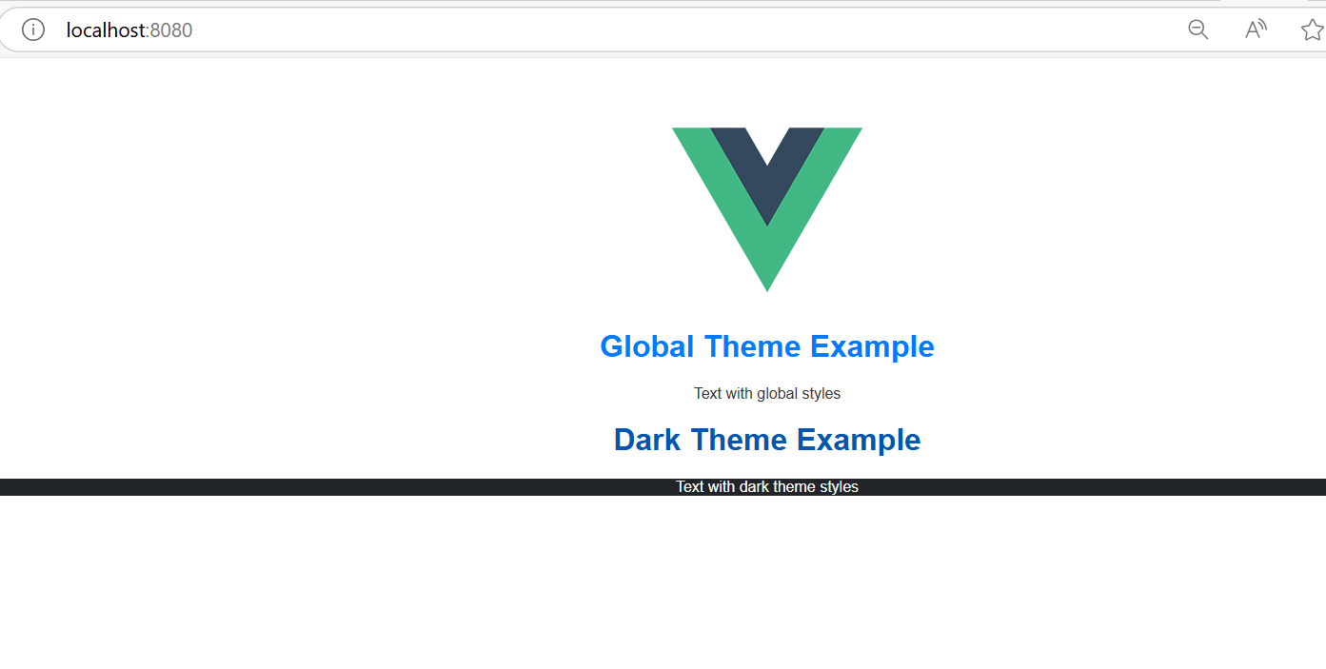

**Using Vuetify**:

Command to create vue3 appl with vuetify: (new appl)

***vue create vuetify3-vue3***

To add Vuetify for existing appln

***npm install vuetify***

**vuetify.js**

import { createVuetify } from 'vuetify';

import * as components from 'vuetify/components';

import * as directives from 'vuetify/directives';

export default createVuetify({

  components,

  directives,

  theme: {

    defaultTheme: 'dark', // Or 'light'

    themes: {

      dark: {

        colors: {

          primary: '#0056b3',

          secondary: '#495057',

          background: '#212529',

          text: '#fff',

        },

      },

      light: {

        colors: {

          primary: '#007bff',

          secondary: '#6c757d',

          background: '#fff',

          text: '#333',

        },

      },

    },

  },

});

**Importing vuetify.js file in the main.js file and registering it with app for the themes to be applied automatically**

import { createApp } from 'vue'

import App from './App.vue'

import vuetify from './plugins/vuetify'

createApp(App)

.use(vuetify) //registering the vuetify with app

.mount('#app')

**DefaultTheme set as “dark”**

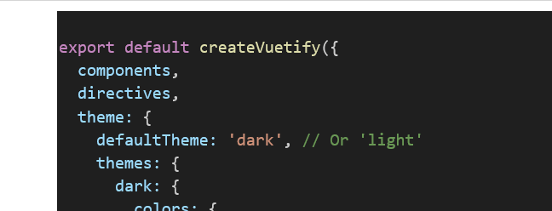

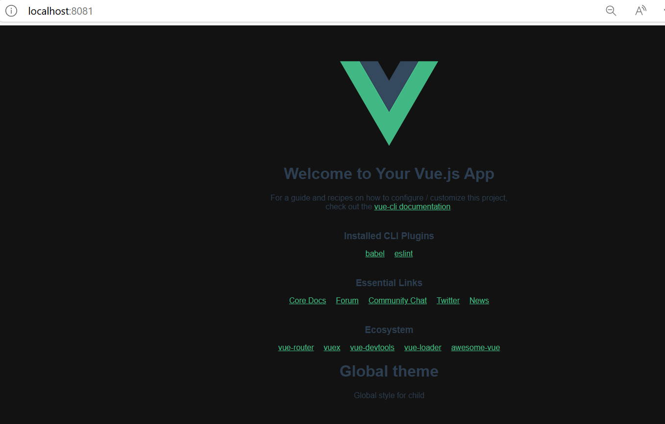

***DefaultTheme set as light:***

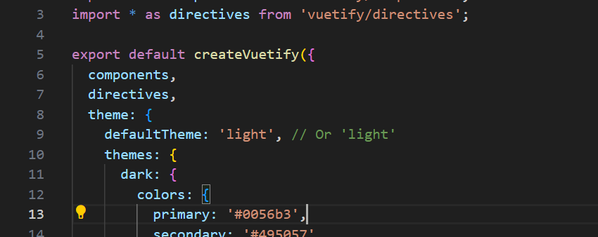

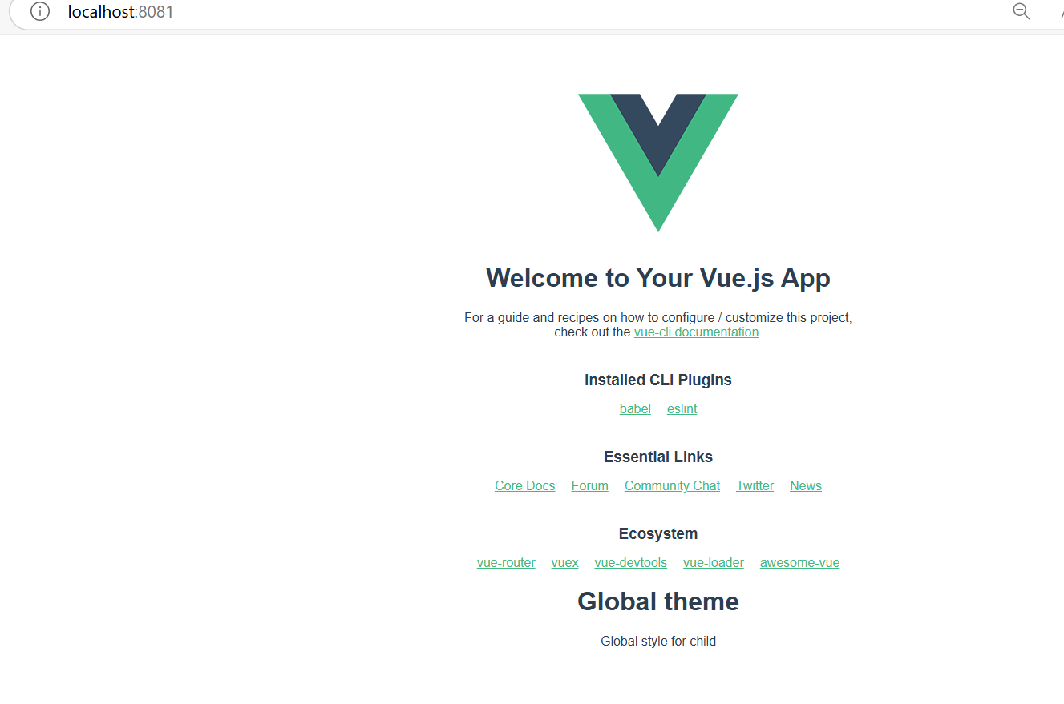

***What data types v-model support?***

*The @v-model directive in Vue.js supports two-way data binding with various types of data, including:*

*Strings*

*Numbers*

*Booleans*

*Arrays*

*Objects*

***During the initial rendering of a Vue component, the order of execution is:***

**Computed properties:** Computed properties are evaluated and cached during the initial rendering. This is because computed properties are used to compute derived state, and Vue needs to know their initial values to render the component correctly.

**Methods:** Methods are not executed automatically during initial rendering. They are only executed when called explicitly, either from the template or from another part of the code.

**Watchers:** Watchers are executed after the initial rendering, when the watched data changes. However, during the initial rendering, watchers are not executed immediately. Instead, they are registered and will be executed later when the watched data changes.

**So, to summarize:**

Computed properties are executed during initial rendering.

Methods are not executed during initial rendering, unless called explicitly.

Watchers are registered during initial rendering, but not executed until the watched data changes.

**Interceptors:**

In Vue.js, an interceptor is a function that can be used to intercept and modify the request or response of an HTTP request. Interceptors are typically used to add global headers, handle authentication, or modify the response data.

Defining Interceptors

To define an interceptor, you can create a function that takes two arguments: config and error. The config object contains the request configuration, and the error object contains any error that occurred during the request.

**Sanitizing and validating user input is crucial to prevent security vulnerabilities and ensure data consistency in your Vue.js application.**

Here are some ways to do it:

**Sanitizing User Input:**

Use v-model with trim modifier: When using v-model to bind user input to a data property, add the trim modifier to remove whitespace from the input value.

**<input v-model.trim="username" type="text">**

Use a library like DOMPurify: DOMPurify is a popular library for sanitizing HTML input. You can use it to remove malicious code from user input.

**import DOMPurify from 'dompurify';**

**const userInput = '<script>alert("XSS")</script>';**

**const sanitizedInput = DOMPurify.sanitize(userInput);**

**Validating User Input**

Use Vue's built-in validation: Vue provides a built-in validation system using the $validator property. You can define validation rules using the validate method.

export default {

data() {

return {

username: '',

password: ''

}

},

validate() {

if (!this.username) {

this.errors.push('Username is required');

}

if (!this.password) {

this.errors.push('Password is required');

}

}

}

**V2 – V3 changes:**

|  |  |
| --- | --- |
| **V2** | **V3** |
| new Vue({    el: '#app', //works only for v2, in case of v3 use mount()    data: {      message: 'This works in Vue 2!',    },    methods: {      changeMessage() {        this.message = 'Will it work in Vue 3?';      },    },  });  In V2, app is created with the Vue global object instance | const app = Vue.createApp({    data() {      return {        message: 'This works in Vue 3!',      };    },    methods: {      changeMessage() {        this.message = 'Will it work in Vue 2?';      },    },  });  In V3, app is created with the “createApp” method |
| To mount “el” property is used | mount() method is used |
| **Sub-component is registered with the gobal Vue object**  Vue.component('the-button', {    template: '<button @click="updateMessage">Click me</button>',    methods: {      updateMessage() {        this.$emit('update');      },    },  }); | **Sub-component is registered with the component() method** |
| No such feature | Emits property is introduced just to indicate that, that specific component will emit the custom event somewhere in the component |
|  | **Class name change**  box-fade-enter -> changed to box-fade-enter-from  box-fade-leave -> changed to box-fade-leave-from |
|  |  |
|  |  |

**Computed Properties and when would you use a writable computed property , and how is it defined ?**

**Computed Properties in Vue.js**

In Vue.js, computed properties are a feature that allows you to define a property on a component that is computed on the fly when accessed, rather than being stored as a simple value. They are often used to simplify complex logic or to provide a convenient way to access derived data.

**Writable Computed Properties in Vue.js**

A writable computed property is a computed property that can be assigned a value, just like a regular property. Thisallows you to not only compute a value on the fly but also to store a value that can be used to update the underlying data.

When to use a writable computed property in Vue.js

You would use a writable computed property in Vue.js when you need to:

Simplify complex logic: When you have a complex calculation that depends on multiple factors, a writable computed property can help simplify the logic and make it more readable.

Provide a convenient interface: When you need to provide a simple way to access or update derived data, a writable computed property can be a good solution.

Decouple data from presentation: When you need to separate the data from its presentation, a writable computed property can help you achieve this by providing a computed value that can be used in the presentation layer.

Defining a writable computed property in Vue.js

In Vue.js, you can define a writable computed property using the computed property on a component. Here is an example:

***<template>***

***<div>***

***{{ fullName }}***

***<input v-model="fullName" type="text">***

***</div>***

***</template>***

***<script>***

***export default {***

***data() {***

***return {***

***firstName: 'John',***

***lastName: 'Doe'***

***}***

***},***

***computed: {***

***fullName: {***

***get() {***

***return `${this.firstName} ${this.lastName}`***

***},***

***set(value) {***

***const [firstName, lastName] = value.split(' ')***

***this.firstName = firstName***

***this.lastName = lastName***

***}***

***}***

***}***

***}***

***</script>***

In this example, the fullName property is a writable computed property that can be accessed and updated like a regular property. The get method is used to compute the value of the property, and the set method is used to update the underlying data when the property is assigned a new value.

Note that in Vue.js, you can also use the computed property to define a read-only computed property by only providing a get method.

**Accessing the computed set and get methods of computed property:**

In the example I provided earlier, the fullName computed property has both a get and set method. To access these methods, you can use the following syntax:

**Accessing the get method**

To access the get method, you can simply use the computed property as a value, like this:

console.log(this.fullName) // calls the get method and returns the computed value

In the template, you can also use the computed property as a value, like this:

***<template>***

***<div>***

***{{ fullName }} <!-- calls the get method and displays the computed value -->***

***</div>***

***</template>***

**Accessing the set method**

*To access the set method, you can assign a new value to the computed property, like this:*

*this.fullName = 'Jane Doe' // calls the set method and updates the underlying data*

*In the template, you can also use the v-model directive to bind the computed property to an input field, like this:*

***<template>***

***<div>***

***<input v-model="fullName" type="text"> <!-- calls the set method when the input field is updated -->***

***</div>***

***</template>***

*Note that when you access the set method, Vue.js will automatically call the set method and update the underlying data. You don't need to call the set method explicitly.*

***Directly accessing the get and set methods***

*If you need to access the get and set methods directly, you can use the $computed property on the component instance, like this:*

***const fullNameGet = this.$computed.fullName.get***

***const fullNameSet = this.$computed.fullName.set***

***console.log(fullNameGet()) // calls the get method and returns the computed value***

***fullNameSet('Jane Doe') // calls the set method and updates the underlying data***

*However, this is not a common use case, and you should usually access the computed property using the syntax I described earlier.*

***In Vue.js, if you create a computed property that returns Date.now() as its value, it will not behave as you might expect.***

*What happens?*

*When you create a computed property that returns Date.now(), Vue.js will cache the result of the computation and return the same value every time the property is accessed. This means that the computed property will not be updated in real-time, even though Date.now() returns the current timestamp.*

*Why?*

*This happens because Vue.js uses a technique called "caching" to optimize the performance of computed properties. When a computed property is first accessed, Vue.js computes its value and stores it in a cache. Subsequent accesses to the property will return the cached value instead of re-computing it.*

*In the case of Date.now(), the value is not dependent on any reactive data, so Vue.js assumes that the value will not change and caches it. However, Date.now() returns a new timestamp every time it is called, so the cached value becomes stale immediately.*

*Consequences*

*This behavior can lead to unexpected consequences, such as:*

*The computed property will not update in real-time, even though the timestamp changes.*

*If you use the computed property in a template, it will display a stale value.*

*If you use the computed property in a method, it will use the stale value.*

*Solution*

*To avoid this issue, you can use a different approach, such as:*

*Using a method instead of a computed property, like getTimestamp() { return Date.now() }.*

*Using a watcher to update a data property with the current timestamp, like watch: { now: Date.now }.*

*Using a library like moment.js to handle dates and timestamps, which provides a more robust way to work with time-related data.*

*By understanding how Vue.js caches computed properties and how Date.now() behaves, you can avoid unexpected issues and write more effective code.*

***In Vue.js, computed properties are designed to be treated as read-only and should not be mutated directly. Here's why:***

***Reason 1: Caching***

*Computed properties are cached by Vue.js to improve performance. When a computed property is first accessed, Vue.js computes its value and stores it in a cache. Subsequent accesses to the property will return the cached value instead of re-computing it. If you mutate a computed property directly, you'll be modifying the cached value, which can lead to unexpected behavior and errors.*

***Reason 2: Dependency tracking***

*Computed properties are dependent on other reactive data, such as data properties or other computed properties. When a computed property is updated, Vue.js needs to re-compute its value based on the new dependencies. If you mutate a computed property directly, you'll be bypassing the dependency tracking mechanism, which can lead to stale or incorrect values.*

***Reason 3: Side effects***

*Computed properties are designed to be pure functions, meaning they should not have side effects. Mutating a computed property directly can introduce side effects, such as updating other data properties or triggering unnecessary re-renders.*

***Reason 4: Debugging and maintainability***

*Treating computed properties as read-only makes it easier to debug and maintain your code. When a computed property is updated, you can easily track the changes by looking at the dependencies and the computation logic. If you mutate a computed property directly, it can be harder to understand what's happening and why.*

***Best practice***

*To avoid mutating computed properties directly, follow these best practices:*

*Use a separate data property to store the value, and update that property instead of the computed property.*

*Use a method to update the data property, and call that method when needed.*

*Use a watcher to update the data property when the dependencies change.*

*By treating computed properties as read-only and following these best practices, you'll ensure that your Vue.js application is more predictable, maintainable, and efficient.*

*Here's an example of how to update a data property instead of a computed property:*

*data() {*

*return {*

*firstName: 'John',*

*lastName: 'Doe',*

*fullName: ''*

*}*

*},*

*computed: {*

*fullNameComputed() {*

*return `${this.firstName} ${this.lastName}`*

*}*

*},*

*methods: {*

*updateFullName() {*

*this.fullName = `${this.firstName} ${this.lastName}`*

*}*

*}*

*In this example, the fullName data property is updated using the updateFullName method, instead of mutating the fullNameComputed computed property directly.*

**How should the value defined for key attribute using with v-for**

When using v-for in Vue.js, it's essential to define a unique key attribute for each item in the loop. Here's why:

Why is a unique key important?

When Vue.js updates the DOM, it uses the key attribute to keep track of the identity of each element. If the key is not unique, Vue.js may not be able to correctly update the DOM, leading to unexpected behavior, such as:

Incorrect rendering of elements

Loss of state or data

Poor performance

What makes a good key?

A good key should be:

Unique: Each item in the loop should have a unique key.

Stable: The key should not change over time.

Predictable: The key should be predictable, so Vue.js can easily identify the element.

Examples of good keys

Here are some examples of good keys:

**ID: If your data has a unique ID, use it as the key.**

<ul>

<li v-for="item in items" :key="item.id">{{ item.name }}</li>

</ul>

**Index: If you're looping over an array, you can use the index as the key.**

*<ul>*

*<li v-for="(item, index) in items" :key="index">{{ item.name }}</li>*

*</ul>*

***Combination of properties: If you have multiple properties that together make a unique identifier, use them as the key.***

*<ul>*

*<li v-for="item in items" :key="`${item.name}-${item.email}`">{{ item.name }}</li>*

*</ul>*

*What to avoid*

*Avoid using the following as keys:*

*Random numbers: Random numbers are not stable and can change over time.*

*Timestamps: Timestamps are not unique and can change over time.*

*Non-unique properties: Properties that are not unique, such as name or email, should not be used as keys.*

*By using a unique and stable key, you'll ensure that Vue.js can correctly update the DOM and maintain the state of your application.*

**In which scenario you might use .capture in a Vue Component. What does it do ?**

In Vue.js, the .capture modifier is used to capture events in the capturing phase, rather than the bubbling phase.

What is the difference between capturing and bubbling phases?

When an event occurs in the DOM, it goes through two phases:

Capturing phase: The event starts at the root of the DOM and travels down to the target element.

Bubbling phase: The event starts at the target element and travels up to the root of the DOM.

By default, Vue.js listens to events in the bubbling phase. However, in some scenarios, you might want to capture events in the capturing phase.

When to use .capture?

You might use .capture in the following scenarios:

Preventing event propagation: If you want to prevent an event from propagating to other elements, you can use .capture to capture the event in the capturing phase and stop it from bubbling up.

Handling events before child elements: If you want to handle an event before it reaches a child element, you can use .capture to capture the event in the capturing phase.

Creating a global event handler: If you want to create a global event handler that captures events from all elements, you can use .capture to capture events in the capturing phase.

*<template>*

*<div @click.capture="handleClick">Click me!</div>*

*</template>*

*<script>*

*export default {*

*methods: {*

*handleClick(event) {*

*console.log('Captured click event!')*

*event.stopPropagation()*

*}*

*}*

*}*

*</script>*

*In this example, the handleClick method is called when the click event is captured in the capturing phase. The stopPropagation method is used to prevent the event from bubbling up to other elements.*

*Note: The .capture modifier only works with native DOM events, not with custom events emitted by Vue components.*

*By using .capture, you can gain more control over event handling in your Vue.js application and handle events in a more flexible way.*

**Primary use case of custom directive in Vue, purpose of binding object in custom directive..**

*Custom directives in Vue are used to extend the functionality of HTML elements and provide a way to attach custom behavior to elements. The primary use case of custom directives is to:*

*Manipulate the DOM: Custom directives can be used to manipulate the DOM, such as adding or removing classes, styles, or attributes.*

*Bind data to elements: Custom directives can be used to bind data to elements, such as text, attributes, or styles.*

*Handle events: Custom directives can be used to handle events, such as clicks, hover, or focus.*

*Create reusable functionality: Custom directives can be used to create reusable functionality that can be applied to multiple elements.*

*Purpose of the binding object in custom directives*

*In Vue, the binding object is an object that is passed to the custom directive's bind function. The binding object contains information about the element, the directive, and the Vue instance. The purpose of the binding object is to:*

*Provide context: The binding object provides context about the element, such as its name, value, and attributes.*

*Expose Vue instance: The binding object exposes the Vue instance, allowing the custom directive to access the instance's data, methods, and lifecycle hooks.*

*Pass data: The binding object can be used to pass data from the Vue instance to the custom directive.*

*The binding object typically contains the following properties:*

*name: The name of the directive.*

*value: The value of the directive.*

*expression: The expression that is being evaluated.*

*arg: The argument passed to the directive.*

*modifiers: An object containing the modifiers passed to the directive.*

*instance: The Vue instance.*

*el: The element that the directive is bound to.*

***Vue.directive('focus', {***

***bind(el, binding, vnode) {***

***console.log(binding.value) // logs the value of the directive***

***console.log(binding.expression) // logs the expression being evaluated***

***console.log(vnode.context) // logs the Vue instance***

***}***

***})***

*In this example, the bind function is called when the focus directive is bound to an element. The binding object is passed as an argument, which contains information about the directive, the element, and the Vue instance.*

**How does client -side routing differ from server-side routing in SPA and how can simple routing be implemented in Vue without using a full-featured router library ?**

***Client-side routing vs Server-side routing in SPA***

*In a Single-Page Application (SPA), client-side routing and server-side routing differ in how the routing is handled:*

***Client-side routing***

*Routing is handled by the client (browser)*

*The client requests the initial HTML page from the server*

*The client-side router (e.g., Vue Router) takes over and handles routing requests*

*When the user navigates to a new route, the client-side router updates the URL and renders the new route without making a new request to the server*

***Server-side routing***

*Routing is handled by the server*

*The server receives requests for different routes and returns the corresponding HTML pages*

*When the user navigates to a new route, the browser makes a new request to the server, which returns the new HTML page*

*Simple routing in Vue without a full-featured router library*

*You can implement simple routing in Vue without using a full-featured router library like Vue Router by using the following approaches:*

*Using the window.location object: You can use the window.location object to update the URL and render different routes based on the URL.*

***SSR (Server-Side Rendering) vs SSG (Static Site Generation) in Vue.js***

*In Vue.js, both SSR and SSG are techniques used to render web applications on the server, but they differ in their approach and use cases.*

***SSR (Server-Side Rendering)***

*SSR involves rendering the Vue.js application on the server, generating the initial HTML, and sending it to the client. The client then takes over and handles subsequent interactions.*

***Key characteristics of SSR:***

*Server-generated HTML: The server generates the initial HTML of the application.*

*Dynamic rendering: The server renders the application dynamically for each request.*

*Faster page loads: SSR can improve page load times, as the initial HTML is generated on the server.*

*Better SEO: SSR can improve search engine optimization (SEO), as the server-generated HTML is crawlable by search engines.*

***SSG (Static Site Generation)***

*SSG involves pre-rendering the Vue.js application at build time, generating static HTML files, and serving them directly to the client.*

***Key characteristics of SSG:***

*Pre-rendered HTML: The application is pre-rendered at build time, generating static HTML files.*

*Static rendering: The server serves the pre-rendered HTML files directly to the client.*

*Faster page loads: SSG can improve page load times, as the static HTML files are served directly to the client.*

*Improved security: SSG can improve security, as the server is not involved in rendering the application.*

*Comparison of SSR and SSG:*

*| | SSR | SSG | | --- | --- | --- | | Rendering | Dynamic | Static | | Server involvement | High | Low | | Page load times | Faster | Faster | | SEO | Better | Better | | Security | Good | Improved |*

*When to use SSR:*

*Dynamic content: Use SSR when your application has dynamic content that needs to be rendered on the server.*

*Real-time updates: Use SSR when your application requires real-time updates, such as live updates or streaming data.*

*When to use SSG:*

*Static content: Use SSG when your application has static content that can be pre-rendered at build time.*

*Fast page loads: Use SSG when you want to improve page load times and reduce the load on your server.*

*In Vue.js, you can use libraries like Nuxt.js for SSR and VuePress for SSG. Ultimately, the choice between SSR and SSG depends on your application's specific needs and requirements.*

***Effect of using a production build compared to a development build in Vue.js***

*In Vue.js, the production build and development build differ in several ways, which affect the performance, security, and debugging capabilities of your application.*

***Development Build***

*A development build is used during the development phase of your application. It is optimized for debugging and provides features that help you identify and fix issues quickly.*

***Characteristics of a development build:***

*Source maps: Source maps are enabled, which allows you to debug your application using the original source code.*

*Debugging tools: Debugging tools like the Vue Devtools are enabled, which provide features like component inspection, event tracking, and performance monitoring.*

*Error reporting: Error reporting is enabled, which provides detailed error messages and stack traces.*

*Hot reloading: Hot reloading is enabled, which allows you to see changes to your application in real-time without requiring a full page reload.*

***Production Build***

*A production build is used when your application is deployed to a production environment. It is optimized for performance, security, and reliability.*

***Characteristics of a production build:***

*Minification and compression: The code is minified and compressed, which reduces the file size and improves page load times.*

*Source maps disabled: Source maps are disabled, which reduces the file size and improves performance.*

*Debugging tools disabled: Debugging tools like the Vue Devtools are disabled, which improves performance and reduces the attack surface.*

*Error reporting disabled: Error reporting is disabled, which reduces the amount of error data sent to the server.*

*Caching: Caching is enabled, which improves performance by reducing the number of requests made to the server.*

***Why is it important to remove unused development-only code when deploying to production in Vue?***

*Removing unused development-only code when deploying to production in Vue is important for several reasons:*

***1. Security***

*Unused development-only code can pose a security risk if it is not removed. This code may contain sensitive information, such as API keys or database credentials, that could be exploited by an attacker. By removing this code, you can reduce the attack surface of your application.*

***2. Performance***

*Unused development-only code can also impact the performance of your application. This code may be executed unnecessarily, consuming resources and slowing down your application. By removing this code, you can improve the performance of your application.*

***3. Code Maintenance***

*Unused development-only code can make it more difficult to maintain your application. This code may be outdated or no longer relevant, making it harder to understand and debug your application. By removing this code, you can simplify your codebase and make it easier to maintain.*

***4. Compliance***

*In some cases, removing unused development-only code may be required for compliance with regulatory requirements. For example, if your application handles sensitive data, you may be required to remove any code that is not necessary for the production environment.*

***5. Best Practices***

*Removing unused development-only code is a best practice in software development. It helps to ensure that your codebase is clean, efficient, and secure.*

***Examples of development-only code***

*Some examples of development-only code that should be removed when deploying to production in Vue include:*

*Console logs: Console logs are often used for debugging purposes, but they can also impact performance and security.*

*Debugging tools: Debugging tools, such as the Vue Devtools, are often used during development, but they should be removed when deploying to production.*

*Test code: Test code, such as unit tests and integration tests, are often used during development, but they should be removed when deploying to production.*

*Development-only dependencies: Development-only dependencies, such as Webpack and Babel, are often used during development, but they should be removed when deploying to production.*

*How to remove unused development-only code*

*To remove unused development-only code when deploying to production in Vue, you can use the following techniques:*

*Use a build tool: Use a build tool, such as Webpack or Rollup, to bundle and minify your code. This can help to remove unused code and reduce the size of your codebase.*

*Use a code analyzer: Use a code analyzer, such as ESLint or TSLint, to identify and remove unused code.*

*Use a deployment script: Use a deployment script, such as a Bash script or a Node.js script, to automate the process of removing unused code and deploying your application to production.*

*By removing unused development-only code when deploying to production in Vue, you can improve the security, performance, and maintainability of your application.*

***Measuring Performance during Local Development on Vue***

*Measuring performance during local development on Vue is crucial to ensure that your application is running smoothly and efficiently. Here are some ways to measure performance during local development on Vue:*

***1. Browser DevTools***

*Browser DevTools, such as Chrome DevTools or Firefox Developer Edition, provide a range of tools to measure performance, including:*

*Network panel: Measures the time it takes for resources to load and the size of the resources.*

*Performance panel: Measures the time it takes for the application to render and the CPU usage.*

*Memory panel: Measures the memory usage of the application.*

***2. Vue Devtools***

*Vue Devtools is a Chrome extension that provides a range of tools to measure performance, including:*

*Performance panel: Measures the time it takes for the application to render and the CPU usage.*

*Memory panel: Measures the memory usage of the application.*

*Component tree: Measures the time it takes for each component to render.*

***3. Webpack Bundle Analyzer***

*Webpack Bundle Analyzer is a tool that provides a visual representation of the size of your application's bundles. This can help identify performance bottlenecks and optimize the size of your bundles.*

***4. Lighthouse***

*Lighthouse is a tool that provides a range of metrics to measure performance, including:*

*Page load time: Measures the time it takes for the page to load.*

*First meaningful paint: Measures the time it takes for the first meaningful paint to occur.*

*Speed index: Measures the time it takes for the page to become interactive.*

***5. Vue Performance Devtool***

*Vue Performance Devtool is a tool that provides a range of metrics to measure performance, including:*

*Component render time: Measures the time it takes for each component to render.*

*Component update time: Measures the time it takes for each component to update.*

*Memory usage: Measures the memory usage of the application.*

***6. Manual Testing***

*Manual testing involves testing your application manually to identify performance bottlenecks. This can include:*

*Page load testing: Testing the time it takes for the page to load.*

*Interaction testing: Testing the time it takes for the application to respond to user interactions.*

*Scrolling testing: Testing the time it takes for the application to render when scrolling.*

*By using these tools and techniques, you can measure performance during local development on Vue and identify areas for optimization to improve the performance of your application.*

***Securing URL Binding and Preventing JS Injection in Vue.js***

*Securing URL binding and preventing JavaScript injection is crucial to protect your Vue.js application from security vulnerabilities. Here are some techniques and libraries that can help:*

*1. Use the v-bind directive with caution*

*When using the v-bind directive to bind URLs, make sure to use it with caution. Avoid binding user-input data directly to URLs, as this can lead to JavaScript injection attacks.*

*2. Use a URL sanitizer library*

*There are several URL sanitizer libraries available for Vue.js, such as:*

*vue-url-sanitizer: This library provides a simple way to sanitize URLs and prevent JavaScript injection attacks.*

*url-sanitizer: This library provides a more comprehensive URL sanitization solution that can help prevent a wide range of security vulnerabilities.*

*3. Use a whitelist approach*

*Instead of trying to block specific malicious URLs, use a whitelist approach to only allow specific URLs that are known to be safe. This can help prevent JavaScript injection attacks and other security vulnerabilities.*

*4. Use a Content Security Policy (CSP)*

*A Content Security Policy (CSP) is a security feature that helps prevent JavaScript injection attacks by defining which sources of content are allowed to be executed within a web page. You can use a CSP to specify which URLs are allowed to be loaded and executed within your Vue.js application.*

*5. Use a URL encoding library*

*URL encoding libraries, such as encodeURIComponent, can help prevent JavaScript injection attacks by encoding URLs in a way that prevents malicious code from being executed.*

*6. Validate user input*

*Always validate user input data to prevent malicious code from being injected into your Vue.js application. Use techniques such as input validation and sanitization to ensure that user input data is safe and secure.*

*7. Use a security-focused Vue.js framework*

*Some Vue.js frameworks, such as Vue.js Security, provide built-in security features that can help prevent JavaScript injection attacks and other security vulnerabilities.*

*Example of using vue-url-sanitizer*

*import Vue from 'vue'*

*import VueUrlSanitizer from 'vue-url-sanitizer'*

*Vue.use(VueUrlSanitizer)*

*// Sanitize a URL*

*const sanitizedUrl = VueUrlSanitizer.sanitize('https://example.com/script.js')*

*// Bind the sanitized URL to a Vue component*

*<template>*

*<a :href="sanitizedUrl">Click me!</a>*

*</template>*